**Title: Evaluating Factors Associated with Mental Health Outcomes among Dublin Hospital Healthcare Workers Exposed to the COVID-19 Pandemic**

**SECTION 1: DEMOGRAPHICS QUESTIONS**

The first set of questions are about you and your work.

**1 Please start by creating your own unique ID. This lets us link your answers to this survey to your answers to future surveys to see how mental health outcomes vary over time. Your unique code is:**

* The first initial of your middle name (or your surname if you don't have one), plus
* The first initial of your mother's maiden name (or your father's surname), plus
* The two digits of your birth month, plus
* The last two digits of your birth year

e.g. EW0774

Create your code here: _____________________

**2 What is your gender? (select one)**

Male Female Non Binary Prefer not to say

**3**  **What hospital do you work in?**  ____________________________

4 What is your **age are you?**  ____________________________

**5 How would you describe your discipline? (circle one)**

Medical Nursing HSCP Other healthcare worker

1. **What’s your sub-discipline (specify your profession)?** _______________
2. **Are you a manager?** Yes No
3. **Which describes your work status best?** Full-time or Part-time

**9 How many years of professional experience do you have**? ___________

**SECTION 2: COVID-19 SPECIFIC QUESTIONS**

1. **What percentage of your work has had direct COVID-19 contact?**

(‘none’ 0-100 ‘all the time’) __________________________________

1. **Have you had COVID-19?** Yes / No
2. **If yes, were you treated in hospital?** Yes No N/A
3. **Have any colleagues of yours had COVID-19?** Yes No
4. **If yes, have they been treated in hospital?** Yes No
5. **How many people do you know personally who’ve had COVID-19**? _____
6. **How would you rate your fear of COVID-19, right now?**

(‘no fear’ 0-100 ‘extreme fear’) ___________________

1. **How would you rate your stress levels before the COVID-19 pandemic?**

(‘minimal’ 0-100 ‘extreme’) ________________________

1. **Have you had any negative work experiences due to the COVID crisis?**

(briefly describe - optional) _______________________________________

1. **Have you had any positive work experiences because of COVID crisis**?  
   (briefly describe - optional)_____________________________________________
2. ‘**Moral injury’ is a term sometimes given to distress caused by having to make difficult decisions in the course of your work that go against your beliefs or morals. Do you feel you’ve been caused any ‘moral injury’ because of COVID19?** Yes No
3. **If yes, how ‘morally injured’ do you feel you are?**

(‘minimally’ 0–100 ‘extremely’) __________________________________

1. **If yes, is there anything you’d like to say about this?** (Open Q) ______________________________________________________________________________________________________________________________________

**SECTION 3: MEASURES (see below)**

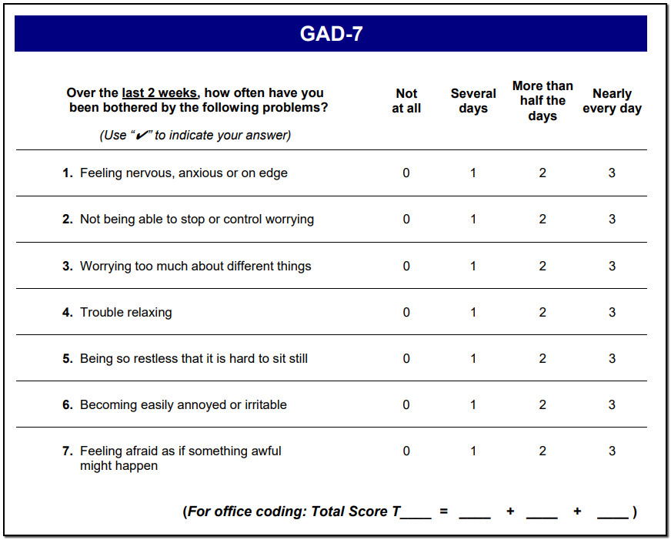

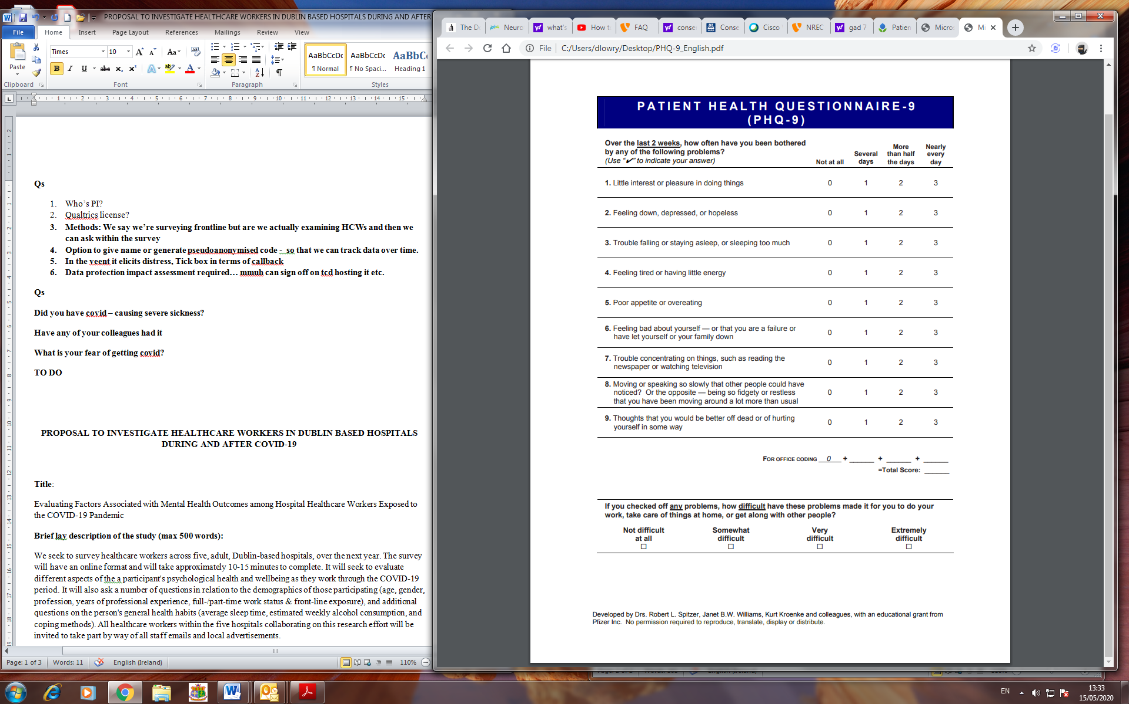 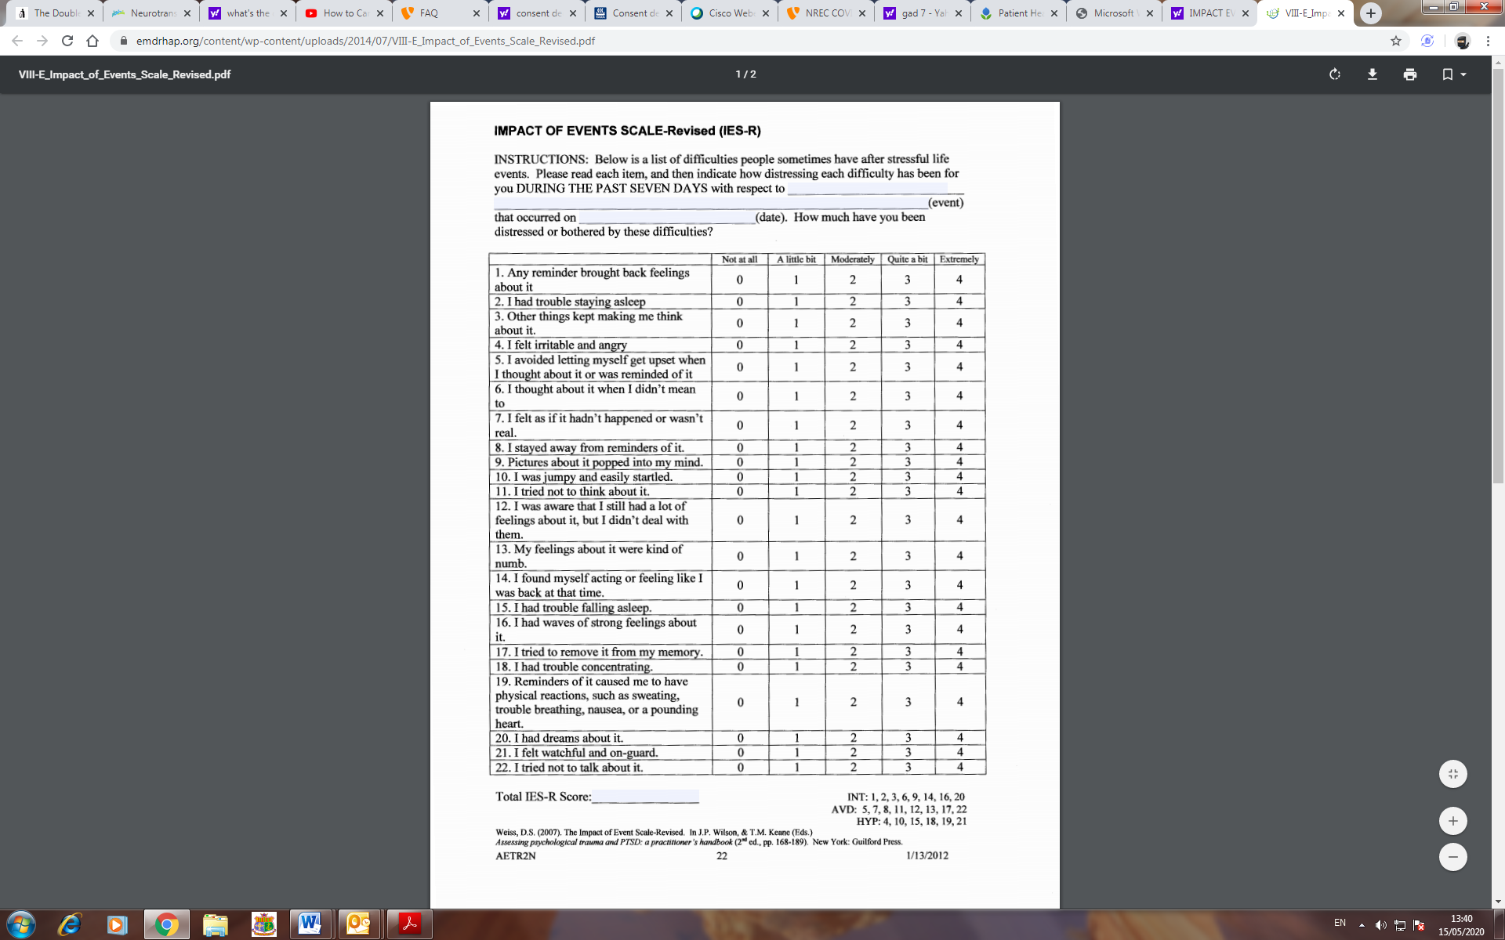

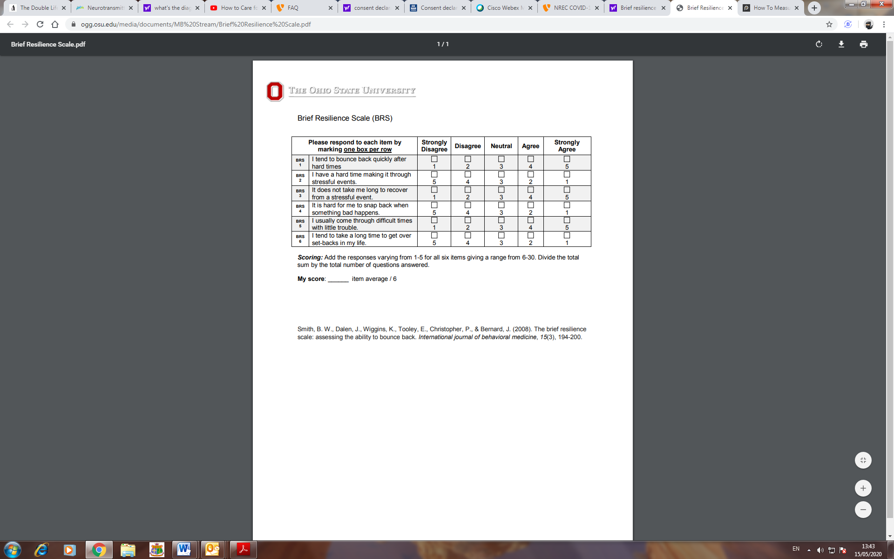

**LAST SECTION : OTHER HEALTH RELATED QUESTIONS**

1. How many hours sleep per night do you get, on average? ______________
2. How would you rate the quality of sleep you get? (‘poor’ 0-100 ‘excellent’) _______
3. How many nights a week, on average, do you consume alcohol? _____________
4. On Avg, how many standard drinks do you consume when you do consume ALC? (Note: 1 standard drink = ½ pint beer, 100ml glass of wine, or 1 pub measure of spirits) **_________**
5. How many close social contacts do you have? ________________
6. How have you coped with stress? (Open Q) ___________________________

___________________________________________________________________

1. Are there any ways you cope that might not be helpful for you? (open Q) ________

___________________________________________________________________

1. Which of the following workplace resources have you accessed to cope with stress? (tick any that apply)  
   Peers EAP Online hospital staff supports Psychology resilience training  
   Manager Occ health Staff support helpline Staff drop in clinic  
   Other __________________
2. In general terms, how would you rate the support available from your organisation through this pandemic? (‘poor’ 0-100 ‘excellent’) _______________________________
3. What are your top 5 methods of coping? – rank in order of use (1-5):  
   mindfulness use medication socialise with friends Cooking  
   exercise spend time alone go online listen to/play music  
   yoga/pilates etc talk to family/friend Gardening Hobbies

talk to a professional

1. Is there anything you’d like to add? ______________________________________________
2. Would you like to be contacted by a member of the research team about any of the above? Yes No
3. If Yes, and in order to arrange for the appropriate research team member to follow up with you, we will need:

* your work site _____________________
* and your preferred phone number __________________________
* or email address if preferred ______________________________

***THANK YOU FOR TAKING PART IN THIS RESEARCH!***