Supplementary Material:
Procedure for calculating Knowledge, Attitudes, Behaviours, and Affected variables:
To calculate Knowledge, participants were given a score of 1 for each correct answer to the following sub questions under Question 5 of the questionnaire:
Schizophrenia/bipolar disorder/autism…:
1. ... Is Contagious (false)
2. ... Is a disease with which one can live normally, with treatments (true)
3. ... Involves lifelong treatment (true - schizophrenia/bipolar disorder, false - autism)
4. ... Is a hereditary disease (true)
5. ... Is a disease like any other (true)

Where participants gave an incorrect answer or said “I do not know”, they were given a score of 0. Correct scores were added to give a total Knowledge score.

To calculate Attitudes, each of the Question 7 sub questions were used:
7. A person with ...
…schizophrenia/bipolar disorder/autism…
- ... Is able to assume the responsibility of a family
- ... Must follow treatments that leave them numbed
- ... Can not live with a partner
- ... Can not live in society, must be isolated
- ... needs to be assisted in his/her life everyday
- ... Can not hold down a job
- ... Represents a danger to herself (suicide, prison, indebtedness)
- ... Often Represents a danger to others (murder, rape, violence ...)

For Question 7 sub question 1, higher agreement was recorded as a higher score, with “Agree” recorded as 3, “I do not know” recorded as 2, and “Disagree” recorded as 1.
For Question 7 sub questions 2 to 8, lower agreement was recorded as a higher score, with “Agree” recorded as 1, “I do not know” recorded as 2, and “Disagree” recorded as 3. Scores were added to give a total Attitudes score.

To calculate Behaviours, Questions 12, 13, and 14 of the questionnaire were used:
12. Would you work with someone who had... ... schizophrenia/bipolar disorder/autism ?
13. Would you allow your children to be in the same class as a child with ... ... schizophrenia/bipolar disorder/autism ?
14. Would you accept to live under the same roof as a loved one if s/he had ... ... schizophrenia/bipolar disorder/autism ?

Higher agreement was recorded as a higher score, with “Yes happily” recorded as 3, “Yes if I had to” recorded as 2, and “Absolutely not” recorded as 1. Scores were added to give a total Behaviours score.

Finally, to examine whether participants were Affected by schizophrenia, bipolar disorder, and/or autism, we examined Question 10 and Question 10a of the questionnaire:
10. If you have ever suffered from a mental illness, which of these illnesses have you had?
10a. If you have had a loved one with a mental illness, which of these illnesses have they had?

If participants reported schizophrenia, bipolar disorder, autism, or mentioned any variation on the terms schizophrenia, bipolar disorder, or autism under Question 10 and/or Question 10a, they were recorded as being personally affected by schizophrenia, bipolar disorder, or autism (1); otherwise, they were recorded as not being personally affected (0).

Supplementary Material Figures:

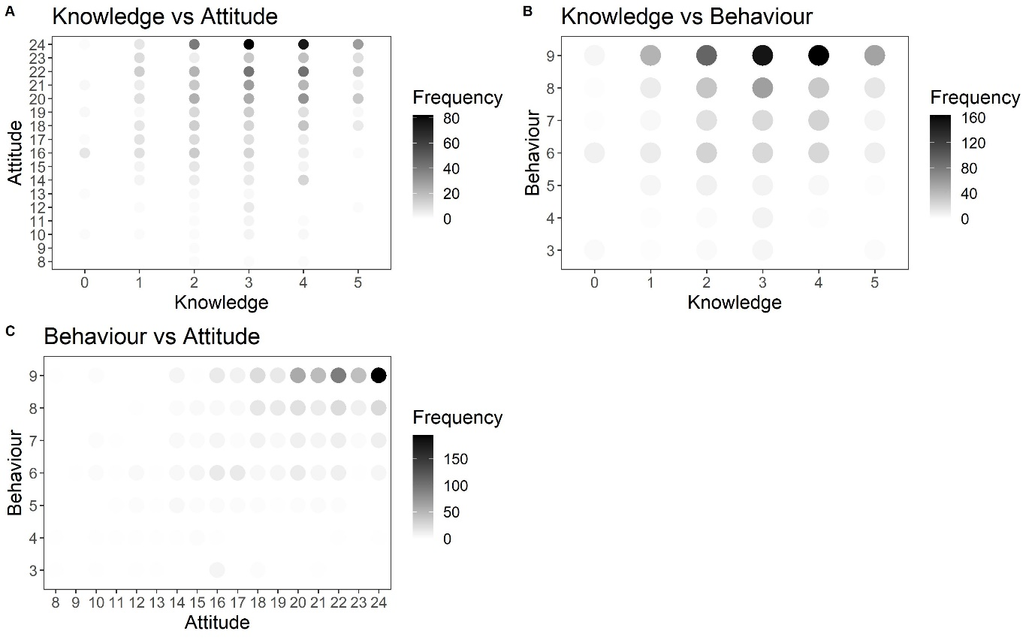
Supplementary Material Figure 1: Fluctuation plots of the relationship between (a) Knowledge (x-axis) versus Attitude (y-axis), (b) Knowledge (x-axis) versus Behaviour (y-axis), and (c) Attitude (x-axis) versus Behaviour (y-axis); increasing Knowledge represents greater knowledge, increasing Attitude represents more positive attitude, and increasing Behaviour represents more positive intended behaviour.

