Supplemental Appendix
Exploratory Hypotheses, Data Collection, and Analyses
Exploratory Partial Correlations
We conducted partial correlations controlling for BMI, time spent weight training, age, political orientation, and residence (U.S. versus non U.S.) found that the correlations between formidability, disaster and environmental views were accounted for by our covariates. However, relationships between formidability and hierarchical worldviews, status quo maintaining worldviews and empathy, remained significant (though slightly weaker in magnitude) after controlling for our covariates. These changes largely reflected remaining relationships within men, as any relationships between formidability and other variables within women became non-significant after controlling for the above covariates.
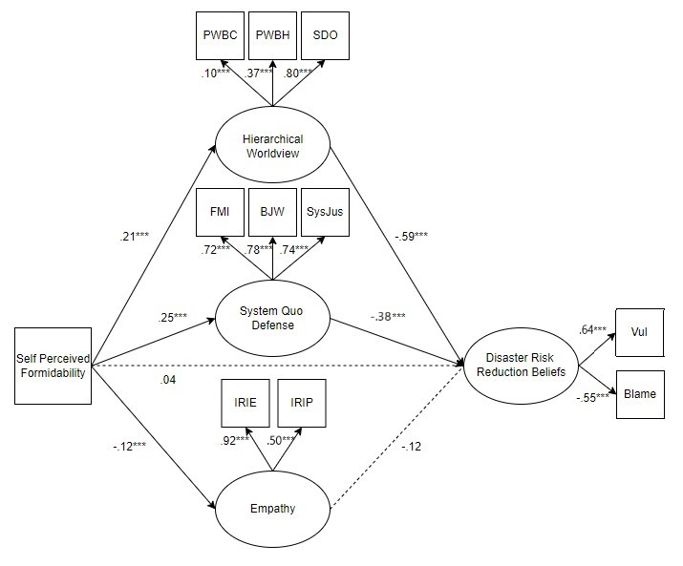
Supplemental Figure 1. Study 1 Model fit to whole group (standardized estimates)

Exploratory Hypothesis testing: Climate Beliefs
Are formidability, hierarchy and status quo maintaining worldviews, and empathy related to men’s climate change beliefs? We hypothesize that formidability, hierarchy and status quo maintaining worldviews will relate to greater climate change denial, while
Analyses. We used Structural Equation Modeling with Maximum Likelihood (ML) estimation in MPLUS (Muthén & Muthén, 2017) to fit our proposed analytic model in two separate ways: 1) on the full sample, and 2) separately within men and women each. Fit statistics were used to evaluate model fit (e.g., Nonsignificant Chi square, RMSEA ≤05, SRMR ≤.08, CFI ≥.95), with Chi square difference testing used to compare nested models. Model indices were used to judge any potential deviations from the analytic model that significantly improve model fit. Bootstrapping was used to examine indirect and direct effects in our full, parallel mediation model (see e.g., Cheung & Lau, 2008).
Table S1. Study 1 Exploratory Analyses Model Fit Statistics
Model | χ² | df | p | CFI | RMSEA | RMSEA 90% CI | SRMR | Fit
Baseline CFA | 1008.97 | 17 | <.001 | 0.77 | 0.18 | [.166, .185] | 0.13 | Poor
Final CFA | 200.42 | 16 | <.001 | 0.96 | 0.08 | [.068, .088] | 0.04 | Great
Baseline Whole Group S-R | 1203.77 | 29 | <.001 | 0.76 | 0.15 | [.139, .153] | 0.14 | Poor
Final Whole Group S-R | 237.84 | 26 | <.001 | 0.96 | 0.07 | [.058, .073] | 0.04 | Great
Multi-group S-R | 313.10 | 62 | <.001 | 0.95 | 0.07 | [.053, .073] | 0.05 | Good

We fit the hypothesized analytic model to our data in three sequential steps, using MPlus statistical software. Supplemental Table 1 depicts the model fit statistics.
First, we fit the structural portion of the model by conducting a CFA on our hypothesized latent variables. The final CFA model demonstrated good fit across our sample, suggesting that the overall hypothesized structure of our latent variables fit across both men and women. Second, we added the hypothesized regression pathways to fit the full structural regression model. R-squared estimates revealed that the model explained 21.7% of variance in climate belief. Third, we used the grouping variable to examine the model within men and women. The final multi-group model demonstrated great fit and accounted for 20.2% of variance in women’s and 21.7% of variance in men’s climate beliefs.
Deviations made during model building. During model building, the following steps were taken to improve model fit, based upon model indices suggestions and theory. First, while fitting the CFA we allowed the error variances for the primal world belief competition and hierarchy subscales to correlate, as the scales were validated together as part of the Primals Inventory (Clifton et al., 2019). While fitting the full S-R model, we allowed our latent variable errors for hierarchical worldviews, status quo defense, and empathy to correlate.
Final S-R model in full sample. Results (see Supplemental Figures 2 and 3) revealed that greater self-perceived formidability predicted more hierarchical worldviews: b = .02 (SE = .01), p =.037, 95% CI (); more status quo defense: b = .35 (SE = .04), p <.001, 95% CI (); and lower empathy: b = -.16 (SE = .03), p <.001, 95% CI (). Hierarchical worldviews predicted climate beliefs such that people who reported more hierarchical worldviews were less likely to endorse that climate change is occurring, b= -3.27 (SE = 1.72), 95% CI (-17.78, -1.35). A similar pattern emerged for status quo defense, where those who reported more defense of current systems also reported lesser belief in climate change, b = -.27 (SE = .05), p <.001, 95% CI (-.36, -.16). Empathy did not predict climate beliefs, b = 0.05 (SE = .04), p = .22, 95% CI (-.05, .15).
We next evaluated statistical mediation by examining the total, indirect, and direct effects. The direct effect was not significant, b = .02 (SE = .04), p = .69, 95% CI (-.06, .09). The total effect, b = -.17 (SE = .04), p <.001, 95% CI, (-.25, -.09) and total indirect effects, b = -.18 (SE = .02), p <.001, 95% CI (-.23, -.14) were each significant, suggesting fully statistically mediation. Probing this, there were significant specific indirect effects of self-perceived formidability on climate beliefs via hierarchical worldviews, b = -.08 (SE = .03), p =.001, 95% CI (-.14, -.04), and status quo defense, b = -.10 (SE = .02), p <.001, 95% CI (-.14, -.06), were significant. The specific indirect effect of self-perceived formidability on disaster beliefs via empathy was not significant, b = -.01 (SE = .01), p =.30, 95% CI (-.06, .09).
S-R Model within Men. Self-perceived formidability predicted hierarchical worldviews, system quo defense, and empathy, where men who reported greater formidability expressed more hierarchical worldviews, b = .03 (SE = .02), p = .038, 95% CI (); more status quo defense, b = .46 (SE = .06), p < .001, 95% CI (); and lesser empathy, b = -.16 (SE = .05), p = .003; 95% CI (). Greater hierarchical worldviews, b = -3.39 (SE = 3.85), 95% CI (-16.22, -1.40), and more status quo defense, b = -.22 (SE = .06), p < .001, 95% CI (-.33, -.09) each predicted lesser belief in climate change. Empathy did not predict climate beliefs, b = .09 (SE = .07), p = .25, 95% CI (-.06, .23).
The total effect, b = -.25 (SE = .06), p <.001, 95% CI, (-.36, -.13) was significant; but the direct effect was not significant, b = -.02 (SE = .06), p = .73, 95% CI (-.16, .09). The total indirect effect was significant, b = -.23 (SE = .04), p <.001, 95% CI (-.30, -.16), again suggesting the relationship between self-perceived formidability and climate beliefs was fully statistically mediated. An examination that this mediation was driven by the specific indirect effects of hierarchical worldviews, b = -.11 (SE = .04), p =.004, 95% CI (-.21, -.06), and status quo defense, b = -.10 (SE = .03), p =.001, 95% CI (-.16, -.04). The specific indirect effect via empathy was not significant, b = -.01 (SE = .01), p =.30, 95% CI (-.05, .01).
S-R Model within Women. There was a significant relationship between self-perceived formidability and system defense, where women who reported greater self-perceived formidability expressed greater status quo defense, b = .13 (SE = .05), p = .01, 95% CI (.03, .24). Women who expressed greater status quo defense also expressed less belief that climate change is occurring, b = -.38 (SE = .10), p < .001, 95% CI (-.54, -.16). The relationships between self-perceived formidability and hierarchical worldviews, between formidability and empathy, between hierarchical worldviews and climate beliefs, and between climate and disaster beliefs were not significant. There was not a significant total effect.
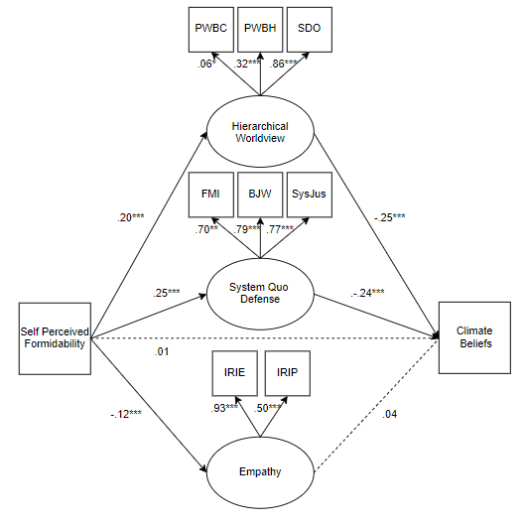
Supplemental Figure 2. Study 1 Exploratory model fit to whole group (standardized estimates)

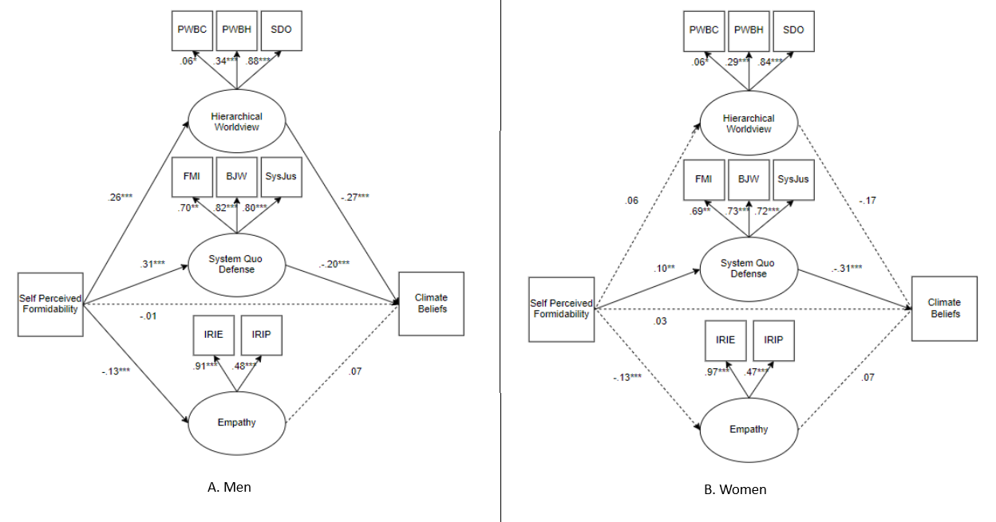
Supplemental Figure 3. Study 1 Exploratory model fit within genders (standardized estimates)

