Appendix

Abbreviated SCL-90-R

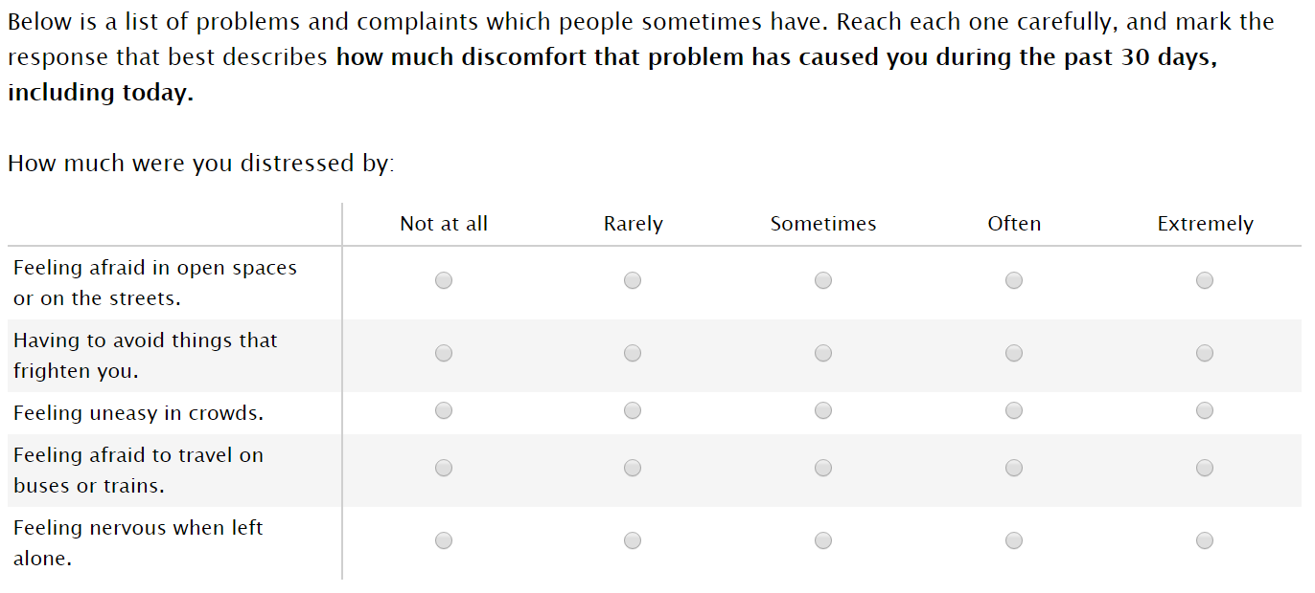

Social fear: sum of scores for all five prompts
Fear Questionnaire

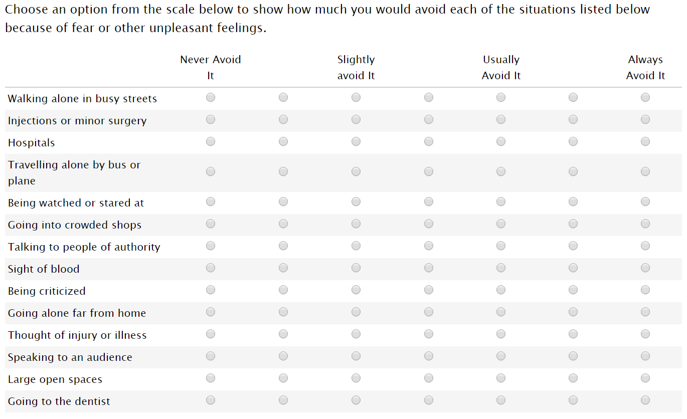

Total fear: sum of all 14 prompts

Fear of others: sum of “walking alone” “traveling alone” “crowded shops” “far from home” and “open spaces” prompts

Fear of authority: “talking to people in authority” prompt

Correlations Between Phobic-Anxiety Measures

 | Social  Fear | Total  Fear | Fear  of Others | Fear  of Authority
Social  Fear | 1.00 | --- | --- | --
Total  Fear | 0.59 | 1.00 | --- | ---
Fear  of Others | 0.64 | 0.87 | 1.00 | ---
Fear  of Authority | 0.45 | 0.68 | 0.56 | 1.00

Multicollinearity Analyses (Table 2)

Stata command: collin fear_others fear_authority pid7 income education age gender white

Variable VIF SQRT VIF Tolerance R-Squared

fear_others 1.59 1.26 0.6307 0.3693
fear_authority 1.56 1.25 0.6403 0.3597
pid7 1.07 1.03 0.9385 0.0615
income 1.17 1.08 0.8521 0.1479
education 1.15 1.07 0.8704 0.1296
age 1.06 1.03 0.9469 0.0531
gender 1.07 1.04 0.9317 0.0683
white 1.05 1.02 0.9562 0.0438
Mean VIF: 1.21

Note: collin Stata package written by Ender (2010)
Descriptive Statistics of Samples
 | MTurk  Study | Lab  Study
Age (mean) | 39.7  (13.2) | 20.4  (4.88)
Gender (percentage)
Female | 55.9 | 62.9
Male | 44.1 | 37.1
Race (percentage)
White | 81.6 | 55.6
Black | 8.24 | 26.7
Hispanic | 5.53 | 6.67
Asian | 7.36 | 18.9
Education (percentage)
Less than high school | 0.77 | 0.00
High school diploma | 7.95 | 27.8
Some college | 24.1 | 4.44
Currently in college | 4.06 | 63.3
College graduate | 45.5 | 0.00
Postgraduate degree | 17.6 | 4.44
Income (mean) | 4.82  (2.23) | 5.70  (2.61)
Party ID (proportion)
Strong Democrat | 25.5 | 33.3
Democrat | 18.6 | 21.1
Lean Democrat | 10.7 | 26.7
Independent | 12.4 | 8.89
Lean Republican | 6.24 | 2.22
Republican | 14.3 | 5.56
Strong Republican | 12.4 | 2.22
Note: standard deviations in parentheses. Income measured on 10-point scale
Mean Phobic-Anxiety Scores
 | Social  Fear | Total  Fear |  | Fear of  Others |  | Fear of Authority
Range | 0 to 20 | 0 to 84 |  | 0 to 30 |  | 0 to 6
Age
18-25 | 6.2 | 30.9 |  | 9.5 |  | 2.1
25-40 | 5.0 | 27.6 |  | 7.8 |  | 1.7
40-65 | 3.4 | 25.0 |  | 6.5 |  | 1.3
65+ | 2.4 | 24.8 |  | 6.8 |  | 1.0
Gender
Female | 4.8 | 29.4 |  | 8.6 |  | 1.6
Male | 3.8 | 23.4 |  | 5.9 |  | 1.6
Race
White | 4.2 | 26.4 |  | 7.3 |  | 1.5
Black | 5.1 | 31.2 |  | 9.0 |  | 1.9
Hispanic | 4.4 | 26.1 |  | 7.5 |  | 1.7
Asian | 4.9 | 27.1 |  | 7.1 |  | 1.7
Education
High School | 4.7 | 28.7 |  | 8.3 |  | 1.8
College | 4.1 | 25.1 |  | 6.8 |  | 1.4
Post-graduate | 3.7 | 23.2 |  | 6.1 |  | 1.3
Party
Strong Democrat | 4.7 | 26.4 |  | 6.9 |  | 1.7
Democrat | 4.7 | 29.6 |  | 8.5 |  | 1.8
Lean Democrat | 4.4 | 25.3 |  | 7.0 |  | 1.6
Independent | 3.6 | 24.1 |  | 5.9 |  | 1.5
Lean Republican | 3.7 | 24.9 |  | 7.0 |  | 1.2
Republican | 4.2 | 27.6 |  | 8.0 |  | 1.5
Strong Republican | 4.1 | 27.1 |  | 8.1 |  | 1.4

Table 2. Predictors of Social Conservatism (Unstandardized Coefficients)

 |  | I: Social Fear | II: Total Fear | III: Source of Fear
Aggregate Score |  | .057*  (0.017) | 0.011*  (0.005) | --
Fear of Others |  | -- | -- | 0.079*  (0.013)
Fear of Authority |  | -- | -- | -0.25*  (0.054)
Party ID |  | 0.41*  (0.035) | 0.39*  (0.036) | 0.37*  (0.035)
Income |  | 0.10*  (0.036) | 0.10*  (0.036) | 0.090*  (0.036)
Education |  | -0.047  (0.062) | -0.068  (0.063) | -0.049  (0.062)
Age |  | 0.013*  (0.006) | 0.009  (0.006) | 0.007  (0.006)
Male |  | -0.12  (0.15) | -0.099  (0.16) | 0.011  (0.15)
White |  | -0.69*  (0.20) | -0.66*  (0.20) | -0.66*  (0.20)
Constant |  | 5.86*  (0.43) | 6.00*  (0.46) | 6.12*  (0.44)
Observations |  | 1694 | 1638 | 1669
R² |  | 0.086 | 0.079 | 0.10
F-statistic |  | 22.52 | 20.00 | 22.95
Note: Standard errors in parentheses. Coefficients marked with an asterisk (*) are significant at p<.05 (two-tailed). Party identification measured as a seven-point Likert scale, with higher values indicating stronger identification with the Republican party.

Ordered Logit Regressions for Figure 1 (Unstandardized Coefficients)

 | Deportations | Surveillance | Death Penalty
Fear Others | 0.025*  (0.008) | 0.049*  (0.008) | 0.022*  (0.008)
Fear Authority | -0.071*  (0.032) | -0.11*  (0.033) | -0.12*  (0.032)
Party ID | 0.007  (0.022) | 0.047*  (0.021) | 0.35*  (0.022)
Income | -0.008  (0.021) | 0.059*  (0.021) | 0.065*  (0.021)
Education | 0.073*  (0.036) | 0.020  (0.037) | -0.14*  (0.037)
Age | 0.003  (0.003) | 0.004  (0.003) | 0.002  (0.003)
Male | 0.011  (0.090) | -0.27*  (0.092) | 0.19*  (0.090)
White | -0.032  (0.11) | -0.46*  (0.12) | -0.30*  (0.11)
Observations | 1669 | 1669 | 1669
Pseudo R² | 0.003 | 0.015 | 0.056
LR chi-square | 14.37 | 82.16 | 331.63
Standard errors in parentheses. Coefficients marked with an asterisk (*) are significant at p<.05 (two-tailed).

Statistical power calculations for Figures 3, 4, and 5’s interaction effects (-retrodesign- by Linden (2019)):

I. Deportations: power=0.6465, S<0.0001, M=1.2462
II. Surveillance: power=0.5428, S=0.0001, M=1.3535
III. Death Penalty: power=0.0587, S=0.2163, M=8.5678

