Appendix:
Ideology and Cognition: Are Liberals and Conservatives Differentially Affected by Social Cues About Group Inequality?

Section 1: Instructions to Participants

Section 2: Common Support:
Full Wilson Patterson: Pg. 4
Attitudes Towards Inequality: Pg. 6

Section 3: Regression Models
Correlations and Model Tests: Pg. 9
Overall Cooperation: Pg. 11
Full Wilson-Patterson Model: Pg. 12

Section 4: Inequality Model: Pg. 17

Section 5: Binary Inequality Model: Pg. 24

Section 6: Alternative Wilson-Patterson Model: Pg. 28

Section 7: Continuous Models of Wilson-Patterson and Inequality: Pg. 34

Section 1: Instructions to Participants

Research Outline

You will be participating in an experimental interactions with other MTurk workers. Participants will be matched with 5 other workers to form groups of 6. During the studies participants may receive information about the opinions, attitudes, or decisions of other members of their group, in these cases you will be matched with other participants who actually expressed this information. Similarly, other participants will be matched with you based on the attitudes and information you express during the study. This means that while you and the other members of your group may not be completing the study at the same time the information you receive about your groups members will be accurate. The matching of participants into group will be performed using computer software.

Importantly, no deception is employed in this study, participants in this study are actual workers participating from MTurk. The usage of deception in experimental research can have a number of undesirable effects. In cases where users anticipate deception this can influence individual decision-making and produce undesirable outcomes. There are also strong norms against employing deception within a number of behaviour disciplines which may effect the publication of our research findings. As a result not deception is used in this study.
Research Outline

The payment you earn will reflect the decision that you and the other members of the group make during the interaction. Approximately, 750 participants will be recruited from mTurk to complete this study.
Participants in the study will complete an interaction involving other participants in the study. Each participants will earn a payment for their participants in this interaction. Based on your decision together with the decisiosn of the other participants in your group you can earn between $0.50-$5.20 US. Payments will be sent to participants as bonuses within 4 days of their completion of the study. The delay in sending participants payments reflects the fact that researchers will be matching participants into groups of 6 after all participants have completed the study. Please be patient while waiting to receive your payment

Payments are calculated based on the number of monetary Tokens participants earn during the interaction, which will be exchanged by the researchers for real money $US at the end of the experiment.

EXPERIMENTAL INTSTRUCTIONS

At the start of each interaction you will be allocated 20 monetary Tokens. During the interaction you will have the option to keep your Tokens or to transfer your Tokens to a common pot. Every Token you earn will be exchanged for real money $US by the experimenters at the end of the experiment. Payments reflect the number of Tokens you keep plus to the number of Tokens you earn from the common pot.

Token Transfers:

Each Token transferred to the common pot by yourself and the other participants is multiplied by 1.5x in number. These tokens are then added together to produce a single common pot. The total number of Tokens in the common pot is then divided by 6, the number of participants in the group. At the end of the game these Tokens are then transfered back to players in the group.

Example 1: if each of the 6 participants transfers 4 Tokens the total number of Tokens in the pot is 36

(4x6)x1.5 = 36

If there are 36 Tokens in the pot then each participant earns 6 Tokens, which are added to their remaining 16 Tokens for a total of 22

Example 2: if you transfer 8 Tokens and each other participants transfers 4 Tokens, the total number of Tokens in the pot is 36,

(8+20)x1.5 = 42

If there are 42 tokens in the pot, which are divided by 6 participants you earn 7 Tokens. These 6 Tokens are added to your remaining 12 Tokens for a total of 19 Tokens.

Prior to the interaction participants are randomly assigned to a group and are given a participant number. Each participant number corresponds to the value in $US that they will earn for each individual Token they obtain during the interaction. During the interaction you will be able to observe the participant number and payout of other members of your group.

The number of Tokens transferred to the common pot by all players is multiplied by what factor?

The number of tokens you earned from the common pot is a product of what factor?

Do you understand that the responses you give in each round of interaction will be match with those of other real mTurk participants.

Do you understand the game instructions?

Redistribution Prime

Before participating in the interaction, we asked the three participants who were assigned to receive the higher payout ($0.13) per Token payout the following question.

The payout structure of the proceeding interaction has been assigned such that some individuals will randomly receive a high payout ($0.13) per Token, and some will randomly receive a low payout ($0.07) per Token. Given the option, do you wish to redistribute the payouts so that all participants in your group will earn ($0.11) per Token?

Yes, please redistribute the payouts so that each player will earn the same amount
No, please keep the payouts the same.
On the next page, you will see the outcome of the vote by these three players based on a majority decision.

Redistribute Condition:
Based on a majority decision the participants voted…
Yes, please redistribute the payouts so that each player will earn the same amount

No Redistribute Condition:
Based on a majority decision the participants voted…
No, please keep the payouts the same.

Redistribution Decision

Before participating in the interaction, we are asking the three participants who were assigned to receive the higher payout ($0.13) per token payout the following question. The experimenters will perform which ever action is decided based on majority decision.

The payout structure of the proceeding interaction has been assigned such that some individuals will randomly receive a high payout ($0.13) per Token, and some will randomly receive a low payout ($0.07) per Token. Given the option, do you wish to redistribute the payouts so that all participants in your group will earn ($0.11) per Token?
- Yes, please redistribute the payouts so that each player will earn the same amount
- No, please keep the payouts the same

Based on a majority decision you voted…
Yes, please redistribute the payouts so that each player will earn the same amount

Based on a majority decision you voted…
No, please keep the payouts the same

Section 2:

Common Support: Wilson Patterson Model

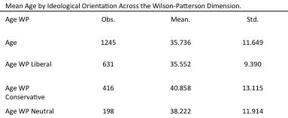

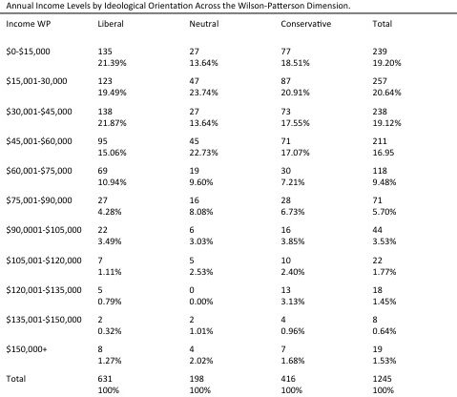

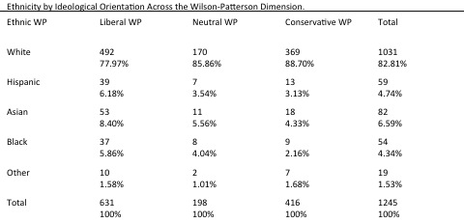

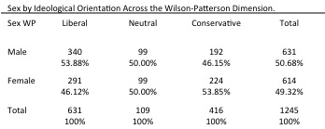

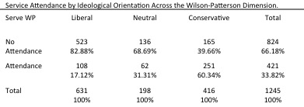

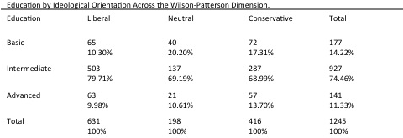

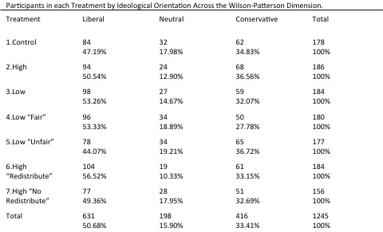

Common Support: Attitudes towards Inequality Model

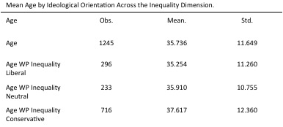

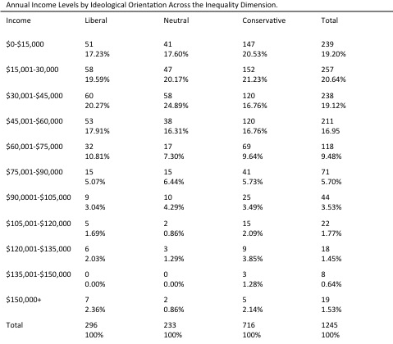

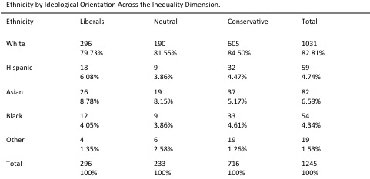

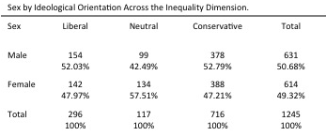

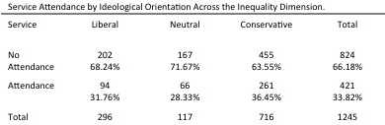

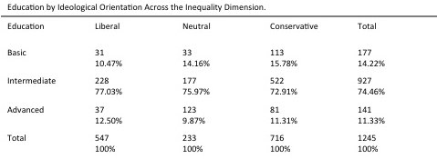

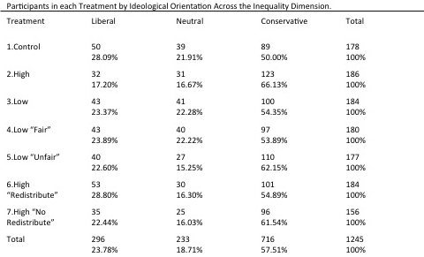

Section 3: Regression Models:

Correlations and Validity Tests:

Prior to the regression the normalcy of the dependent variable (cooperation) is evaluated using a Pearson’s coefficient of skewedness. The Pearson’s test indicated that there is a skew within the levels of cooperation that could potentially bias the comparison of cooperation between liberals, neutrals, and conservatives. To address the possibility that this skew could impact accuracy of the statistical results I perform a comparison of variance test on the level of cooperation between each ideological category using a Levene’s Test of robustness. Based on the study by Conover, Johnson, and Johnson (1981), I focus on the results obtained by substituting the median for the mean, (W₅₀ on Table 2). On the Levene’s Test, a P-value below (P>0.050) would indicate that the variances of two variables are significantly different from one another. The results of this test (Table 2) indicate that there are no statistically significant differences in the variance of cooperation between liberal, neutrals, and conservative oriented individuals in either the Full Wilson Patterson Index (P=0.102), or Inequality Models (P=0.298). A Breusch-Pagan Test of Heteroskedasticity is also performed on each of the statistical models. The result show that variance of the independent variables in the model is not dependent on the values of the independent variables (P>0.6952) (Table 3).

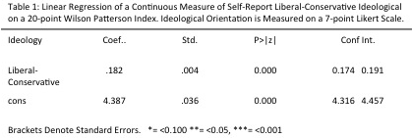

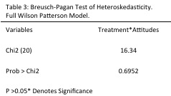

Overall Levels of Cooperation:

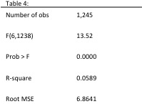

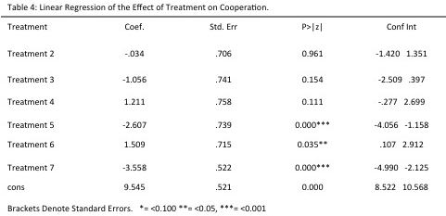

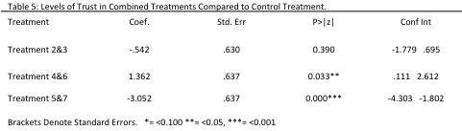

Regression Models: Wilson-Patterson Model

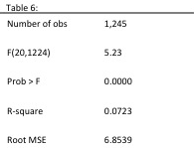

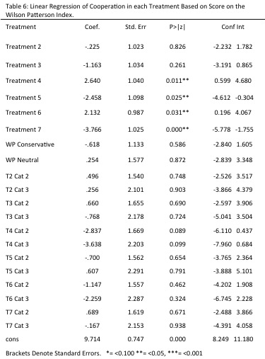

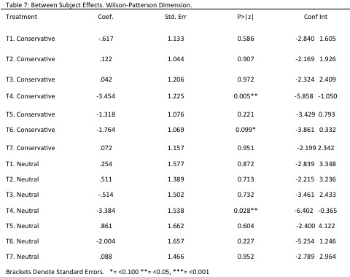

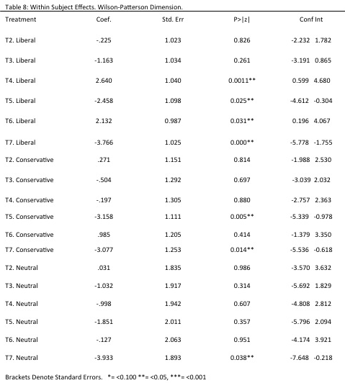

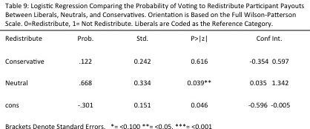

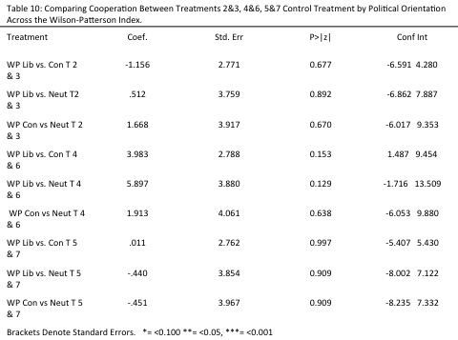

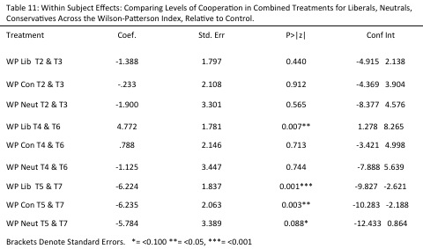

Section 4: Regression Model By Attitudes Towards Inequality

Model Coding: (-4/-2=1 “liberal”) (-1=3 “neutral”) (0/4=2 “conservative”)

Section 5: Binary Regression Model. Attitudes towards Inequality

Model coding: (-4/-1=1 “liberal”) (0/4=2 “conservative”)

Section 6: Alternative Wilson Patterson Model

Model coding: (-21/-2=1 “liberal”) (-1/1=3 “neutral”) (2/21=2 “conservative”)

Section 7: Continuous Models of Wilson-Patterson and Inequality

Comparing the variance between only liberals and conservatives on the Full Wilson Patterson Index produces similar results (P=0.218).

