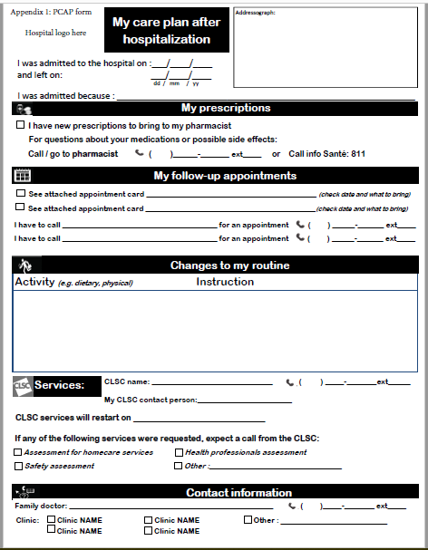

|  |  |  |  |  |
| --- | --- | --- | --- | --- |
| **Appendix 2: Transition experiences questionnaire** | | | | |
|  | |  | **Scoring criteria** | |
| **Brief item name** | **Full question** |  | **1 point** | **0 point** |
|  |  |  |  |  |
| 1) Verbal discharge instructions | During the days before you left the hospital, did a member of staff meet with you (or your family member) to tell you about upcoming appointments and/or review your prescriptions with you? |  | Yes | No Don't know |
| 2) Opportunity to ask questions | During the days before you left the hospital, were you (or your family member) given an opportunity to ask questions about any follow-up required once you were back home (for example about follow-up appointments, new medications or other changes)? |  | Yes | No Don't know |
| 3) Written discharge instructions | Did you (or your family member) receive any written information on what to do after leaving the hospital? If yes, what materials did you receive? |  | Date/time of a follow-up appointment you have to go to **and/or** Information on appointments you need to book **and/or** Instructions on changes in your routine (pamphlets about eating, exercise, or other) | No materials given  Prescriptions only **and/or** Results or summary to bring to a health care professional only  Don't know |
| 4) Knows reason for admission | Do you know the reason that you were admitted? |  | Yes | No Don't know |
| 5) Knows purpose and how to take medications | a) Do you understand the purpose of all your medications? |  | a) Yes **and** b) Yes (with or without help) | No Don’t know/Unsure Meds prepared and given by nurse or caregiver |
| b) Do you know how to take your medications? |  |
| 6) Information about symptoms to look out for | Were you (or your family member) given information about which symptoms related to your medical condition to look out for now that you’re back home? |  | Yes | No Don't know/Unsure No symptoms |
| 7) Information on changes to daily routine | Were you (or your family member) given information about changes to make to your daily routine or activities? For example, did someone discuss issues related to diet, physical activity, mobility, self-care or hygiene with you? |  | Yes | No Don't know/Unsure No changes |
| 8) Information about follow-up appointments | a) Do you (or your family member) know what follow up appointments you have to go to? |  | Yes **to both** | No Don't know/Unsure No follow-up **to either** |
| b) Do you (or your family member) know what follow up appointments you still have to make? |  |
| 9) Number to call with questions | Did the hospital staff give you (or your family member) information about who to call with questions? |  | Yes | No Don't know |
| 10) Information on CLSC services | Did the hospital staff inform you (or your family member) which services, if any, you will receive from the CLSC? |  | Yes Not a CLSC client | No Don't know |
|  |  |  |  |  |



