Supplement 1

Model 1
Multilevel linear model with random intercepts, as defined through R script

Library(nlme)

lme(Adjusted.value ~ FY,
data = x,
method = "ML",
na.action = "na.omit",
random = ~ 1|Facility.identificator,
control = lmeControl(opt = "optim"))

Where:
Adjusted.value is the adjusted value for the indicator for a specific facility and a specific year
FY is the fiscal year as integer variable, so that fiscal year 2011/2012=1, fiscal year 2012/2013=2 etc.
Facility.Indetificator is a random unique number assigned to each facility

Model 2
Multilevel linear model with random intercepts, as defined through R script

Library(nlme)

lme(Adjusted.value ~ FY + Quadrian + Quadrian/FY,
data = x,
method = "ML",
na.action = "na.omit",
random = ~ 1|Facility.identificator,
control = lmeControl(opt = "optim"))

Where:
Adjusted.value is the adjusted value for the indicator for a specific facility and a specific year
Quadrian indicates the 4 year period, so that the period 2011-2014=0 and the period 2015-2018=1
FY is the fiscal year as integer variable, so that fiscal year 2011/2012=1, fiscal year 2012/2013=2 etc.
Facility.Indetificator is a random unique number assigned to each facility

Supplement 2
Figure S2.1: Adjusted values of selected indicators (publicly reported since 2015) between 2011 and 2018 in Canada (full names of indicators’ acronyms are reported in Supplement 1)

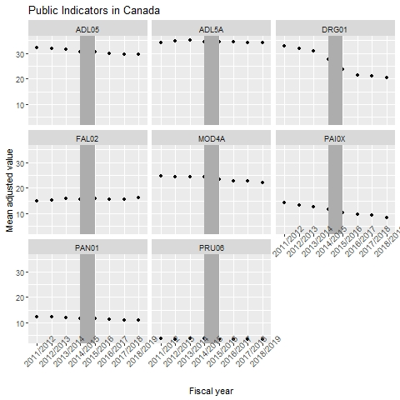

Figure S2.2: Adjusted values of selected indicators, which are not publicly reported, between 2011 and 2018 in Canada (full names of indicators’ acronyms are reported in Supplement 1)

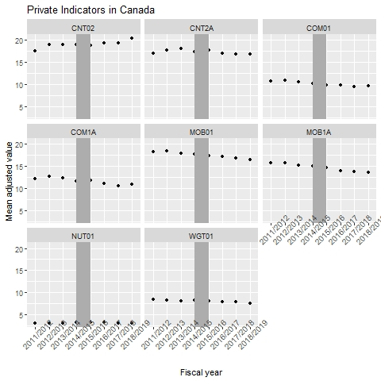

Figure S2.3: Adjusted values of selected indicators (publicly reported since 2015) between 2011 and 2018 in Ontario (full names of indicators’ acronyms are reported in Supplement 1)

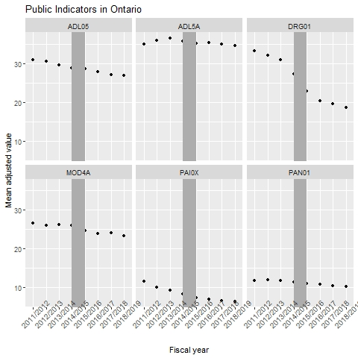

Figure S2.4: Adjusted values of selected indicators, which are not publicly reported, between 2011 and 2018 in Ontario (full names of indicators’ acronyms are reported in Supplement 1)

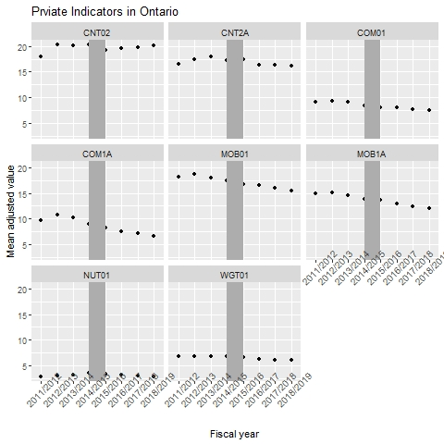

Figure S2.5: Adjusted values of selected indicators (publicly reported since 2015) between 2011 and 2018 in Manitoba (full names of indicators’ acronyms are reported in Supplement 1)

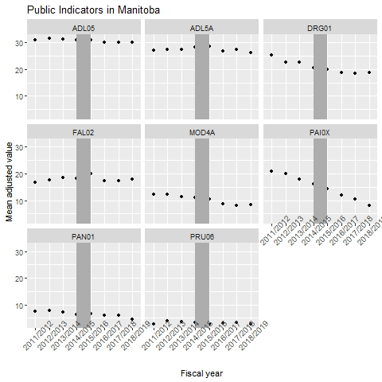

Figure S2.6: Adjusted values of selected indicators, which are not publicly reported, between 2011 and 2018 in Manitoba (full names of indicators’ acronyms are reported in Supplement 1)

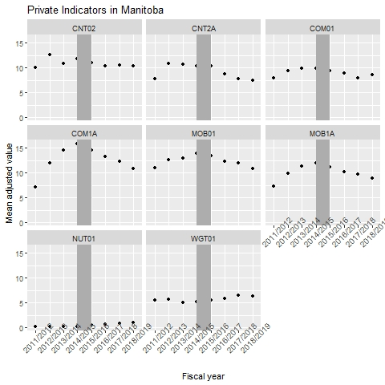

Figure S2.7: Adjusted values of selected indicators (publicly reported since 2015) between 2011 and 2018 in Alberta (full names of indicators’ acronyms are reported in Supplement 1)

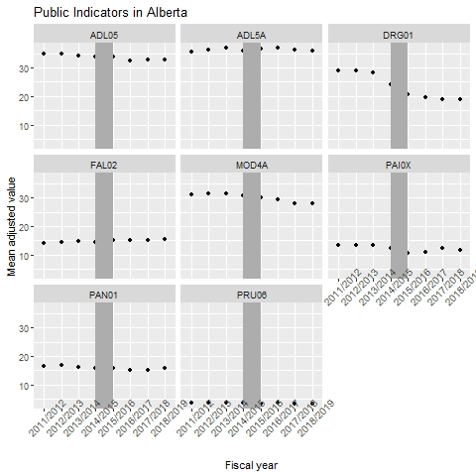

Figure S2.8: Adjusted values of selected indicators, which are not publicly reported, between 2011 and 2018 in Alberta (full names of indicators’ acronyms are reported in Supplement 1)

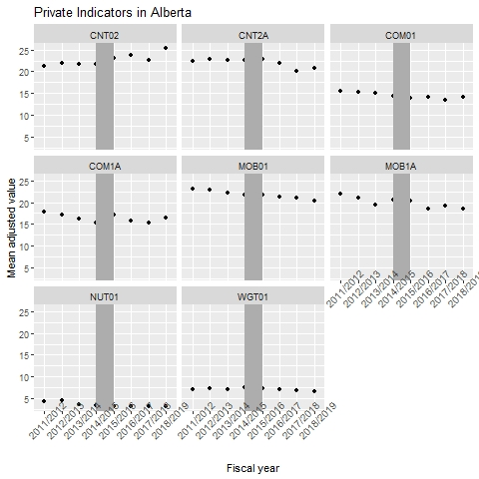

Figure S2.9: Adjusted values of selected indicators (publicly reported since 2015) between 2011 and 2018 in British Columbia (full names of indicators’ acronyms are reported in Supplement 1)

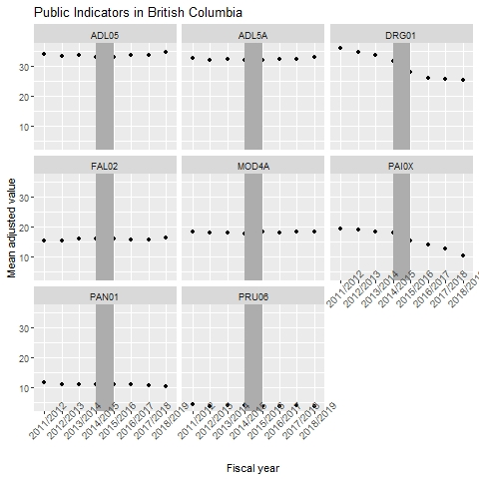

Figure S2.10: Adjusted values of selected indicators, which are not publicly reported, between 2011 and 2018 in British Columbia (full names of indicators’ acronyms are reported in Supplement 1)

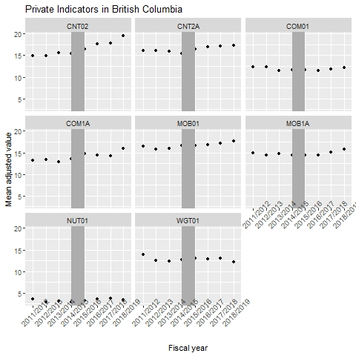

Supplement 3
Table S3.1: List of fixed effects regression coefficients for the variable “fiscal year” in Model 1 and respective p-value for the period 2011-2014 and for the period 2015-2018 and list of fixed effect regression coefficient of the fiscal year/period interaction term and respective p-value by indicator, for all available data (nationwide)
 |  | Model 1 for the period 2011-2014 |  | Model 1 for the period 2015-2018 |  | Model 2
Indicator shortened name (Indicator acronym) | Number of facilities included in the calculation | Regression coefficient of the fiscal year | p-value of the coefficient | Regression coefficient of the fiscal year | p-value of the coefficient | Regression coefficient of the interaction term | p-value of the coefficient
Public indicators
% of residents whose ADL improved (ADL05) | 1087 | -0.54 | 0.000 | -0.28 | 0.000 | 0.26 | 0.020
% of residents whose ADL worsened (ADL5A) | 1086 | 0.16 | 0.013 | -0.14 | 0.024 | -0.30 | 0.002
% of residents with antipsychotics without diagnosis (DRG01) | 1068 | -1.76 | 0.000 | -1.06 | 0.000 | 0.70 | 0.000
% of residents who recently fell (FAL02) | 445 | 0.26 | 0.004 | 0.05 | 0.585 | -0.22 | 0.112
% of residents with worsened depression (MOD4A) | 1081 | -0.14 | 0.061 | -0.37 | 0.000 | -0.22 | 0.061
% of residents with pain (PAI0X) | 926 | -0.87 | 0.000 | -0.63 | 0.000 | 0.22 | 0.069
%of residents whose pain worsened (PAN01) | 1046 | -0.20 | 0.000 | -0.22 | 0.000 | -0.03 | 0.684
% of residents whose pressure ulcer worsened (PRU06) | 194 | 0.04 | 0.297 | -0.01 | 0.763 | -0.06 | 0.364
Private indicators
% of residents whose bowel continence worsened (CNT02) | 1050 | 0.45 | 0.000 | 0.48 | 0.000 | 0.03 | 0.805
% of residents whose bowel continence improved (CNT2A) | 959 | 0.14 | 0.095 | -0.32 | 0.000 | -0.47 | 0.000
% of residents with worsened communication (COM01) | 1015 | -0.23 | 0.000 | -0.09 | 0.059 | 0.14 | 0.073
% of residents with improved communication (COM1A) | 657 | -0.20 | 0.031 | -0.29 | 0.000 | -0.09 | 0.521
% of residents with worsened locomotion (MOB01) | 1048 | -0.20 | 0.002 | -0.27 | 0.000 | -0.07 | 0.457
% of residents with improved locomotion (MOB1A) | 968 | -0.31 | 0.000 | -0.33 | 0.000 | -0.02 | 0.865
% of residents with a feeding tube (NUT01) | 538 | 0.02 | 0.668 | -0.08 | 0.073 | -0.10 | 0.174
% of residents who had unexplained weight loss (WGT01) | 927 | -0.11 | 0.027 | -0.17 | 0.001 | -0.05 | 0.483
*p-value<0.05, **p-value<0.01

Table S3.2: List of fixed effects regression coefficients for the variable “fiscal year” in Model 1 and respective p-value for the period 2011-2014 and for the period 2015-2018 and list of fixed effect regression coefficient of the fiscal year/period interaction term and respective p-value by indicator, by jurisdiction

 |  |  | Model 1 for the period 2011-2014 |  | Model 1 for the period 2015-2018 |  | Model 2
Jurisdiction | Indicator shortened name (Indicator acronym) | Number of facilities included in the calculation | Regression coefficient of the fiscal year | p-value of the coefficient | Regression coefficient of the fiscal year | p-value of the coefficient | Regression coefficient of the interaction term | p-value of the coefficient
Public indicators
Alberta | % of residents whose ADL improved (ADL05) | 161 | -0.38 | 0.083 | -0.27 | 0.203 | 0.10 | 0.759
Alberta | % of residents whose ADL worsened (ADL5A) | 159 | 0.15 | 0.404 | -0.29 | 0.107 | -0.44 | 0.106
Alberta | % of residents with antipsychotics without diagnosis (DRG01) | 152 | -1.53 | 0.000 | -0.50 | 0.013 | 0.98 | 0.007
Alberta | % of residents who recently fell (FAL02) | 140 | 0.15 | 0.266 | 0.20 | 0.138 | 0.06 | 0.779
Alberta | % of residents with worsened depression (MOD4A) | 160 | -0.03 | 0.889 | -0.78 | 0.000 | -0.74 | 0.029
Alberta | % of residents with pain (PAI0X) | 123 | -0.38 | 0.116 | 0.51 | 0.020 | 0.83 | 0.033
Alberta | %of residents whose pain worsened (PAN01) | 154 | -0.30 | 0.063 | -0.04 | 0.821 | 0.25 | 0.302
Alberta | % of residents whose pressure ulcer worsened (PRU06) | 86 | 0.03 | 0.648 | -0.09 | 0.075 | -0.12 | 0.173
British Columbia | % of residents whose ADL improved (ADL05) | 260 | -0.24 | 0.080 | 0.48 | 0.001 | 0.71 | 0.002
British Columbia | % of residents whose ADL worsened (ADL5A) | 261 | -0.13 | 0.278 | 0.28 | 0.019 | 0.39 | 0.030
British Columbia | % of residents with antipsychotics without diagnosis (DRG01) | 261 | -1.49 | 0.000 | -0.86 | 0.000 | 0.66 | 0.025
British Columbia | % of residents who recently fell (FAL02) | 257 | 0.27 | 0.041 | 0.07 | 0.566 | -0.21 | 0.290
British Columbia | % of residents with worsened depression (MOD4A) | 256 | -0.19 | 0.196 | -0.02 | 0.895 | 0.16 | 0.450
British Columbia | % of residents with pain (PAI0X) | 240 | -0.50 | 0.004 | -1.60 | 0.000 | -1.12 | 0.000
British Columbia | %of residents whose pain worsened (PAN01) | 239 | -0.16 | 0.133 | -0.20 | 0.061 | -0.05 | 0.765
British Columbia | % of residents whose pressure ulcer worsened (PRU06) | 85 | 0.02 | 0.788 | 0.05 | 0.466 | 0.04 | 0.743
Manitoba | % of residents whose ADL improved (ADL05) | 38 | -0.04 | 0.889 | -0.33 | 0.107 | -0.25 | 0.550
Manitoba | % of residents whose ADL worsened (ADL5A) | 38 | 0.39 | 0.060 | -0.66 | 0.001 | -1.05 | 0.001
Manitoba | % of residents with antipsychotics without diagnosis (DRG01) | 38 | -1.38 | 0.000 | -0.35 | 0.219 | 1.03 | 0.045
Manitoba | % of residents who recently fell (FAL02) | 38 | 0.56 | 0.024 | -0.64 | 0.040 | -1.20 | 0.009
Manitoba | % of residents with worsened depression (MOD4A) | 38 | -0.40 | 0.078 | -0.60 | 0.000 | -0.19 | 0.565
Manitoba | % of residents with pain (PAI0X) | 36 | -1.68 | 0.000 | -2.01 | 0.000 | -0.33 | 0.559
Manitoba | %of residents whose pain worsened (PAN01) | 37 | -0.43 | 0.019 | -0.63 | 0.000 | -0.20 | 0.444
Manitoba | % of residents whose pressure ulcer worsened (PRU06) | 20 | 0.21 | 0.123 | 0.00 | 0.985 | -0.21 | 0.264
Ontario | % of residents whose ADL improved (ADL05) | 617 | -0.74 | 0.000 | -0.59 | 0.000 | 0.14 | 0.335
Ontario | % of residents whose ADL worsened (ADL5A) | 617 | 0.28 | 0.001 | -0.23 | 0.005 | -0.51 | 0.000
Ontario | % of residents with antipsychotics without diagnosis (DRG01) | 607 | -1.95 | 0.000 | -1.34 | 0.000 | 0.61 | 0.000
Ontario | % of residents with worsened depression (MOD4A) | 616 | -0.15 | 0.150 | -0.37 | 0.000 | -0.22 | 0.177
Ontario | % of residents with pain (PAI0X) | 517 | -1.10 | 0.000 | -0.37 | 0.000 | 0.73 | 0.000
Ontario | %of residents whose pain worsened (PAN01) | 608 | -0.17 | 0.004 | -0.25 | 0.000 | -0.08 | 0.339
Private indicators
Alberta | % of residents whose bowel continence worsened (CNT02) | 151 | 0.10 | 0.587 | 0.55 | 0.016 | 0.46 | 0.181
Alberta | % of residents whose bowel continence improved (CNT2A) | 144 | -0.03 | 0.911 | -0.73 | 0.002 | -0.71 | 0.072
Alberta | % of residents with worsened communication (COM01) | 153 | -0.37 | 0.031 | -0.05 | 0.750 | 0.34 | 0.184
Alberta | % of residents with improved communication (COM1A) | 125 | -0.86 | 0.000 | -0.28 | 0.220 | 0.60 | 0.085
Alberta | % of residents with worsened locomotion (MOB01) | 153 | -0.48 | 0.011 | -0.42 | 0.026 | 0.07 | 0.804
Alberta | % of residents with improved locomotion (MOB1A) | 150 | -0.49 | 0.028 | -0.48 | 0.014 | 0.02 | 0.954
Alberta | % of residents with a feeding tube (NUT01) | 73 | -0.43 | 0.007 | -0.04 | 0.650 | 0.39 | 0.049
Alberta | % of residents who had unexplained weight loss (WGT01) | 110 | 0.14 | 0.293 | -0.19 | 0.133 | -0.32 | 0.085
British Columbia | % of residents whose bowel continence worsened (CNT02) | 245 | 0.19 | 0.142 | 0.95 | 0.000 | 0.74 | 0.001
British Columbia | % of residents whose bowel continence improved (CNT2A) | 206 | -0.25 | 0.158 | 0.29 | 0.089 | 0.51 | 0.078
British Columbia | % of residents with worsened communication (COM01) | 244 | -0.25 | 0.017 | 0.20 | 0.055 | 0.45 | 0.004
British Columbia | % of residents with improved communication (COM1A) | 159 | 0.04 | 0.842 | 0.35 | 0.073 | 0.30 | 0.305
British Columbia | % of residents with worsened locomotion (MOB01) | 244 | 0.12 | 0.349 | 0.30 | 0.024 | 0.18 | 0.378
British Columbia | % of residents with improved locomotion (MOB1A) | 198 | -0.11 | 0.442 | 0.47 | 0.002 | 0.56 | 0.019
British Columbia | % of residents with a feeding tube (NUT01) | 140 | -0.16 | 0.186 | 0.07 | 0.552 | 0.23 | 0.238
British Columbia | % of residents who had unexplained weight loss (WGT01) | 221 | -0.39 | 0.013 | -0.20 | 0.186 | 0.19 | 0.462
Manitoba | % of residents whose bowel continence worsened (CNT02) | 38 | 0.35 | 0.343 | -0.18 | 0.337 | -0.52 | 0.255
Manitoba | % of residents whose bowel continence improved (CNT2A) | 29 | 0.75 | 0.118 | -0.98 | 0.000 | -1.73 | 0.003
Manitoba | % of residents with worsened communication (COM01) | 38 | 0.62 | 0.034 | -0.35 | 0.041 | -0.97 | 0.011
Manitoba | % of residents with improved communication (COM1A) | 21 | 2.83 | 0.001 | -1.20 | 0.003 | -4.03 | 0.000
Manitoba | % of residents with worsened locomotion (MOB01) | 38 | 0.89 | 0.004 | -0.82 | 0.000 | -1.70 | 0.000
Manitoba | % of residents with improved locomotion (MOB1A) | 28 | 1.54 | 0.001 | -0.71 | 0.006 | -2.25 | 0.000
Manitoba | % of residents with a feeding tube (NUT01) | 27 | 0.02 | 0.115 | 0.17 | 0.252 | 0.15 | 0.385
Manitoba | % of residents who had unexplained weight loss (WGT01) | 38 | -0.19 | 0.197 | 0.31 | 0.089 | 0.49 | 0.049
Ontario | % of residents whose bowel continence worsened (CNT02) | 607 | 0.65 | 0.000 | 0.31 | 0.000 | -0.34 | 0.030
Ontario | % of residents whose bowel continence improved (CNT2A) | 577 | 0.29 | 0.004 | -0.39 | 0.000 | -0.69 | 0.000
Ontario | % of residents with worsened communication (COM01) | 574 | -0.24 | 0.000 | -0.21 | 0.000 | 0.03 | 0.791
Ontario | % of residents with improved communication (COM1A) | 349 | -0.25 | 0.051 | -0.53 | 0.000 | -0.29 | 0.111
Ontario | % of residents with worsened locomotion (MOB01) | 607 | -0.32 | 0.000 | -0.44 | 0.000 | -0.12 | 0.335
Ontario | % of residents with improved locomotion (MOB1A) | 588 | -0.41 | 0.000 | -0.53 | 0.000 | -0.12 | 0.302
Ontario | % of residents with a feeding tube (NUT01) | 295 | 0.23 | 0.000 | -0.18 | 0.001 | -0.41 | 0.000
Ontario | % of residents who had unexplained weight loss (WGT01) | 551 | -0.05 | 0.260 | -0.18 | 0.000 | -0.13 | 0.059

Table S3.3: List of fixed effects regression coefficients for the variable “fiscal year” in Model 1 and respective p-value for the period 2011-2014 and for the period 2015-2018 and list of fixed effect regression coefficient of the fiscal year/period interaction term and respective p-value by indicator, by membership in a corporation

 |  |  | Model 1 for the period 2011-2014 |  | Model 1 for the period 2015-2018 |  | Model 2
Member of a larger corporation | Indicator shortened name (Indicator acronym) | Number of facilities included in the calculation | Regression coefficient of the fiscal year | p-value of the coefficient | Regression coefficient of the fiscal year | p-value of the coefficient | Regression coefficient of the interaction term | p-value of the coefficient
Public indicators
No | % of residents whose ADL improved (ADL05) | 505 | -0.68 | 0.000 | -0.11 | 0.293 | 0.57 | 0.001
No | % of residents whose ADL worsened (ADL5A) | 503 | 0.26 | 0.009 | -0.07 | 0.437 | -0.33 | 0.020
No | % of residents with antipsychotics without diagnosis (DRG01) | 490 | -1.49 | 0.000 | -0.84 | 0.000 | 0.66 | 0.001
No | % of residents who recently fell (FAL02) | 263 | 0.30 | 0.013 | -0.08 | 0.493 | -0.39 | 0.031
No | % of residents with worsened depression (MOD4A) | 500 | -0.09 | 0.398 | -0.31 | 0.002 | -0.21 | 0.193
No | % of residents with pain (PAI0X) | 429 | -0.72 | 0.000 | -0.66 | 0.000 | 0.03 | 0.886
No | %of residents whose pain worsened (PAN01) | 471 | -0.10 | 0.199 | -0.21 | 0.006 | -0.12 | 0.312
No | % of residents whose pressure ulcer worsened (PRU06) | 106 | 0.05 | 0.440 | 0.03 | 0.621 | -0.02 | 0.867
Yes | % of residents whose ADL improved (ADL05) | 582 | -0.43 | 0.000 | -0.42 | 0.000 | 0.01 | 0.970
Yes | % of residents whose ADL worsened (ADL5A) | 583 | 0.08 | 0.359 | -0.19 | 0.016 | -0.28 | 0.034
Yes | % of residents with antipsychotics without diagnosis (DRG01) | 578 | -1.98 | 0.000 | -1.24 | 0.000 | 0.74 | 0.000
Yes | % of residents who recently fell (FAL02) | 182 | 0.21 | 0.127 | 0.24 | 0.074 | 0.03 | 0.867
Yes | % of residents with worsened depression (MOD4A) | 581 | -0.18 | 0.081 | -0.42 | 0.000 | -0.23 | 0.168
Yes | % of residents with pain (PAI0X) | 497 | -0.99 | 0.000 | -0.60 | 0.000 | 0.39 | 0.007
Yes | %of residents whose pain worsened (PAN01) | 575 | -0.28 | 0.000 | -0.23 | 0.000 | 0.04 | 0.655
Yes | % of residents whose pressure ulcer worsened (PRU06) | 88 | 0.04 | 0.484 | -0.07 | 0.188 | -0.11 | 0.210
Private indicators
No | % of residents whose bowel continence worsened (CNT02) | 471 | 0.47 | 0.000 | 0.36 | 0.001 | -0.12 | 0.499
No | % of residents whose bowel continence improved (CNT2A) | 415 | 0.11 | 0.382 | -0.38 | 0.001 | -0.51 | 0.010
No | % of residents with worsened communication (COM01) | 460 | -0.14 | 0.100 | -0.03 | 0.691 | 0.11 | 0.389
No | % of residents with improved communication (COM1A) | 295 | -0.30 | 0.022 | -0.15 | 0.282 | 0.14 | 0.513
No | % of residents with worsened locomotion (MOB01) | 472 | -0.02 | 0.862 | -0.15 | 0.126 | -0.12 | 0.394
No | % of residents with improved locomotion (MOB1A) | 417 | -0.36 | 0.001 | -0.20 | 0.058 | 0.16 | 0.339
No | % of residents with a feeding tube (NUT01) | 249 | -0.14 | 0.091 | -0.07 | 0.266 | 0.07 | 0.575
No | % of residents who had unexplained weight loss (WGT01) | 398 | -0.09 | 0.287 | -0.14 | 0.094 | -0.04 | 0.761
Yes | % of residents whose bowel continence worsened (CNT02) | 579 | 0.43 | 0.000 | 0.57 | 0.000 | 0.15 | 0.374
Yes | % of residents whose bowel continence improved (CNT2A) | 544 | 0.15 | 0.145 | -0.28 | 0.003 | -0.43 | 0.007
Yes | % of residents with worsened communication (COM01) | 555 | -0.31 | 0.000 | -0.14 | 0.018 | 0.17 | 0.094
Yes | % of residents with improved communication (COM1A) | 362 | -0.13 | 0.333 | -0.41 | 0.000 | -0.28 | 0.140
Yes | % of residents with worsened locomotion (MOB01) | 576 | -0.34 | 0.000 | -0.37 | 0.000 | -0.03 | 0.813
Yes | % of residents with improved locomotion (MOB1A) | 551 | -0.28 | 0.001 | -0.42 | 0.000 | -0.15 | 0.241
Yes | % of residents with a feeding tube (NUT01) | 289 | 0.16 | 0.006 | -0.09 | 0.156 | -0.25 | 0.008
Yes | % of residents who had unexplained weight loss (WGT01) | 529 | -0.12 | 0.031 | -0.19 | 0.001 | -0.06 | 0.466

Table S3.4: List of fixed effects regression coefficients for the variable “fiscal year” in Model 1 and respective p-value for the period 2011-2014 and for the period 2015-2018 and list of fixed effect regression coefficient of the fiscal year/period interaction term and respective p-value by indicator, by size (small facilities are excluded due to low number of small facilities)

 |  |  | Model 1 for the period 2011-2014 |  | Model 1 for the period 2015-2018 |  | Model 2
Facility size | Indicator shortened name (Indicator acronym) | Number of facilities included in the calculation | Regression coefficient of the fiscal year | p-value of the coefficient | Regression coefficient of the fiscal year | p-value of the coefficient | Regression coefficient of the interaction term | p-value of the coefficient
Public indicators
Large | % of residents whose ADL improved (ADL05) | 558 | -0.45 | 0.000 | -0.26 | 0.001 | 0.19 | 0.150
Large | % of residents whose ADL worsened (ADL5A) | 558 | 0.18 | 0.013 | -0.14 | 0.046 | -0.32 | 0.005
Large | % of residents with antipsychotics without diagnosis (DRG01) | 556 | -1.86 | 0.000 | -1.07 | 0.000 | 0.80 | 0.000
Large | % of residents who recently fell (FAL02) | 194 | 0.15 | 0.149 | 0.05 | 0.656 | -0.10 | 0.553
Large | % of residents with worsened depression (MOD4A) | 557 | 0.02 | 0.836 | -0.34 | 0.000 | -0.36 | 0.022
Large | % of residents with pain (PAI0X) | 500 | -1.15 | 0.000 | -0.71 | 0.000 | 0.45 | 0.000
Large | %of residents whose pain worsened (PAN01) | 555 | -0.19 | 0.000 | -0.15 | 0.001 | 0.04 | 0.602
Large | % of residents whose pressure ulcer worsened (PRU06) | 134 | 0.06 | 0.195 | 0.01 | 0.872 | -0.05 | 0.428
Medium | % of residents whose ADL improved (ADL05) | 462 | -0.76 | 0.000 | -0.33 | 0.004 | 0.44 | 0.017
Medium | % of residents whose ADL worsened (ADL5A) | 462 | 0.08 | 0.448 | -0.12 | 0.231 | -0.20 | 0.193
Medium | % of residents with antipsychotics without diagnosis (DRG01) | 456 | -1.71 | 0.000 | -1.11 | 0.000 | 0.58 | 0.006
Medium | % of residents who recently fell (FAL02) | 226 | 0.34 | 0.014 | 0.08 | 0.589 | -0.27 | 0.187
Medium | % of residents with worsened depression (MOD4A) | 459 | -0.39 | 0.001 | -0.36 | 0.001 | 0.03 | 0.882
Medium | % of residents with pain (PAI0X) | 380 | -0.67 | 0.000 | -0.58 | 0.000 | 0.09 | 0.672
Medium | %of residents whose pain worsened (PAN01) | 444 | -0.30 | 0.000 | -0.32 | 0.000 | -0.03 | 0.831
Medium | % of residents whose pressure ulcer worsened (PRU06) | 59 | 0.01 | 0.906 | -0.04 | 0.637 | -0.05 | 0.702
Private Indicators
Large | % of residents whose bowel continence worsened (CNT02) | 558 | 0.56 | 0.000 | 0.69 | 0.000 | 0.13 | 0.390
Large | % of residents whose bowel continence improved (CNT2A) | 539 | 0.30 | 0.001 | -0.26 | 0.001 | -0.56 | 0.000
Large | % of residents with worsened communication (COM01) | 552 | -0.18 | 0.004 | -0.06 | 0.279 | 0.12 | 0.202
Large | % of residents with improved communication (COM1A) | 423 | -0.05 | 0.654 | -0.14 | 0.122 | -0.09 | 0.580
Large | % of residents with worsened locomotion (MOB01) | 556 | -0.23 | 0.003 | -0.30 | 0.000 | -0.07 | 0.565
Large | % of residents with improved locomotion (MOB1A) | 543 | -0.22 | 0.006 | -0.23 | 0.001 | -0.02 | 0.868
Large | % of residents with a feeding tube (NUT01) | 277 | 0.27 | 0.000 | -0.29 | 0.000 | -0.55 | 0.000
Large | % of residents who had unexplained weight loss (WGT01) | 548 | -0.13 | 0.007 | -0.15 | 0.002 | -0.02 | 0.806
Medium | % of residents whose bowel continence worsened (CNT02) | 450 | 0.35 | 0.003 | 0.18 | 0.130 | -0.17 | 0.384
Medium | % of residents whose bowel continence improved (CNT2A) | 393 | -0.08 | 0.564 | -0.34 | 0.009 | -0.28 | 0.211
Medium | % of residents with worsened communication (COM01) | 425 | -0.34 | 0.000 | -0.20 | 0.013 | 0.14 | 0.283
Medium | % of residents with improved communication (COM1A) | 216 | -0.43 | 0.018 | -0.58 | 0.000 | -0.15 | 0.576
Medium | % of residents with worsened locomotion (MOB01) | 448 | -0.15 | 0.163 | -0.21 | 0.037 | -0.05 | 0.738
Medium | % of residents with improved locomotion (MOB1A) | 392 | -0.46 | 0.000 | -0.41 | 0.000 | 0.04 | 0.807
Medium | % of residents with a feeding tube (NUT01) | 214 | -0.22 | 0.006 | 0.18 | 0.012 | 0.39 | 0.001
Medium | % of residents who had unexplained weight loss (WGT01) | 365 | -0.10 | 0.281 | -0.15 | 0.110 | -0.04 | 0.787

Table S3.5: List of fixed effects regression coefficients for the variable “fiscal year” in Model 1 and respective p-value for the period 2011-2014 and for the period 2015-2018 and list of fixed effect regression coefficient of the fiscal year/period interaction term and respective p-value by indicator, by urban or rural location

 |  |  | Model 1 for the period 2011-2014 |  | Model 1 for the period 2015-2018 |  | Model 2
Facility location | Indicator shortened name (Indicator acronym) | Number of facilities included in the calculation | Regression coefficient of the fiscal year | p-value of the coefficient | Regression coefficient of the fiscal year | p-value of the coefficient | Regression coefficient of the interaction term | p-value of the coefficient
Public indicators
Rural | % of residents whose ADL improved (ADL05) | 252 | -0.55 | 0.001 | -0.26 | 0.142 | 0.29 | 0.282
Rural | % of residents whose ADL worsened (ADL5A) | 254 | 0.09 | 0.598 | -0.26 | 0.102 | -0.35 | 0.146
Rural | % of residents with antipsychotics without diagnosis (DRG01) | 241 | -1.37 | 0.000 | -1.18 | 0.000 | 0.20 | 0.534
Rural | % of residents who recently fell (FAL02) | 93 | 0.49 | 0.032 | -0.01 | 0.958 | -0.53 | 0.122
Rural | % of residents with worsened depression (MOD4A) | 256 | -0.06 | 0.742 | -0.51 | 0.003 | -0.46 | 0.081
Rural | % of residents with pain (PAI0X) | 207 | -0.59 | 0.006 | -0.26 | 0.148 | 0.30 | 0.363
Rural | %of residents whose pain worsened (PAN01) | 233 | -0.20 | 0.121 | -0.38 | 0.002 | -0.19 | 0.323
Rural | % of residents whose pressure ulcer worsened (PRU06) | 20 | 0.09 | 0.601 | 0.03 | 0.866 | -0.07 | 0.783
Urban | % of residents whose ADL improved (ADL05) | 835 | -0.54 | 0.000 | -0.28 | 0.000 | 0.26 | 0.036
Urban | % of residents whose ADL worsened (ADL5A) | 832 | 0.18 | 0.008 | -0.10 | 0.115 | -0.29 | 0.005
Urban | % of residents with antipsychotics without diagnosis (DRG01) | 827 | -1.87 | 0.000 | -1.02 | 0.000 | 0.85 | 0.000
Urban | % of residents who recently fell (FAL02) | 352 | 0.20 | 0.038 | 0.07 | 0.499 | -0.14 | 0.354
Urban | % of residents with worsened depression (MOD4A) | 825 | -0.17 | 0.040 | -0.32 | 0.000 | -0.14 | 0.269
Urban | % of residents with pain (PAI0X) | 719 | -0.95 | 0.000 | -0.74 | 0.000 | 0.20 | 0.112
Urban | %of residents whose pain worsened (PAN01) | 813 | -0.19 | 0.000 | -0.18 | 0.000 | 0.02 | 0.819
Urban | % of residents whose pressure ulcer worsened (PRU06) | 174 | 0.04 | 0.366 | -0.02 | 0.691 | -0.06 | 0.385
Private indicators
Rural | % of residents whose bowel continence worsened (CNT02) | 232 | 0.19 | 0.212 | 0.20 | 0.230 | 0.00 | 0.988
Rural | % of residents whose bowel continence improved (CNT2A) | 201 | 0.07 | 0.759 | -0.57 | 0.005 | -0.66 | 0.048
Rural | % of residents with worsened communication (COM01) | 222 | -0.21 | 0.121 | -0.21 | 0.088 | 0.00 | 0.981
Rural | % of residents with improved communication (COM1A) | 109 | -0.47 | 0.065 | -0.80 | 0.002 | -0.34 | 0.399
Rural | % of residents with worsened locomotion (MOB01) | 233 | -0.36 | 0.027 | -0.35 | 0.026 | 0.01 | 0.960
Rural | % of residents with improved locomotion (MOB1A) | 206 | -0.52 | 0.003 | -0.42 | 0.017 | 0.12 | 0.649
Rural | % of residents with a feeding tube (NUT01) | 126 | -0.25 | 0.044 | 0.11 | 0.100 | 0.36 | 0.014
Rural | % of residents who had unexplained weight loss (WGT01) | 176 | -0.17 | 0.264 | -0.01 | 0.928 | 0.15 | 0.552
Urban | % of residents whose bowel continence worsened (CNT02) | 818 | 0.52 | 0.000 | 0.56 | 0.000 | 0.04 | 0.785
Urban | % of residents whose bowel continence improved (CNT2A) | 758 | 0.15 | 0.074 | -0.26 | 0.000 | -0.42 | 0.001
Urban | % of residents with worsened communication (COM01) | 793 | -0.24 | 0.000 | -0.06 | 0.262 | 0.18 | 0.032
Urban | % of residents with improved communication (COM1A) | 548 | -0.15 | 0.136 | -0.19 | 0.025 | -0.04 | 0.777
Urban | % of residents with worsened locomotion (MOB01) | 815 | -0.15 | 0.027 | -0.25 | 0.000 | -0.10 | 0.360
Urban | % of residents with improved locomotion (MOB1A) | 762 | -0.26 | 0.000 | -0.30 | 0.000 | -0.06 | 0.612
Urban | % of residents with a feeding tube (NUT01) | 412 | 0.10 | 0.051 | -0.14 | 0.011 | -0.24 | 0.005
Urban | % of residents who had unexplained weight loss (WGT01) | 751 | -0.10 | 0.055 | -0.20 | 0.000 | -0.10 | 0.189

Table S3.6: List of fixed effects regression coefficients for the variable “fiscal year” in Model 1 and respective p-value for the period 2011-2014 and for the period 2015-2018 and list of fixed effect regression coefficient of the fiscal year/period interaction term and respective p-value by indicator, by performance achievement (showing 16% best performers)

 |  | Model 1 for the period 2011-2014 |  | Model 1 for the period 2015-2018 |  | Model 2
Indicator shortened name (Indicator acronym) | Number of facilities included in the calculation | Regression coefficient of the fiscal year | p-value of the coefficient | Regression coefficient of the fiscal year | p-value of the coefficient | Regression coefficient of the interaction term | p-value of the coefficient
Public indicators
% of residents whose ADL improved (ADL05) | 174 | -0.47 | 0.011 | -1.08 | 0.000 | -0.64 | 0.032
% of residents whose ADL worsened (ADL5A) | 174 | 0.44 | 0.016 | 0.15 | 0.372 | -0.30 | 0.241
% of residents with antipsychotics without diagnosis (DRG01) | 171 | -1.50 | 0.000 | 0.21 | 0.153 | 1.71 | 0.000
% of residents who recently fell (FAL02) | 72 | 0.03 | 0.914 | 0.32 | 0.169 | 0.30 | 0.382
% of residents with worsened depression (MOD4A) | 173 | -0.15 | 0.364 | 0.47 | 0.002 | 0.61 | 0.012
% of residents with pain (PAI0X) | 149 | -0.85 | 0.000 | -0.13 | 0.132 | 0.72 | 0.000
%of residents whose pain worsened (PAN01) | 168 | -0.22 | 0.024 | 0.04 | 0.691 | 0.26 | 0.073
% of residents whose pressure ulcer worsened (PRU06) | 31 | 0.14 | 0.110 | 0.03 | 0.781 | -0.11 | 0.405
Private indicators
% of residents whose bowel continence worsened (CNT02) | 168 | 0.62 | 0.000 | 0.82 | 0.000 | 0.20 | 0.441
% of residents whose bowel continence improved (CNT2A) | 154 | -0.24 | 0.379 | -1.63 | 0.000 | -1.40 | 0.000
% of residents with worsened communication (COM01) | 163 | -0.17 | 0.187 | 0.17 | 0.103 | 0.35 | 0.050
% of residents with improved communication (COM1A) | 105 | -0.15 | 0.655 | -0.87 | 0.003 | -0.73 | 0.146
% of residents with worsened locomotion (MOB01) | 168 | 0.04 | 0.813 | 0.49 | 0.001 | 0.45 | 0.047
% of residents with improved locomotion (MOB1A) | 155 | -0.64 | 0.009 | -1.01 | 0.000 | -0.38 | 0.257
% of residents with a feeding tube (NUT01) | 307 | -0.09 | 0.078 | 0.17 | 0.000 | 0.26 | 0.000
% of residents who had unexplained weight loss (WGT01) | 149 | 0.15 | 0.087 | 0.06 | 0.523 | -0.09 | 0.530

Table S3.7: List of fixed effects regression coefficients for the variable “fiscal year” in Model 1 and respective p-value for the period 2011-2014 and for the period 2015-2018 and list of fixed effect regression coefficient of the fiscal year/period interaction term and respective p-value by indicator, by performance achievement (showing 16% worst performers)

 |  | Model 1 for the period 2011-2014 |  | Model 1 for the period 2015-2018 |  | Model 2
Indicator shortened name (Indicator acronym) | Number of facilities included in the calculation | Regression coefficient of the fiscal year | p-value of the coefficient | Regression coefficient of the fiscal year | p-value of the coefficient | Regression coefficient of the interaction term | p-value of the coefficient
Public indicators
% of residents whose ADL improved (ADL05) | 174 | -0.94 | 0.000 | 0.09 | 0.591 | 1.03 | 0.001
% of residents whose ADL worsened (ADL5A) | 174 | -0.12 | 0.546 | -0.50 | 0.003 | -0.38 | 0.182
% of residents with antipsychotics without diagnosis (DRG01) | 171 | -2.72 | 0.000 | -2.05 | 0.000 | 0.71 | 0.071
% of residents who recently fell (FAL02) | 72 | 0.63 | 0.021 | -0.70 | 0.009 | -1.34 | 0.001
% of residents with worsened depression (MOD4A) | 173 | -0.40 | 0.061 | -1.47 | 0.000 | -1.07 | 0.001
% of residents with pain (PAI0X) | 149 | -0.96 | 0.002 | -2.21 | 0.000 | -1.31 | 0.005
%of residents whose pain worsened (PAN01) | 168 | -0.22 | 0.195 | -0.72 | 0.000 | -0.51 | 0.037
% of residents whose pressure ulcer worsened (PRU06) | 31 | -0.01 | 0.920 | -0.10 | 0.412 | -0.08 | 0.664
Private indicators
% of residents whose bowel continence worsened (CNT02) | 168 | 0.46 | 0.061 | 0.02 | 0.930 | -0.44 | 0.206
% of residents whose bowel continence improved (CNT2A) | 154 | 0.37 | 0.022 | 0.06 | 0.613 | -0.32 | 0.190
% of residents with worsened communication (COM01) | 163 | -0.26 | 0.151 | -0.57 | 0.000 | -0.31 | 0.207
% of residents with improved communication (COM1A) | 105 | 0.60 | 0.005 | 0.30 | 0.115 | -0.30 | 0.333
% of residents with worsened locomotion (MOB01) | 168 | -0.50 | 0.010 | -0.82 | 0.000 | -0.32 | 0.246
% of residents with improved locomotion (MOB1A) | 155 | -0.15 | 0.286 | 0.22 | 0.106 | 0.36 | 0.079
% of residents with a feeding tube (NUT01) | 86 | 0.38 | 0.076 | -0.72 | 0.000 | -1.11 | 0.000
% of residents who had unexplained weight loss (WGT01) | 149 | -0.69 | 0.001 | -0.93 | 0.000 | -0.24 | 0.452

