Appendix A: Search Strategy

Major Search Concepts
- Dementia
- Model
- Primary Care
- Patients
- Quality of Life

When searching the databases, the search terms and keywords for these concepts were combined to capture articles that include all five concepts, as shown in the diagram below.

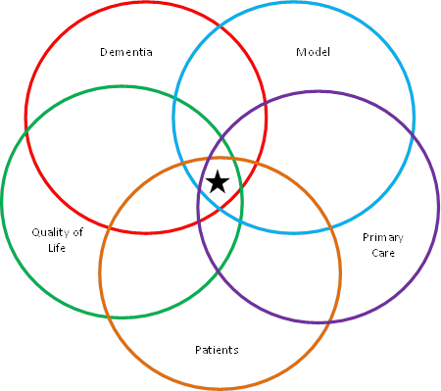

Search Limitations
- Publications from 2009 – Current
- English language (note: the same search was replicated separately to capture French language articles).
- No limitations on publication type

Subject Heading Terms
In addition to searching the text for keywords, we searched the database’s catalogue of subject headings/concepts with the below subject heading terms. The databases were searched for articles that fall under these subject headings.
Dementia | Model | Primary Care | Patients | Quality of Life
- Dementia | - Evidence-Based Practice | - Primary Health Care  - General Practice  - Family Practice | - Patients  - Dementia Patients | - Quality of Life  - Activities of Daily Living

Keywords
The databases were searched for articles that contain the below keywords in either the title or abstract. * = truncation, i.e. by searching “education*” we capture “education” and “educational”.
Dementia | Model | Primary Care | Patients | Quality of Life
- Dementia  - Alzheimer*  - Cognitive impairment  - Cogniti* disorder*  - Cognitive function*  - Cognitive dysfunction*  - Neurodegenerative disease*  - Other dementias  - Progressive condition | - Model  - Practice  - Approach  - Intervention  - Program  - Education*  - Education* program*  - Care support  - Training  - Collaborative care  - Collaborative care model*  - Collaborative care program*  - Dementia care management  - Dementia strategy  - Evidence-based approach  - Evidence-based practice  - Evidence-based medicine  - Practice guideline*  - Delivery of health care  - Patient care management | - Primary care  - Primary health care  - Primary healthcare  - Primary care clinician*  - Primary care physician*  - Primary care service*  - Primary care setting*  - General practice  - Family medicine  - Family practice*  - Family clinic  - Health clinic  - Walk-in clinic*  - Family physician*  - Family doctor*  - Family practitioner*  - General practitioner*  - General physician*  - Generalist*  - Regular provider*  - Nurse practitioner*  - Patient care team | - Patient*  - Person* living with dementia  - People living with dementia | - Quality of life  - Patient comfort  - Symptom management  - Health status  - Activities of daily living  - Activities of daily life  - Health level  - Wellness  - Well being  - Functional ability  - Good health  - Healthiness
This search was replicated for French language articles.

