Appendix 2 : Scree plot of Eigenvalue decomposition
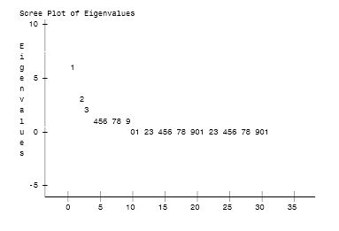
The x-axis represents the number of factors. The numbers on the graph represent the unit position of each factors. For example, the first number 0 is the 10th factor.

