Appendix A. The Arabic translation of the modified Montgomery Borgatta Caregiver Burden Scale (MBCBS).
مقياس مونتقمري لعبء مقدم الرعاية
As a result of assisting the care receiver (parent or relative), have the following aspects of your life changed? Have your caregiving responsibilities:
كنتيجة لتقديم الرعاية لقريبك، كيف تأثرت الجوانب التالية من حياتك؟ هل أدت مسؤولياتك في الرعاية إلى أنها:
 | Not at all  مطلقا1 | A little  2قليلا | Moderately  3 أحيانا | A lot  4 كثيرا | A great deal  5 كثير جدا
1- Decreased time you have to yourself? (OB)
قللت من الوقت المخصص لنفسك ؟
2- Increased attempts by your relative to manipulate you? (RB)
زادت من محاولات قريبك في التحكم بك ؟
3- Created a feeling of hopelessness? (SB)
ولدت لديك شعورا باليأس؟
4- Kept you from recreational activities? (OB)
حالت بينك و بين ممارسة الأنشطة الترفيهية؟
5- Increased the number of unreasonable requests made by your relative? (RB)
زادت عدد الطلبات الغير معقولة من قبل قريبك؟
6- Made you nervous? (SB)
جعلتك عصبي المزاج؟
7- Caused your social life to suffer? (OB)
سببت لك المعاناة في حياتك الاجتماعية؟
8- Caused you to feel that your relative makes demands over and above what he or she needs? (RB)
جعلتك تشعر بأن قريبك يطلب أشياء كثر مما يحتاج؟
9- Depressed you? (SB)
جعلتك مكتئبا؟
10- Changed your routine? (OB)
غيرت من نظام حياتك اليومي؟
11- Made you feel you were being taken advantage by your relative? (RB)
جعلتك تشعر بأنه يتم تحميلك فوق طاقتك من قبل قريبك؟
12- Made you anxious? (SB)
جعلتك قلقا؟
13- Given you little time for friends and relatives? (OB)
أعطتك القليل من الوقت لتقضيه مع الأصدقاء و الأقارب؟
14- Caused conflicts between you and your relative? (RB)
سببت لك خلافات بينك و بين قريبك؟
15- Caused you to worry? (SB)
جعلتك مشغول البال؟
16- Left you with almost no time to relax? (OB)
لم تترك لك وقتا للاسترخاء؟

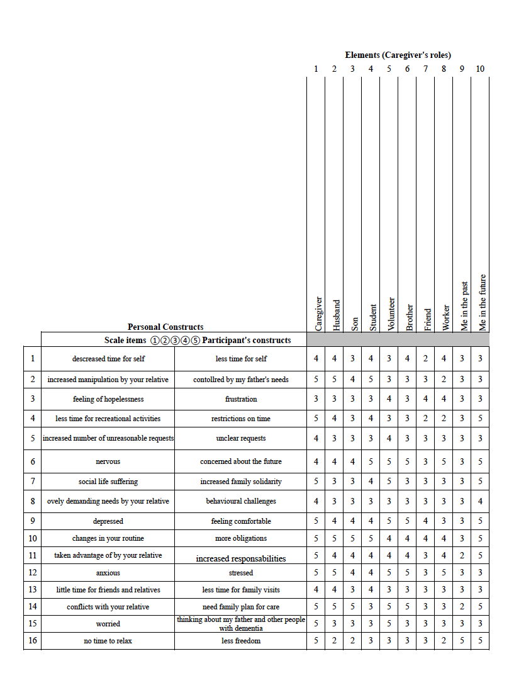
Appendix B. Repertory grid technique (participant 9).

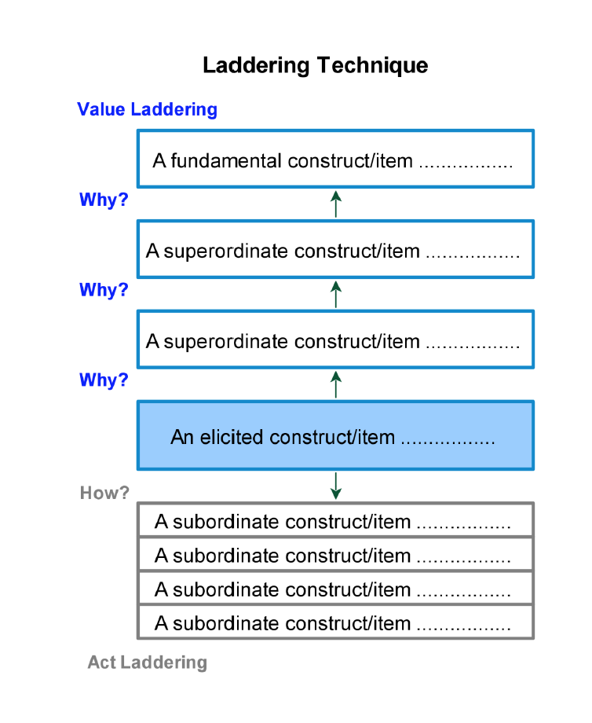
Appendix C. Laddering procedure (adapted from Hinkle, 2010 & Hill, 1995)

Appendix D. Item characteristics of the translated MBCBS.
Items  (Subscale) | Mean | SD | 1  % | 2  % | 3  % | 4  % | 5  %
Item 1 (OB)  Item 2 (RB)  Item 3 (SB) | 3.45  3.05  2.55 | 1.19  1.10  1.19 | 10.0  10.0  25.0 | 05.0  15.0  20.0 | 35.0  45.0  35.0 | 30.0  20.0  15.0 | 20.0  10.0  05.0
Item 4 (OB)  Item 5 (RB)  Item 6 (SB) | 3.15  3.55  2.55 | 1.23  1.32  0.94 | 15.0  10.0  20.0 | 15.0  10.0  15.0 | 15.0  25.0  55.0 | 50.0  25.0  10.0 | 05.0  30.0  00.0
Item 7 (OB)  Item 8 (RB)  Item 9 (SB)  Item 10 (OB)  Item 11 (RB)  Item 12 (SB)  Item 13 (OB)  Item 14 (RB)  Item 15 (SB)  Item 16 (OB) | 2.85  3.10  1.75  3.50  3.45  2.95  3.25  2.80  1.95  2.65 | 1.31  1.17  1.12  1.36  1.15  1.15  1.21  1.15  1.05  1.09 | 25.0  10.0  65.0  10.0  05.0  15.0  10.0  15.0  40.0  20.0 | 10.0  20.0  05.0  15.0  10.0  15.0  20.0  25.0  35.0  20.0 | 25.0  30.0  20.0  45.0  45.0  35.0  15.0  30.0  20.0  35.0 | 35.0  30.0  10.0  15.0  15.0  30.0  45.0  25.0  00.0  25.0 | 05.0  10.0  00.0  25.0  25.0  05.0  10.0  05.0  05.0  00.0

Appendix E. Comparison of fit indices for exploratory (rotate = "oblimin", fm="ml") and confirmatory (overall fit) factor analysis of the translated MBCBS.
Model | X² (df) | RMSEA  (90% CI) | RMR | SRMR | TLI | CFI
Model (1)  2-factor solution (EFA)  with all translated items | 285.1- (104) | 0.312 | 0.17 | - | 0.343 | 0.481
Model (2)  2-factor solution (EFA)  excl. items 2, 5, 9, & 11 | 190.68 (54) | 0.277 | 0.12 | - | 0.572 | 0.675
Model (3)  2-factor solution (EFA)  excl. the RB subscale | 158.45 (44) | 0.249 | 0.14 | - | 0.663 | 0.749
Model (4)  2-factor solution (EFA)  excl. the RB subscale  and item 9 (SB subscale) | 150.97 (35) | 0.265 | 0.12 | - | 0.663 | 0.754
Model (5)  1-factor solution (CFA)  with all translated items | 311.63 (104) | 0.316 | - | 0.15 | 0.261 | 0.360
Model (6)  2-factors solution (CFA) excluding the items of RB subscale | 80.86 (43) | 0.210 | - | 0.10 | 0.701 | 0.766
Model (7)  2-factor solution (CFA)  excluding the items of RB subscale and one item from SB subscale (item 9) | 55.03 (34) | 0.176 | - | 0.09 | 0.809 | 0.856
Model (8)  3-factors solution (CFA)  with all translated items | 282.59 (101) | 0.300 | - | 0.21 | 0.335 | 0.440

Note. EFA= Exploratory factor analysis, CFA= Confirmatory factor analysis, X² (df) = Chi Square (degrees of freedom), RMSEA = The root mean square error of approximation, RMR = The root mean square of the residuals, SRMR = The standardized root mean square of the residuals, TLI = Tucker Lewis index of factoring reliability, CFI = the comparative fit index.

