Droughts and controlled rivers: how Belo Monte dam has affected the food security of Amazonian riverine communities
Lopes, PFM^{1,2*}; Cousido-Rocha, M³; Silva, MRO^{1,4}; Carneiro, CC⁵; Pezzuti, JCB^{2,6}; Martins, EG⁷; de Paula, EMS⁸; Begossi, A^{2,9†}; Pennino, MG^{1,10}

Supplementary Material 1

River flow rate and the El Niño/Southern Oscillation effect
This appendix shows the historic pattern of the river flow rate for the studied time series (2012-2021) and the influence of the climatic phenomenon El Niño/Southern Oscillation (ENSO) on the river flow rate.
Figure S2 presents the median flow rate (m³/s) and the flow rate in each river region (downstream, reservoir, and de-watered reach) along the Xingu River. There is a clear decrease in the river flow rate during the years of 2015 and 2016 (Figure S2a), which is the period the region was subject to a strong El Niño that influenced the climate in Amazonia. Additionally, a decrease in the river flow is also observed in the de-watered reach region after 2018 and intensified in 2021 (Figure S2b), however, these decreases were not related to the climate event.
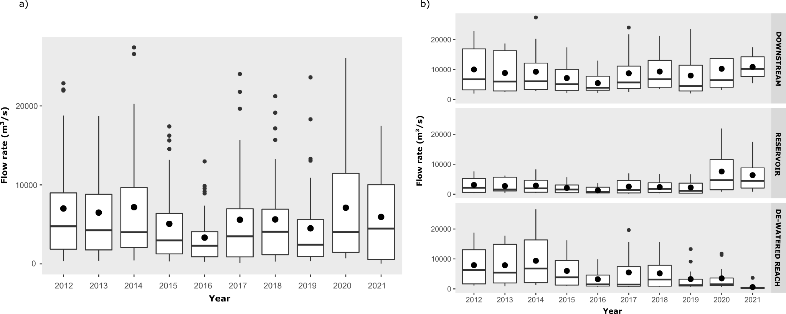
Figure S1: Boxplots showing (a) the median river flow rate and (b) the flow rate separated by each river region (downstream, reservoir, and de-watered reach) over the years (from 2012 to 2021).
To check the influence of ENSO on the river flow rate, we used the second version of the MEI (Multivariate El Niño/Southern Oscillation Index), a single index of assessment of ENSO (available at the NOAA’s website: https://psl.noaa.gov/enso/mei/). While ENSO is a process that varies both in space and time, it can be convenient to use a single time series to represent it in data monitoring and analyses. This index combines both oceanic and atmospheric variables that give real-time indications of ENSO intensity: sea level pressure, sea surface temperature, surface zonal winds, surface meridional winds, and outgoing longwave radiation (Wolter and Timlin, 1998, 2011). Table S1 presents the historic bi-monthly values of MEI from 2012 to 2021. We used the two values of each month to calculate the monthly average value (Table S2). We run a correlation test to check the relationship between monthly MEI and the river flow rate at the de-watered reach region over the years (R = 0.002, df = 118, p=0.977), as this would help separate the effect of El Niño from an artificially controlled flow (Figure S3). To clearly show the effect of ENSO on the flow rate, we presented the relationship between flow rate at the de-watered reach region and the MEI separated by year (Figure S3).

Table S1: Time series of the bi-monthly Multivariate El Niño/Southern Oscillation (ENSO) index (MEI.v2) for the period of 2012 to 2021. Warm (red) and cold (blue) periods based on a threshold of +/- 0.5. DJ = December/January; JF = January/February; FM = February/March; MA = March/April; AM = April/May; MJ = May/June; JJ = June/July; JA = July/August; AS = August/September; SO = September/October; ON = October/November; ND = November/December.
Year | DJ | JF | FM | MA | AM | MJ | JJ | JA | AS | SO | ON | ND
2012 | -1.1 | -0.7 | -0.6 | -0.4 | -0.3 | -0.3 | 0.3 | -0.1 | -0.3 | -0.2 | -0.1 | -0.1
2013 | 0 | -0.1 | -0.1 | -0.4 | -0.7 | -1.2 | -0.8 | -0.5 | -0.4 | -0.2 | -0.2 | -0.3
2014 | -0.5 | -0.4 | -0.1 | -0.2 | -0.2 | 0 | 0.3 | 0.2 | -0.1 | 0.1 | 0.3 | 0.3
2015 | 0.2 | 0.1 | 0.1 | 0.4 | 1 | 1.9 | 1.7 | 1.9 | 2.2 | 2.1 | 1.9 | 1.9
2016 | 1.9 | 1.8 | 1.3 | 1.3 | 1.3 | 0.4 | -0.5 | -0.3 | -0.3 | -0.6 | -0.5 | -0.3
2017 | -0.4 | -0.4 | -0.6 | -0.2 | 0.2 | -0.3 | -0.7 | -0.8 | -0.8 | -0.6 | -0.6 | -0.7
2018 | -0.8 | -0.7 | -0.8 | -1.3 | -0.9 | -0.5 | -0.2 | 0.4 | 0.5 | 0.4 | 0.3 | 0.1
2019 | 0.1 | 0.5 | 0.8 | 0.3 | 0.3 | 0.4 | 0.2 | 0.3 | 0.2 | 0.3 | 0.5 | 0.4
2020 | 0.3 | 0.3 | 0.2 | -0.1 | -0.2 | -0.7 | -1 | -1 | -1.2 | -1.2 | -1.1 | -1.2
2021 | -1 | -1 | -1 | -1 | -1 | -1 | -2 | -1 | -1 | -2 | -1 | -1

Table S2: Average monthly MEI values calculated from the historic MEI values from 2012 to 2021. These values were used in the correlation test between river flow rate and MEI. Red values mean warm periods.
Year | Jan | Feb | Mar | Apr | May | Jun | Jul | Aug | Sep | Oct | Nov | Dec
2012 | -0.9 | -0.65 | -0.5 | -0.35 | -0.3 | 0 | 0.1 | -0.2 | -0.25 | -0.15 | -0.1 | -0.05
2013 | -0.05 | -0.1 | -0.25 | -0.55 | -0.95 | -1 | -0.65 | -0.45 | -0.3 | -0.2 | -0.25 | -0.4
2014 | -0.45 | -0.25 | -0.15 | -0.2 | -0.1 | 0.15 | 0.25 | 0.05 | 0 | 0.2 | 0.3 | -0.1
2015 | 0.15 | 0.1 | 0.25 | 0.7 | 1.45 | 1.8 | 1.8 | 2.05 | 2.15 | 2 | 1.9 | 1.05
2016 | 1.85 | 1.55 | 1.3 | 1.3 | 0.85 | -0.05 | -0.4 | -0.3 | -0.45 | -0.55 | -0.4 | 0.8
2017 | -0.4 | -0.5 | -0.4 | 0 | -0.05 | -0.5 | -0.75 | -0.8 | -0.7 | -0.6 | -0.65 | -0.55
2018 | -0.75 | -0.75 | -1.05 | -1.1 | -0.7 | -0.35 | 0.1 | 0.45 | 0.45 | 0.35 | 0.2 | -0.35
2019 | 0.3 | 0.65 | 0.55 | 0.3 | 0.35 | 0.3 | 0.25 | 0.25 | 0.25 | 0.4 | 0.45 | 0.25
2020 | 0.3 | 0.25 | 0.05 | -0.15 | -0.45 | -0.85 | -1 | -1.1 | -1.2 | -1.15 | -1.15 | -1.2
2021 | -1.05 | -0.85 | -0.9 | -1.05 | -1.1 | -1.3 | -1.4 | -1.35 | -1.45 | -1.45 | -1.3 | -1.15

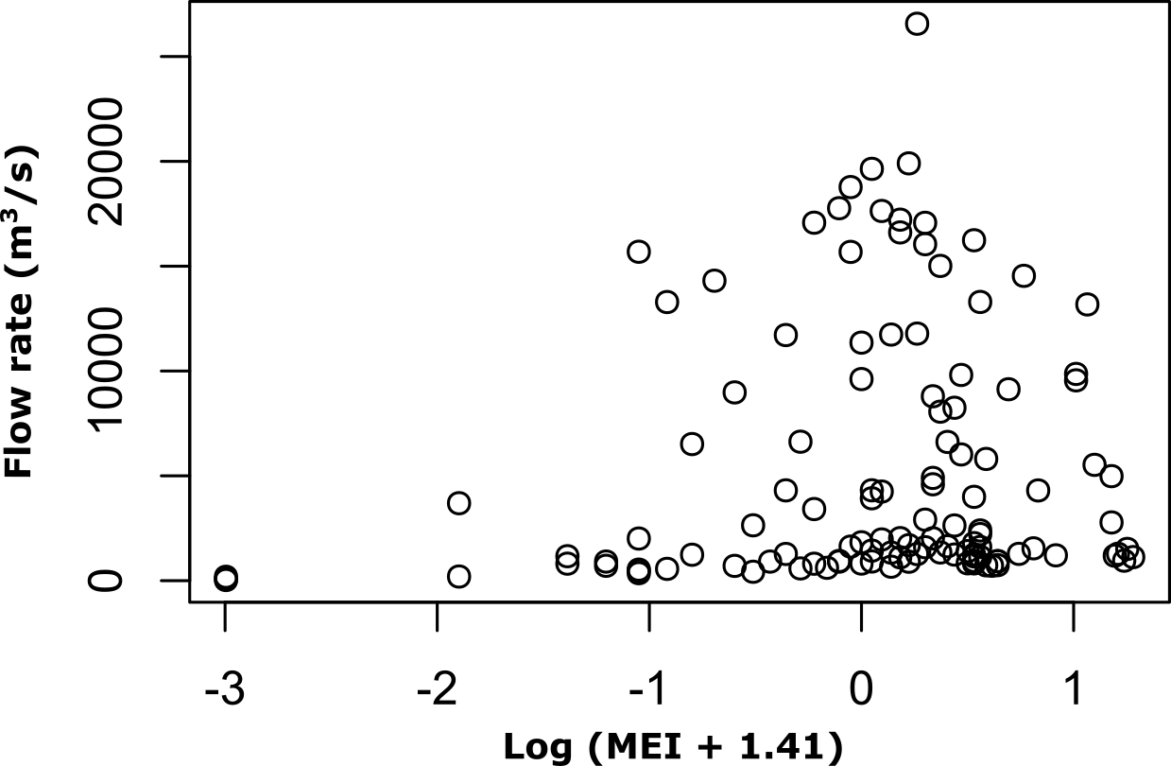
Figure S2: Correlation between river flow rate (m3/s) and Multivariate El Niño/Southern Oscillation Index (MEI). The MEI variable was log transformed. The logarithmic transformation was necessary to avoid negative values observed in some MEI.
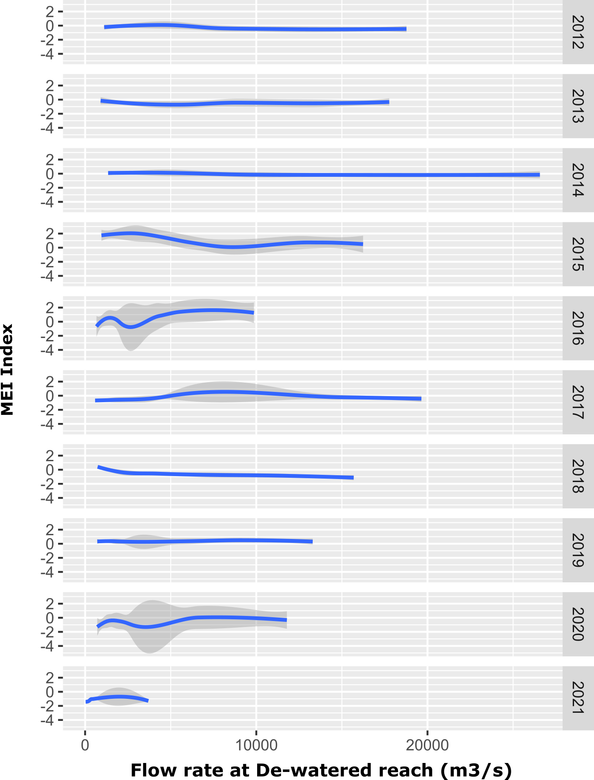
Figure S3: Plots of the relationships between MEI and flow rate at the de-watered reach region separated by year (from 2012 to 2021). Notice the low flow levels observed in 2015 and 2016, when the El Niño event is supposed to have drastically reduced rains in the region. Low flow levels are also observed between 2019 and 2021 but these are not related to a climate event.

REFERENCES
NOAA – National Oceanic and Atmospheric Administration. Physical Sciences Laboratory. Datasets Useful for Research. Time Series of MEI.v2. Available on: https://psl.noaa.gov/enso/mei/
Wolter, K., and M. S. Timlin, 1998: Measuring the strength of ENSO events - how does 1997/98 rank? Weather, 53, 315-324. DOI: 10.1002/j.1477-8696.1998.tb06408.x.
Wolter, K., and M. S. Timlin, 2011: El Niño/Southern Oscillation behaviour since 1871 as diagnosed in an extended

