APPENDIX S1. Survey
SECTION I: CONNECTION WITH NATURE
1.- How connected do you feel with nature?
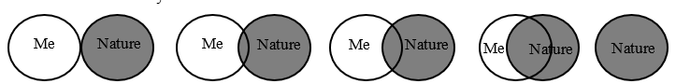
1a.- Could you explain in your own words why you have chosen that answer?
……………………………………………………………………………………………

SECTION II: SOCIAL PERCEPTION OF THE ARENILLAS ECOLOGICAL RESERVE
2.- Do you know the Arenillas Ecological Reserve?
- Yes
- No

3. Have you ever visited it? (only respondents who said yes to question 1)
- No
- Yes
3a. Why do you visit it? ……………………………………………………………….

SECTION III - SOCIO-DEMOGRAPHIC INFORMATION
4. Could you tell me what is your level of formal studies?
- Primary | - High school | - University
- No studies
5. How old are you?
6. What is your gender?
- Female
- Male

