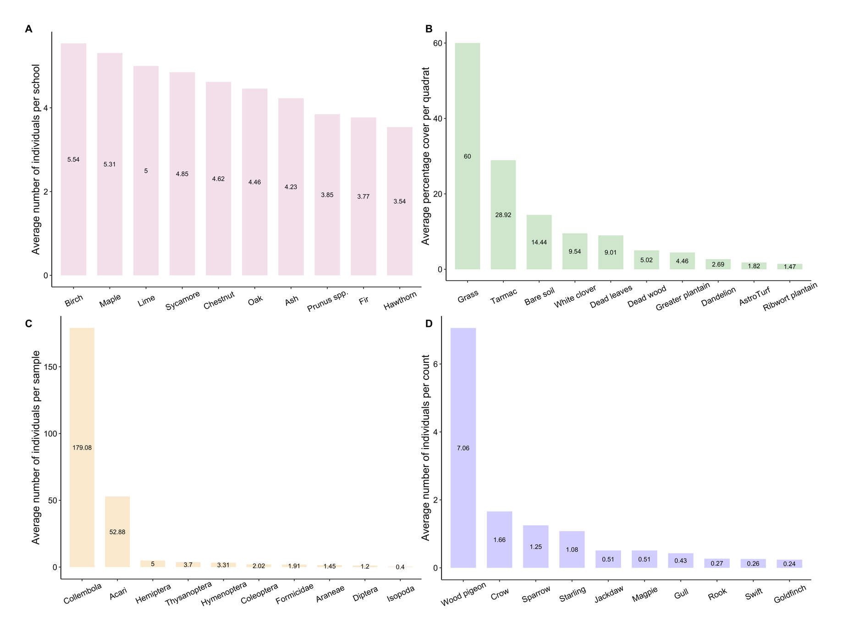

**Figure S3.** Most common groups found in school grounds. A: Bar graph showing the ten most abundant tree morphospecies by average number of individuals per school. B: Bar graph showing the ten most common types of ground cover by average coverage per quadrat. C: Bar graph showing the ten most abundant ground invertebrate orders by average number of individuals per sample. D: Bar graph showing the ten most abundant bird species by average number of individuals per count.