Supplementary material
Table S1. Key values from the optimal solutions of the bootstrapped MPT (i.e., mean portfolio weights, number of optimally selected counties, and kurtosis values for selected counties), and portfolio weights using the fixed MPT at five risk tolerances for the 10 sample counties with the variance-covariance matrix containing the average pairwise correlations of 0.3.
Risk tolerance | County | Bootstrapped MPT |  |  |  | Fixed MPT
 |  | Mean Portfolio Weight | Number of times* | Kurtosis  Value | Coefficient of Variation | Portfolio  Weight
Minimum | Caldwell, NC | 0.1031 | 492 | 0.54 | 1.3944 | 0.0382
 | Rabun, GA | 0.2682 | 984 | 0.45 | 0.3582 | 0.3024
 | Lawrence, KY | 0.5699 | 1000 | 3.07 | 0.1092 | 0.5695
 | Morgan, AL | 0.0587 | 526 | 3.95 | 1.3278 | 0.0900
 | Harlan, KY | 0.0001 | 6 | 388.47 | 16.5168 | -
10% | Talladega, AL | 0.0006 | 17 | 365.39 | 10.6272 | -
 | Caldwell, NC | 0.0040 | 35 | 63.47 | 6.3705 | -
 | Scott, VA | 0.0461 | 788 | 0.83 | 1.4204 | 0.0139
 | Rabun, GA | 0.0013 | 22 | 149.18 | 8.538 | -
 | Chilton, AL | 0.4634 | 974 | -0.77 | 0.4929 | 0.5000
 | Harlan, KY | 0.4845 | 831 | -0.45 | 0.5418 | 0.4860
30% | Caldwell, NC | 0.0001 | 1 | 995 | 31.6228 | -
 | Scott, VA | 0.3079 | 1000 | 1.13 | 0.7991 | 0.2004
 | Rabun, GA | 0.0049 | 40 | 71.24 | 6.3534 | -
 | Chilton, AL | 0.6313 | 994 | -0.57 | 0.4356 | 0.7996
 | Harlan, KY | 0.0558 | 207 | 7.83 | 2.5518 | -
50% | Scott, VA | 0.4850 | 1000 | 0.98 | 0.2573 | 0.4364
 | Rabun, GA | 0.0049 | 36 | 67.95 | 6.5683 | -
 | Page, VA | 0.0410 | 169 | 1.22 | 2.2238 | -
 | Chilton, AL | 0.4565 | 825 | 0.24 | 0.4895 | 0.5636
 | Harlan, KY | 0.0127 | 50 | 35.26 | 5.1359 | -
Maximum | Scott, VA | 0.8274 | 953 | 1.12 | 0.4489 | 1
 | Page, VA | 0.1683 | 169 | 1.12 | 2.2186 | -
 | Chilton, AL | 0.0043 | 816 | 0.58 | 0.4783 | -
*Number of times the county was assigned a non-negative portfolio weight in one of the 1000 bootstrap samples
Table S2. Key values from the optimal solutions of the bootstrapped MPT (i.e., mean portfolio weights, number of optimally selected counties, and kurtosis values for selected counties), and portfolio weights using the fixed MPT at five risk tolerances for the 10 sample counties with the variance-covariance matrix containing the average pairwise correlations of 0.5.
Risk tolerance | County | Bootstrapped MPT |  |  |  | Fixed MPT
 |  | Mean Portfolio Weight | Number of times* | Kurtosis  Value | Coefficient of Variation | Portfolio  Weight
Minimum | Putnam, TN | 0.6477 | 987 | 6.48 | 0.2341 | 0.7068
 | Caldwell, NC | 0.3159 | 1000 | 4.58 | 0.2146 | 0.2932
 | Lawrence, KY | 0.0364 | 215 | 6.83 | 2.4745 | -
10% | Summers, WV | 0.0070 | 150 | 19.81 | 3.1997 | -
 | Caldwell, NC | 0.1224 | 765 | -1.65 | 0.8439 | 0.2025
 | Yancey, NC | 0.0233 | 564 | -0.55 | 1.2182 | -
 | Tazewell, VA | 0.8473 | 1000 | -1.37 | 0.0923 | 0.7975
30% | Summers, WV | 0.2852 | 980 | -0.73 | 0.6647 | 0.1321
 | Yancey, NC | 0.1408 | 855 | -1.43 | 0.7917 | 0.0757
 | Tazewell, VA | 0.5740 | 970 | -1.08 | 0.4865 | 0.7923
50% | Summers, WV | 0.4433 | 988 | 6.59 | 0.2111 | 0.3821
 | Yancey, NC | 0.2863 | 879 | -1.7 | 0.7471 | 0.1484
 | Tazewell, VA | 0.2704 | 588 | -1.72 | 0.9476 | 0.4695
Maximum | Summers, WV | 0.5090 | 893 | -2 | 0.9772 | 1
 | Yancey, NC | 0.4904 | 767 | -2 | 1.0154 | -
 | Tazewell, VA | 0.0006 | 118 | 3.97 | 2.7523 | -
* Number of times the county was assigned a non-negative portfolio weight in one of the 1000 bootstrap samples
Table S3. Key values from the optimal solutions of the bootstrapped MPT (i.e., mean portfolio weights, number of optimally selected counties, and kurtosis values for selected counties), and portfolio weights using the fixed MPT at five risk tolerances for the 10 sample counties with the variance-covariance matrix containing the average pairwise correlations of 0.7.
Risk tolerance | County | Bootstrapped MPT |  |  |  | Fixed MPT
 |  | Mean Portfolio Weight | Number of times* | Kurtosis  Value | Coefficient of Variation | Portfolio  Weight
Minimum | Blount, TN | 0.9971 | 1000 | 94.17 | 0.0044 | 0.9988
 | Preston, WV | 0.0028 | 608 | 1.93 | 1.2673 | 0.0012
 | Greene, VA | 0.0002 | 6 | 672.06 | 17.5513 | -
10% | Blount, TN | 0.1322 | 575 | 0.09 | 1.1959 | 0.0114
 | Hamilton, TN | 0.0003 | 1 | 995 | 31.6228 | -
 | Clay, KY | 0.0038 | 70 | 34.14 | 4.7284 | -
 | Whitley, KY | 0.4296 | 963 | 0.13 | 0.4265 | 0.4850
 | Preston, WV | 0.1043 | 1000 | 0.71 | 0.1161 | 0.1027
 | Greene, VA | 0.3298 | 882 | -0.58 | 0.703 | 0.4009
30% | Clay, KY | 0.2167 | 925 | 0.05 | 0.6166 | 0.2737
 | Whitley, KY | 0.2423 | 521 | -1.52 | 1.1045 | -
 | Preston, WV | 0.2911 | 1000 | 2.33 | 0.0497 | 0.2838
 | Hamblen, TN | 0.0001 | 2 | 966.92 | 28.4271 | -
 | Greene, VA | 0.2498 | 637 | -1.53 | 0.8999 | 0.4425
50% | Clay, KY | 0.4114 | 983 | 0.52 | 0.3381 | 0.4912
 | Whitley, KY | 0.0452 | 241 | 5.77 | 2.2894 | -
 | Preston, WV | 0.4697 | 1000 | 2.46 | 0.0569 | 0.4545
 | Greene, VA | 0.0736 | 441 | 1.86 | 1.5645 | 0.0542
Maximum | Clay, KY | 0.0047 | 994 | 21.5 | 0.1266 | -
 | Preston, WV | 0.9953 | 1000 | -0.15 | 0 | 1
* Number of times the county was assigned a non-negative portfolio weight in one of the 1000 bootstrap samples

Table S4. Key values from the optimal solutions of the bootstrapped MPT (i.e., mean portfolio weights, number of optimally selected counties, and kurtosis values for selected counties), and portfolio weights using the fixed MPT at five risk tolerances for the 10 sample counties with the variance-covariance matrix containing the average pairwise correlations of 1.
Risk tolerance | County | Bootstrapped MPT |  |  |  | Fixed MPT
 |  | Mean Portfolio Weight | Number of times* | Kurtosis  Value | Coefficient of Variation | Portfolio  Weight
Minimum | Shelby, AL | 0.1211 | 236 | 3.95 | 2.2789 | -
 | Putnam, TN | 0.8789 | 949 | 3.95 | 0.3139 | 1
10% | Breathitt, KY | 0.0030 | 57 | 28.08 | 4.9549 | -
 | Whitley, KY | 0.2297 | 986 | 13.31 | 0.1897 | 0.2495
 | Putnam, TN | 0.7672 | 1000 | 5.02 | 0.0411 | 0.7505
30% | Breathitt, KY | 0.0205 | 167 | 10.42 | 2.8662 | -
 | Whitley, KY | 0.6743 | 987 | 5.38 | 0.2424 | 0.7217
 | Putnam, TN | 0.3053 | 998 | 2.23 | 0.372 | 0.2783
50% | Breathitt, KY | 0.1645 | 982 | 2.77 | 0.5364 | 0.1464
 | Whitley, KY | 0.8012 | 987 | 8.71 | 0.2163 | 0.8536
 | Putnam, TN | 0.0343 | 183 | 10.49 | 2.8688 | -
Maximum | Breathitt, KY | 0.9923 | 1000 | 2.26 | 0 | 1
 | Whitley, KY | 0.0076 | 986 | 24.01 | 0.1517 | -
 | Putnam, TN | 0.0001 | 15 | 63.92 | 8.1629 | -
* Number of times the county was assigned a non-negative portfolio weight in one of the 1000 bootstrap samples
Figure S1. Probability density distributions of the estimated portfolio weights with 95% confidence intervals (a pair of black dotted vertical lines in each graph), means of the estimated portfolio weights from the bootstrapped MPT (red dotted vertical line in each graph), and the optimal portfolio weights from the MPT with uniform probability distributions (green vertical line in each graph) at 10%, 30%, and 50% risk tolerances. The x-axis and y-axis in each probability density distribution are portfolio weight and probability density. Values on the x-axis are 95% confidence intervals and mean of the estimated portfolio weights from the bootstrapped MPT.
- 10% risk tolerance
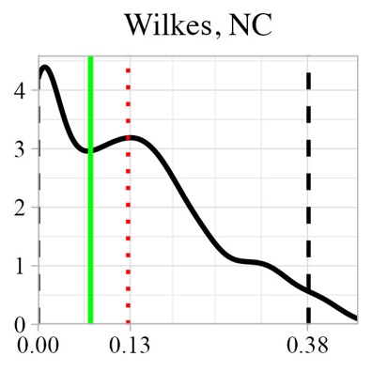 | 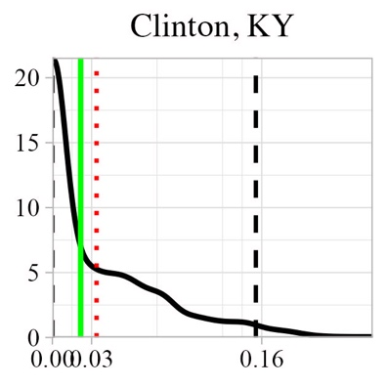  0.03 | 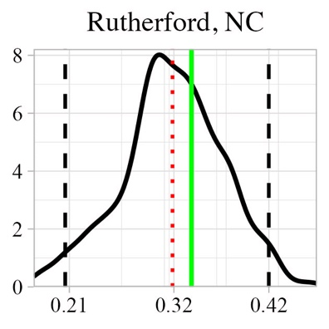 | 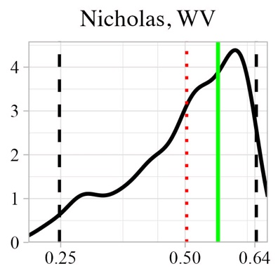 | 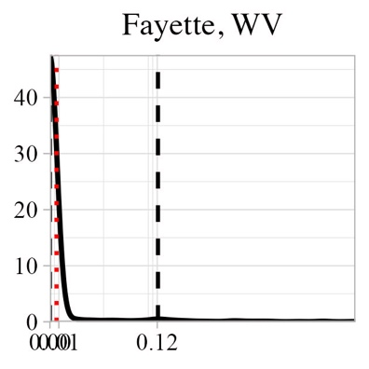  0.01
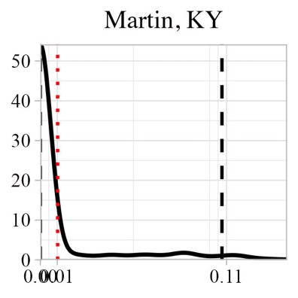
0.01

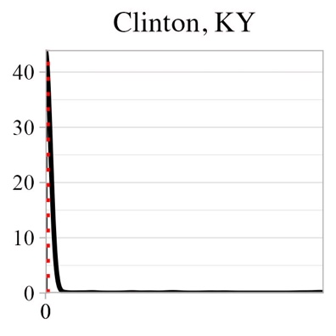 | 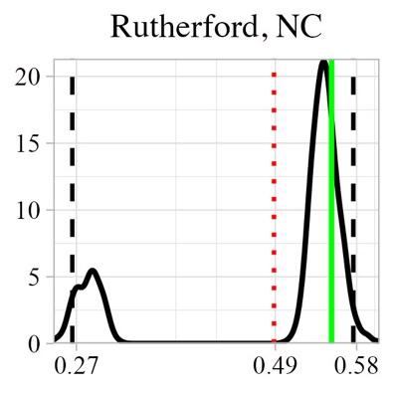 | 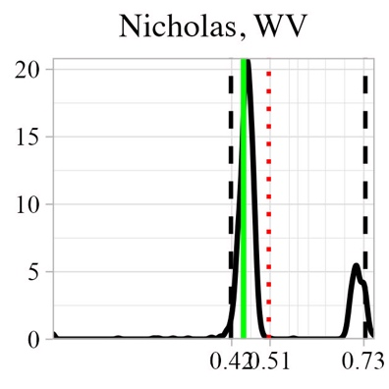  0.42  0.51
- 30% risk tolerance

- 50% risk tolerance
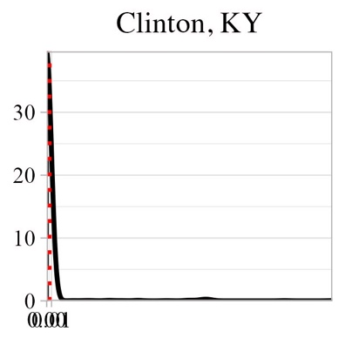  0.01 | 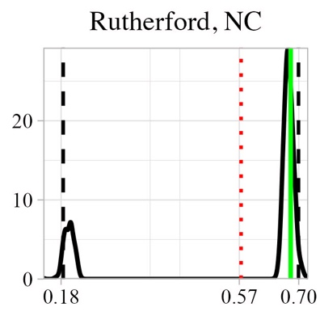 | 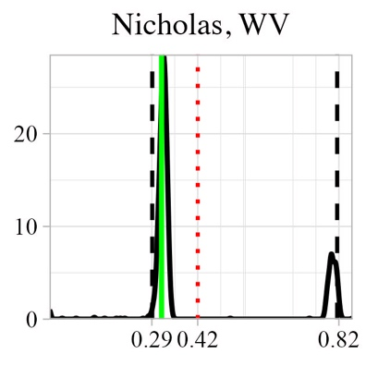

Figure S2. Probability density distributions of the estimated portfolio weights with 95% confidence intervals (a pair of black dotted vertical lines in each graph), means of the estimated portfolio weights from the bootstrapped MPT (red dotted vertical line in each graph), and the optimal portfolio weights from the MPT with uniform probability distributions (green vertical line in each graph) at minimum and maximum risk tolerances. The x-axis and y-axis in each probability density distribution are portfolio weight and probability density. Values on the x-axis are 95% confidence intervals and mean of the estimated portfolio weights from the bootstrapped MPT for the 10 sample counties with the variance-covariance matrix containing the average pairwise correlations of 0.3.
- Minimum risk tolerance level
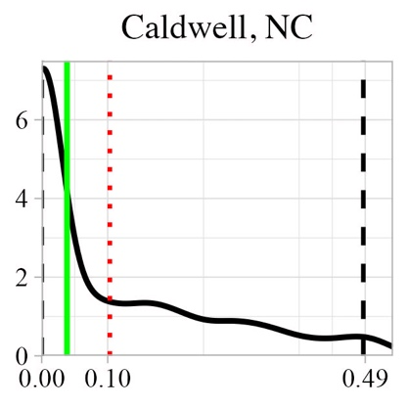 | 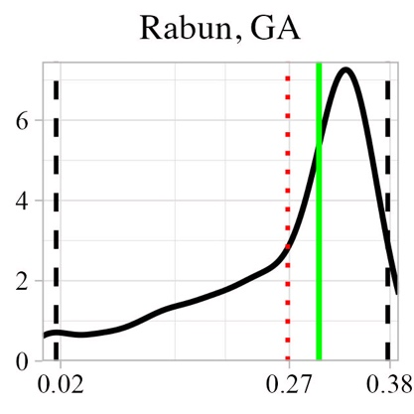 | 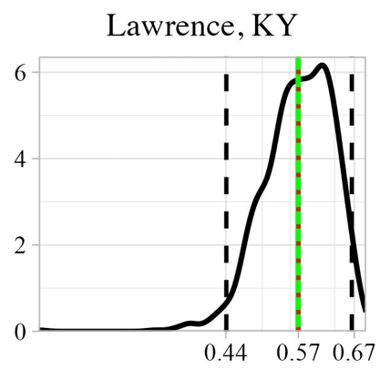 | 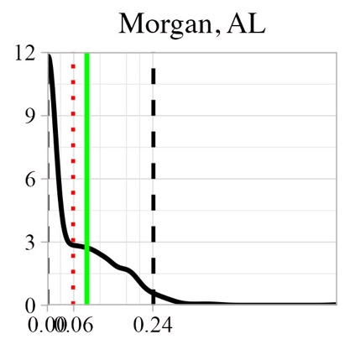  0.06 | 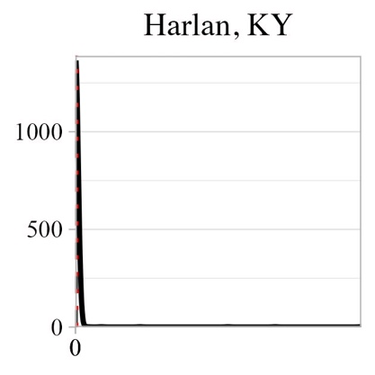

- Maximum risk tolerance level
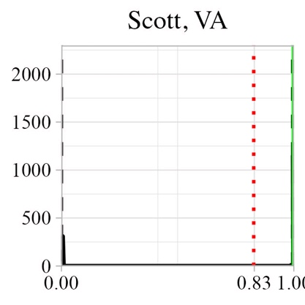 | 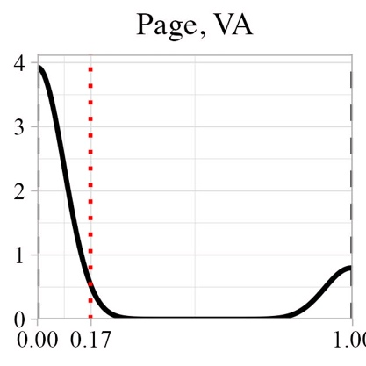 | 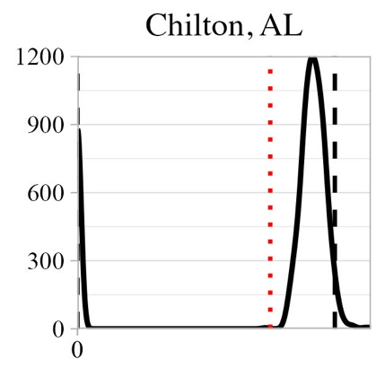

Figure S3. Probability density distributions of the estimated portfolio weights with 95% confidence intervals (a pair of black dotted vertical lines in each graph), means of the estimated portfolio weights from the bootstrapped MPT (red dotted vertical line in each graph), and the optimal portfolio weights from the MPT with uniform probability distributions (green vertical line in each graph) at minimum and maximum risk tolerances. The x-axis and y-axis in each probability density distribution are portfolio weight and probability density. Values on the x-axis are 95% confidence intervals and mean of the estimated portfolio weights from the bootstrapped MPT for the 10 sample counties with the variance-covariance matrix containing the average pairwise correlations of 0.5.
- Minimum risk tolerance level
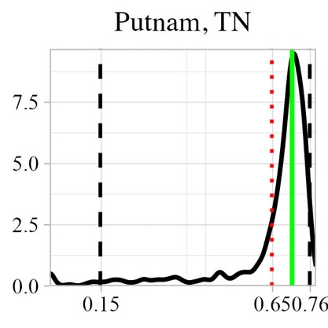  0.65 | 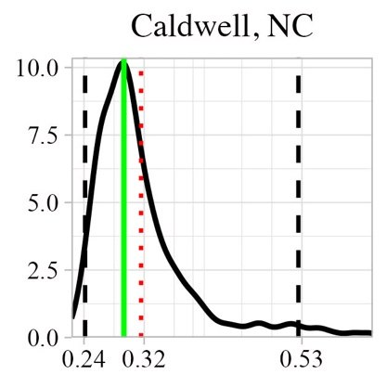 | 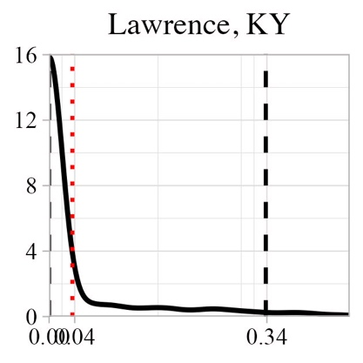  0.04

- Maximum risk tolerance level
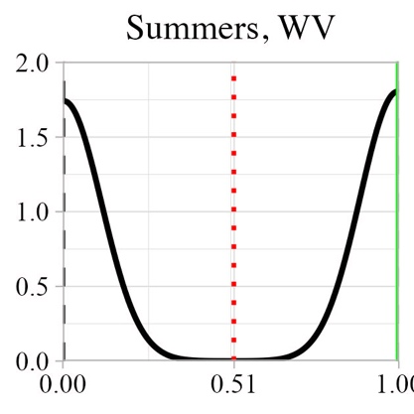 | 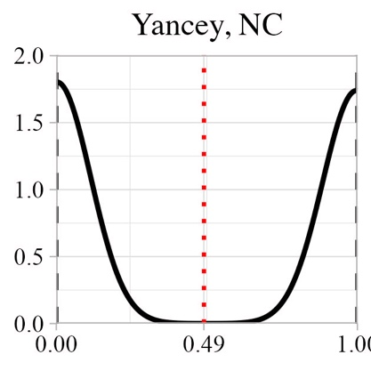 | 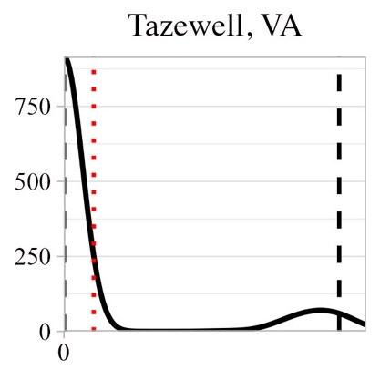

Figure S4. Probability density distributions of the estimated portfolio weights with 95% confidence intervals (a pair of black dotted vertical lines in each graph), means of the estimated portfolio weights from the bootstrapped MPT (red dotted vertical line in each graph), and the optimal portfolio weights from the MPT with uniform probability distributions (green vertical line in each graph) at minimum and maximum risk tolerances. The x-axis and y-axis in each probability density distribution are portfolio weight and probability density. Values on the x-axis are 95% confidence intervals and mean of the estimated portfolio weights from the bootstrapped MPT for the 10 sample counties with the variance-covariance matrix containing the average pairwise correlations of 0.7.
- Minimum risk tolerance level
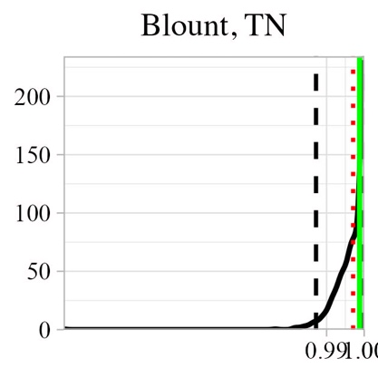 | 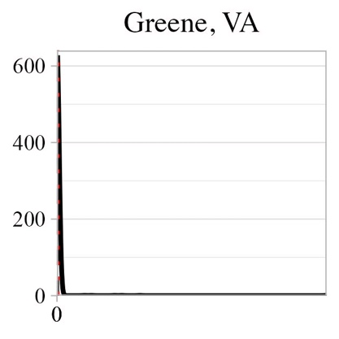 | 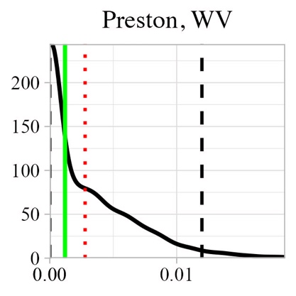

- Maximum risk tolerance level
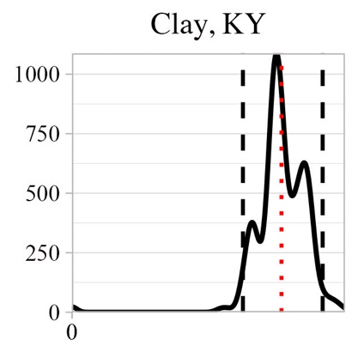 | 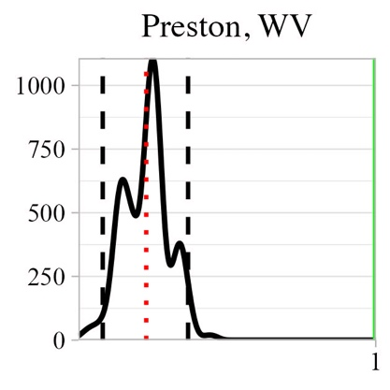

Figure S5. Probability density distributions of the estimated portfolio weights with 95% confidence intervals (a pair of black dotted vertical lines in each graph), means of the estimated portfolio weights from the bootstrapped MPT (red dotted vertical line in each graph), and the optimal portfolio weights from the MPT with uniform probability distributions (green vertical line in each graph) at minimum and maximum risk tolerances. The x-axis and y-axis in each probability density distribution are portfolio weight and probability density. Values on the x-axis are 95% confidence intervals and mean of the estimated portfolio weights from the bootstrapped MPT for the 10 sample counties with the variance-covariance matrix containing the average pairwise correlations of 1.

- Minimum risk tolerance level
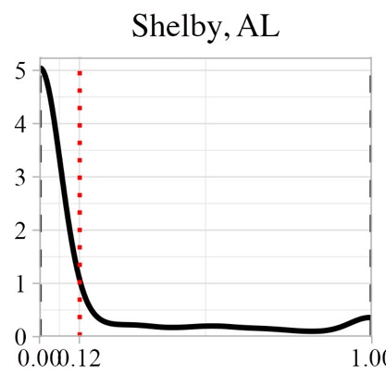  1  0.12 | 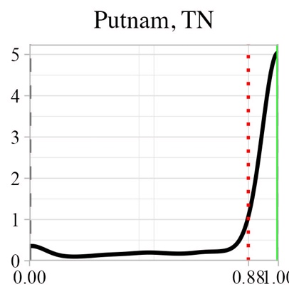  1

- Maximum risk tolerance level
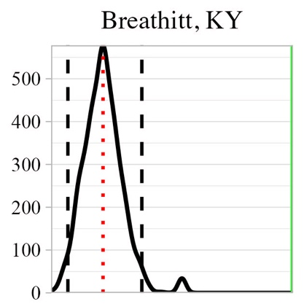 | 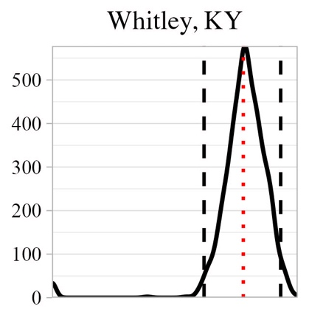 | 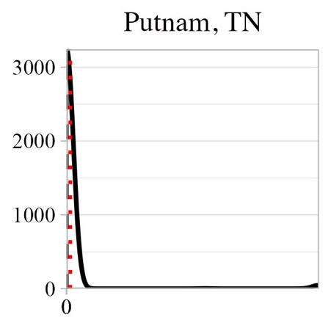

Figure S6. The expected ROI-risk tolerance relationship with two efficient frontiers based on the average expected ROIs and their standard deviations of the optimal solutions from the bootstrapped MPT and the fixed MPT for the 10 sample counties with the variance-covariance matrix containing the average pairwise correlations of 0.3.

Figure S7. The expected ROI-risk tolerance relationship with two efficient frontiers based on the average expected ROIs and their standard deviations of the optimal solutions from the bootstrapped MPT and the fixed MPT for the 10 sample counties with the variance-covariance matrix containing the average pairwise correlations of 0.5.

Figure S8. The expected ROI-risk tolerance relationship with two efficient frontiers based on the average expected ROIs and their standard deviations of the optimal solutions from the bootstrapped MPT and the fixed MPT for the 10 sample counties with the variance-covariance matrix containing the average pairwise correlations of 0.7.

Figure S9. The expected ROI-risk tolerance relationship with two efficient frontiers based on the average expected ROIs and their standard deviations of the optimal solutions from the bootstrapped MPT and the fixed MPT for the 10 sample counties with the variance-covariance matrix containing the average pairwise correlations of 1.

