Supplementary Material

Table S1. Conceptual definitions of the variables
Item | Variable | Definition
1 | Economic | The university advocates for green jobs by allocating a budget and reducing costs through the use of clean technologies.
2 | Organizational | The university integrates environmental considerations into its operations.
3 | Social | The university engages with the community by providing environmental public, humanitarian, and philanthropic services. It also provides voluntary advisory and technical services, offers feedback on environmental decisions made by local and national authorities, and takes part in improving actions. Additionally, it celebrates and appreciates environmental behaviors of individuals and institutions.
4 | Regulatory | The university develops requirements, instructions, codes, guidelines, approvals, incentives, and other tools to fulfill its environmental responsibilities and goals.
5 | Educational | The university defines the quality of education that aligns with improving the environmental situation of the community and organizes related training workshops.
6 | Research | The university defines the quality of research that aligns with improving the environmental situation and produces knowledge (such as books and meetings) to address ongoing environmental challenges in the community.
7 | Cultural | The university instills environmental ethics, patterns, norms, values, beliefs, and attitudes within communities.
8 | Questioning | The university encourages critical thinking and creativity in addressing environmental problems and issues among students and the public.

Table S2. Pearson correlation between the variables
Questioning | Social | Cultural | Regulatory | Research | Education | Organizational | Economic | Variable
 |  |  |  |  |  | 1 | 0.581** | Organizational
 |  |  |  |  | 1 | 0.195** | 0.599** | Education
 |  |  |  | 1 | 0.685** | 0.570** | 0.555** | Research
 |  |  | 1 | 0.296** | 0.310** | 0.284** | 0.263** | Regulatory
 |  | 1 | 0.221** | 0.578** | 0.623** | 0.536** | 0.527** | Cultural
 | 1 | 0.631** | 0.301** | 0.724** | 0.673** | 0.579** | 0.552** | Social
1 | 0.719** | 0.595** | 0.317** | 0.659** | 0.622** | 0.502** | 0.500** | Questioning
0.675** | 0.670** | 0.645** | 0.615** | 0.670** | 0.705** | 0.610** | 0.598** | USER
* Correlation at a significance level above 95% ** Correlation at a significance level above 99%

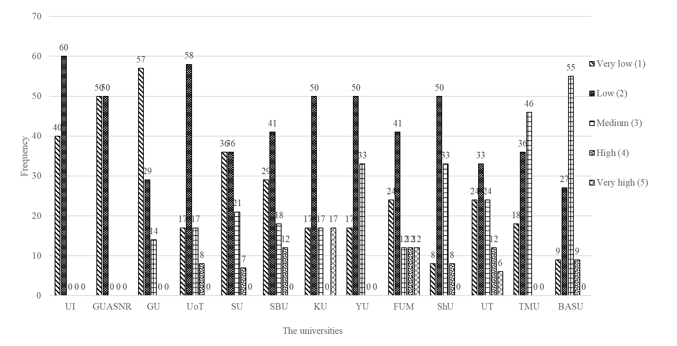
Figure S1. Distribution of responses to the variable of USER by the universities

