Supplementary Information

Figure S1. Optimal generalized linear model results assessing the overlap of hunting territories, showing the relationship between distance of the cell center from the community and the number of families which hunted in the cell. Different colors indicate whether the cell was located along a major river.

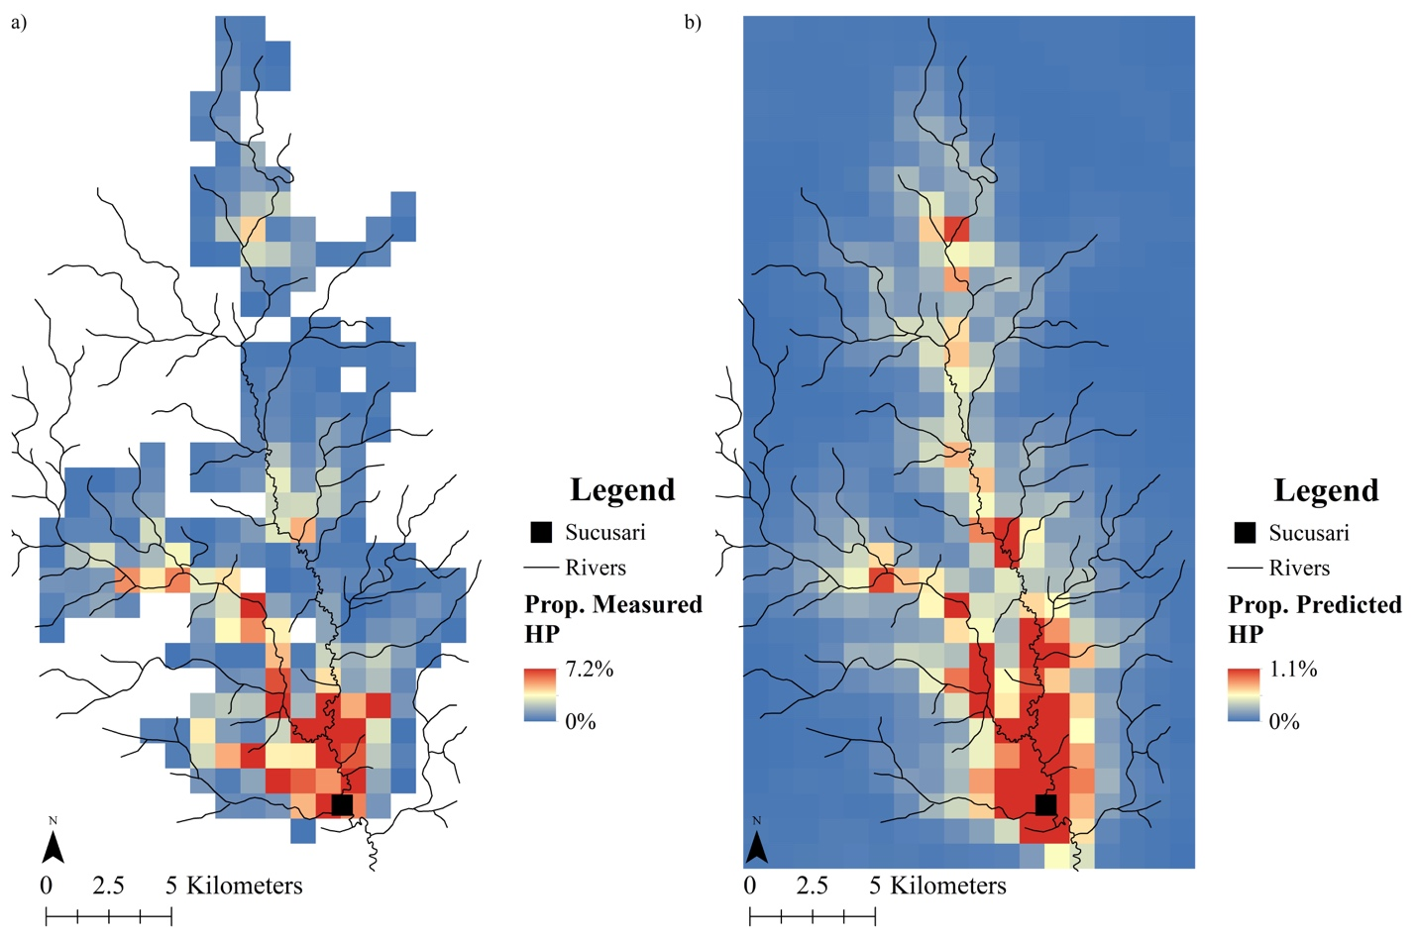

Figure S2. Map of a), actual spatial spread of hunting pressure on primates in the Sucusari River basin of the northeastern Peruvian Amazon and b) predicted spatial spread of hunting pressure on primates according to application of the central place foraging theory.

