Additional figures

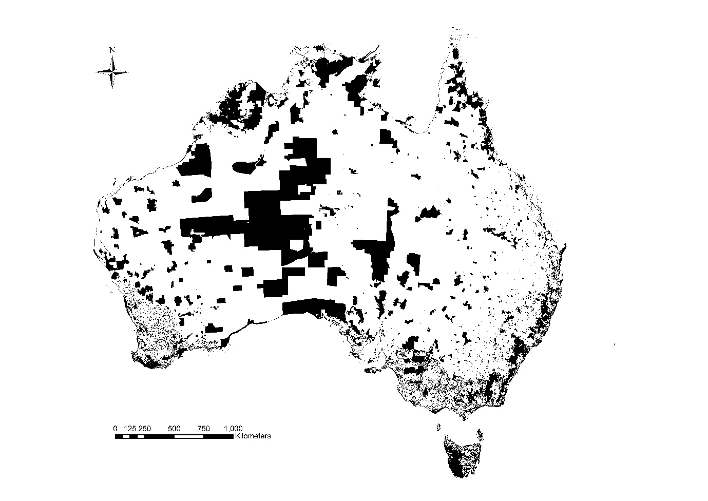
Figure S3.1. The spatial configuration of Australia’s protected areas network (from Ivanova & Cook 2020).

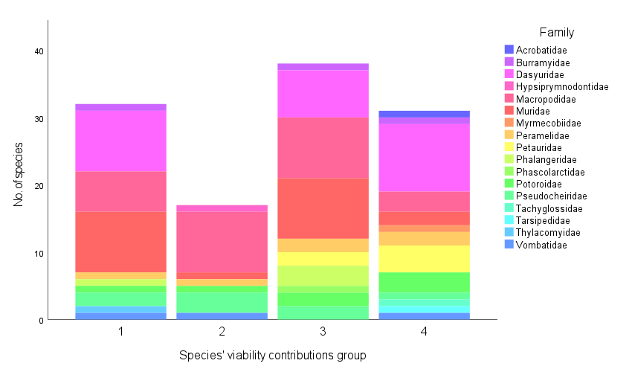
Figure S3.2. The number of species, identified by their family, within each of the four viability contributions groups determined by means of a K-clustering analysis. The groups were defined based on the most likely point of separation across three input parameters, namely the percentage of PAs found to contribute towards species viability, and the proportion of those that are of public and private land tenure type.

A
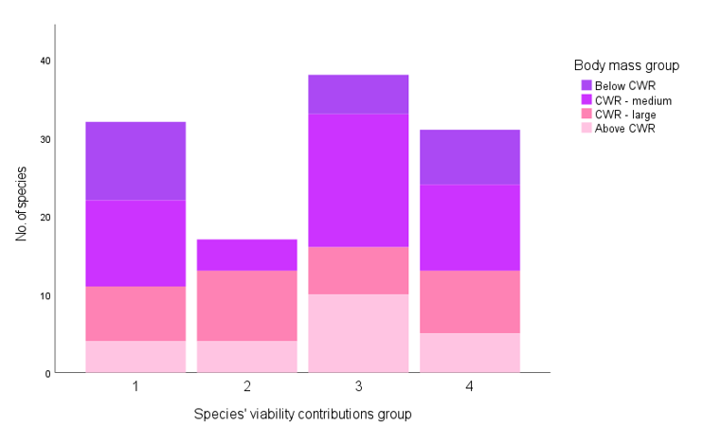

B
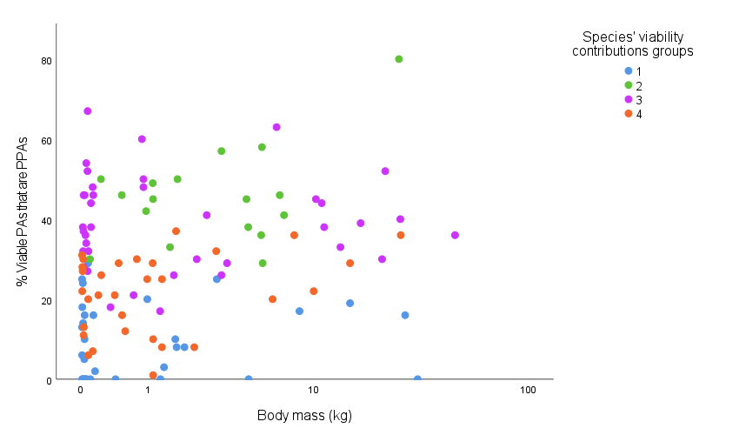
Figure S3.3. A) The number of species, identified by their body mass, within each of the four viability contributions groups determined by means of a K-clustering analysis. The critical weight range (CWR) is defined in literature as 35-5500g. B) The proportional contribution of privately protected areas (PPAs) to the number of PAs that add to species viability, across the four viability contribution groups, as compared to the species’ body mass.

Figure S3.4. The viability contribution reported for PAs of two land tenure types (public and private) across three habitat size classes (i.e. area of species’ habitat contained therein).

A

B

Figure S3.5. The habitat quality (as represented by r_{m} scores) of protected areas of private (A) and public (B) tenure type as averaged per species. The difference between PAs that do versus ones that don’t contribute to the species’ viability is presented, further grouped by the habitat size present therein (in km²).

