**Supplementary Material to the paper**

Silva, J.L.A., Souza, A.F., Vitória, A.P. Mapping functional tree regions of the Atlantic Forest: how much is left, and opportunities for conservation. *Environmental Conservation.*

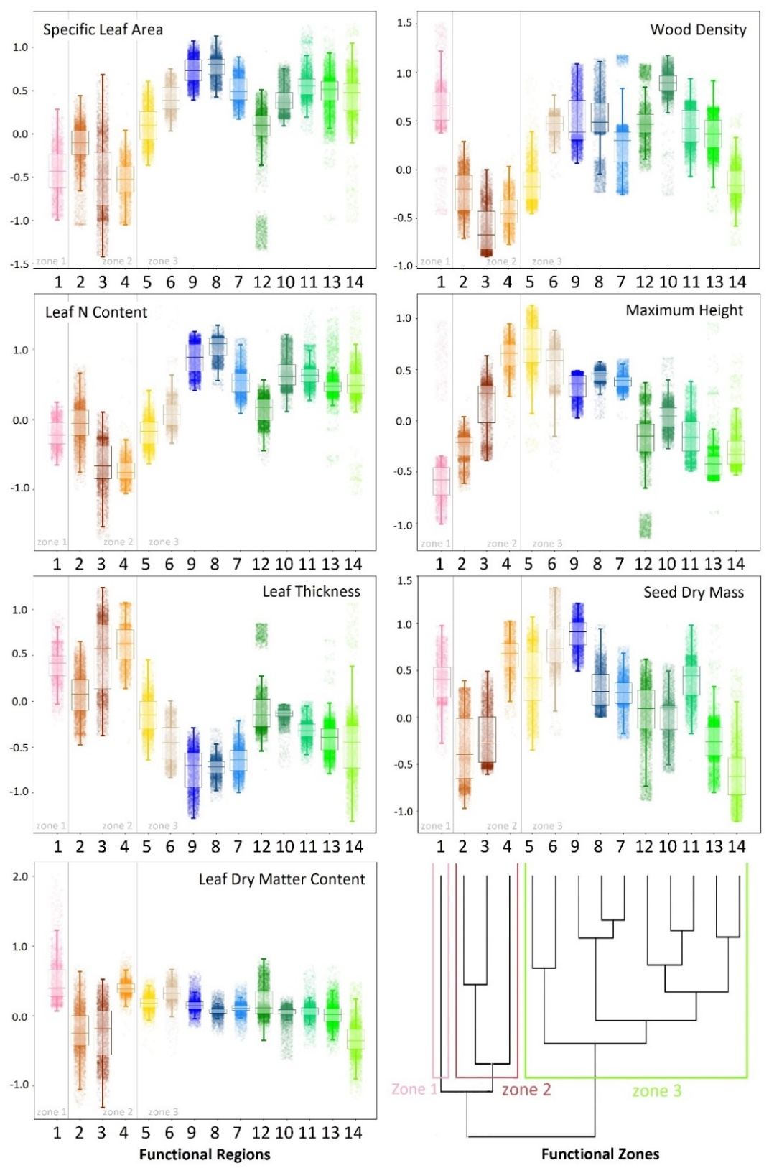

**Figure S1.** Distribution of community-weighted mean traits per functional region (1-14) of the Atlantic Forest. Points are standardized values of CWM traits for each cell within interpolated maps.

**Table S1.** Summary of the principal component analysis on community-weighted mean traits extracted from the interpolated maps. Eigenvalues and the total variance explained by each PCA axes, and loadings of variables associated to axes are shown.

|  |  |  |  |  |
| --- | --- | --- | --- | --- |
|  | **Trait** | **PCA axes** | | |
|  | **Code** | **PC1** | **PC2** | **PC3** |
| Eigenvalue |  | 1.73 | 1.39 | 1.16 |
| Explained variance (%) |  | 42.78 | 27.65 | 19.16 |
| *Loadings of variables* |  |  |  |  |
| Specific leaf area | SLA | 0.55 | -0.05 | -0.15 |
| Leaf nitrogen content | N | 0.55 | -0.11 | 0.09 |
| Leaf thickness | Leaf.thick | -0.52 | 0.06 | 0.19 |
| Leaf dry matter content | LDMC | -0.05 | 0.58 | 0.38 |
| Wood density | WD | 0.33 | 0.21 | 0.60 |
| Plant maximum height | Hmax | 0.05 | 0.42 | -0.64 |
| Seed dry mass | Seed.mass | 0.10 | 0.64 | -0.13 |

**Figure S2.** The spatial configuration of functional regions provided by this study (A), and the compositional regions provided by Cantideo & Souza (2019) based on species abundances (B).

