Supplementary Material

Serra do Divisor National Park: a protected area under threat in the southwestern Brazilian Amazon
Diogo Mitsuru Koga¹, Irving Foster Brown^{2,4*}, Philip Martin Fearnside¹, David S. Salisbury³, Sonaira Souza da Silva⁴
¹Instituto Nacional de Pesquisas da Amazônia, Programa de Pós-Graduação em Gestão de Áreas Protegidas na Amazônia, Manaus, AM, Brasil, 69067375, diogomkoga@hotmail.com; pmfearn@inpa.gov.br
²Woodwell Climate Research Center, 149 Woods Hole Rd., Falmouth, MA 02540, USA, fbrown@woodwellclimate.org
³University of Richmond, Department of Geography and the Environment, Westhampton Way, Richmond, VA, 23173, USA, dsalisbu@richmond.edu
⁴Universidade Federal do Acre, Geoprocessing Laboratory Applied to the Environment - LabGAMA, Cruzeiro do Sul, AC, CEP 69.980-000, Brazil, sonaira.silva@ufac.br,
* Corresponding author

Table S1. Satellite imagery used. ..................................................................................................... 2

Table S2. Confusion matrix based on the 2018 image. The main diagonal (values in bold)
corresponds to correctly sorted samples. ........................................................................................... 2

Table S3. Area in hectares and percentage of land-use and land-cover classes in the SDNP
in 1988, 2003 and 2018. ..................................................................................................................... 3

Table S4. Area in hectares and percentage of land-use and land-cover classes in
the area surrounding the SDNP in 1988, 2003 and 2018 ................................................................... 3

Figure S1. Location of samples (aerial photos) collected with the DJI Spark drone ........................ 4

Table S1. Satellite imagery used.
Year | Path/Row | Sensor/Satellite | Scene date | Spatial Resolution
 | 05/66 | TM/Landsat 5 | 13/06/1988 | 30 m
1988 | 06/66 | TM/Landsat 5 | 07/08/1988 | 30 m
 | 06/65 | TM/Landsat 5 | 07/08/1988 | 30 m
 | 05/66 | TM/Landsat 5 | 23/06/2003 | 30 m
2003 | 06/66 | TM/Landsat 5 | 02/09/2003 | 30 m
 | 06/65 | TM/Landsat 5 | 02/09/2003 | 30 m
 | 05/66 | OLI/Landsat 8 | 19/08/2018 | 30 m
2018 | 06/66 | OLI/Landsat 8 | 27/09/2018 | 30 m
 | 06/65 | OLI/Landsat 8 | 11/09/2018 | 30 m

Table S2. Confusion matrix based on the 2018 image. The main diagonal (values in bold)
corresponds to correctly sorted samples.
 | Field truth |  |  |  |  |  |  | TOTAL
Thematic class | PV | P | D | SV | W | O | MU | TOTAL
Primary vegetation (PV) | 126 |  |  | 15 |  | 2 | 2 | 145
Pasture (P) |  | 50 |  | 1 |  |  | 2 | 53
Deforestation (D) |  |  | 18 |  |  |  |  | 18
Secondary vegetation (SV) |  |  |  | 59 |  |  | 3 | 62
Waterbodies (W) | 1 |  |  |  | 23 |  |  | 24
Others (O) |  |  |  |  |  | 25 | 1 | 26
Mixed uses (MU) |  | 3 |  | 3 |  | 2 | 77 | 85
TOTAL | 127 | 53 | 18 | 78 | 23 | 29 | 85 | 413

Table S3. Area in hectares and percentage of land-use and land-cover classes in the SDNP in 1988, 2003 and 2018.
 | Interior of the SDNP
Thematic class / Year | 1988 |  |  | 2003 |  |  | 2018
Thematic class / Year | Area | % |  | Area | % |  | Area | %
Primary vegetation (PV) | 829,578 | 99.04 |  | 825,570 | 98.56 |  | 822,150 | 98.16
Pasture (P) | 1,098 | 0.13 |  | 1,942 | 0.23 |  | 3,084 | 0.37
Deforestation (D) | 228 | 0.03 |  | 387 | 0.05 |  | 290 | 0.03
Secondary vegetation (SV) | 3,436 | 0.41 |  | 4,911 | 0.59 |  | 5,963 | 0.71
Waterbodies (W) | 1,614 | 0.19 |  | 1,517 | 0.18 |  | 1,754 | 0.21
Others (O) | 1,190 | 0.14 |  | 1,542 | 0.18 |  | 1,377 | 0.16
Mixed uses (MU) | 455 | 0.05 |  | 1,720 | 0.21 |  | 2,972 | 0.35
Unobserved area (UA) | 0 | 0.00 |  | 10 | 0.00 |  | 9 | 0.00
Total | 837,599 | 100 |  | 837,599 | 100 |  | 837,599 | 100

Table S4. Area in hectares and percentage of land-use and land-cover classes in the area surrounding the SDNP in 1988, 2003 and 2018.
 | Surrounding area (5-km buffer) of the SDNP
Thematic class / Year | 1988 |  |  | 2003 |  |  | 2018
Thematic class / Year | Area | % |  | Area | % |  | Area | %
Primary vegetation (PV) | 182,588 | 97.09 |  | 175,862 | 93.51 |  | 164,537 | 87.49
Pasture (P) | 363 | 0.19 |  | 1,924 | 1.02 |  | 8,024 | 4.27
Deforestation (D) | 134 | 0.07 |  | 344 | 0.18 |  | 962 | 0.51
Secondary vegetation (SV) | 1,750 | 0.93 |  | 4,822 | 2.56 |  | 6,024 | 3.20
Waterbodies (W) | 1,811 | 0.96 |  | 1,978 | 1.05 |  | 1,723 | 0.92
Others (O) | 1,078 | 0.57 |  | 1,299 | 0.69 |  | 1,376 | 0.73
Mixed uses (MU) | 340 | 0.18 |  | 1,766 | 0.94 |  | 5,282 | 2.81
Unobserved area (UA) | 0 | 0.00 |  | 69 | 0.04 |  | 136 | 0.07
Total | 188,064 | 100 |  | 188,064 | 100 |  | 188,064 | 100

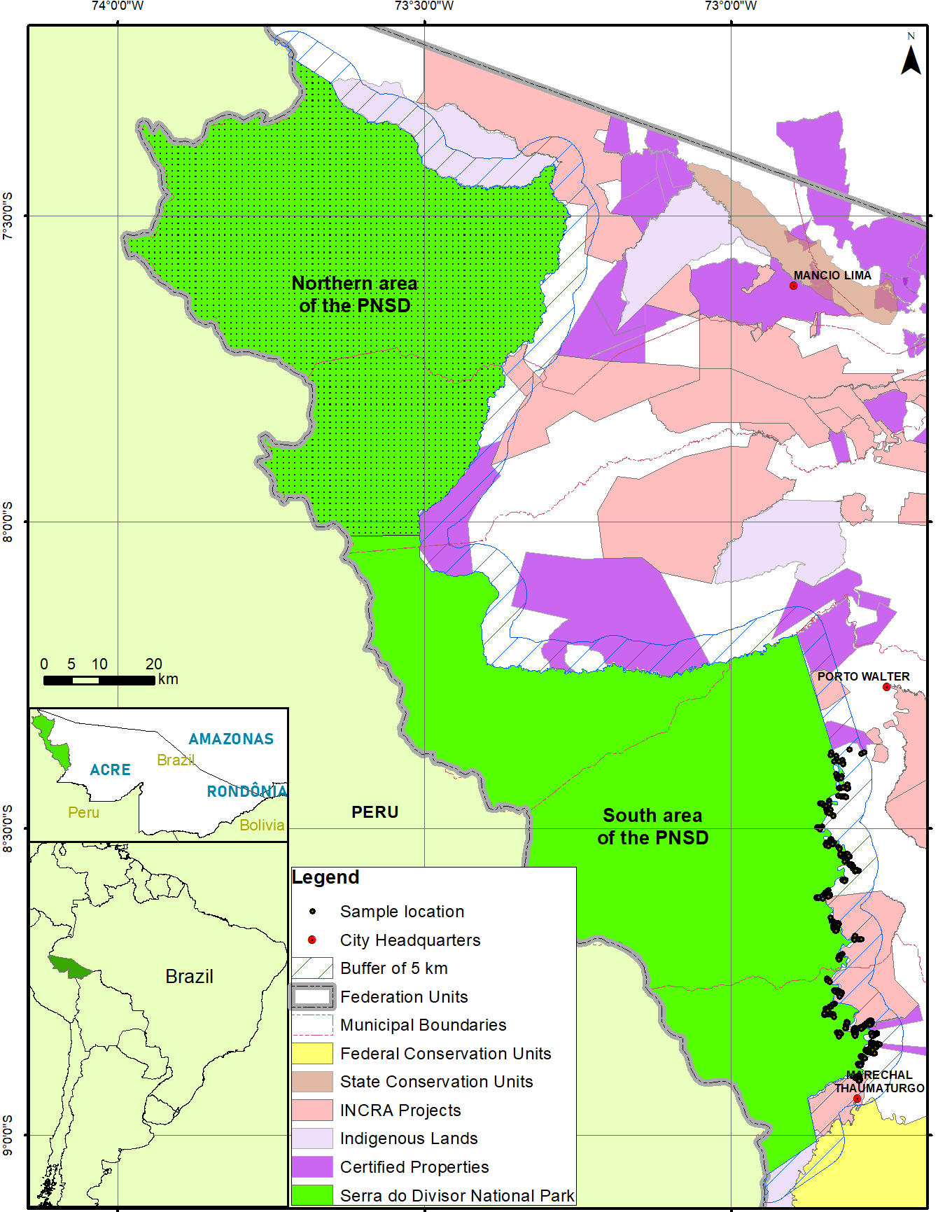
Figure S1. Location of samples (aerial photos) collected with the DJI Spark drone.

Adjustment of mapping land-use change
During the supervised classification process, adjustments were made in the sample collection between the land-use classes. This adjustment was based on the analysis of the product of the first classification with images with better spatial resolution (15 m) obtained through the fusion of the panchromatic band with red, near-infrared and short-wave infrared bands, both Landsat 8 bands. This product allowed the reevaluation of confusing classes, such as pasture, secondary vegetation and others. From this analysis, it was possible to adjust the collection of samples and improve our supervised classification.

