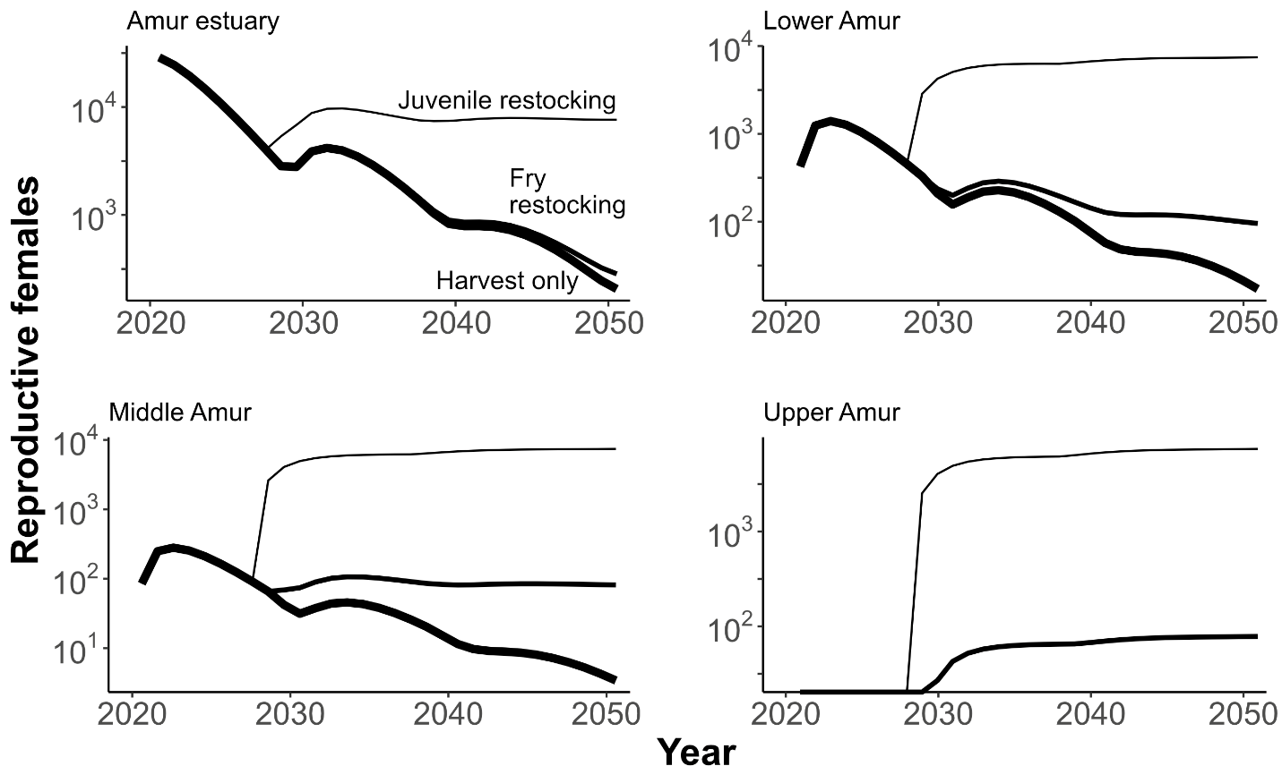 Figure S1—Sensitivity analyses testing the effects of reducing the annual rate of spawner harvest to 90% (from 95% in the baseline models).

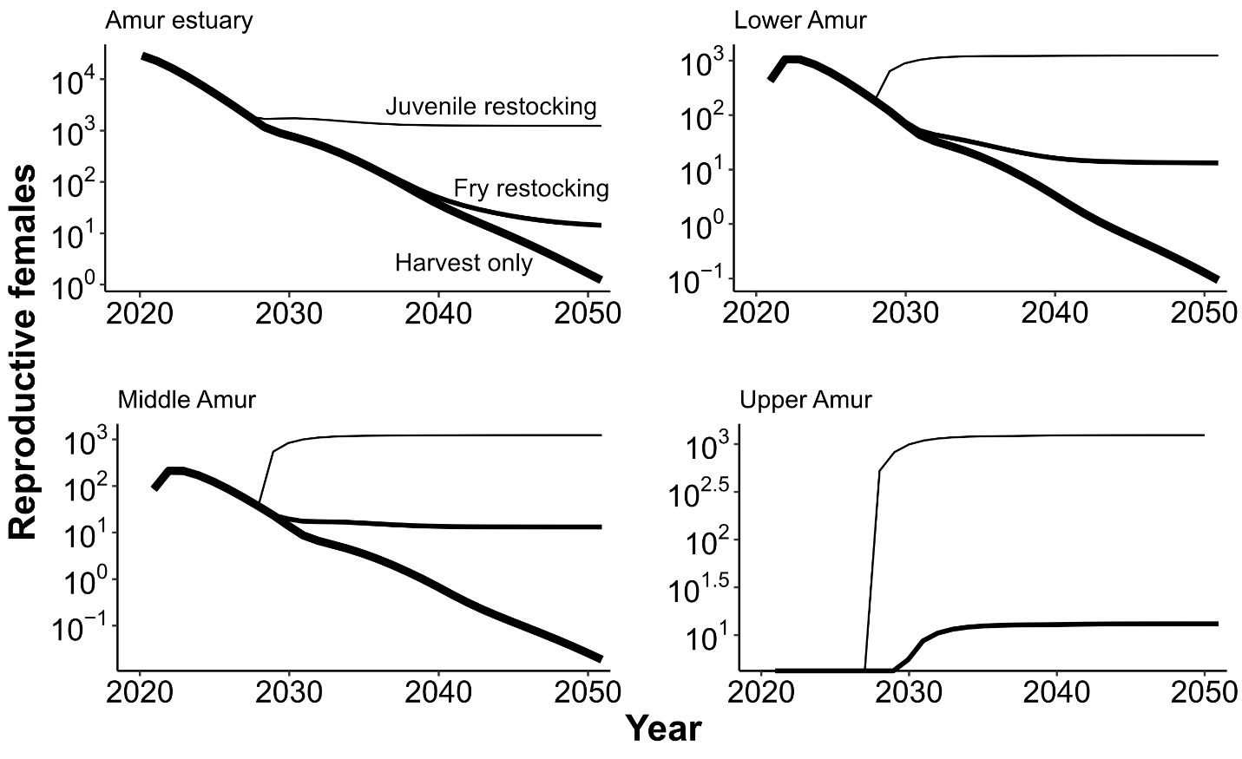
Figure S2—Sensitivity analyses testing the effects of reducing annual juvenile survival to 55% (from 67% in the baseline models).

