Appendix S1- Supplementary Material

Brazil’s Highway BR-319 shows crucial lack of environmental governance in Amazonia

M. B. T ANDRADE1 * L. FERRANTE1, P. M. FEARNSIDE2

1 Programa de Pós-Graduação, Instituto Nacional de Pesquisas da Amazônia (INPA),
Av. André Araújo, 2936, CEP 69067-375, Manaus, Amazonas, Brazil.
2 Instituto Nacional de Pesquisas da Amazônia (INPA), Av. André Araújo, 2936,
CEP 69067-375, Manaus, Amazonas, Brazil.

LEGAL INCONSISTENCIES
Bidding has been opened for one segment of Highway BR-319 (Lot ‘C’: kms
177.8 to 250. Note: BR-319’s km 0 is at the Manaus end of the Highway), even though
it lacks the Environmental Impact Study and Report (EIA/RIMA) that is required by
Brazilian legislation (Brazil, Justiça Federal da 1ª Região 2020, Ferrante & Fearnside
2020). In the case of another section (the ‘middle section’: kms 250.00 to 655.70) the
bidding has not yet been opened, but preparations for the start of the construction are
proceeding quickly despite the EIA/RIMA that has recently been prepared for this
section still being under analysis by licensing agency, the Brazilian Institute for the
Environment and Renewable Natural Resources (IBAMA). The EIA/RIMA must be
approved before either the bidding or the construction work can legally be done, but in
Brazil there is a long tradition of many laws being ignored or circumvented, especially
when powerful interests are involved (e.g., Rosenn 1971).
Neither of these segments could legally be constructed without consulting
affected indigenous peoples as required by ILO Convention 169 (ILO 1989) and the
corresponding Brazilian law (Decree No. 10,088, of 5 November 2019; formerly Decree
No. 5051, of 19 April 2004) (Brazil, PR 2004, 2019). These require the prior, free and
informed consent of Indigenous and Traditional Peoples, and this consent must be
obtained not only before the beginning the construction project itself but also before the
decision on whether or not the project should be built (e.g., Brazil, DNIT 2020, p. 27;
Fearnside 2020a, Ferrante et al. 2020). The project also lacks a Technical, Economic
and Environmental Feasibility Study (EVTEA), which is also legally required (Law 5917/1973 art. 3, paragraph i): Brazil, PR 1973, Brazil, TCU 2016, 2018).
Despite this scenario of legal inconsistencies and environmental risks the
deforestation and the building of illegal side roads are already occurring along the BR-
319 route, even in areas of traditional indigenous use (Fearnside et al. 2020a,b).
Political pressure to rebuild BR-319 is high, and interested parties argue (fallaciously)
that territorial governance would be able to contain the migration of illegal actors, such
as loggers, land grabbers (grileiros) and wildcat miners (garimpeiros).
A LAWLESS LAND
Migration of deforestation actors to the BR-319 area is occurring in synergy
with the lack of governance. This is particularly worrying along BR-319 because in
2018 gold miners in Humaitá (with the help of local politicians) set fire to the offices of
IBAMA and ICMbio (Farias 2018), once again showing a total lack of governance in
this part of Amazonia.

That same year and in the same municipality (county), migrants who settled
along the BR-319 in Realidade district were interviewed by the Folha de São Paulo
newspaper. One of the migrants indicated that, in addition to livestock, he had a forest-
management project with a license issued by the environmental agency of the state
government of Amazonas (IPAAM) and that he did not have a land title (Maisonnave &
Almeida 2018).
Even with clear problems of inspection and punishment of illegal actors. Brazil
is taking the opposite path, decreasing command-and-control in the Amazon. At the
president’s request, the Ministry of the Environment has punished IBAMA officials and
inspectors for carrying out repression measures on illegal mining in indigenous land
(Gonzales 2020).

Figure 1. Diagrammatic map of BR-319 with the administrative sections of the
highway and study site.
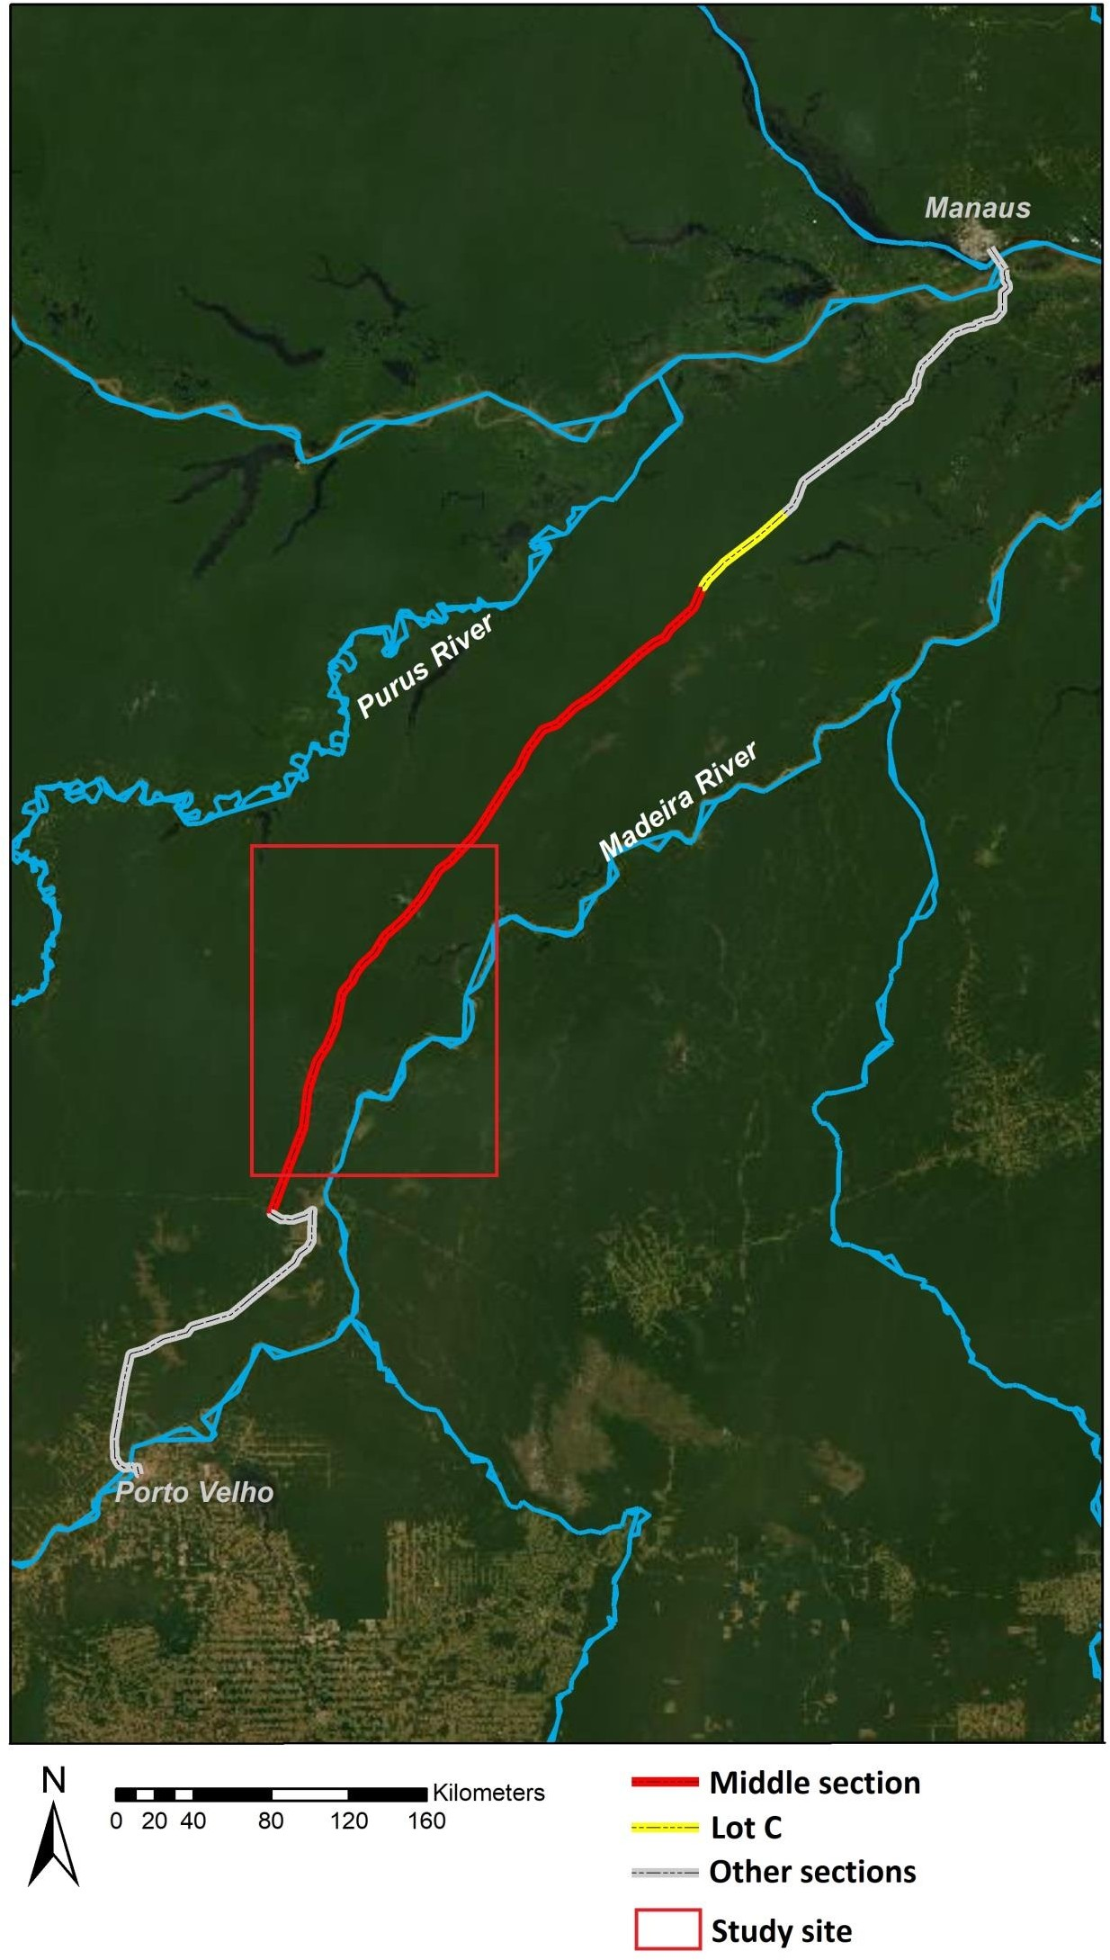
References

Brazil, DNIT (Departamento Nacional de Infraestrutura de Transportes) (2020) Estudo
do Componente Indígena CI Preliminar da Etnia 3 – Apurinã – Rev C. DNIT,
Brasília, DF. 173 pp. [www document]. URL https://bit.ly/2HSyc00
Brazil, Justiça Federal da 1ª Região (2020) Número: 1016749-49.2019.4.01.3200.
[www document]. URL https://bit.ly/2JhJgEI
Brazil, PR (Presidência da Republica) (1973) Lei No 5.917, de 10 de setembro de 1973.
PR, Brasília, DF, Brazil. [www document]. URL https://bityl.co/4G93
https://www.planalto.gov.br/ccivil_03/leis/l5917.htm
Brazil, PR (Presidência da Republica) (2004) Decreto No 5.051, de 19 de abril de 2004,
PR, Brasília, DF, Brazil. [www document]. URL
http://www.planalto.gov.br/ccivil_03/_ato2004-2006/2004/decreto/d5051.htm
Brazil, PR (Presidência da Republica) (2019) Decreto Nº 10.088, de 5 de novembro de
2019. PR, Brasília, DF, Brazil. [www document]. URL
http://www.planalto.gov.br/ccivil_03/_Ato2019-
2022/2019/Decreto/D10088.htm#art5
Brazil, TCU (Tribunal de Contas da União) (2016) Sumário: representação. Portaria
DNIT 1.562/2008. Autorização para dispensa de estudos de viabilidade técnica e
econômica em obras de infraestrutura. Determinações para correção das
irregularidades. TCU, Brasília, DF, Brazil. [www document]. URL
https://bit.ly/31WTKjd
Brazil, TCU (Tribunal de Contas da União). 2018. Sumário: pedido de reexame em
representação. Ilegalidade em portaria que dispensou a elaboração de estudo de
viabilidade técnica e econômica em obras do PAC do DNIT. Insuficiência dos
argumentos apresentados para modificar o aresto recorrido. Provimento parcial.
Prestar esclarecimentos. TCU, Brasília, DF, Brazil. [www document]. URL
https://bit.ly/37Zx71q

Farias E (2018) Prefeito de Humaitá e vereadores são presos por envolvimento em
ataque a prédios do Ibama e ICMBIo. Amazônia Real, 27 March 2018. [www
document]. URL https://amazoniareal.com.br/prefeito-de-humaita-e-vereadores-
sao-presos-por-envolvimento-em-ataque-a-predios-do-ibama-e-icmbio/

Fearnside PM (2020a) BR-319 – O começo do fim para a floresta amazônica brasileira.
Amazônia Real, 6 October 2020. https://amazoniareal.com.br/br-319-o-comeco-
do-fim-para-a-floresta-amazonica-brasileira-06-10-2020/
Fearnside PM (2020b) Oil and gas project threatens Brazil’s last great block of Amazon
forest (commentary). Mongabay, 9 March 2020. [www document]. URL
https://news.mongabay.com/2020/03/oil-and-gas-project-threatens-brazils-last-
great-block-of-amazon-forest-commentary/
Fearnside PM, Ferrante L, de Andrade MBT (2020a) BR-319 illegal side road threatens
Amazon protected area, indigenous land (commentary). Mongabay, 27 March
2020. [www document]. URL https://news.mongabay.com/2020/03/br-319-
illegal-side-road-threatens-amazon-protected-area-indigenous-land-commentary/
Fearnside PM, Ferrante L, Yanai AM, Isaac Júnior MA (2020b). Região Trans-Purus, a
última floresta intacta. Amazônia Real, 24 August -21 September 2020. [www
document]. URL https://bit.ly/3jTtr3X
Ferrante L, Fearnside PM (2020) The Amazon road to deforestation. Science 369: 634.
https://doi.org/10.1126/science.abd6977
Ferrante L, Gomes M, Fearnside PM (2020) Amazonian indigenous peoples are
threatened by Brazil’s Highway BR-319. Land Use Policy 94: art. 104548. https://doi.org/10.1016/j.landusepol.2020.104548

Gonzales J (2020) Brazil sacks officials who curbed deforestation on amazon
indigenous lands. Mongabay, 5 May 2020.
https://news.mongabay.com/2020/05/brazil-sacks-officials-who-curbed-
deforestation-on-amazon-indigenous-lands/#

ILO (International Labour Organization) (1989) C169 - Indigenous and Tribal Peoples
Convention, 1989 (No. 169). ILO, Geneva, Switzerland. https://bit.ly/34KymzN

Maisonnave F, Almeida L (2018) Estrada que liga Manaus ao resto do país ameaça abrir
uma Alemanha na mata. Folha de São Paulo, 4 September 2018. [www
document]. URL https://bit.ly/3oJvcnE

Matricardi EAT, Skole DL., Costa OB, Pedlowski MA, Samek JH, Miguel EP (2020)
Long-term forest degradation surpasses deforestation in the Brazilian Amazon. Science 369: 1378–1382. https://doi.org/10.1126/science.abb3021

Rosenn KS (1971) The jeito: Brazil’s institutional bypass of the formal legal system and
its development implications. American Journal of Comparative Law 19: 514-549. https://doi.org/10.2307/839559

