Supplementary Information

Figures
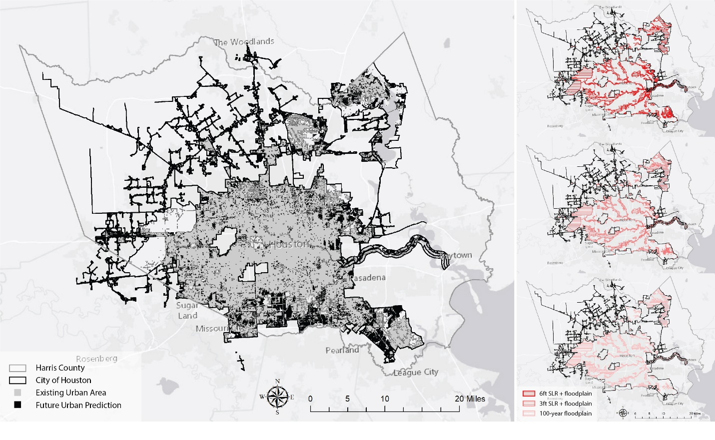
Figure S1: Future urban development prediction and flood risk scenarios (100-year floodplain, 3ft & 6ft SLR).

Figure S2: Ranking of watershed vacancy and flood risk.

Tables

Table S1: Top-10 HUC 12 watersheds in the study area based on selection criteria
Watershed | Watershed Area  (1,000 sqm) | Vacant Area  (1,000 sqm) | Predicted Development Area  (1,000 sqm) | Wetland Area  (1,000 sqm) | Floodplain Area  (1,000 sqm) | Flood claim Amount  (1,000 $) | Land Cost  (1,000 $) | Raw Score
Clear Creek | 4,236,212 | 17,795 | 42,564 | 1,291,197 | 103,045, | 788,776 | 79,799 | 242
Keegan | 1,952,547 | 3,307 | 14,537 | 595,136 | 610,292 | 738,724 | 175,842 | 225
Bens Branch | 1,170,179 | 1,144 | 15,483 | 356,670 | 42,295 | 453,920 | 23,689 | 222
Halls | 1,448,053 | 2,053 | 10,358 | 441,366 | 32,673 | 248,018 | 22,496 | 206
Cole Creek | 1,433,977 | 2,648 | 12,019 | 437,076 | 25,417 | 212,362 | 59,080 | 199
Turkey Creek | 1,560,420 | 1,250 | 5,636 | 475,616 | 20,758 | 281,746 | 12,789 | 194
South Mayde | 1,230,293 | 2,334 | 2,103 | 374,993 | 57,810 | 70,862 | 4,384 | 192
Upper Greens | 1,136,353 | 5,776 | 7,494 | 346,360 | 32,409 | 161,766 | 43,931 | 191
Lower Sims | 1,384,272 | 1,983 | 18,041 | 421,926 | 16,035 | 186,934 | 31,505 | 186
Hunting | 1,137,477 | 3,145 | 14,728 | 346,703 | 18,720 | 119,213 | 42,465 | 185

Table S2. Summary statistics of sample vacant sites
Measure | Min | Max | Sum | Mean | SD
Parcel Area (square meters) | 387.00 | 137,377.00 | 910,954.00 | 36,438.00 | 37,632.00
Distance to Nearest Flood claim (meters) | 80.00 | 696.00 | 8,510.00 | 380.00 | 186.36
Wetland distance (meters) | 0.00 | 150.43.00 | 755.01 | 30.20 | 39.70
Park distance (meters) | 618.33 | 1,90.56 | 30,276.27 | 1,211.05 | 287.46
Protected Areas (meters) | 612.45 | 1,582.48 | 30,091.88 | 1,203.68 | 288.42
Number of Proposed Residential | 0.00 | 205.00 | 1,103.00 | 44.12 | 50.72

