SUPPLEMENTARY MATERIAL
Statistical analysis
Benthic predictors of sea urchin abundance
We used the dataset resulting from the 21 reef site survey to analyse abiotic and biotic habitat predictors of sea urchin abundance at the scale of the survey replicates (n = 168). We expected urchin abundance to be predicted by six biotic and abiotic variables measured at the replicate scale and one measured at the site scale (Table 1). We also included one ecologically sensible two-way interaction between macroalgae and structural complexity which has yielded pertinent results in previously published work resulting from the same surveys (Dajka et al. 2019). We recorded ‘reef type’ as a categorical variable with three reef types: carbonate, patch, and granite. After isolating the influence of each reef type on urchin abundance during data exploration, patch reefs stood out as most influential while carbonate and granite reefs showed comparable effects. Given our number of observations (n = 168), we replaced ‘reef type’ with a binary dummy variable that isolates the patch reef type and groups carbonate and granitic reef types to reduce our covariates to a number that can be sensibly interpreted. Our chosen variables did not present problematic variance inflation factors (Table 1), indicating that our model was not biased by collinearity issues (Zuur et al. 2009). We scaled variables to a mean of 0 and standard deviation of 1, allowing for meaningful comparisons of effect sizes when variables are on different scales (e.g. structural complexity vs. reef type) (Schielzeth 2010). To account for overdispersion and high frequencies of true zeros in our response variable (45.8 %), we fitted a zero-inflated negative binomial (ZINB) regression, a two-part model that fits two distributions to the data (Zuur, Saveliev & Ieno 2012). The first part fits a binomial distribution to the full dataset, treating the response variable as presence-absence (i.e. 0 urchins or 1 urchin, zero component). The second part fits a negative binomial distribution to all response data excluding true zeros (i.e. > 1 urchin, count component). We initially used a zero-inflated model with ‘site’ as a random factor using the glmmTMB-package (Brooks et al. 2017) and one without a random effect using the ‘pscl’-package (Zeileis, Kleiber & Jackman 2008). Model selection based on the Akaike Information Criterion (AIC, Zuur et al. 2009) determined the latter model as better performing, suggesting that auto-correlation did not bias our parameter estimates. Backwards selection based on AIC (Table 2) excluded three variables (‘coral’, ‘herbivorous fish biomass’, ‘invertivorous fish biomass’) resulting in the final model:
$$Sea urchin abundance \sim Macroalgae+Complexity+Patch reef type+Macroalgae*Complexity$$
During model validation, we found no alarming patterns in the model’s residuals apart from the clustering in the model’s zero component, which is expected with zero-inflated models (Zuur, Saveliev & Ieno 2012). To visualise the relationships between predicted urchin abundance across the observed range of each individual variable in our ZINB model, we held all other variables to constant means of 0 (Schielzeth 2010).
Experimental sea urchin penning
To analyse effects of ‘urchin stocking density’ and ‘time’ (fixed effects), we fitted generalised linear mixed models (GLMM) to our response variable ‘macroalgae cover’ using the lme4-package in R (Bates et al. 2015). The model was fitted with ‘plot’ as a random effect to address dependencies induced by repeated measures through time (Zuur, Ieno & Elphick 2010). We used macroalgal cover as a binary response variable (1 = macroalgae, 0 = no macroalgae) with each randomly allocated point in our HD-photographs being one observation (n = 50 per photo, n = 1950 in total), these points being averaged to give one macroalgal cover value per pen. We fitted a GLMM using a Gamma distribution and the following formula:
$Macroalgae cover \sim Urchin stocking density *Time+\left(1 \right| Plot)$
The plots of the GLMMs’ residuals did not show any alarming clustering or patterns and therefore suggest good model fits. Subsequently, we used a pair-wise comparison Tukey post-hoc test using the emmeans-package in R (Lenth et al. 2019).
All analyses were conducted in R version 3.5.3 (R-Core-Team 2019). We provide our R-scripts and dataset at an open source repository (https://github.com/JanDajka/SeyUrchins-2018).

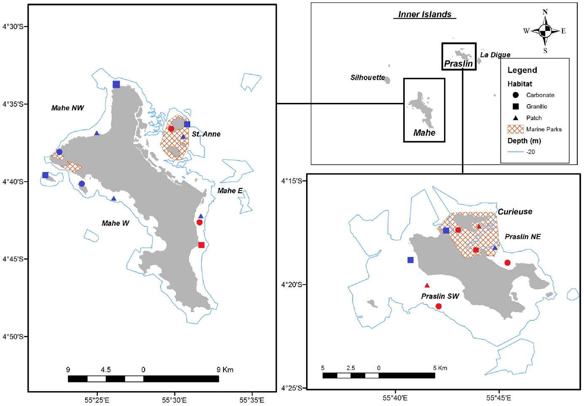
Supplementary Figure S1. Map of Seychelles showing 21 study sites categorised into previous categorisations regime shifted to macroalgal dominance (red) and recovering (blue) from the 1998 bleaching event, and study site of 2018 penning study: red triangle at south-west Curieuse; adapted from Graham et al. (2015).

Supplementary table 1. Generalised linear mixed model summary.
Generalized linear mixed model fit by maximum likelihood (Laplace Approximation)
Family: Gamma ( inverse ), Formula: macroalgae ~ time * stocking density + (1 | plot)
Fixed effects | Estimate | Standard error | t-value | p-value
Intercept | 0.0108 | 0.0004 | 25.214 | <0.001
Time week 3 | 0.0016 | 0.0006 | 2.35 | 0.019
Time week 6 | 0.0031 | 0.0007 | 4.32 | <0.001
Stocking density 4 | 0.0016 | 0.0007 | 2.44 | 0.015
Stocking density control | 0.0018 | 0.0008 | 2.25 | 0.025
Time week 3 * stocking density 4 | -0.0024 | 0.0009 | -2.46 | 0.014
Time week 6 * stocking density 4 | -0.0029 | 0.001 | -2.84 | 0.004
Time week 3 * stocking density control | -0.0024 | 0.0011 | -2.166 | 0.03
Time week 6 * stocking density control | -0.0036 | 0.0012 | -3.062 | 0.002

Supplementary table 2. Tukey HSD results for significant differences in macroalgal cover between individual experiment weeks and urchin stocking densities.
Tukey multiple comparisons of means, 95% family-wise confidence level
Comparison | Estimate | Standard error | Z-ratio | p-value
10 urchins week 1 - 10 urchins week 3 | 1.0812 | 0.352 | 3.074 | 0.0543
10 urchins week 1 - 10 urchins week 6 | 1.4802 | 0.345 | 4.293 | <0.001
4 urchins week 1 - 4 urchins week 3 | -0.4028 | 0.315 | -1.277 | 0.9382
4 urchins week 1 - 4 urchins week 6 | 0.1710 | 0.299 | 0.572 | 0.9997
Control week 1 - control week 3 | -0.4223 | 0.402 | -1.050 | 0.9808
Control week 1 - control week 6 | -0.2414 | 0.395 | -0.611 | 0.9996

