Supplementary material

Table S1. Glossary
Betweenness centrality | Measures the extent to which a node lies on non-redundant geodesic paths between other nodes (Freeman 1979). It refers to the proportion of all paths linking nodes j and k passing through nodes i equals to the sum of all paths jk.
Degree | For non-directed networks, equals the sum of the number of links that a node has. In contrast, for directed networks, this metric has two components: outdegree is the sum of links that a node extend outwards and indegree is the sum of links that a node receive (Wasserman and Faust 1994).
Density | The ratio of the number of observed links between the maximum possible numbers of links; can range from 0 to 1, where 0 corresponds to an empty network and 1 to a network with the maximum degree of saturation (Wasserman and Faust 1994). The density denotes social cohesion and overall network activity.
Eigenvector centrality | Defines the prominence of each node as proportional to the sum of the centralities of its neighbors (Bonacich 2007).
Ecological link | Ecological interactions that are “defined through assumptions of how the ecological nodes can affect each other; e.g., species dispersal, flow of contaminants/invasive species, conflicting or synergistic uses of common resources, etc.” (Bodin et al. 2019).
Ecological node | “Ecological components of relevance given the environmental problem under consideration. A relevant ecological node could be a well-delimited resource, for example forest patches, ecosystem management units, water bodies, etc.” (Bodin et al. 2019).
Ecosystem process | “Changes in the stocks and flows of materials in an ecosystem, resulting from interactions between organisms and with their physical-chemical environment” (Mace et al. 2012).
Ecosystem service | “Activity or function of an ecosystem that provides benefits (or disbenefit) to humans. Final ecosystem services deliver welfare gains or losses to people” (Mace et al. 2012).
Ejido | Lands under a federally supported system of communal and social land tenure (Procuraduría Agraria 2009).
Horizontal fit | Describes how well social and ecological network ties are aligned across the layers (Bodin 2017).
Krackhardt’s connectedness | Defined as 1-[V/N*(N-1)/2], which is the total number of dyads that are not mutually reachable (V) divided by the maximum number of possible dyad combinations: N*(N-1)/2 (Krackhardt 1994).
Link | A multiset of relationships among nodes, such as collaboration (Lazega & Pattison 1999).
Node | A fixed set of entities that constitute a network, such as stakeholders (Wasserman & Faust 1994)
Fit/misfit | According to Guerrero et al. (2015), “in order to manage the natural environment effectively, the governance system must fit, or align with, the characteristics of the biophysical system. The extent to which this does not occur is referred to as the problem of fit”.  For Bodin (2017), social-ecological fit implies that the structure of a collaborative network (the actors and their collaborative ties) should be aligned with the structures of the biophysical (ecological) system. The social and the ecological systems are represented as separate but interconnected network layers.
Multilevel governance | Mechanism in which power is shared between tiers of government and with non-state actors, including international bodies, NGOs, community groups and private corporations (Haussman et al. 2010 in McNaughton & Lockie 2017). In environmental literature it is often used to emphasize the transfers of power and responsibility to a variety of stakeholders and scales of governance that do not fit typical government administrative boundaries (Marshall, 2008; Lockwood et al. 2009; Pahl-Wostl et al. 2010; Daniell et al. 2011 in McNaughton & Lockie 2017). In several contexts, the concept tends to refer to systems of governance where there is a dispersion of authority upwards, downwards and sideways between levels of government–local, regional, national and supra-national–as well as across spheres and sectors, including states, markets and civil society.
Social-ecological links | According to Bodin et al. (2019), “Interdependencies that are assumed to be important in understanding and theorizing the environmental problem under consideration e.g. property rights, occupancy, mandates/responsibilities, resource harvest/dependence, energy acquisition, ecosystem service utilization, etc.”
Social-ecological networks | Structures with at several levels and two different types of nodes. One level represents the stakeholders and their relationships, a second level the ecological entities as nodes and their interdependencies as links, and the third level interactions as links across these levels. These are the social-ecological interactions of various kinds, which occur between the stakeholders and the ecological nodes (Alexander et al. 2017).
Social links | According to Bodin et al. (2019), “Social interactions that represent different forms of working together”; for example, collaboration, information exchange, trust, etc. and also “negative links such as antagonism and avoidance behaviors”.
Social node | According to Bodin et al. (2019), “An individual, household, an organization or institution can be represented as a node”. A group of stakeholders of relevance given the social-ecological system.
Vertical fit | Describes how the different social and ecological layers are interconnected (Bodin 2017).

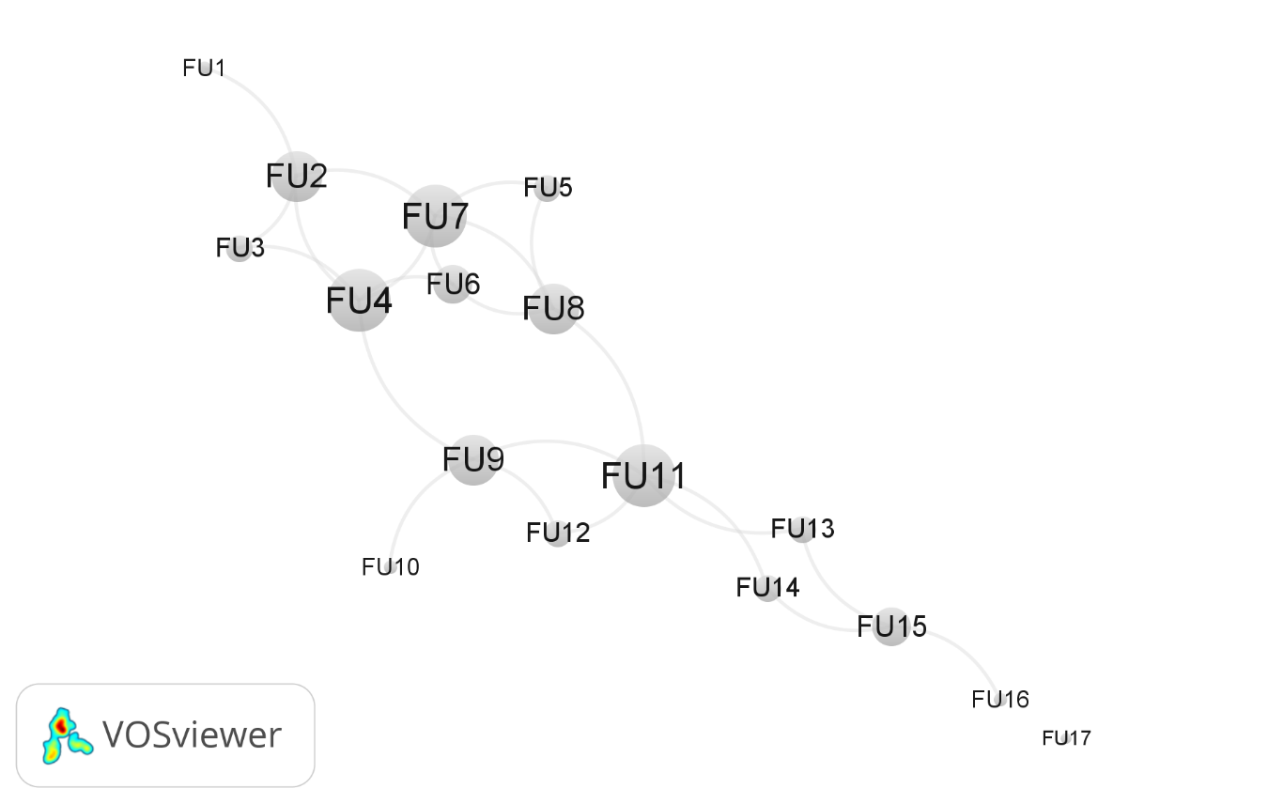
Figure S2. Visualization of the forest unit ecological connectivity network. The circles represent forest units, and the lines ecological connections, the size of the nodes represents the degree.

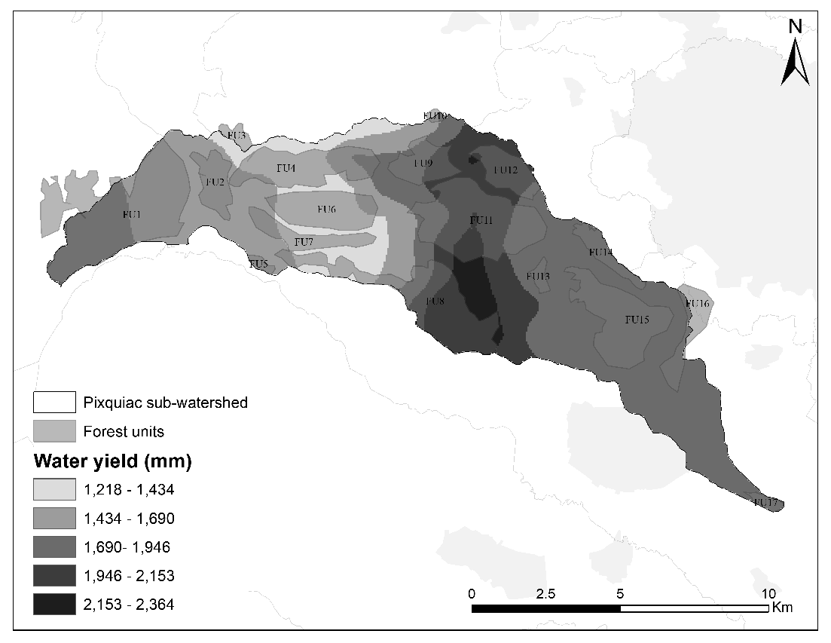
Figure S3. Superposition of forest units and water yield model of InVEST, The water yield is concentrated in forest units located in the middle part of the Pixquiac sub-watershed: FU12, FU11, FU8 and FU9.

Table S2. Network properties of stakeholders in Pixquiac’s local PES collaboration network.
Label | Indegree | Outdegree | Cluster | Betweeness centrality | Eigenvector centrality
NGOA1 | 32 | 24 | 1 | 0.159705 | 1
NGOA2 | 27 | 23 | 0 | 0.116905 | 0.870001
NGOA5 | 26 | 13 | 0 | 0.059466 | 0.833572
GOVB1 | 18 | 16 | 2 | 0.046877 | 0.66822
GOVD1 | 17 | 13 | 2 | 0.037725 | 0.582764
GOVA1 | 10 | 20 | 1 | 0.031691 | 0.423185
NGOA4 | 17 | 12 | 1 | 0.029597 | 0.608304
GOVC1 | 12 | 15 | 2 | 0.029388 | 0.489276
LAOW3 | 10 | 16 | 1 | 0.02599 | 0.408001
EDUA1 | 18 | 10 | 0 | 0.024181 | 0.621866
LAOW11 | 11 | 9 | 1 | 0.020377 | 0.486898
EDUB3 | 13 | 12 | 2 | 0.018439 | 0.465512
NGOB1 | 12 | 12 | 0 | 0.018086 | 0.372084
NGOE1 | 12 | 13 | 0 | 0.015242 | 0.463779
NGOF1 | 9 | 10 | 2 | 0.013753 | 0.326418
GOVA2 | 12 | 13 | 1 | 0.013305 | 0.499761
GOVF1 | 11 | 13 | 0 | 0.010803 | 0.443835
GOVC2 | 9 | 13 | 1 | 0.009824 | 0.412447
NGOB2 | 4 | 11 | 1 | 0.008997 | 0.126351
LAOW7 | 11 | 8 | 1 | 0.008962 | 0.372929
NGOD2 | 9 | 9 | 2 | 0.008198 | 0.247236
LAOW1 | 11 | 6 | 2 | 0.006962 | 0.414728
ENCB1 | 5 | 8 | 2 | 0.004945 | 0.243412
LAOW9 | 5 | 7 | 1 | 0.004935 | 0.229972
LAOW6 | 6 | 5 | 1 | 0.004171 | 0.270663
NGOA3 | 3 | 12 | 0 | 0.004146 | 0.148261
LAOW8 | 7 | 7 | 2 | 0.004094 | 0.243259
GOVA3 | 7 | 6 | 0 | 0.00365 | 0.247413
LAOW4 | 3 | 9 | 1 | 0.003508 | 0.082505
NGOC2 | 8 | 6 | 0 | 0.003266 | 0.29813
LAOW2 | 6 | 7 | 2 | 0.002396 | 0.199765
EDUB2 | 8 | 5 | 2 | 0.002323 | 0.282405
LAOW10 | 7 | 6 | 1 | 0.002298 | 0.239489
ENCA1 | 4 | 9 | 0 | 0.001991 | 0.218306
EDUB1 | 6 | 7 | 0 | 0.001288 | 0.270445
NGOC1 | 6 | 5 | 0 | 0.000776 | 0.269522
LAOW5 | 7 | 0 | 1 | 0 | 0.251465
NGOD1 | 0 | 9 | 0 | 0 | 0

Table S3. Centrality scores of forest units in Pixquiac’s ecological network.
Forest unit | Degree | Cluster | Betweeness centrality | Eigenvector centrality
FU11 | 5 | 2 | 0.420833 | 0.650591
FU9 | 4 | 2 | 0.283333 | 0.605836
FU4 | 5 | 0 | 0.238889 | 0.959096
FU8 | 4 | 1 | 0.195833 | 0.789232
FU2 | 4 | 0 | 0.127778 | 0.708798
FU7 | 5 | 1 | 0.122222 | 1
FU15 | 3 | 3 | 0.120833 | 0.182804
FU13 | 2 | 3 | 0.1 | 0.252192
FU14 | 2 | 3 | 0.1 | 0.252192
FU6 | 3 | 1 | 0.006944 | 0.745098
FU1 | 1 | 0 | 0 | 0.193315
FU3 | 2 | 0 | 0 | 0.453895
FU5 | 2 | 1 | 0 | 0.484517
FU10 | 1 | 2 | 0 | 0.172473
FU12 | 2 | 2 | 0 | 0.361492
FU16 | 1 | 3 | 0 | 0.063173
FU17 | 0 | 4 | 0 | 0

References
Alexander SM, Armitage D, Carrington PJ, Bodin Ö (2017) Examining horizontal and vertical social ties to achieve social–ecological fit in an emerging marine reserve network. Aquatic Conservation: Marine and Freshwater Ecosystems 27: 1209–1223.
Bodin Ö et al. (2019) Improving network approaches to the study of complex social–ecological interdependencies. Nature Sustainability 2: 551–559
Bodin Ö (2017) Collaborative environmental governance: Achieving collective action in social-ecological systems. Science 357:eaan1114.
Bonacich P (2007) Some unique properties of eigenvector centrality. Social networks 29: 555–564
Freeman L (1979) Centrality in social networks conceptual clarification. Social networks 1:215-239.
Guerrero AM, Mcallister RRJ, Wilson KA (2015) Achieving Cross-Scale Collaboration for Large Scale Conservation Initiatives. Conservation Letters 8: 107–117.
Krackhardt D (1994) Graph theoretical dimensions of informal organizations. In: Computational Organization Theory, eds. M Carley, K Prietula, pp. 89–111. New Jersey, USA: Lawrence Erlbaum Associates.
Lockwood M, Davidson J, Curtis A, Stratford E, Griffith R. (2009) Multi-level Environmental Governance: Lessons from Australian natural resource management. Australian Geographer 40: 169–186
Mace GM, Norris K, Fitter AH (2012). Biodiversity and ecosystem services: a multilayered relationship. Trends in ecology & evolution 27: 19-26.
Marshall GR (2008) Nesting, Subsidiarity, and Community-Based Environmental Governance beyond the Local Level. International Journal of the Commons 2: 75
McNaughton A, Lockie S (2017) Private Actors in Multi-level Governance: GLOBAL G.A.P. Standard-setting for Agricultural and Food Products.
Pahl-Wostl C, Holtz G, Kastens B, Knieper C (2010) Analyzing complex water governance regimes: The Management and Transition Framework. Environmental Science and Policy 13: 571–581
Procuraduría Agraria (2009) Glosario de términos jurídico-agrarios. URL http://www.pa.gob.mx/pa/conoce/publicaciones/Glosario%202009/GLOSARIO%20DE%20TÉRMINOS%20JURÍDICO-AGRARIOS%202009.pdf
Wasserman S, Faust K (1994) Social Network Analysis: Methods and Applications. Cambridge University Press.

