Supplementary File 2: Anonymized Screenshots of Detected Facebook Wildlife Selling Posts

Supplementary Figure 1: Examples of Wildlife Trading Posts on Facebook (Image modified)
Figure 1 (1) an advertisement selling live turtle; (2) a post selling carved ivory; (3) a post selling a bracelet made by pantholops hodgsonii horn; (4) a post selling bracelet made from hawksbill shell; (5) a post selling tiger bone, tiger tooth, rhino horn, cartialgenous, wolf tooth, bear gall, pangolin, and elephant ivory, advertised with Chinese-language text and contact information in image.

Supplementary Figure 2: Example of Facebook User “Auction” for Wildlife Product (Image Modified)

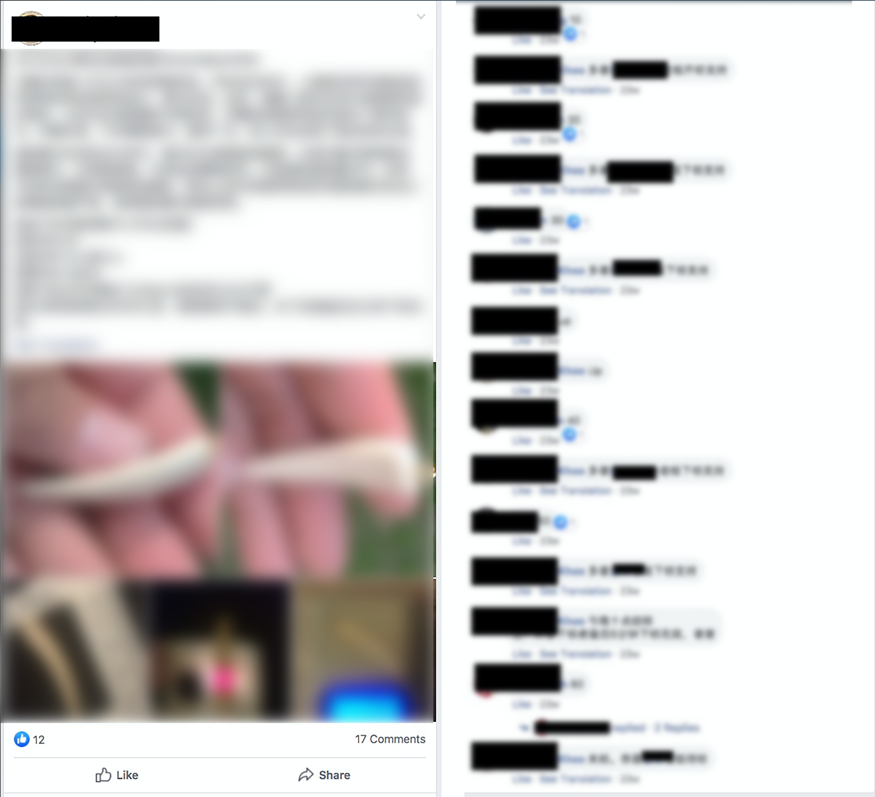

Figure 2: A Facebook elephant ivory product selling post was detected in a public group page. The seller is trying to use different photos to show the clear Schreger lines, weight of the product and the results of infrared testing. The seller uses this approach to authenticate product and solicit bids via the comments section from other group members until a transaction is completed.

