Supplementary Figure 1. Richness of invasive alien plant species (IAPS/100m²) in each survey plot along roadside and in grids

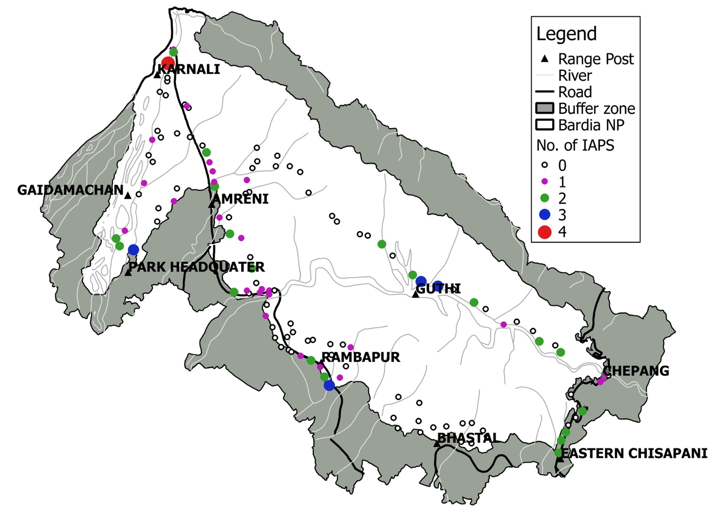

Supplementary Figure 2. Species composition variation between non-invaded and invaded plots. The diagram was obtained from Canonical Correspondence Analysis (CCA) considering quadrat type as environmental variable. The length of the gradient was 4.1621 which was greater than 2.5 s.d. unit, therefore data was analyzed by CCA. Complete names of the species can be found in Supplementary table 1.

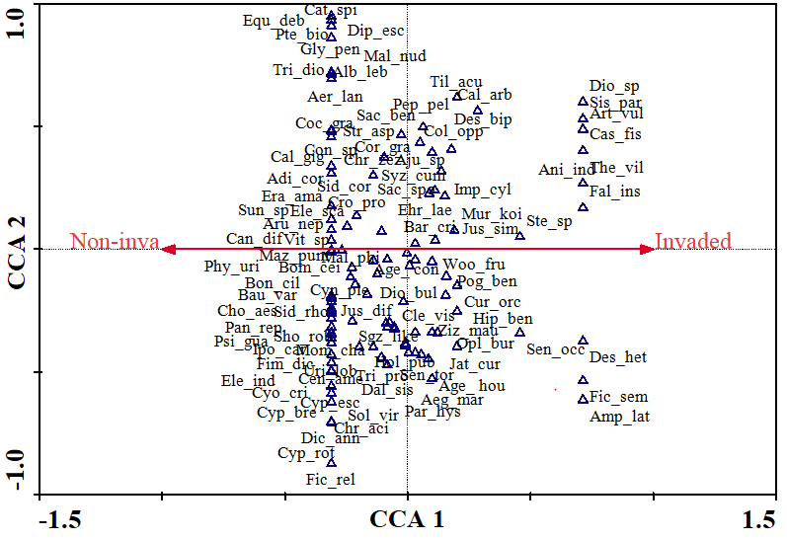

Supplementary table 1. Checklist of species recorded in quadrats sampled for impact assessment.

S.N | Name of species | Family | Abbreviation | Life form | Status
1 | Adina cordifolia (Roxb.) Brandis | Rubiaceae | Adi.cor | Herb | Native
2 | Aegle marmelos (L.) Correa | Rutaceae | Aeg.mar | Tree | Native
3 | Aerva lanata (L.) Juss | Amaranthaceae | Aer.lan | Herb | Native
4 | Ageratum conyzoides L. | Asteraceae | Age.con | Herb | Invasive
5 | Ageratum houstonianum Mill. | Asteraceae | Age.hou | Herb | Invasive
6 | Ajuga sp. | Lamiaceae | Aju.sp | Herb | Native
7 | Albizia lebbeck (L.) Benth | Fabaceae | Alb.leb | Tree | Native
8 | Ampelocissus latifolia (Roxb.) Planch. | Vitaceae | Amp.lat | Climber | Native
9 | Anisomeles indica (L.) Kuntze | Lamiaceae | Ani.ind | Herb | Native
10 | Artemisia vulgaris L. | Asteraceae | Art.vul | Herb | Native
11 | Arundinella nepalensis Trin. | Poaceae | Aru.nep | Herb | Native
12 | Barleria cristata L. | Acanthaceae | Bar.cri | Herb | Native
13 | Bauhinia variegata L. | Fabaceae | Bau.var | Tree | Native
14 | Bombax ceiba L. | Malvaceae | Box.cei | Tree | Native
15 | Bonnaya ciliate subsp. ciliata | Linderniaceae | Bon.cil | Herb | Native
16 | Callicarpa arborea Roxb. | Lamiaceae | Cal.arb | Shrub | Native
17 | Calotropis gigantea (L.) W.T. Aiton | Apocynaceae | Cal.gig | Herb | Native
18 | Canscora diffusa (Vahl) R. Br. ex Roem. & Schult. | Gentinaceae | Can.dif | Herb | Native
19 | Cassia fistula L. | Fabaceae | Cas.fis | Tree | Native
20 | Catunaregam spinosa (Thunb.) Tirveng | Rubiaceae | Cat.spi | Herb | Native
21 | Cenchrus americanus (L.) Morrone | Poaceae | Cen.ame | Herb | Native
22 | Chrysopogon aciculatus (Retz) Trin. | Poaceae | Chr.aci | Herb | Native
23 | Chrysopogon zizanioides (L.) Roberty | Poaceae | Chr.ziz | Herb | Native
24 | Cissampelos pareira L. | Menispermaceae | Cis.par | Climber | Native
25 | Clerodendrum infortunatum L. | Lamiaceae | Cle.inf | Shrub | Native
26 | Coccinia grandis (L.) Voigt | Cucurbitaceae | Coc.gra | Climber | Naturalized non-invasive
27 | Colebrookea oppositifolia Sm. | Lamiaceae | Col.opp | Shrub | Native
28 | Combretum roxburghii Spreng. | Combretaceae | Com.rox | Tree | Native
29 | Conyza sp. | Asteraceae | Con. | Herb | Native
30 | Corchorus aestuans L. | Malvaceae | Cor.aes | Herb | Naturalized non-invasive
31 | Cordia grandis Roxb. | Ehretiaceae | Cor.gra | Tree | Native
32 | Crotalaria prostrata Willd. | Fabaceae | Cro.pro | Herb | Native
33 | Cryptolepis buchananii Schultes ex Roemer and schultes | Apocynaceae | Cry.buc | Climber | Native
34 | Curculigo orchioides Gaertn. | Hypoxidaceae | Cur.orc | Herb | Native
35 | Curcuma aromatica Salisb. | Zingiberaceae | Cur.aro | Herb | Native
36 | Cyanotis cristata (L.) D. Don. | Commelinaceae | Cya.cri | Herb | Native
37 | Cynodon dactylon (L.) Pers. | Poaceae | Cyn.dac | Herb | Native
38 | Cynodon plectostachyus (K.Schum.) Pilg. | Poaceae | Cyn.ple | Herb | Native
39 | Cynoglossum zeylanicum (Vahl) Thunb. ex Lehm. | Boraginaceae | Cyn.zey | Herb | Native
40 | Cyperus brevifolius (Rottb.) Hassk. | Cyperaceae | Cyp.bre | Herb | Native
41 | Cyperus esculentus L. | Cyperaceae | Cyp.esc | Herb | Native
42 | Cyperus rotundus L. | Cyperaceae | Cyp.rot | Herb | Native
43 | Dalbergia sissoo DC. | Fabaceae | Dal.sis | Herb | Native
44 | Desmodium gangeticum (L.) DC. | Fabaceae | Des.gan | Herb | Native
45 | Desmodium heterophyllum (Willd.) DC. | Fabaceae | Des.het | Herb | Native
46 | Desmodium triflorum (L.) DC. | Fabaceae | Des.tri | Herb | Native
47 | Desmostachya bipinnata (L.) Stapf | Poaceae | Des.bip | Herb | Native
48 | Dichanthium annulatum (Forssk.) Stapf | Poaceae | Dic.ann | Herb | Native
49 | Digitaria ciliaris (Retz.) Koeler | Poaceae | Dig.cil | Herb | Native
50 | Dioscorea bulbifera L. | Dioscoreaceae | Dio.bul | Climber | Native
51 | Dioscorea sp. | Dioscoreaceae | Dio.sp | Climber | Native
52 | Diplazium esculentum (Retz.) Sw. | Athyriaceae | Dip.esc | Herb | Native
53 | Ehretia laevis (Rottler ex G. Don) Roxb. | Ehretiaceae | Ehr.lae | Tree | Native
54 | Elephantopus scaber L. | Asteraceae | Ele.sca | Herb | Native
55 | Eleusine indica (L.) Gaertn. | Poaceae | Ele.ind | Herb | Native
56 | Equisetum ramosissimum subsp. debile (Roxb. ex Vaucher) Hauke | Equisetaceae | Equ.deb | Herb | Native
57 | Eragrostis amabilis (L.) Wight and Arn Beauv. ex Roem. & Schult. | Poaceae | Era.ama | Herb | Native
58 | Euphorbia hirta L. | Euphorbiaceae | Eup.hir | Herb | Naturalized non-invasive
59 | Evolvulus nummularius (L.) L. | Convolvulaceae | Evo.num | Herb | Naturalized non-invasive
60 | Falconeria insignis Royle Trimen | Euphorbiaceae | Fal.ins | Tree | Native
61 | Ficus hispida L. fil. | Moraceae | Fic.his | Tree | Native
62 | Ficus religiosa L. | Moraceae | Fic.rel | Tree | Native
63 | Ficus semicordata Buch. ex J. E. Smith | Moraceae | Fic.sem | Tree | Native
64 | Fimbristylis dichotoma (L.) Vahl | Cyperaceae | Fim.dic | Herb | Native
65 | Glycosmis pentaphylla (Retz.) Correa | Rutaceae | Gly.pen | Tree | Native
66 | Hiptage benghalensis subsp. benghalensis | Malpighiaceae | Hip.ben | Climber | Native
67 | Holarrhena pubescens (Buch.-Ham.) Wall. ex G. Don | Apocynaceae | Hol.pub | Tree | Native
68 | Ichnocarpus frutescens (L.) W.T. Aiton | Apocynaceae | Ich.fru | Climber | Native
69 | Imperata cylindrica (L.) P.Beauv. | Poaceae | Imp.cyl | Herb | Native
70 | Ipomoea carnea subsp. fistulosa (Mart. ex Choisy) D.F. Austin | Convolvulaceae | Ipo.car | Herb | Invasive
71 | Jatropha curcas L. | Euphorbiaceae | Jat.cur | Tree | Naturalized non-invasive
72 | Justicia diffusa Willd. | Acanthaceae | Jus.dif | Herb | Native
73 | Justicia simplex D. Don | Acanthaceae | Jus.sim | Herb | Native
74 | Lagerstroemia parviflora Roxb. | Lythraceae | Lag.par | Tree | Native
75 | Lantana camara L. | Verbenaceae | Lan.cam | Shrub | Invasive
76 | Leucas cephalotes (Roth) Spreng. | Lamiaceae | Leu.cep | Herb | Native
77 | Mallotus nudiflorus (L.) Kulju and Welzen | Euphorbiaceae | Mal.nud | Tree | Native
78 | Mallotus philippensis (Lam.) Müll.Arg. | Euphorbiaceae | Mal.phi | Tree | Native
79 | Mazus pumilio R. Br. | Mazaceae | Maz.pum | Herb | Native
80 | Momordica charantia L. | Cucurbitaceae | Mom.cha | Climber | Native
81 | Morus alba Bur. | Moraceae | Mor.alb | Tree | Native
82 | Murraya koenigii (L.) Spreng. | Rutaceae | Mur.koe | Shrub | Native
83 | Oplismenus burmanni (Retz.) P. Beauv. | Poaceae | Opl.bur | Herb | Native
84 | Panicum repens L. | Poaceae | Pan.rep | Herb | Native
85 | Parthenium hysterophorus L. | Asteraceae | Par.hys | Herb | Invasive
86 | Peperomia pellucida (L.) Kunth | Peperaceae | Pep.pel | Herb | Naturalized non-invasive
87 | Phyllanthus urinaria L. | Phyllanthaceae | Phy.uri | Tree | Native
88 | Phyllanthus virgatus G.Forst. | Phyllanthaceae | Phy.vir | Tree | Native
89 | Pogostemon benghalensis (Burm.f.) Kuntze | Lamiaceae | Pog.ben | Herb | Native
90 | Pouzolzia zeylanica (L.) Benn. & R. Br. | Urticaceae | Pou.zey | Herb | Native
91 | Psidium guajava L. | Myrtaceae | Psi.gua | Tree | Naturalized non-invasive
92 | Pteris vittata L. | Pteridaceae | Pte.vit | Herb | Native
93 | Saccharum bengalense Retz. | Poaceae | Sac.ben | Herb | Native
94 | Saccharum spontaneum L. | Poaceae | Sac.spo | Herb | Native
95 | Senegalia catechu (L.f.) P.J.H Hurter and Mabb | Fabaceae | Sen.cat | Tree | Native
96 | Senna occidentalis (L.) Link | Fabaceae | Sen.occ | Herb | Invasive
97 | Senna tora (L.) Roxb. | Fabaceae | Sen.tor | Herb | Invasive
98 | Sesamum indicum subsp. indicum | Pedaliaceae | Ses.ori | Herb | Native
99 | Setaria flavida (Retz.) Veldkamp | Poaceae | Set.fla | Herb | Native
100 | Shorea robusta A. DC. | Dipterocarpaceae | Sho.rob | Tree | Native
101 | Sida cordata (Burm. fil.) Borss. Waalk. | Malvaceae | Sid.cor | Herb | Native
102 | Sida cordifolia Forsk. | Malvaceae | Sid.cor | Herb | Naturalized non-invasive
103 | Sida rhombifolia L. | Malvaceae | Sid.rho | Herb | Naturalized non-invasive
104 | Solanum virginianum L. | Solanaceae | Sol.vir | Herb | Native
105 | Stephania sp. | Menispermaceae | Ste.sp | Climber | Native
106 | Streblus asper Lour. | Moraceae | Str.asp | tree | Native
107 | Syzygium cumini (L.) Skeels | Myrtaceae | Syz.cum | Tree | Native
108 | Themeda villosa (Lam.) A. Camus | Poaceae | The.vil | Herb | Native
109 | Tiliacora acuminata (Lam.) Hook. fil. & Thoms. | Menispermaceae | Til.acu | Climber | Native
110 | Trichosanthes dioica Roxb. | Cucurbitaceae | Tri.dio | Climber | Native
111 | Tridax procumbens L. | Asteraceae | Tri.pro | Herb | Naturalized non-invasive
112 | Urena lobata L. | Malvaceae | Ure.lob | Shrub | Native
113 | Vitis tetraflorum | Vitaceae | Vit.sp | Climber | Native
114 | Woodfordia fruticosa (L.) Kurz | Lythraceae | Woo.fru | Shrub | Native
115 | Xanthium strumarium L. | Asteraceae | Xan.str | Shrub | Invasive
116 | Ziziphus mauritiana Lam. | Rhamnaceae | Ziz.mau | Shrub | Native

Supplementary Table 2a. Summary results of Detredend Correspondence Analysis (DCA)
 | DCA1 | DCA2 | DCA3 | DCA4
Eigen values | 0.7004 | 0.7956 | 0.4966 | 0.3333
Decorana values | 0.8477 | 0.6275 | 0.3955 | 0.3333
Axis lengths | 4.2213 | 4.6218 | 2.4084 | 1.7715

Supplementary Table 2b. Summary results of Canonical Correspondence Analysis (CCA)
 | Inertia | Proportion | Rank
Total | 4.6497 | 1.0000
Constrained | 0.9694 | 0.2083 | 7
Unconstrained | 3.6803 | 0.7915 | 10

