Figure S1. Numbers of indicators by whether they were recommended by AHTEG (top), goal addressed (middle), and scale (bottom) used for each CBD Strategic Goal in each of 40 5th National Reports to the CBD.

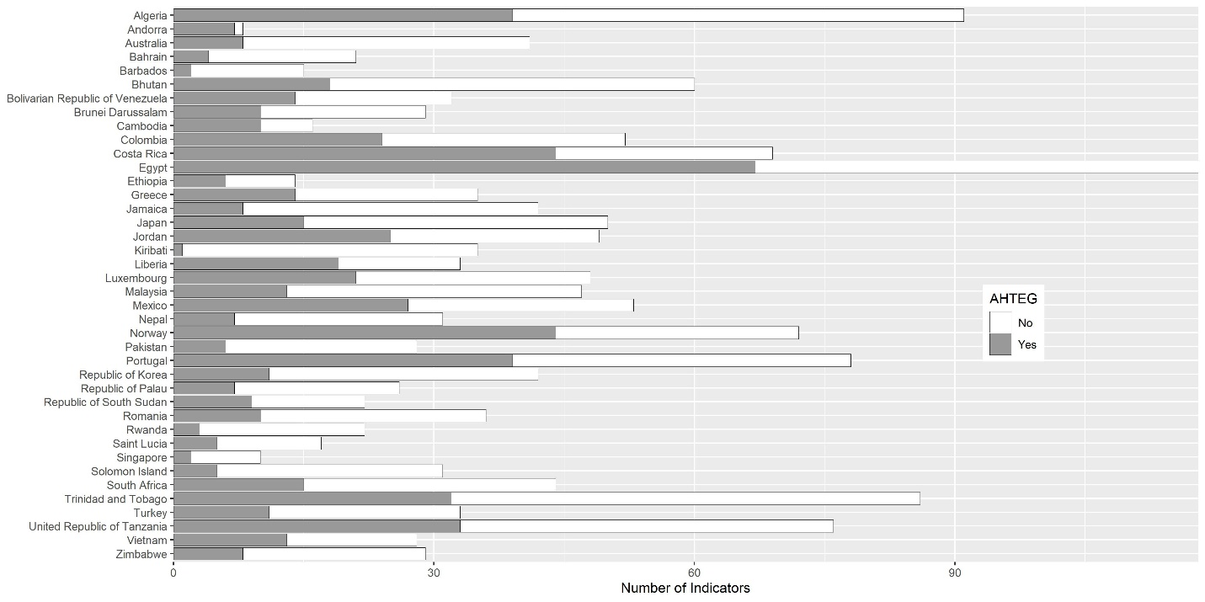

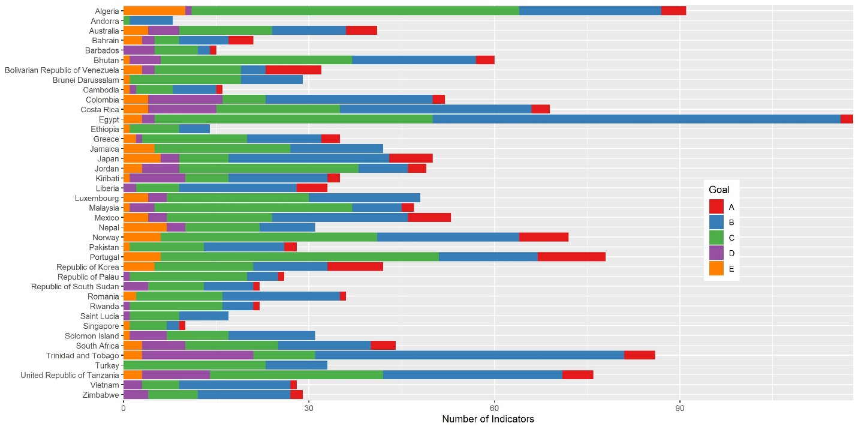
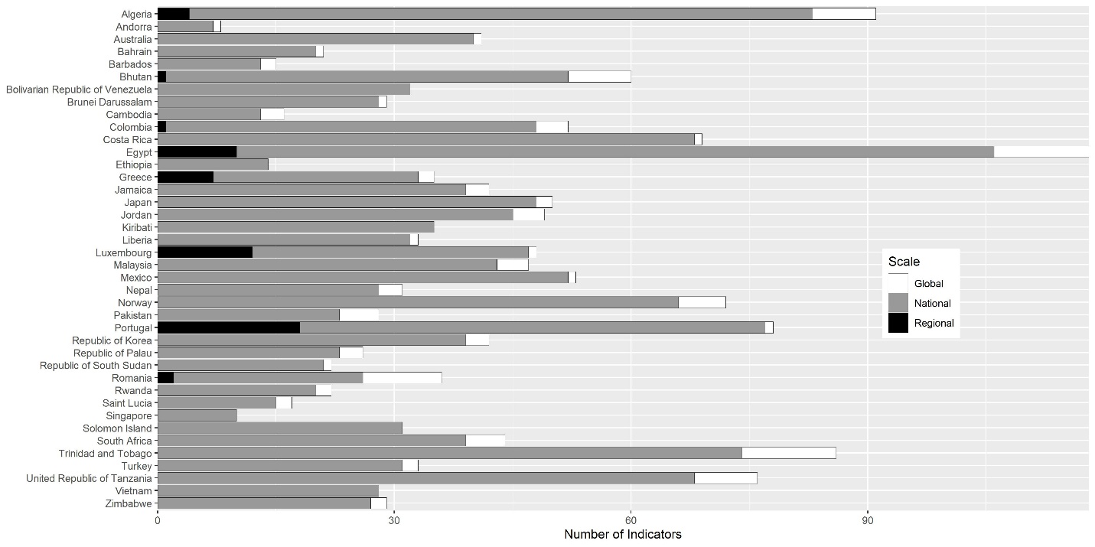

Figure S2. Numbers of generic and specific AHTEG-recommended indicators used for each of the CBD Strategic Goals in the 5th National Reports to the CBD. Goals marked with the same symbol do not differ in the numbers of indicators addressing them.

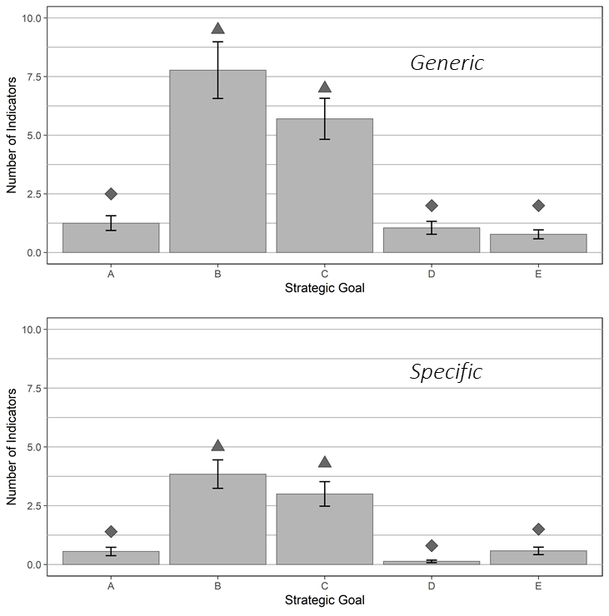

Figure S3. Use of indicators recommended by the AHTEG for each CBD Strategic Goal in each of 40 5th National Reports.

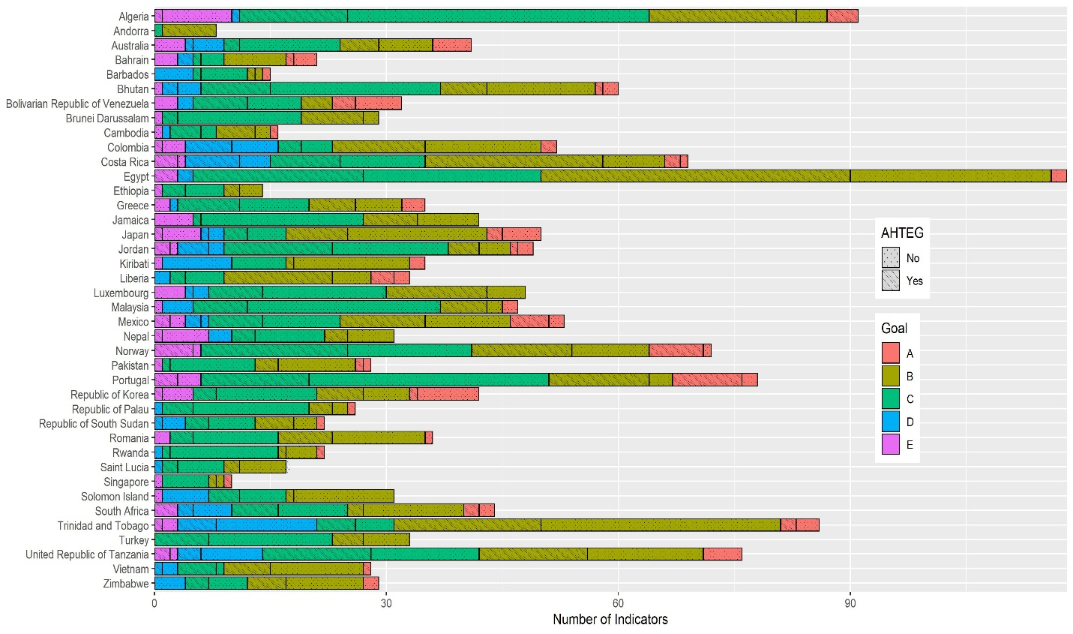

Figure S4. Numbers of 5th National Reports to the CBD that used at least one generic or specific AHTEG-recommended indicator for each of the CBD Strategic Goals. Goals marked with the same symbol do not differ in the numbers of indicators addressing them.
