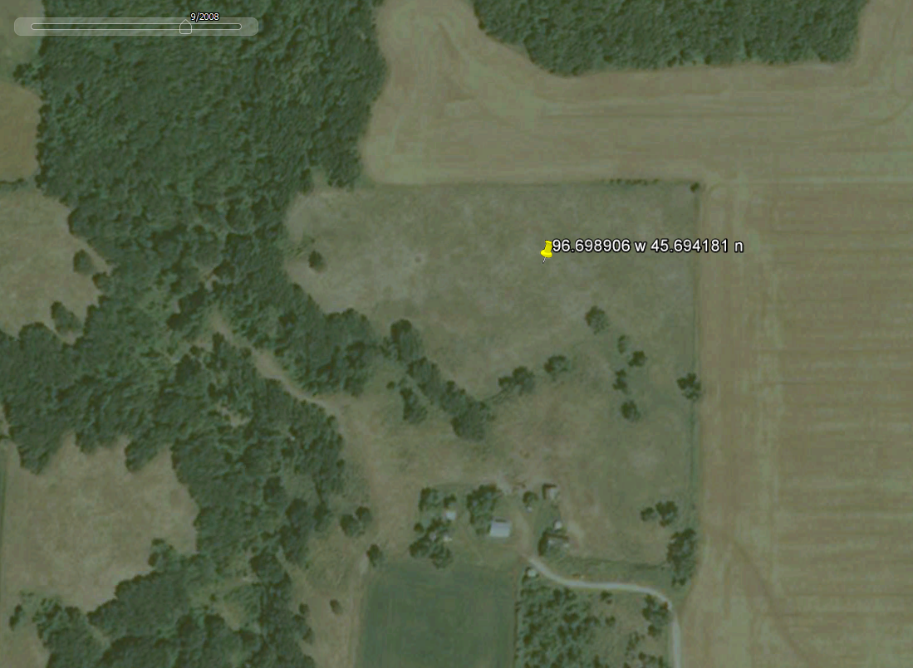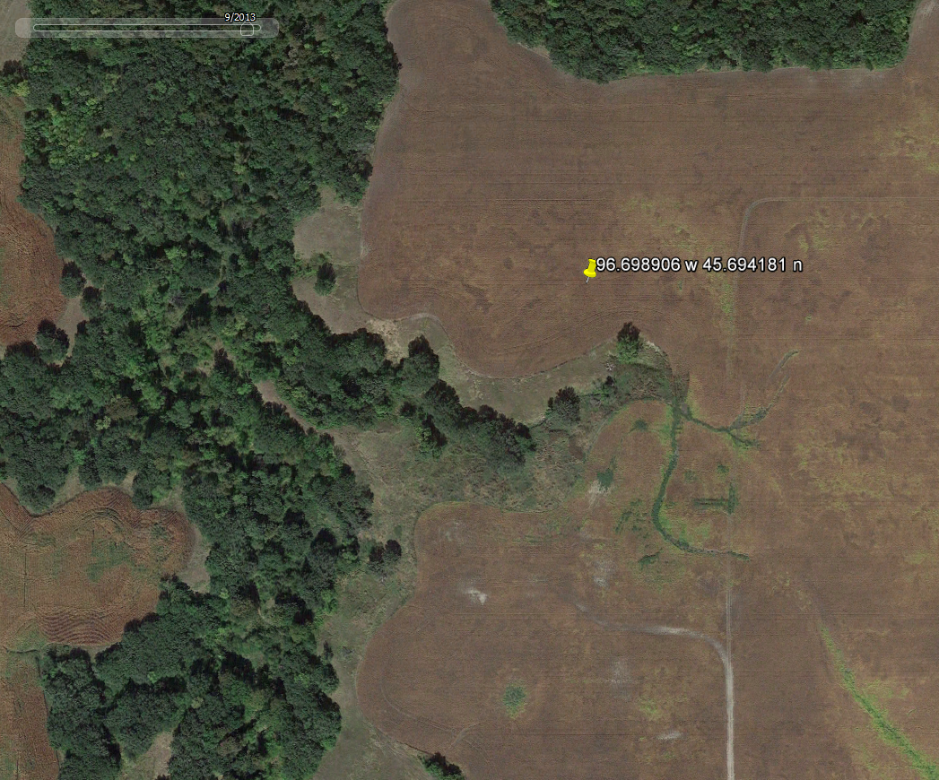
9/2008 9/2013

Supplemental Figure 1: Example of conversion of prairie to cropland. The left image is from September 2008, the right from September 2013, with approximate area of conversion outlined in orange. The majority of observed prairie-to-crop conversion occurred adjacent to existing crop fields, defined as contiguous locations or those bordering a common roadway, homestead, or fence line. Base images from USDA FSA aerial photography accessed through Google Earth Pro.

