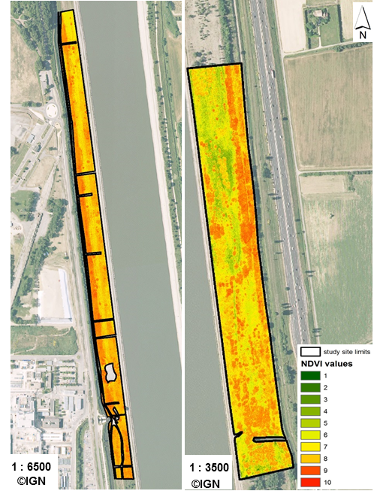
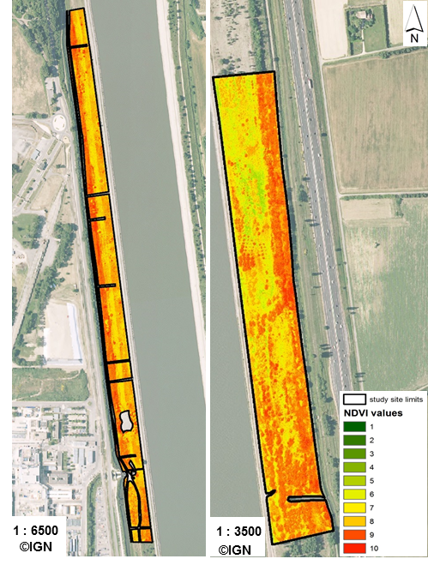
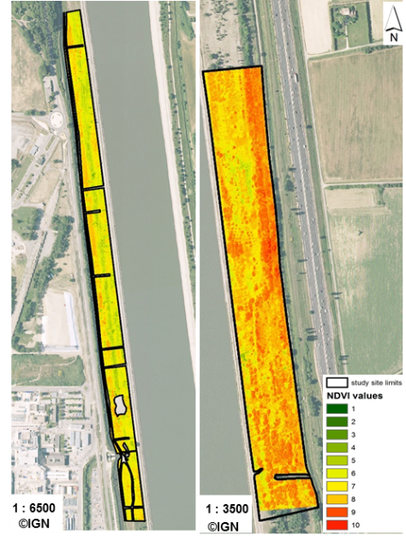
Appendix S2. General maps showing NDVI index pixels in mown grassland (MG, left) and grazed grassland (GG, right) for each study year: 2014 (top left corner), 2015 (top right corner) and 2016 (bottom left corner) in the site of Donzère-Mondragon in the Lower Rhône valley, Southeastern France. NDVI values are ranked in 10 classes for better representation. Orthorectified images derived from IGN (Institut national de l'information géographique et forestière).

