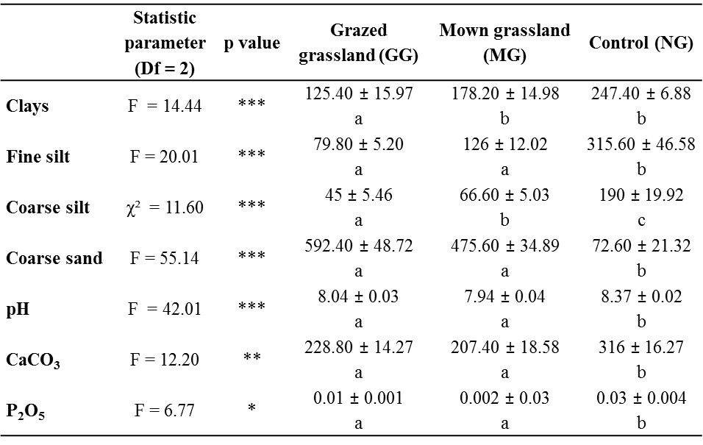

Table S2. Results of soil analyses in the cattle-grazed grassland (GG), mown grassland (MG) and control (NG) on dykes of Donzère–Mondragon canal in the Lower Rhône valley, Southeastern France, in 2014. Statistical test values, p value, parameter means measured by treatment and standard errors are indicated. P value: * < 0.05, ** < 0.01, *** < 0.001. Two values in the same row with a different letter are significantly different according to Tukey post-hoc tests or Mann–Whitney–Wilcoxon tests.

