Supplementary Material
Costs of delivery approaches for providing livelihood projects to local communities as part of REDD+ programmes: An analysis from Madagascar
James L. MacKinnon¹, Luciano Andriamaro², Andoniaina Rambeloson², Mialy Razafindrazakasoa², Celia A. Harvey ³
¹ Haughead, Rickarton, Stonehaven, AB39 3TH, UK
² Conservation International Madagascar, Lot II W 27 D – Ankorahotra – P.O. Box. 5178- Antananarivo-101, Madagascar
³Moore Center for Science and Oceans, Conservation International, 2011 Crystal Drive Suite 500, Arlington, VA 22202, USA

This supplementary material document provides tables of additional data, figures and further information on methodology to support and/or clarify information provided in the publication.

Table S1. Cost categories used for the analysis and the types of data included in them
Category used for analysis | Category from CI’s accounting | Types of data included
Management costs | Salaries and benefits | Salaries, Social security contributions, Taxes (paid by employer) on salaries
 | Office supplies | Stationery
 | Equipment | Equipment purchases
 | Indirect/overhead costs | Management fees of intermediary organizations, audited indirect/overhead costs of CI
 | Other costs | Banking charges and currency exchange losses/gains
Travel and meeting costs | Travel | Public transport costs, Fuel costs, vehicle repairs, vehicle hire, etc.
 | Meetings | Workshop costs, hiring meeting location
Input costs | Building materials | Materials for construction
 | Agricultural inputs | Fertilizer, seeds, etc.
Contractor costs | Contractors | External contractor costs as specified in a contract

Table S2. Model Selection for each of the cost variables. Akaike Information Criterion (AIC) and Bayesian Information Criterion (BIC) were used to choose the most parsimonious of the linear mixed models. The AIC and BIC were calculated under assumptions of homogeneous variances, heterogeneous variances for approach, heterogeneous variances for type and heterogeneous variances for both type and approach. The most parsimonious model (indicated in bold) was selected for each of the cost variables.
 | Homogeneous variances |  | Heterogeneous variances for approaches |  | Heterogeneous variances for type |  | Heterogeneous variances for type and approaches
Variable | AIC | BIC | AIC | BIC | AIC | BIC | AIC | BIC
Total Project costs | 145.14 | 178.14 | 101.02 | 146.39 | 84.9 | 150.9 | 49.79 | 128.15
Costs at community level | 461.09 | 494.09 | 332.59 | 377.96 | 402.01 | 468 | 299.04 | 377.41
Number of households | 276.82 | 301.77 | 120.95 | 153.03 | 205.06 | 251.4 | 92.69 | 146.16
Cost per household | 144.02 | 172.51
Value per household | 114.36 | 142.85 | 31.14 | 88.11 | 50.82 | 100.67
Proportion spent at community level | -310.37 | -277.37 | -349.09 | -303.72 | -345.72 | -279.72 | -401.42 | -323.05

Table S3. Model Selection for each of the cost categories. Akaike Information Criterion (AIC) and Bayesian Information Criterion (BIC) were used to choose the most parsimonious of the linear mixed models. The AIC and BIC were calculated under assumptions of homogeneous variances, heterogeneous variances for approach, heterogeneous variances for type and heterogeneous variances for both type and approach. The assumption of heterogeneous variances for both type and approach was most parsimonious in all cases.
Variable | Homogeneous variances |  | Heterogeneous variances for approaches |  | Heterogeneous variances for type |  | Heterogeneous variances for type and approaches
 | AIC | BIC | AIC | BIC | AIC | BIC | AIC | BIC
Management costs | -249.17 | -216.18 | -321.48 | -276.10 | -353.93 | -287.93 | -435.96 | -361.68
Travel costs | -1064.82 | -1031.82 | -1124.77 | -1079.4 | -1152.07 | -1086.07 | -1236.72 | -1158.36
Input costs | -211.9 | -178.9 | -314.76 | -269.39 | -318 | -252 | -418.19 | -339.82
Contractor costs | -848.27 | -815.27 | -1066.39 | -1021.02 | -1002.19 | -936.2 | -1234.69 | -1156.32

Table S4. Summary of the mean transaction costs (± standard error) in US dollars of each microproject approach and type. Transaction costs as defined here are costs incurred by the lead and intermediary organizations involved in providing a microproject.
Microproject type | Approach
 | Conservation Agreement | Direct | Small grants | Safeguards | Total
Agroforestry |  |  | 564 ± 14 (n=38) |  | 564 ± 14 (n=38)
Beekeeping | 290 ± 57 (n=4) |  | 298 ± 0 (n=19) | 2,283 ± 182 (n=21) | 1,245 ± 174 (n=44)
Cash-crop | 198 ± 20 (n=4) |  | 2,527 ± 173 (n=8) |  | 1,751 ± 350 (n=12)
Education | 242 ± 18 (n=12) |  |  |  | 242 ± 18 (n=12)
Fish-farming | 258 ± NA (n=1) | 110 ± 0 (n=15) | 600 ± 154 (n=10) |  | 304 ± 74 (n=26)
Infrastructure | 213 ± 18 (n=6) | 110 ± 0 (n=11) | 596 ± 0 (n=12) |  | 333 ± 43 (n=29)
Livestock | 299 ± 41 (n=10) | 111 ± 1 (n=46) | 1,151 ± 177 (n=26) | 3,665 ± 392 (n=25) | 1,211 ± 170 (n=107)
Precautionary food storage | 400 ± 34 (n=24) |  |  |  | 400 ± 34 (n=24)
Staple food crops | 465 ± 30 (n=35) | 114 ± 1 (n=25) | 1,155 ± 108 (n=70) | 3,560 ± 475 (n=41) | 1,438 ± 155 (n=171)
Total | 367 ± 18 (n=96) | 111 ± 1 (n=97) | 936 ± 60 (n=183) | 3,282 ± 259 (n=87) | 1,086 ± 75 (n=463)

Table S5. Means and standard errors of the cost variables (in US dollars) of 463 microprojects at CAZ presented for the four delivery approaches.
Variable | Safeguards | Small grants | Conservation agreements | Direct implementation
Total project cost | 7,951 ± 1118 | 1,999 ± 108 | 1,589 ± 104 | 630 ± 50
Total spend at community level | 4,670 ± 875 | 1,063 ± 59 | 1,222 ± 99 | 519 ± 50
Cost per household | 700 ± 64 | 83 ± 7 | - | 31 ± 6
Value per household | 235 ± 18 | 44 ± 3 | - | 22 ± 4
Proportion spent at community level | 0.42 ± 0.02 | 0.53 ± 0.01 | 0.72 ± 0.01 | 0.73 ± 0.02
Management costs | 0.57 ± 0.01 | 0.44 ± 0.02 | 0.34 ± 0.02 | 0.25 ± 0.01
Travel costs | 0.05 ± 0.00 | 0.10 ± 0.00 | 0.01 ± 0.00 | 0.04 ± 0.00
Input costs | 0.08 ± 0.01 | 0.45 ± 0.02 | 0.64 ± 0.03 | 0.59 ± 0.02
Contractor costs | 0.30 ± 0.02 | 0.01 ± 0.00 | 0.00 ± 0.00 | 0.12 ± 0.01
Footnote: Data on the number of recipient households was unavailable for the conservation agreements. For each delivery approach, the means include microprojects of various different types (e.g. beekeeping, cash crops, infrastructure, etc.). To test for differences between delivery approaches we used Linear Mixed Models (LMMs) and included the microproject type as a random effect. We also included the distance of microprojects from tarred roads and major towns as a covariate to account for the potential impact that the remoteness of a microproject had on costs. The results of the LMMs are presented as Table 4 in the publication.

Figure S1. Map of the Ankeniheny Zahamena corridor (CAZ) showing forest cover and the REDD+ pilot location.
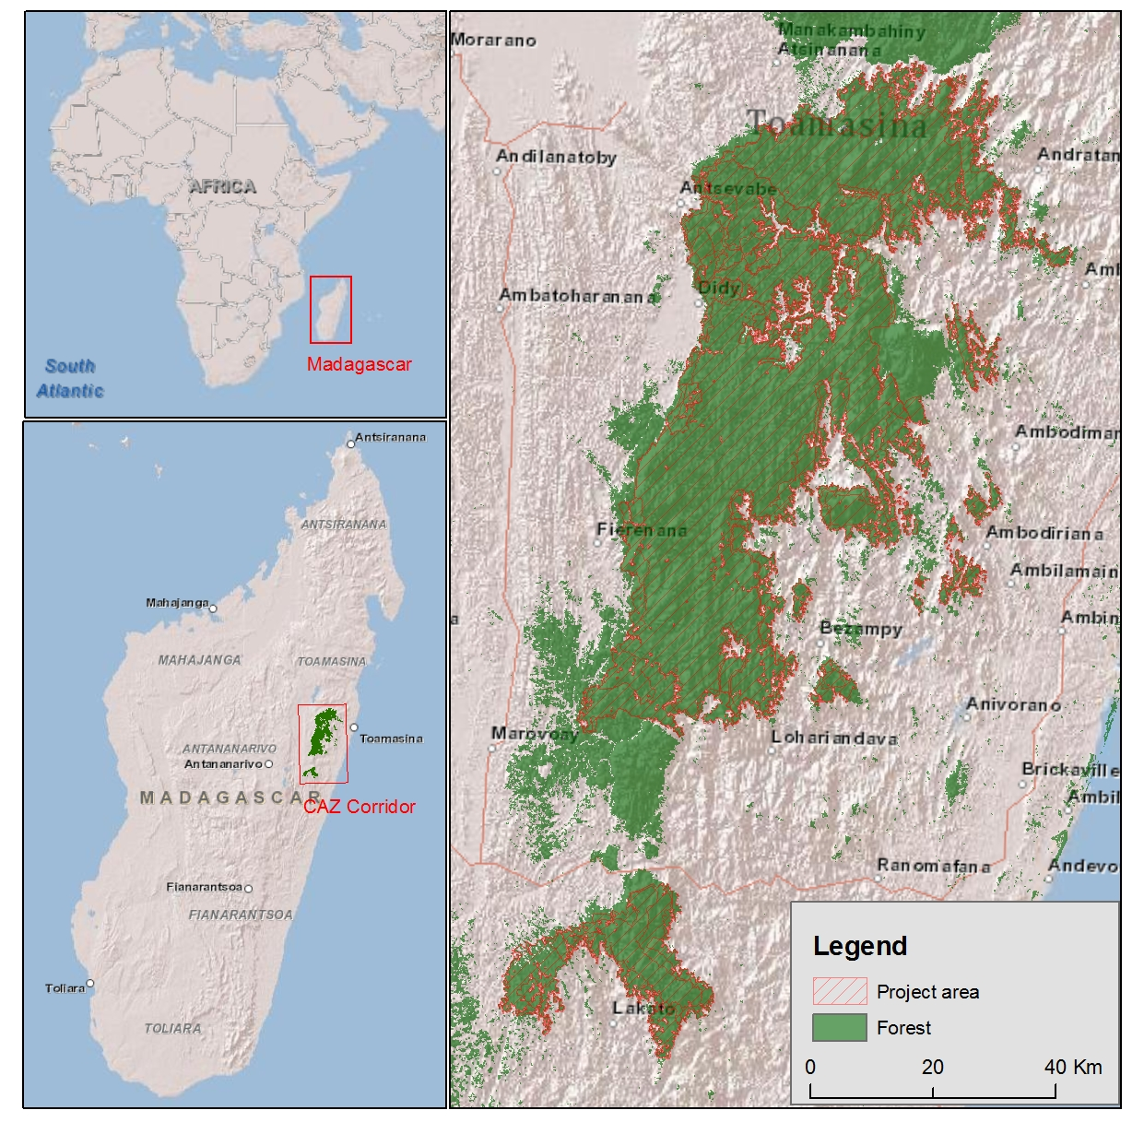

Figure S2. Estimated means and standard errors of cost variables based on the best model for each variable. The cost variables compared are i) total microproject cost, ii) the amount spent in the community on each microproject, iii) the proportion of expenditure in the community, iv) the number of recipient households per microproject, v) the cost of each project per recipient household and vi) the value of each microproject to the household. The four approaches used to deliver the microprojects are conservation agreements (Agreements), direct implementation (Direct), small grants (Grants) and Safeguards (Safeguard). Data on the number of recipient households was unavailable for the conservation agreements. In each case the letters a, b and c are used to indicate significant differences between the means based on LSD Fisher tests. Means with the same letters are not statistically different. The values of the means and standard errors are presented in Table 4 of the publication.

Figure S3. Estimated means and standard errors of the proportion of costs related to different cost categories based on the best model for each cost category. The cost categories are arcsine transformed proportions of the total costs that were related to i) management costs including salaries and administrative costs, ii) travel and meeting costs, iii) supplies and inputs needed for the microproject and iv) contractor costs. In each case the letters a, b and c are used to indicate significant differences between the means based on LSD Fisher tests. Means with the same letters are not statistically different.

Additional Information on Methods
Additional information on the location of microprojects and calculation of distances to roads and district towns.
The quality of locality data associated with the projects varied. While some projects had accurate latitude and longitude information recorded, most were associated with a particular village while some of the older projects were only recorded as being in a particular commune. To use a consistent measure of location we therefore used the centre of the commune where each project occurred. We then calculated two indices of accessibility for each project: the Euclidean distance to the closest tarred road and the Euclidean distance to the closest district town. In the CAZ area, the district towns are relatively well served by the national road network and most of the goods and services needed to provide the livelihood projects in this study were acquired at them.
Distances between the centre of the commune where each microproject was located and the closest tarred road and towns were calculated using ArcGIS. The data used for tarred roads and town locations came from the BD500 database published by the national mapping agency, FTM. Distance from the microproject location to the closest tarred road or district town was calculated using the “Near” function in ArcGIS. The Geodesic distance was calculated and then converted to kilometres.
Additional information on the linear mixed models
The form of the linear mixed model used for statistical analysis is:
$$y_{ijk}= μ+Α_{i }+ {{D.D}_{k}+{D.R}_{k}+Μ_{ij }+ϵ}_{ijk} Μ_{ij} ϵ_{ijk} \sim Ν\left(0, σ^{2}\right),$$
where
$y_{ijk} is observed variable response in i-th Approach, j-th Type and k-th microproject$
$$μ= General mean$$
$$Α_{i }= i-th Approach$$
${Mi}_{j}= j-th Type under i-th Approach$
$${D.D}_{k}=k-th distance to district town$$
$${D.R}_{k}=k-th distance to tarred road$$
$$Random components are assumed {as M}_{ij} \sim Ν\left(0, σ_{M}^{2} \right), ϵ_{ijk} \sim Ν\left(0, σ_{e}^{2}\right),$$
$$with M_{ij} and ϵ_{ijk} mutually independent$$

