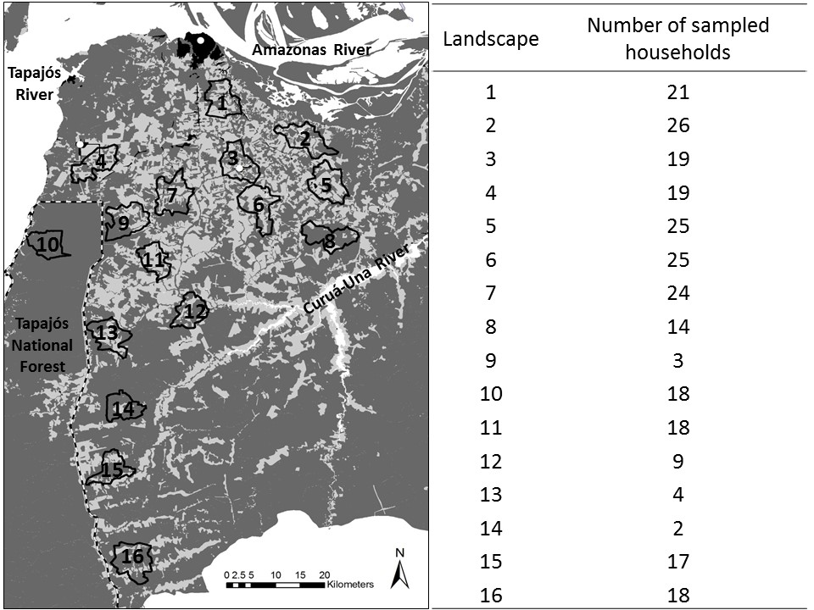
Fig. S2 Number of sampled households within each of the 16 hydrological catchments.

