Supplementary Material—Salish Sea Salmon Qualitative Network Model
  - Appendix 1. Methods and Data Supporting Figure 1.
Methods
To arrive at population trends, we compiled available adult run sizes for salmon in rivers throughout the Salish Sea. Data were from Pacific Fishery Management Council Stock Assessment and Fishery Evaluation (SAFE) Documents (http://www.pcouncil.org/salmon/stock-assessment-and-fishery-evaluation-safe-documents/review-of-2015-ocean-salmon-fisheries/), Pacific Salmon Commission Technical Committee Reports (http://www.psc.org/publications/technical-reports/technical-committee-reports/chinook/), Washington Department of Fish and Wildlife, Ogden et al. 2015, and Zimmerman et al. 2015 (Table A1.1). We used the longest time series available (typically from 1970s to >2010) and used the methods of Holmes (2001) to estimate a population trend and confidence interval for each run. If total run size (TRS, a total of catch and escapement or number of spawners) was not available, we used escapement/spawner (E) data.
Table A1.1 Salmon runs used in the calculation of population trends. TRS=Total Run Size, E=Escapement.
Run | Species | Data | Years | Data Source | Subbasin | Population Trend | 95% Confidence Interval
Lake Washington | Chinook | TRS | 1975-2014 | PSC Joint Tech. Comm. 2016 | Central Puget Sound | 0.004 | 0.009
Green | Chinook | TRS | 1975-2014 | PSC Joint Tech. Comm. 2016 | Central Puget Sound | -0.027 | 0.006
Snohomish | Chinook | TRS | 1975-2014 | PSC Joint Tech. Comm. 2016 | Whidbey | -0.035 | 0.004
Hood Canal | Chinook | TRS | 1981-2014 | PFMC 2016 | Hood Canal | 0.035 | 0.010
Juan de Fuca | Chinook | TRS | 1981-2014 | PFMC 2016 | Juan de Fuca | -0.006 | 0.006
South Puget Sound | Chinook | TRS | 1981-2014 | PFMC 2016 | South Sound | 0.013 | 0.005
Nooksack | Chinook | TRS | 1981-2014 | PFMC 2016 | San Juan and Gulf Islands | -0.046 | 0.007
Skagit Spring | Chinook | TRS | 1975-2014 | PSC Joint Tech. Comm. 2016 | Whidbey | 0.014 | 0.006
Skagit Summer/fall | Chinook | TRS | 1975-2014 | PSC Joint Tech. Comm. 2016 | Whidbey | -0.026 | 0.005
Stillaguamish | Chinook | TRS | 1975-2014 | PSC Joint Tech. Comm. 2016 | Whidbey | -0.030 | 0.011
Willapa | Chinook | TRS | 1976-2014 | PFMC 2016 | Pacific Coast | 0.021 | 0.007
Grays Harbor Spring/Summer | Chinook | TRS | 1976-2014 | PFMC 2016 | Pacific Coast | 0.018 | 0.005
Grays Harbor Fall | Chinook | TRS | 1975-2014 | PSC Joint Tech. Comm. 2016 | Pacific Coast | 0.013 | 0.005
Queets Spr/Summer | Chinook | TRS | 1976-2015 | PSC Joint Tech. Comm. 2016 | Pacific Coast | -0.025 | 0.007
Queets fall | Chinook | TRS | 1976-2014 | PSC Joint Tech. Comm. 2016 | Pacific Coast | 0.002 | 0.004
Hoh Spring/Summer | Chinook | TRS | 1976-2015 | PSC Joint Tech. Comm. 2016 | Pacific Coast | -0.019 | 0.006
Hoh fall | Chinook | TRS | 1976-2015 | PSC Joint Tech. Comm. 2016 | Pacific Coast | -0.002 | 0.004
Quillayute spring/summer | Chinook | TRS | 1976-2015 | PSC Joint Tech. Comm. 2016 | Pacific Coast | -0.029 | 0.005
Quillayute fall | Chinook | TRS | 1976-2015 | PFMC 2016 | Pacific Coast | -0.005 | 0.005
Hoko fall term | Chinook | TRS | 1986-2015 | PSC Joint Tech. Comm. 2016 | Pacific Coast | 0.021 | 0.009
Fraser Spring/summer | Chinook | TRS | 1975-2015 | PSC Joint Tech. Comm. 2016 | Central Strait of Georgia | 0.017 | 0.002
Harrison | Chinook | TRS | 1984-2015 | PSC Joint Tech. Comm. 2016 | Central Strait of Georgia | 0.050 | 0.004
Lake Shuswap | Chinook | E | 1975-2015 | PSC Joint Tech. Comm. 2016 | Central Strait of Georgia | 0.026 | 0.006
Nanaimo | Chinook | E | 1975-2015 | PSC Joint Tech. Comm. 2016 | South Strait of Georgia, San Juan and Gulf Islands | -0.018 | 0.007
Cowichan | Chinook | E | 1975-2015 | PSC Joint Tech. Comm. 2016 | South Strait of Georgia, San Juan and Gulf Islands | -0.006 | 0.007
Nimpkish | Chinook | E | 1975-2015 | PSC Joint Tech. Comm. 2016 | Johnstone Strait | -0.052 | 0.015
Klinaklini | Chinook | E | 1975-2015 | PSC Joint Tech. Comm. 2016 | Johnstone Strait | 0.030 | 0.009
Kakweiken | Chinook | E | 1975-2015 | PSC Joint Tech. Comm. 2016 | Johnstone Strait | -0.043 | 0.011
Kingcome | Chinook | E | 1975-2015 | PSC Joint Tech. Comm. 2016 | Johnstone Strait | -0.064 | 0.018
Wakeman | Chinook | E | 1975-2015 | PSC Joint Tech. Comm. 2016 | Johnstone Strait | -0.151 | 0.028
Marble | Chinook | E | 1975-2015 | PSC Joint Tech. Comm. 2016 | Pacific Coast | 0.013 | 0.005
Burman | Chinook | E | 1975-2015 | PSC Joint Tech. Comm. 2016 | Pacific Coast | 0.061 | 0.012
Tahsis | Chinook | E | 1975-2015 | PSC Joint Tech. Comm. 2016 | Pacific Coast | 0.024 | 0.014
Artlish | Chinook | E | 1975-2015 | PSC Joint Tech. Comm. 2016 | Pacific Coast | 0.029 | 0.016
Kaouk | Chinook | E | 1975-2015 | PSC Joint Tech. Comm. 2016 | Pacific Coast | 0.041 | 0.026
Tahsish | Chinook | E | 1975-2015 | PSC Joint Tech. Comm. 2016 | Pacific Coast | 0.004 | 0.011
Cedar River Winter | Steelhead | TRS | 1987-2013 | N. Kendall, WDFW pers. comm | Central Puget Sound | -0.220 | 0.023
Green River Winter | Steelhead | TRS | 1978-2013 | N. Kendall, WDFW pers. comm | Central Puget Sound | -0.053 | 0.004
Puyallup/Carbon Winter | Steelhead | TRS | 1983-2013 | N. Kendall, WDFW pers. comm comm | Central Puget Sound | -0.077 | 0.006
White River (Puyallup) Winter | Steelhead | TRS | 1986-2013 | N. Kendall, WDFW pers. comm | Central Puget Sound | -0.042 | 0.008
Englishman River winter | Steelhead | E | 1982-2015 | K. Pellett, pers. comm | Central Strait of Georgia | -0.063 | 0.011
East Hood Canal Winter | Steelhead | TRS | 1989-2013 | N. Kendall, WDFW pers. comm | Hood Canal | 0.088 | 0.016
Skokomish Winter | Steelhead | TRS | 1985-2006 | N. Kendall, WDFW pers. comm | Hood Canal | -0.020 | 0.013
South Hood Canal Winter | Steelhead | TRS | 1988-2013 | N. Kendall, WDFW pers. comm | Hood Canal | -0.004 | 0.009
West Hood Canal Winter | Steelhead | TRS | 2003-2013 | N. Kendall, WDFW pers. comm | Hood Canal | 0.015 | 0.021
Tsitika River summer | Steelhead | E | 1976-2015 | K. Pellett, pers. comm | Johnstone Strait | 0.008 | 0.007
Salmon River winter | Steelhead | TRS | 1981-2015 | N. Kendall, WDFW pers. comm | Johnstone Strait | 0.021 | 0.036
Sequim and Discovery Bays Tributaries Winter | Steelhead | TRS | 1987-2013 | N. Kendall, WDFW pers. comm | Juan de Fuca | -0.101 | 0.100
Strait of Juan de Fuca Independent Tributaries Winter | Steelhead | TRS | 1991-2009 | N. Kendall, WDFW pers. comm | Juan de Fuca | -0.028 | 0.022
Glendale winter | Steelhead | E | 1992-2014 | K. Pellett, pers. comm | Pacific Coast | -0.178 | 0.085
Ahnuhati winter | Steelhead | E | 1992-2014 | K. Pellett, pers. comm | Pacific Coast | -0.186 | 0.065
Kakweiken winter | Steelhead | E | 1992-2014 | K. Pellett, pers. comm | Pacific Coast | -0.206 | 0.063
Atwaykellesse winter | Steelhead | E | 1992-2014 | K. Pellett, pers. comm | Pacific Coast | -0.116 | 0.062
Wahpeeto winter | Steelhead | E | 1992-2014 | K. Pellett, pers. comm | Pacific Coast | -0.201 | 0.066
Heber River summer | Steelhead | E | 1975-2015 | K. Pellett, pers. comm | Pacific Coast | -0.012 | 0.004
Gordon River summer | Steelhead | E | 1998-2015 | K. Pellett, pers. comm | Pacific Coast | 0.030 | 0.042
Nisqually Winter | Steelhead | TRS | 1980-2013 | N. Kendall, WDFW pers. comm | South Sound | -0.107 | 0.016
Samish Winter | Steelhead | TRS | 1979-2013 | N. Kendall, WDFW pers. comm | South Strait of Georgia | 0.039 | 0.011
Pilchuck Winter | Steelhead | E | 1981-2014 | N. Kendall, WDFW pers. comm | Whidbey | -0.020 | 0.009
Skagit River Summer and Winter | Steelhead | TRS | 1978-2013 | N. Kendall, WDFW pers. comm | Whidbey | -0.034 | 0.007
Snohomish System Winter | Steelhead | TRS | 1987-2013 | N. Kendall, WDFW pers. comm | Whidbey | -0.048 | 0.012
Snohomish/Skykomish Winter | Steelhead | TRS | 1987-2013 | N. Kendall, WDFW pers. comm | Whidbey | -0.061 | 0.010
Snoqualmie Winter | Steelhead | TRS | 1987-2013 | N. Kendall, WDFW pers. comm | Whidbey | -0.056 | 0.008
Stillaguamish Winter | Steelhead | TRS | 1987-2013 | N. Kendall, WDFW pers. comm | Whidbey | -0.075 | 0.022
Green | Coho | TRS | 1973-2010 | Zimmerman et al. 2015 | Central Puget Sound | 0.039 | 0.014
Puyallup | Coho | TRS | 1974-2010 | Zimmerman et al. 2015 | Central Puget Sound | -0.038 | 0.008
Big Qualicum | Coho | TRS | 1973-2010 | Zimmerman et al. 2015 | Central Strait of Georgia | -0.143 | 0.011
Inch | Coho | TRS | 1984-2010 | Zimmerman et al. 2015 | Central Strait of Georgia | 0.103 | 0.023
Big Beef Creek | Coho | TRS | 1977-2010 | Zimmerman et al. 2015 | Hood Canal | -0.025 | 0.009
Quilcene | Coho | TRS | 1979-2010 | Zimmerman et al. 2015 | Hood Canal | 0.039 | 0.014
Skokomish | Coho | TRS | 1973-2010 | Zimmerman et al. 2015 | Hood Canal | 0.013 | 0.008
Straits | Coho | TRS | 1985-2010 | Zimmerman et al. 2015 | Juan de Fuca | -0.034 | 0.012
Black | Coho | TRS | 1978-2010 | Zimmerman et al. 2015 | North Strait of Georgia | -0.052 | 0.021
Puntledge | Coho | TRS | 1974-2010 | Zimmerman et al. 2015 | North Strait of Georgia | -0.151 | 0.020
Quinsam | Coho | TRS | 1978-2004 | Zimmerman et al. 2015 | North Strait of Georgia | -0.104 | 0.010
Bingham Creek | Coho | TRS | 1976-2010 | Zimmerman et al. 2015 | Pacific Coast | 0.017 | 0.014
Cowlitz | Coho | TRS | 1982-2010 | Zimmerman et al. 2015 | Pacific Coast | -0.126 | 0.030
Grays | Coho | TRS | 1982-2010 | Zimmerman et al. 2015 | Pacific Coast | -0.036 | 0.009
Quinault | Coho | TRS | 1977-2010 | Zimmerman et al. 2015 | Pacific Coast | 0.079 | 0.015
Robertson | Coho | TRS | 1975-2010 | Zimmerman et al. 2015 | Pacific Coast | -0.014 | 0.013
Satsop | Coho | TRS | 1973-2010 | Zimmerman et al. 2015 | Pacific Coast | 0.036 | 0.010
Washougal | Coho | TRS | 1976-2010 | Zimmerman et al. 2015 | Pacific Coast | -0.102 | 0.023
Deschutes | Coho | TRS | 1977-2008 | Zimmerman et al. 2015 | South Sound | -0.048 | 0.041
Chilliwack | Coho | TRS | 1982-2004 | Zimmerman et al. 2015 | South Strait of Georgia | -0.066 | 0.060
Nooksack | Coho | TRS | 1976-2009 | Zimmerman et al. 2015 | South Strait of Georgia | -0.071 | 0.028
Skagit | Coho | TRS | 1991-2010 | Zimmerman et al. 2015 | Whidbey | -0.049 | 0.014
Stilliguamish | Coho | TRS | 1981-2014 | Zimmerman et al. 2015 | Whidbey | -0.013 | 0.013
Snohomish | Coho | TRS | 1981-2014 | Zimmerman et al. 2015 | Whidbey | -0.026 | 0.010
Baker | Coho | TRS | 1983-2010 | Zimmerman et al. 2015 | Whidbey | -0.048 | 0.018
Skykomish | Coho | TRS | 1978-2010 | Zimmerman et al. 2015 | Whidbey | 0.012 | 0.010
Tulalip Bay | Coho | TRS | 1974-2010 | Zimmerman et al. 2015 | Whidbey | 0.011 | 0.017
Green River (Area 10A) | Pink | TRS | 2001-2013 | A. Dufault, WDFW, pers. comm. | Central Puget Sound | 1.053 | 0.364
Puyallup River (Area 11A) | Pink | TRS | 1959-2013 | A. Dufault, WDFW, pers. comm. | Central Puget Sound | 0.133 | 0.038
Chambers | Pink | TRS | 1959-2013 | A. Dufault, WDFW, pers. comm. | Central Puget Sound | 0.096 | 0.206
Nisqually R. Drainage | Pink | TRS | 1959-2013 | A. Dufault, WDFW, pers. comm. | Central Puget Sound | 0.167 | 0.088
Area 13A streams | Pink | TRS | 1959-2013 | A. Dufault, WDFW, pers. comm. | Central Puget Sound | -0.029 | 0.054
Area 13B streams | Pink | TRS | 1959-2013 | A. Dufault, WDFW, pers. comm. | Central Puget Sound | 0.036 | 0.035
Port Gamble | Pink | TRS | 1959-2013 | A. Dufault, WDFW, pers. comm. | Hood Canal | 0.425 | 0.593
Dosewallips | Pink | TRS | 1959-2013 | A. Dufault, WDFW, pers. comm. | Hood Canal | -0.095 | 0.028
Duckabush | Pink | TRS | 1959-2013 | A. Dufault, WDFW, pers. comm. | Hood Canal | -0.025 | 0.054
Hamma | Pink | TRS | 1959-2013 | A. Dufault, WDFW, pers. comm. | Hood Canal | 0.091 | 0.052
Hoodsport Hatchery | Pink | TRS | 1959-2013 | A. Dufault, WDFW, pers. comm. | Hood Canal | 0.063 | 0.024
Misc 12C | Pink | TRS | 1959-2013 | A. Dufault, WDFW, pers. comm. | Hood Canal | -0.002 | 0.041
Skokomish R. Drainage | Pink | TRS | 1959-2013 | A. Dufault, WDFW, pers. comm. | Hood Canal | 0.093 | 0.055
Dungeness River | Pink | TRS | 1959-2013 | A. Dufault, WDFW, pers. comm. | Juan de Fuca | -0.009 | 0.053
Elwha River | Pink | TRS | 1959-2013 | A. Dufault, WDFW, pers. comm. | Juan de Fuca | -0.182 | 0.093
Nooksack River | Pink | TRS | 1959-2013 | A. Dufault, WDFW, pers. comm. | South Strait of Georgia | -0.012 | 0.035
Samish River | Pink | TRS | 1959-2013 | A. Dufault, WDFW, pers. comm. | South Strait of Georgia | 0.221 | 0.068
Fraser | Pink | TRS | 1959-2011 | Ogden et al. 2015 | South Strait of Georgia | 0.070 | 0.030
Skagit River | Pink | TRS | 1959-2013 | A. Dufault, WDFW, pers. comm. | Whidbey | 0.004 | 0.030
Snohomish River | Pink | TRS | 1959-2013 | A. Dufault, WDFW, pers. comm. | Whidbey | 0.080 | 0.025
Stillaguamish River | Pink | TRS | 1959-2013 | A. Dufault, WDFW, pers. comm. | Whidbey | 0.000 | 0.027
Lake Washington | Sockeye | E | 1972-2015 | A. Dufault, WDFW, pers. comm. | Central Puget Sound | -0.005 | 0.006
Fraser | Sockeye | TRS | 1960-2012 | Ogden et al. 2015 | South Strait of Georgia | 0.003 | 0.004
Baker Lake | Sockeye | E | 1970-2015 | A. Dufault, WDFW, pers. comm | Whidbey | 0.044 | 0.012
Misc 10 -Seattle | Chum | TRS | 1968-2009 | A. Dufault, WDFW, pers. comm | Central Puget Sound | 0.084 | 0.009
Green-Duwamish River | Chum | TRS | 1968-2009 | A. Dufault, WDFW, pers. comm | Central Puget Sound | 0.135 | 0.014
Misc 10e -Port Orchard | Chum | TRS | 1968-2009 | A. Dufault, WDFW, pers. comm | Central Puget Sound | 0.022 | 0.007
Misc 11 -Tacoma | Chum | TRS | 1968-2009 | A. Dufault, WDFW, pers. comm | Central Puget Sound | 0.020 | 0.006
Puyallup River | Chum | TRS | 1968-2009 | A. Dufault, WDFW, pers. comm | Central Puget Sound | 0.062 | 0.012
Port Gamble Pens (9a) | Chum | TRS | 1968-2009 | A. Dufault, WDFW, pers. comm | Hood Canal | -0.016 | 0.009
N. Hood Canal (12) | Chum | TRS | 1968-2009 | A. Dufault, WDFW, pers. comm | Hood Canal | -0.015 | 0.008
Misc 12b -Hood Canal | Chum | TRS | 1968-2009 | A. Dufault, WDFW, pers. comm | Hood Canal | 0.013 | 0.007
Quilcene River (12a) | Chum | TRS | 1968-2009 | A. Dufault, WDFW, pers. comm | Hood Canal | 0.034 | 0.011
Misc 12c -Hood Canal | Chum | TRS | 1968-2009 | A. Dufault, WDFW, pers. comm | Hood Canal | 0.063 | 0.006
Hoodsport Hatchery | Chum | TRS | 1968-2009 | A. Dufault, WDFW, pers. comm | Hood Canal | 0.049 | 0.010
Skokomish River | Chum | TRS | 1968-2009 | A. Dufault, WDFW, pers. comm | Hood Canal | 0.073 | 0.007
Misc 12d -Hood Canal | Chum | TRS | 1968-2009 | A. Dufault, WDFW, pers. comm | Hood Canal | 0.025 | 0.007
Dungeness River | Chum | TRS | 1968-2009 | A. Dufault, WDFW, pers. comm | Juan de Fuca | 0.052 | 0.012
Elwha River | Chum | TRS | 1968-2009 | A. Dufault, WDFW, pers. comm | Juan de Fuca | -0.061 | 0.014
Misc Strait Streams | Chum | TRS | 1968-2009 | A. Dufault, WDFW, pers. comm | Juan de Fuca | 0.023 | 0.009
Grays Harbor Wild Runsize | Chum | TRS | 1968-2009 | A. Dufault, WDFW, pers. comm | Pacific Coast | -0.006 | 0.006
Willapa Bay Wild And Hatchery Escapement And Total Runsize | Chum | TRS | 1980-1999 | A. Dufault, WDFW, pers. comm | Pacific Coast | -0.010 | 0.006
Inside South Coast (Non-Fraser) | Chum | TRS | 1953-2012 | Ogden et al. 2015 | Pacific Coast | 0.000 | 0.005
Hecate Lowlands | Chum | E | 1954-2012 | Ogden et al. 2015 | Pacific Coast | -0.014 | 0.004
North Haida Gwaii | Chum | E | 1954-2012 | Ogden et al. 2015 | Pacific Coast | -0.028 | 0.009
Portland Inlet | Chum | E | 1954-2012 | Ogden et al. 2015 | Pacific Coast | -0.006 | 0.005
Rivers Inlet | Chum | E | 1954-2012 | Ogden et al. 2015 | Pacific Coast | -0.009 | 0.014
Skidegate | Chum | E | 1954-2012 | Ogden et al. 2015 | Pacific Coast | -0.013 | 0.006
Misc 13 -South Puget Sound | Chum | TRS | 1968-2009 | A. Dufault, WDFW, pers. comm | South Sound | -0.018 | 0.050
Chambers Creek | Chum | TRS | 1968-2009 | A. Dufault, WDFW, pers. comm | South Sound | 0.004 | 0.032
Nisqually River | Chum | TRS | 1968-2009 | A. Dufault, WDFW, pers. comm | South Sound | 0.026 | 0.054
Misc 13a -Minter Creek | Chum | TRS | 1968-2009 | A. Dufault, WDFW, pers. comm | South Sound | 0.062 | 0.008
Misc 13b -Olympia | Chum | TRS | 1968-2009 | A. Dufault, WDFW, pers. comm | South Sound | 0.029 | 0.003
Nooksack River | Chum | TRS | 1968-2009 | A. Dufault, WDFW, pers. comm | South Strait of Georgia | 0.019 | 0.005
Samish River | Chum | TRS | 1968-2009 | A. Dufault, WDFW, pers. comm | South Strait of Georgia | 0.007 | 0.010
Misc 7b Streams | Chum | TRS | 1968-2009 | A. Dufault, WDFW, pers. comm | South Strait of Georgia | 0.082 | 0.011
Skagit River | Chum | TRS | 1968-2009 | A. Dufault, WDFW, pers. comm | Whidbey | -0.026 | 0.006
Tulalip Tribe | Chum | TRS | 1968-2009 | A. Dufault, WDFW, pers. comm | Whidbey | 0.063 | 0.013
Snohomish River | Chum | TRS | 1968-2009 | A. Dufault, WDFW, pers. comm | Whidbey | -0.001 | 0.011
Stillaguamish River | Chum | TRS | 1968-2009 | A. Dufault, WDFW, pers. comm | Whidbey | -0.011 | 0.008

  - Appendix 2. Model Sensitivity Analysis
  - Methods
To assess the sensitivity of the model linkages in the simulations, we calculated means and standard deviations of the weights for all linkages from the pool of accepted models. Our hypothesis was that some linkages would be more influential in model stability and that those with mean weights different than the expected mean (µ=0.5, given assignments that were random (U(0,1))) would provide some indication of linkage sensitivity.
  - Results
Our sensitivity analysis showed that most model edges (linkages between groups) were stable with regard to the weights applied in the simulation routine, with means from the pool of balanced models very close to the expected mean of 0.5 (>75% of 148 edges). However, some model linkages in the pool of accepted models had mean weights above or below the expected mean and we considered these model groups more sensitive (Fig. A2.1). Linkages among salmon traits were most sensitive, with means in the balanced models considerably higher or lower than the expected mean (e.g., Fitness to Size and Survival to Abundance, self-limiting loops on salmon traits). However, some food web components such as Ichthyoplankton and Forage Fish were also in the group of lower-than-expected model means, suggesting that certain food web pathway weights were sensitive in the model simulations. The links with bidirectional connectivity (positive feedbacks, e.g. Fitness to Size, arrows shown in royal blue in Fig. 2) tended to be the most sensitive to the weighting scheme, with lower-than-average weights resulting in balanced models. Model linkages with mean weights above the expected mean included many high trophic level linkages (e.g., Piscivorous Fish to Marine Mammals), as well as self-limiting loops (salmon traits especially), highly connected nodes (e.g. Zooplankton), and top-level predators (Marine Mammals and Piscivorous Birds). The linkages with both higher- and lower-than-expected means (that were not self-limiting loops) tended be highly connected food web components rather than anthropogenic impacts or physical drivers.

Figure A2.1. Calculated means and standard deviations from all model runs for edges (model linkages) with mean values different from the expected mean (0.5). The expected mean is denoted by the black dashed line. Positive linkages are indicated by an arrow and negative linkages are indicated by a dash and asterisk.

  - Appendix 3. Model Perturbations and References
Drivers | Variables | Reference | Invoked Perturbation
Environmental | Sunlight | Littell et al. 2009 | ↑
 | Winter Storms | Littell et al. 2009 | ↑
 | Precipitation | Mauger et al. 2015, Littell et al. 2009 | ↑
 | Upwelling | Mauger et al. 2015 | ↓
 | Stratification | Mauger et al. 2015 | ↑
 | Temperature | Littell et al. 2009, Field et al. 2006, Hollowed et al. 2001 | ↑
 | River Flow | Littell et al. 2009 | ↑
 | Turbidity | PSEMP 2016, WADOE 2017 | ↓
 | Dissolved Oxygen | Roberts et al. 2014 | ↓
Production | Nutrients | Roberts et al. 2014 | ↑
 | Microplankton | Moore et al. 2015 | ↑
 | Microbial Detritivores | PSEMP 2016 | ↑
 | Diatoms | Brandenberger 2008, WADOE 2017 | ↓
Food web | Zooplankton | Li et al. 2013 | ↓
 | Gelatinous Zooplankton | Greene et al. 2015 | ↑
 | Forage Fish | Greene et al. 2015 | ↓
 | Ichthyoplankton | Palsson et al. 1998 | ↓
 | Other Salmon | PFMC 2016, Figure 1 | ↑
 | Piscivorous Fish | Palsson et al. 1998 | ↓
 | Piscivorous Birds | Gaydos and Pearson 2011, Anderson et al. 2009 | ↓
 | Marine Mammals | Chasco et al. 2017 | ↑
Anthropogenic | Hatcheries | Christie et al. 2012, Waples 1999 | ↑
 | Harvest |  | ↑
 | Habitat Loss | Puget Sound Water Quality Action Team 2002 | ↑
 | CO2 | Feely et al. 2010 | ↑
 | Global Warming | IPCC 2014 | ↑
 | Contaminants | O’Neill et al. 2009, Meador et al. 2006, Crecelius et al. 1995 | ↑
 | Disease | Roon et al. 2015 | ↑
  - Literature Cited
Anderson, E.M., Bower, J.L., Nysewander, D.R., Evenson, J.R. and Lovvorn, J.R. 2009. Changes in avifaunal abundance in a heavily-used wintering and migration site in Puget Sound, Washington during 1966–2007. Marine Ornithology 37: 19-27.

Burke, B. J., B. R. Beckman, W. T. Peterson, C. Morgan, E. A. Daly, M. Litz. 2013. Multivariate methods to forecast Pacific salmon returns. PLoS ONE 8(1): e54134.

Chasco, B. I. Kaplan, A. Thomas, A. Alejandro-Gutiérrez, D.P. Noren, M.J. Ford, M.B. Hanson, J. Scordino, S.J. Jeffries, S.F. Pearson, K. Marshall, E.J. Ward. 2017. Estimates of Chinook salmon consumption in Washington State inland water by four marine mammal predators from 1970-2015. Can. J. of Fish. and Aqua. Sci. 10.1139/cjfas-2016-0203

Christie, M.R., M.L. Marine, R.A. French, R.S. Waples and M.S. Blouin. 2012. Effective size of a wild salmonid population is greatly reduced by hatchery supplementation. Heredity 109: 254-260.

Crecilius, E.A., V.I. Cullinan, L.F. Lefkovitz and C. Peden. 1995. Historical trends in the accumulation of chemicals in Puget Sound. 825-831, in Volume 2, Puget Sound Research '95 Proceedings, Puget Sound Water Quality Authority, Olympia.

Feely, R. A., S. R. Alin, J. Newton, C. L. Sabine, M. Warner, A. Devol, C. Krembs, and C. Maloy. 2010. The combined effects of ocean acidification, mixing, and respiration on pH and carbonate saturation in an urbanized estuary. Estuarine, Coastal and Shelf Science, 88, 442-449, doi:10.1016/j.ecss.2010.05.004

Field, D., D. Cayan, and F. Chavez. 2006. Secular warming in the California current and North Pacific. California Cooperative Oceanic Fisheries Investigations Reports, 47, 92-108.

Hoekstra, J. M., K.K. Bartz, M.H. Ruckelshaus, J.M. Moslemi, and T.K. Harms. 2007. Quantitative threat analysis for management of an imperiled species: Chinook salmon (Oncorhynchus tshawytscha). Ecological Applications, 17: 2061-2073.

Hollowed, A. B., S. R. Hare, and W. S. Wooster. 2001. Pacific Basin climate variability and patterns of Northeast Pacific marine fish production. Progress in Oceanography, 49, 257-282, doi:10.1016/S0079-6611(01)00026-X.

Gaydos, J.K. and S.F. Pearson. 2011. Birds and mammals that depend on the Salish Sea: A compilation. Northwest Naturalist: 92:79–94.

Intergovernmental Panel on Climate Change. 2014. Climate Change 2014: Synthesis Report. Contribution of Working Groups I, II and III to the Fifth Assessment Report of the Intergovernmental Panel on Climate Change [Core Writing Team, R.K. Pachauri and L.A. Meyer (eds.)]. IPCC, Geneva, Switzerland, 151 pp.

Li, L., D. Mackas, B. Hunt, J. Schweigert, E. Pakhomov, I. Perry, M. Galbraith, T.J. Pitcher. 2013. Zooplankton communities in the Strait of Georgia, British Columbia, track large-scale climate forcing over the Pacific Ocean. Progress in Oceanography. doi:http://dx.doi.org/10.1016/j.pocean.2013.05.025

Littell, J.S., M. McGuire Elsner, L.C. Whitely Binder, and A.K. Snover (eds). 2009. The Washington Climate Change Impacts Assessment: Evaluating Washington's Future in a Changing Climate. Climate Impacts Group, University of Washington, Seattle, Washington. Available at: www.cses.washington.edu/db/pdf/wacciaexecsummary638.pdf

Mauger, G.S., J.H. Casola, H.A. Morgan, R.L. Strauch, B. Jones, B. Curry, T.M. Busch Isaksen, L. Whitely Binder, M.B. Krosby, and A.K. Snover. 2015. State of Knowledge: Climate Change in Puget Sound. Report prepared for the Puget Sound Partnership and the National Oceanic and Atmospheric Administration. Climate Impacts Group, University of Washington, Seattle. doi:10.7915/CIG93777D

Meador, J.P., F.C. Sommers, G.M. Ylitalo, C.A. Sloan. 2006. Altered growth and related physiological response in juvenile Chinook salmon (Oncorhynchus tshawytscha) from dietary exposure to polycyclic aromatic hydrocarbons (PAHs). Can. J. of Fish. and Aqua. Sci. 63: 2364-2376.

Moore, S.K. et al., 2011. Past trends and future scenarios for environmental conditions favoring the accumulation of paralytic shellfish toxins in Puget Sound shellfish. Harmful Algae, 10, 521-529.

Moore, S.K. et al., 2015. Present-day and future climate pathways affecting the harmful algal blooms species Alexandrium catenella in Puget Sound, WA, USA. Harmful Algae, 48, 1-11. 25

O'Neill, S.M., and West, J.E. 2009. Marine Distribution, Life History Traits, and the Accumulation of Polychlorinated Biphenyls in Chinook Salmon from Puget Sound, Washington. Transactions of the American Fisheries Society 138(3): 616-632.

Pacific Fishery Management Council. 2016. Review of 2015 Ocean Salmon Fisheries: Stock Assessment and Fishery Evaluation Document for the Pacific Coast Salmon Fishery Management Plan. Pacific Fishery Management Council, Portland, Oregon. http://www.pcouncil.org/wp-content/uploads/2016/02/Review_of_2015_Salmon_Fisheries_FullDocument.pdf

Palsson, W.A., T.J. Northrup, and M.W. Baker. 1998. Puget Sound Groundfish Management Plan. Washington Department of Fish and Wildlife. Olympia, WA.

PSEMP Marine Waters Workgroup. 2016. Puget Sound marine waters: 2015 overview. S. K. Moore, R. Wold, K. Stark, J. Bos, P. Williams, K. Dzinbal, C. Krembs and J. Newton (Eds). URL: www.psp.wa.gov/PSEMP/PSmarinewatersoverview.php.

Puget Sound Water Quality Action Team. 2002. 2002 Puget Sound Update: Eighth Annual Report of the Puget Sound Ambient Monitoring Program. Puget Sound Water Quality Action Team. Olympia, Washington.

Roberts, M., T. Mohamedali, B. Sackmann, T. Khangaonkar, W. Long. 2014. Puget Sound and the Straits Dissolved Oxygen Assessment Impacts of Current and Future Human Nitrogen Sources and Climate Change through 2070. Washington State Department of Ecology, Publication No. 14-03-007. Olympia, WA.

Roon, S.R., J.D. Alexander, K.C. Jacobson, and J.L. Bartholomew. 2015. Effect of Nanophyetus salmincola and bacterial co-infection on mortality of juvenile Chinook salmon. Journal of Aquatic Animal Health, 27:4, 209-216.

Waples, R.S. 1999. Dispelling some myths about hatcheries. Fisheries 24: 12–21.

WADOE. 2017. Marine Waters Program, Washington Department of Ecology. http://www.ecy.wa.gov/programs/eap/mar_wat/

  - Appendix 4. Model Output for Individual Perturbations
Model output showing 6 model nodes of interest: salmon survival, abundance, size, residency, fitness and other salmon. Other salmon refers to the populations (chum, pink, and sockeye) which have not seen a noticeable decline in survival in recent decades. In each plot box, the model node that was perturbed is shown in the title, with the direction of the press (increase or decrease) shown below. The bar graphs indicate the proportion of model simulations with negative (red bars) and positive (blue bars) outcomes for that model node, given the invoked press perturbation. Where the bars are dark gray, there was no impact to those nodes.

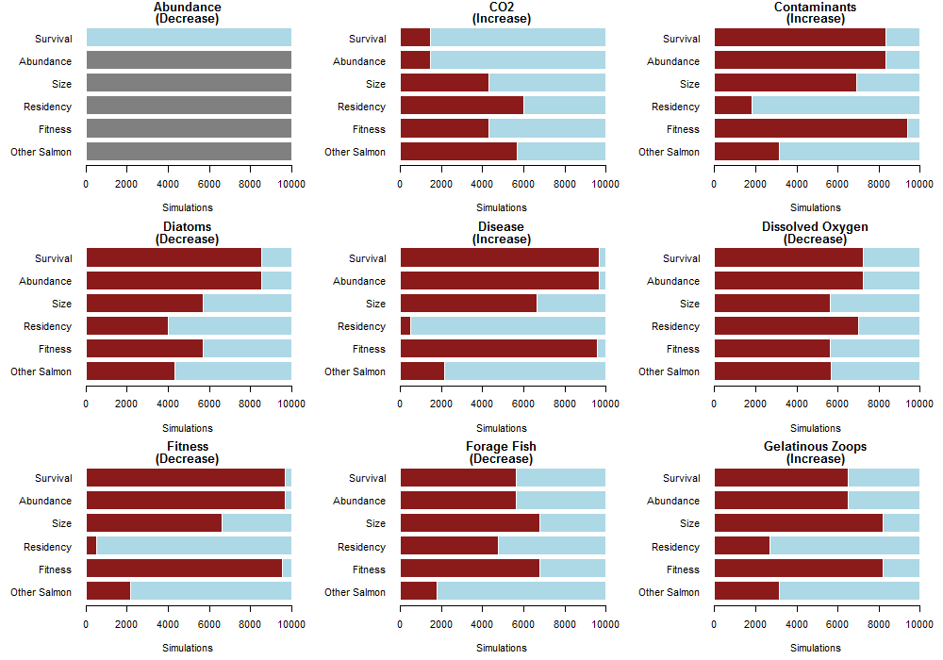

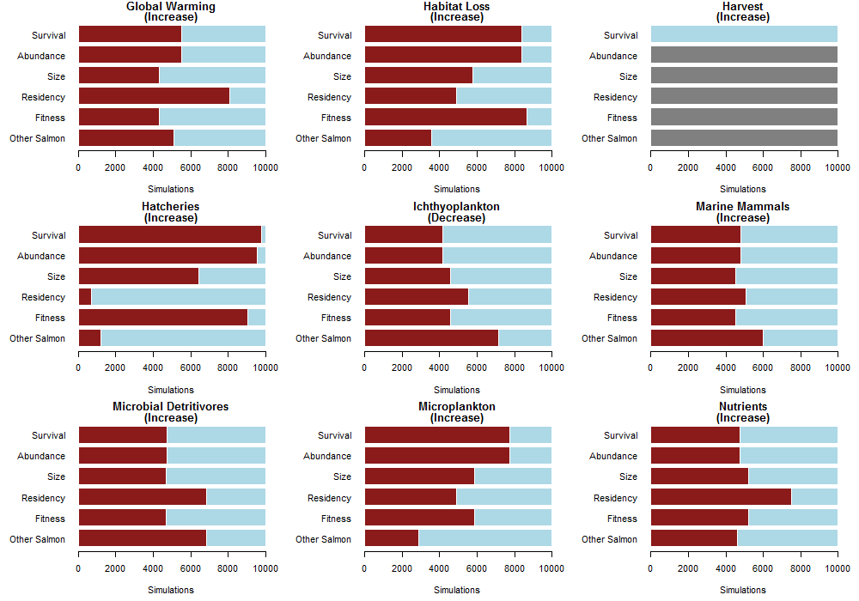
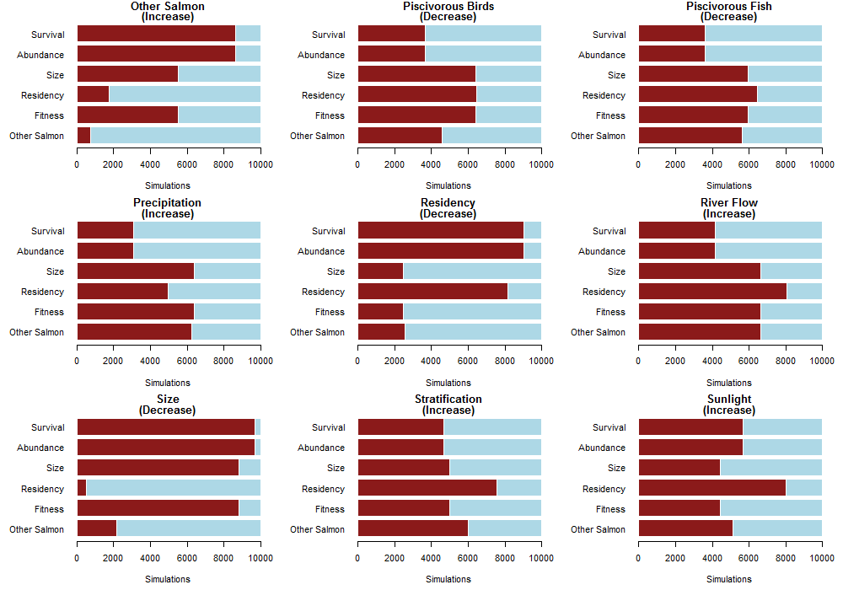

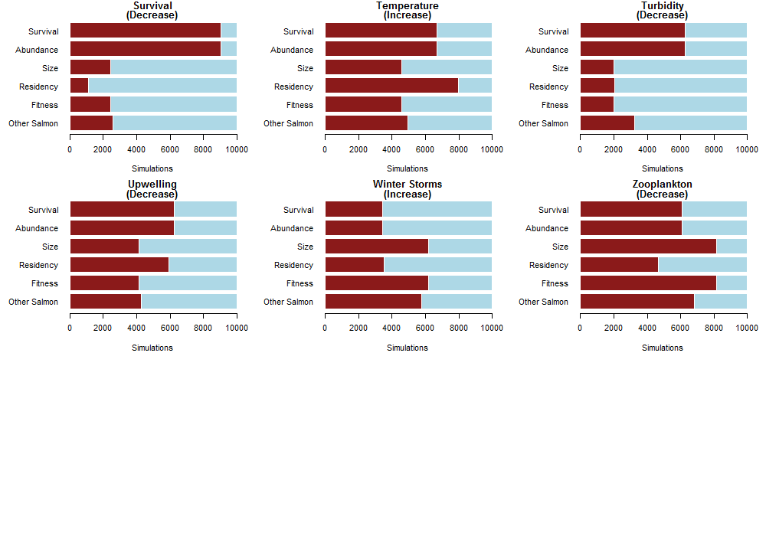

While impacts to upwelling are unknown, we invoked a decrease in upwelling because it would reduce the delivery of nutrients to Puget Sound and potentially disrupt primary production.
Decreased mixing as a result of changes in freshwater flow could lead to increased stratification; while the exact response is unknown (see Mauger et al. 2015), we have invoked an increase in stratification because decreased mixing would likely lead to declines in primary productivity.
River flow is projected to be higher during the winter/spring period of salmon outmigration, but lower in the summers due to decreased precipitation and higher temps. during this season (Littell et al. 2009).
While it is unknown if total abundance of zooplankton has decreased, there is some indication that the community has shifted. We invoked a decrease in zooplankton to reflect this shift.
Harvest has decreased over the time period we used to frame this analysis; however, we were interested in the impacts of increased harvest on salmon survival so invoked an increase in harvest as the perturbation

