Appendix S3 - MYRLIN: Data input and species grouping.
Model Description
Methods of Yield Regulation with Limited Information (MYRLIN; Figure S3.1) is a toolkit comprising of three tools designed to calculate timber yield for forests using limited information (Alder et al. 2002). MYRLIN is based upon a simple diameter-class projection (Wright & Alder 2000) which allows the projection of stand tables in order to estimate growth rates. MYRLIN is directed at organisations with a limited research base of information on forest dynamics (van Gardingen 2003).

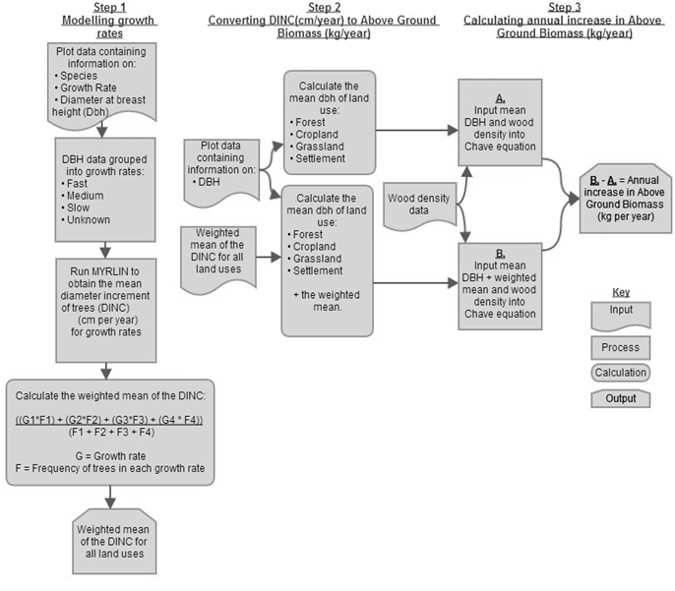
Figure S3.1 Schematic of the MYRLIN methodology.

Table S3.1 Main functions of the MYRLIN #1 tool and values inputted into the model. Adapted from Nicol et al. (2002).
Function and Features | Comment | Values used
PlotData  Data can be stratified by suitable column in the plot data (dbh/species/tree id.) as required. | PlotData  Stratum (land use category), Plot number, tree number, species vernacular name and tree diameter data were inserted into PlotData sheet. | N/A
SpList  Species vernacular name and scientific name can be entered but are not used by MYRLIN. A species group column is needed to reflect difference in ecology.  Species list can be sorted by Genus/Species or grouped by growth rate. | SpList  Species vernacular and scientific name were entered into the sheet in addition to species groups:  - Fast  - Medium  - Slow  - Unknown | N/A
Areas  Macro StratumRecordCount can be used to calculate the number of records in each sample plot. | Areas  Area (ha) of plots is required. | 0.04ha
StandTables  The following area units can be used:  - Stems per km²  - Stems per ha  - Basal area per ha  Flexible diameter limits can be employed within the stand tables. | StandTables  Stems per km² was chosen. | Diameter classes were changed to include trees over 0.5cm dbh.  Diameter class widths of 10cm were chosen.

Methodology
The MYRLIN toolkit comprises three Microsoft Excel workbooks with embedded macros. MYRLIN #1 and MYRLIN #2 were utilised in this study (Figure A3.2)
Figure S3.2 Flowchart of displaying the main data inputs and process of the MYRLIN toolbox.

MYRLIN #1
MYRLIN #1 uses inventory plot data to produce stand tables, required for modelling tree growth rates. Tree diameter at breast height (dbh), species name and grouping value and area of plot are the input data required (Table S3.1).

MYRLIN #2
MYRLIN #2 uses the data from MYRLIN #1 to estimate annual diameter increment (Dinc) for each species group (Table S3.2). This is based upon the mean regression of worldwide tropical forest data (Alder et al. 2002).

Table S3.2 Main functions of the MYRLIN #2 tool and values inputted into the model. Adapted from Nicol et al. (2002).
Function and Features | Comment
Species group values can be adjusted on the graph based on knowledge of ecological characteristics. | Species growth rates adjusted to fit ecological characteristics:  - Fast growth = blue line  - Medium growth = red line  - Slow growth = yellow line  Trees with unknown growth rates were left as default as ecological characteristics could not be determined.

References
Alder, D., Baker, N., and Wright, H.L. 2002. MYRLIN: Simple tools for yield regulation in tropical forests. Working Document of the University of Oxford. Oxford Forestry Institute Research Project, UK.
Nicol, G., Singh, J., and Khan, T. 2002. Methods of yield regulation in tropical mixed forests: pilot studies using MYRLIN and SYMFOR in Guyana. DFID, Guyana Forestry Commission.
van Gardingen, P.R. 2003. Regulating the yield of goods and services from forests: Developing tools to support management decisions and policy development for multiple objective forest management. Pages 307-319 in A. Amaro, D. Reed, P. Goares, editors. Modelling Forest Systems. CABI publishing, Oxon, UK.
Wright, H.L. and Alder, D. 2000. Proceedings of a Workshop on Humid and Semi-humid Tropical Forest Yield Regulation with Minimal Data. OFI occasional papers, No. 52, Oxford Forestry Institute, Oxford, UK.

