Dear Participant:

Your involvement in this study will help us understand decisions about conserving nature in North America. The survey should take no longer than 10-15 minutes. Please note that participation is voluntary and you can choose to stop participating at any point during the study. The survey is anonymous and no one will know what answers you give. This research is for residents of the United States over the age of 18; if you are not a resident of the United States and/or under the age of 18, please do not complete this survey. There is a limit of one survey per person.

Thank you for agreeing to participate in our research. If you have any questions, please do not hesitate to send us an email at: survey.iub@gmail.com.

Sincerely,
Dr. Michelle Lute and Dr. Shahzeen Attari

[page break—case studies randomly presented—Vignette 1: Owls]

In the Pacific Northwest, decades of habitat loss have caused northern spotted owls to decline in number and become endangered. In more recent years, another species of owl, the more common barred owl, has expanded into spotted owl range. Barred owls can outcompete spotted owls for food and space.

Two separate groups suggest different responses to this issue:

- Some people suggest that killing barred owls may help spotted owls. They believe habitat protection and restoration is too difficult, expensive and would undermine local economies dependent on logging.

- Others object to killing barred owls on the grounds that the ultimate cause of spotted owl declines is habitat loss brought on by humans, not competition with barred owls. They believe habitat protection and restoration is worth the effort and expense.

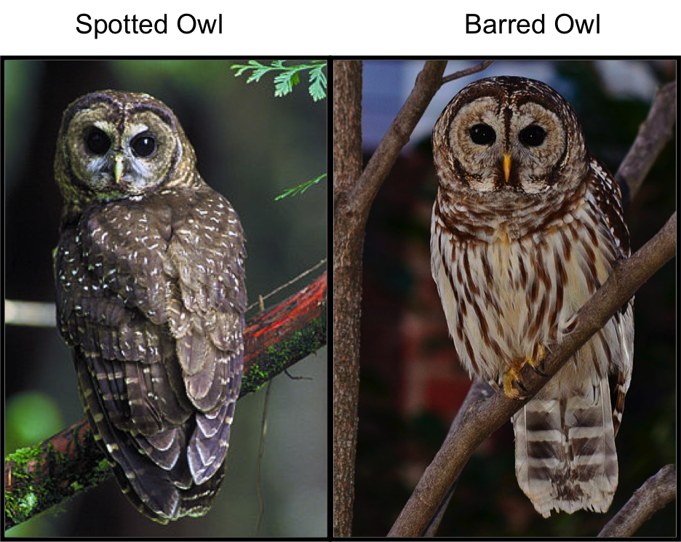

Which of the following responses do you believe is most appropriate? [forced response]
- Barred owls should be killed.
- Spotted owl habitat should be protected and restored.
- Both of the above actions should be taken.
- No action should be taken.

[page break]

How important were the following considerations in your decision? [forced response]
 |  | Not at all Important | Somewhat Unimportant | Neutral | Somewhat Important |  | Very Important
Being consistent with moral principles
Doing what is best for the economy
Doing what is best for the ecosystem
Doing what is practical
Maximizing benefits while minimizing costs

[page break]
BARRED OWL
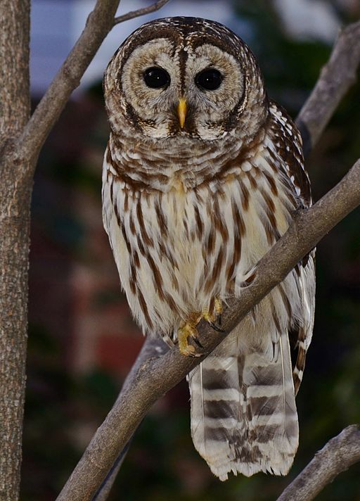

To what extent do you agree or disagree with the following descriptions of BARRED OWLS? [forced response]
 |  | Strongly disagree | Disagree | Neither agree nor disagree | Agree | Strongly agree | I don’t know
Attractive
Dangerous
Endangered
Nuisance
Familiar to me
Important to the economy
Important to the ecosystem

[page break]
SPOTTED OWL
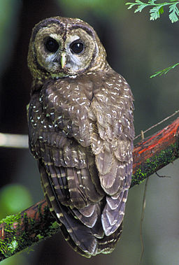

To what extent do you agree or disagree with the following descriptions of SPOTTED OWLS? [forced response]
 |  | Strongly disagree | Disagree | Neither agree nor disagree | Agree | Strongly agree | I don’t know
Attractive
Dangerous
Endangered
Nuisance
Familiar to me
Important to the economy
Important to the ecosystem

[page break—case studies randomly presented—Vignette 2: Sea Lions]

California sea lions along the west coast of North America have rebounded as a result of past conservation efforts (that are no longer ongoing). Sea lions eat salmon, which have been declining in recent years and are important for regional livelihoods and economies. Salmon population declines are attributed to human consumption and habitat degradation.

Two separate groups suggest different responses to this issue:

- Some people suggest that sea lions be killed to reduce their impact on salmon fisheries. They emphasize protecting the economic and human health benefits of sustainable salmon fisheries.

- Others object to killing sea lions for reasons such as sea lions’ right to exist and their important role as predators in the ecosystem. They believe both salmon and sea lions can be protected by restoring and protecting shared habitat.
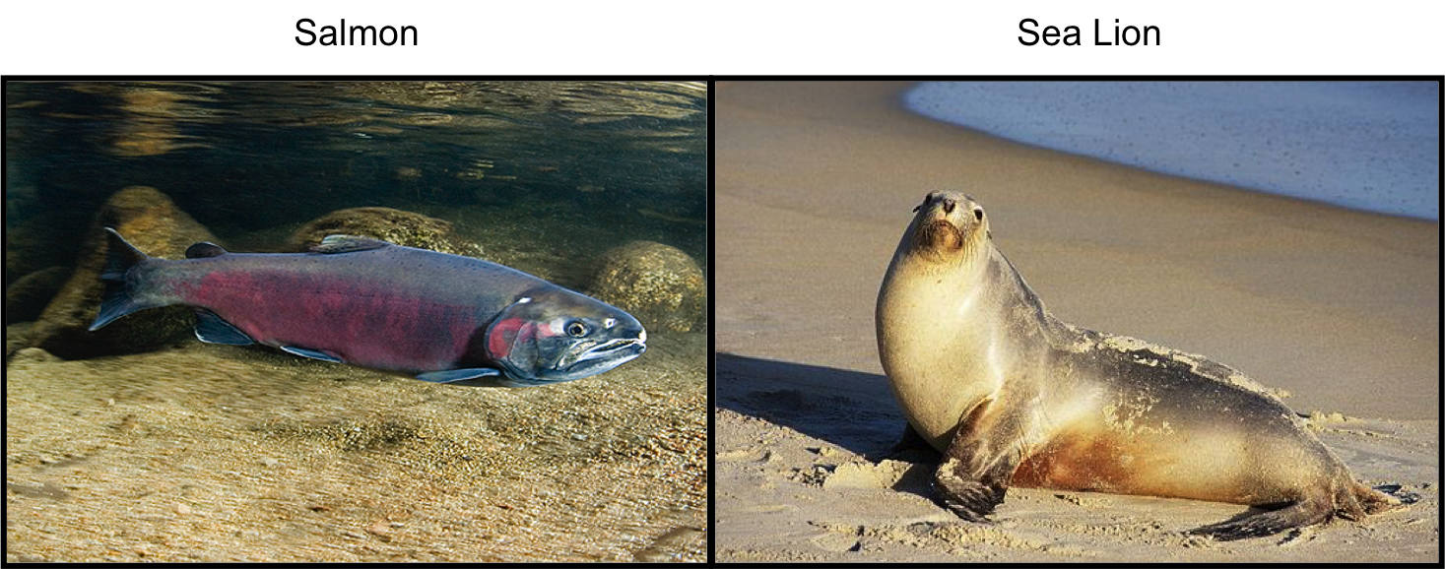

Which of the following responses do you believe is most appropriate? [forced response]
- Sea lions should be killed.
- Salmon habitat should be protected and restored.
- Both of the above actions should be taken.
- No action should be taken.

[page break]

How important were the following considerations in your decision? [forced response]
 |  | Not at all Important | Somewhat Unimportant | Neutral | Somewhat Important |  | Very Important
Being consistent with moral principles
Doing what is best for the economy
Doing what is best for the ecosystem
Doing what is practical
Maximizing benefits while minimizing costs

[page break]

SALMON
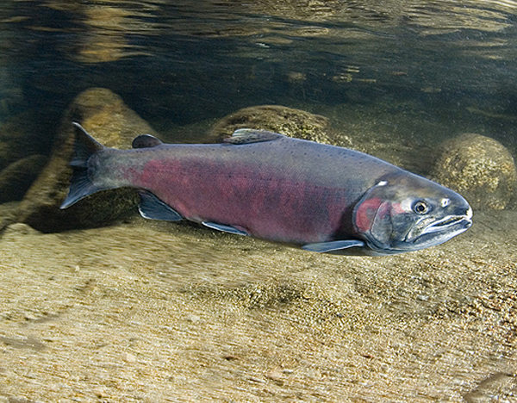

To what extent do you agree or disagree with the following descriptions of SALMON? [forced response]
 |  | Strongly disagree | Disagree | Neither agree nor disagree | Agree | Strongly agree | I don’t know
Attractive
Dangerous
Endangered
Nuisance
Familiar to me
Important to the economy
Important to the ecosystem

[page break]

SEA LION
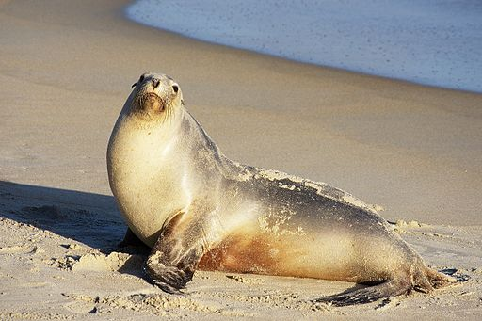

To what extent do you agree or disagree with the following descriptions of SEA LIONS? [forced response]
 |  | Strongly disagree | Disagree | Neither agree nor disagree | Agree | Strongly agree | I don’t know
Attractive
Dangerous
Endangered
Nuisance
Familiar to me
Important to the economy
Important to the ecosystem

[page break—case studies randomly presented—Vignette 3: Gray wolves]

Caribou herds are declining in British Columbia, Canada. Human activity such as energy development and logging have degraded caribou habitat. Natural predators such as wolves and bears may also affect caribou populations.

Two separate groups suggest different responses to this issue:

- Some people argue that gray wolves are having a significant impact on caribou populations and suggest that wolves be killed to protect caribou. They believe habitat protection and restoration is too difficult, expensive and would undermine local economies dependent on energy development.

- Others argue that habitat loss and degradation is the root of the problem and that killing wolves will do little to help caribou rebound. They believe both caribou and wolves can be protected by restoring and protecting shared habitat.

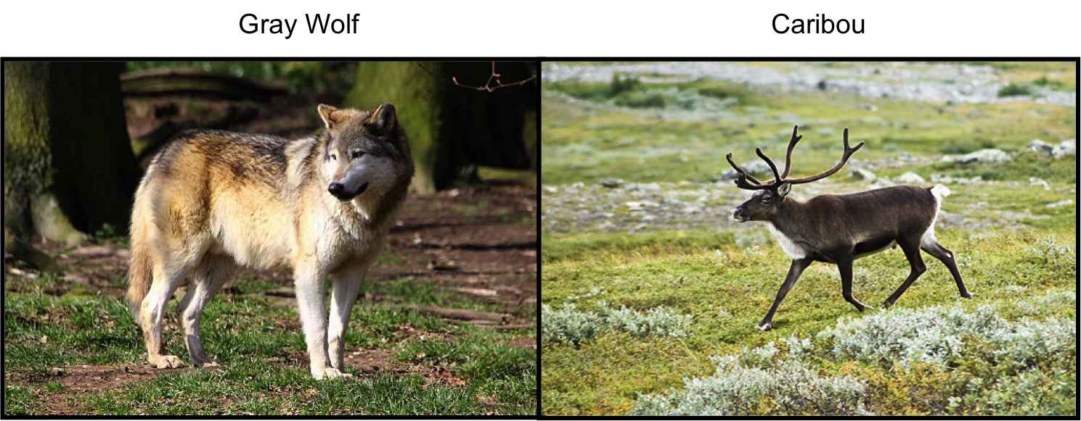

Which of the following responses do you believe is most appropriate? [forced response]
- Wolves should be killed.
- Caribou habitat should be protected and restored.
- Both of the above actions should be taken.
- No action should be taken.

[page break]

How important were the following considerations in your decision? [forced response]
 |  | Not at all Important | Somewhat Unimportant | Neutral | Somewhat Important |  | Very Important
Being consistent with moral principles
Doing what is best for the economy
Doing what is best for the ecosystem
Doing what is practical
Maximizing benefits while minimizing costs

[page break]

CARIBOU
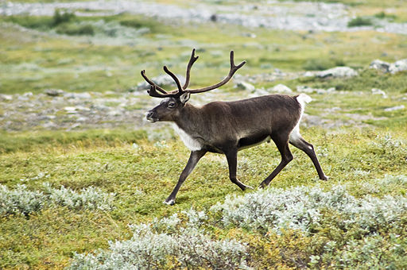

To what extent do you agree or disagree with the following descriptions of CARIBOU? [forced response]
 |  | Strongly disagree | Disagree | Neither agree nor disagree | Agree | Strongly agree | I don’t know
Attractive
Dangerous
Endangered
Nuisance
Familiar to me
Important to the economy
Important to the ecosystem

[page break]

WOLF
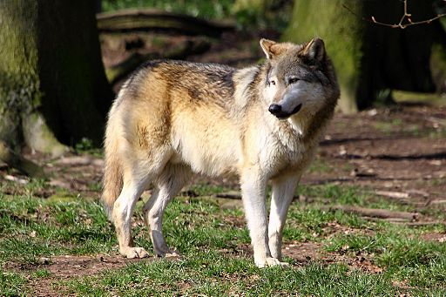

To what extent do you agree or disagree with the following descriptions of WOLVES? [forced response]
 |  | Strongly disagree | Disagree | Neither agree nor disagree | Agree | Strongly agree | I don’t know
Attractive
Dangerous
Endangered
Nuisance
Familiar to me
Important to the economy
Important to the ecosystem

[page break—case studies randomly presented—Vignette 4: Brown-headed cowbirds]

Brown-headed cowbirds exist throughout North America. Formerly restricted to prairies where bison roamed, cowbirds adapted and expanded as natural areas were converted for agriculture and domestic livestock replaced bison. Their life strategy includes laying eggs in the nests of other bird species like the endangered Kirtland’s warbler, who then rear cowbirds’ young to the detriment of their own young. Kirtland’s warbler populations have declined in part because their specific habitat requires wildfires that humans suppress.

Two separate groups suggest different responses to this issue:

- Some people believe that cowbirds may be contributing to the decline of the endangered Kirtland’s warbler, and should be killed to protect the warblers. People who like to bird-watch will travel to see warblers and in doing so support local economies.

- Others do not believe there is enough evidence that cowbirds contribute to the declines of warblers and point to habitat loss and degradation as the real reasons. They believe both cowbirds and warblers can be protected by restoring and protecting shared habitat.

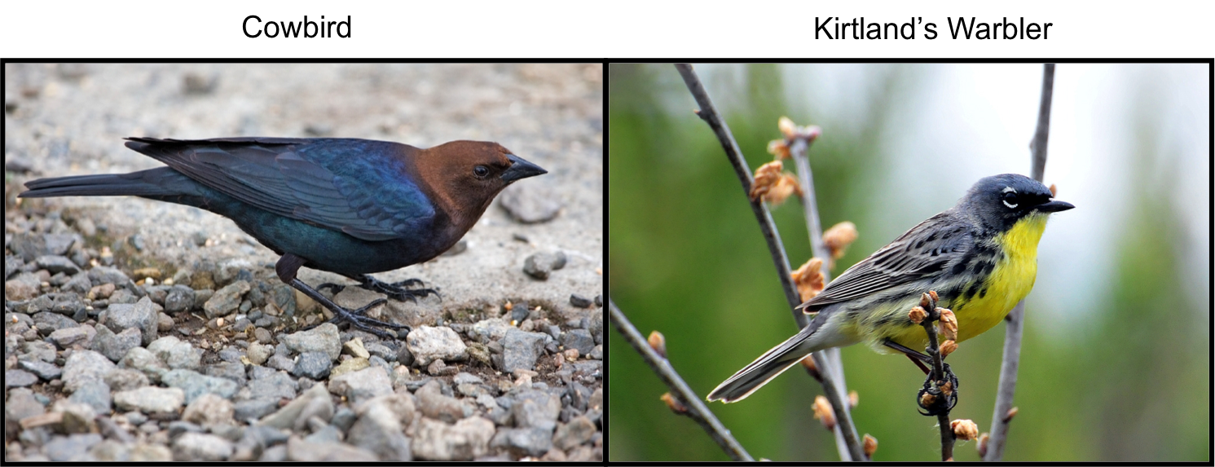

Which of the following responses do you believe is most appropriate? [forced response]
- Cowbirds should be killed.
- Warbler habitat should be protected and restored.
- Both of the above actions should be taken.
- No action should be taken.

[page break]

How important were the following considerations in your decision? [forced response]
 |  | Not at all Important | Somewhat Unimportant | Neutral | Somewhat Important |  | Very Important
Being consistent with moral principles
Doing what is best for the economy
Doing what is best for the ecosystem
Doing what is practical
Maximizing benefits while minimizing costs

[page break]

BROWN-HEADED COWBIRD
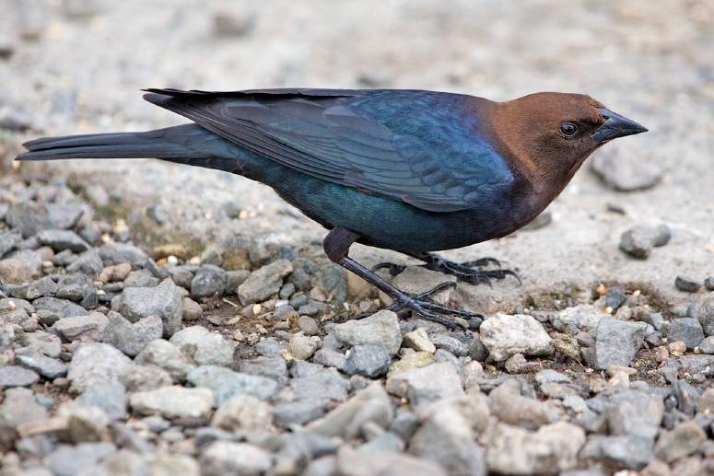

To what extent do you agree or disagree with the following descriptions of BROWN-HEADED COWBIRDS? [forced response]
 |  | Strongly disagree | Disagree | Neither agree nor disagree | Agree | Strongly agree | I don’t know
Attractive
Dangerous
Endangered
Nuisance
Familiar to me
Important to the economy
Important to the ecosystem

[page break]
KIRTLAND’S WARBLER
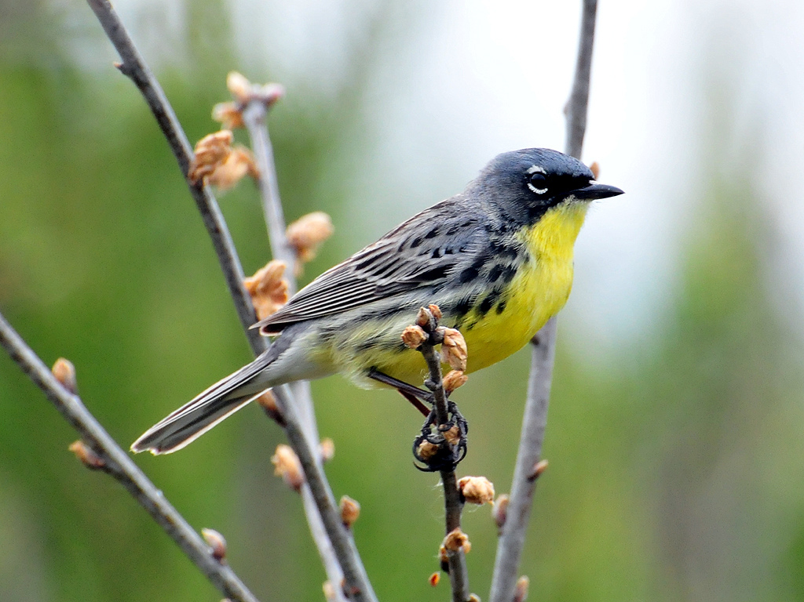

To what extent do you agree or disagree with the following descriptions of KIRTLAND’S WARBLERS? [forced response]
 |  | Strongly disagree | Disagree | Neither agree nor disagree | Agree | Strongly agree | I don’t know
Attractive
Dangerous
Endangered
Nuisance
Familiar to me
Important to the economy
Important to the ecosystem

[page break—case studies randomly presented—Vignette 5: Coqui frogs]

Coqui frogs were unintentionally introduced to Hawaii from Puerto Rico by humans. Coqui frogs have become established, reaching high densities in some areas. A potential meal for a coqui frog is the happy-face spider, a species only found in Hawaii. Happy-face spiders are not currently listed as endangered but maybe threatened by habitat loss.

Two separate groups suggest different responses to this issue:

- Some people are concerned that the frogs’ large appetite threatens the happy-face spider. The frog is also quite loud and people claim that may lower home values in areas where the frogs are dense. Therefore, people have suggested killing coqui frogs.

- Others object to killing the frogs because they enjoy hearing the frogs’ or believe that completely removing coqui frogs is unlikely.
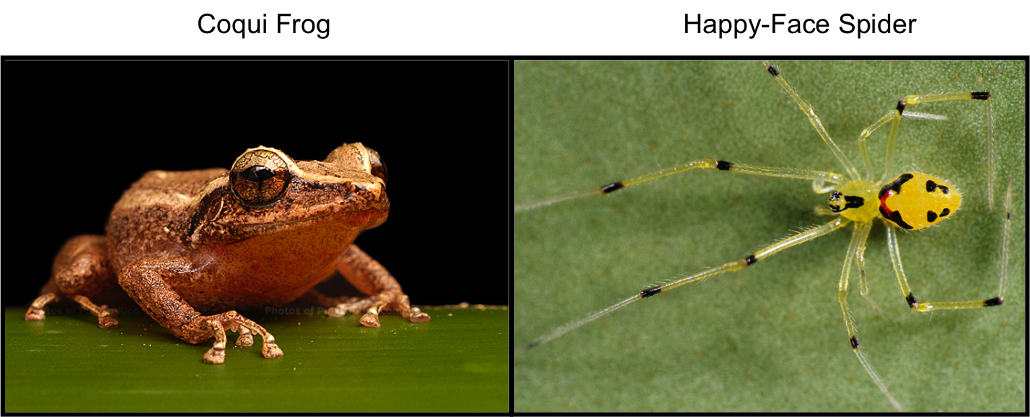
Which of the following responses do you believe is most appropriate? [forced response]
- Coqui frogs should be killed.
- Spider habitat should be protected and restored.
- Both of the above actions should be taken.
- No action should be taken.

[page break]

How important were the following considerations in your decision? [forced response]
 |  | Not at all Important | Somewhat Unimportant | Neutral | Somewhat Important |  | Very Important
Being consistent with moral principles
Doing what is best for the economy
Doing what is best for the ecosystem
Doing what is practical
Maximizing benefits while minimizing costs

[page break]

COQUI FROG
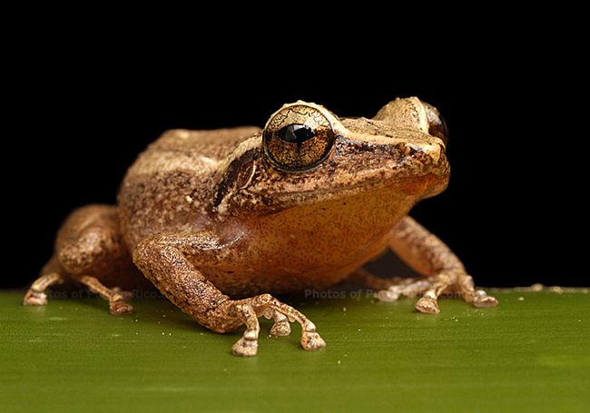

To what extent do you agree or disagree with the following descriptions of COQUI FROGS? [forced response]
 |  | Strongly disagree | Disagree | Neither agree nor disagree | Agree | Strongly agree | I don’t know
Attractive
Dangerous
Endangered
Nuisance
Familiar to me
Important to the economy
Important to the ecosystem

[page break]
HAPPY-FACE SPIDER
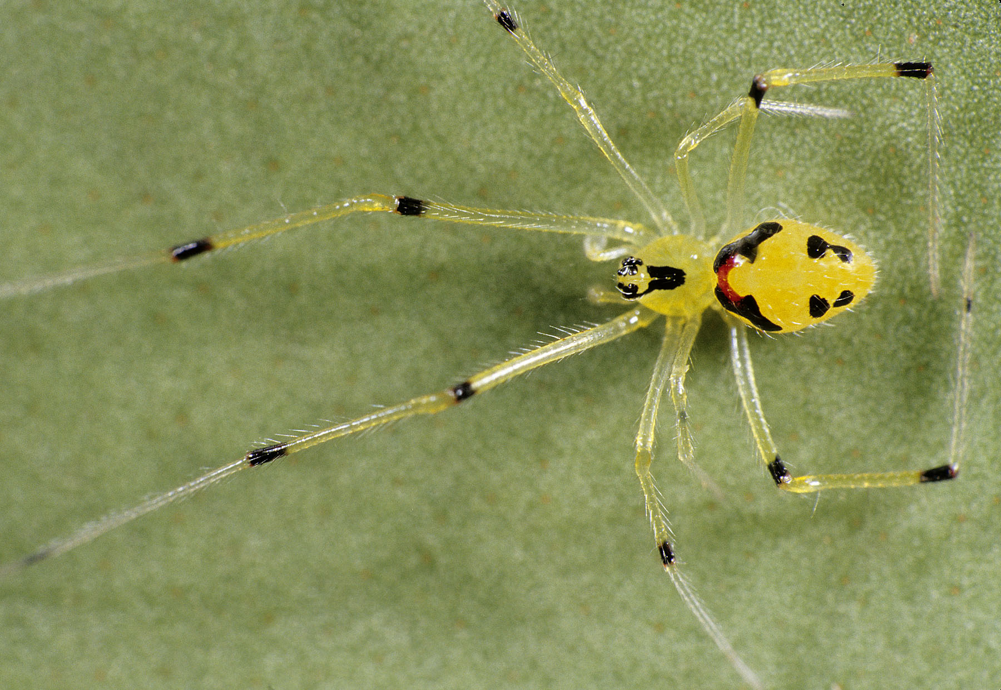

To what extent do you agree or disagree with the following descriptions of HAPPY-FACE SPIDERS? [forced response]
 |  | Strongly disagree | Disagree | Neither agree nor disagree | Agree | Strongly agree | I don’t know
Attractive
Dangerous
Endangered
Nuisance
Familiar to me
Important to the economy
Important to the ecosystem

[page break]

Generally speaking, it is more important for conservation to benefit nature, people or both? [forced response]
- Nature
- People
- Both

Where is it most important for conservation to occur? [forced response]
- My backyard (human-dominated areas)
- Protected areas (natural areas, away from people)
- Everywhere (human-dominated and natural areas)

On what levels should conservation activities focus? Please select all that apply. [forced response]
- Local
- Intermediate
- Global

What entities are important for conservation to protect? Please select all that apply. [forced response]
- Individuals
- Populations
- Species
- Ecosystems

[page break]

The following question is about intrinsic value, or the value of someone or something above and beyond its use to people.

To what extent do you agree or disagree that the following entities have intrinsic value? [forced response]
 |  | Strongly disagree | Disagree | Neither agree nor disagree | Agree | Strongly agree
Humans
Some animals
All animals
All living things
Ecosystems

[page break]

Below are a few questions about your background.

What is your age?
[Open-ended, forced response, numerical validation, restricted 18-110, 0 decimals] _______

What is your gender? [forced response]
- Male
- Female
- Other

What is the highest level of education you have attained? [forced response]
- Elementary / Middle school
- High school diploma
- Some college, but no degree
- Two-year degree / certificate
- Technical degree/ college
- Bachelor's degree
- Some graduate / professional school but no degree
- M.A. / Professional degree
- Ph.D. / M.D.

[page break]

How would you describe your political beliefs? [forced response]
- Very liberal
- Liberal
- Slightly liberal
- Moderate
- Slightly conservative
- Conservative
- Very conservative

During 2014, what was your yearly household income before tax? Your best estimate is fine. [forced response]
- None
- < $20,000
- $20,000 - $40,000
- $40,000 - $80,000
- $80,000 - $120,000
- $120,000 - $200,000
- > $200,000

What is your Zip code?
[Open-ended, forced response, US postal code validation]_______

[page break]

Do you have any additional thoughts or comments you would like to share with us? (Please fill in below.)
[Open-ended; not required] _______

[page break]

In order to get paid for the work you have done on this survey, you need to enter the following code in the box at the bottom of the Mechanical Turk page where you started once you close this survey.
Please copy and paste this code into the HIT: 776gfr${e://Field/confirm_code}

Thank you for completing this survey! Please press the next button to submit your responses.

