Balancing effective conservation with sustainable resource use in protected areas: precluded by knowledge gaps
NICOLA J. VAN WILGEN AND MELODIE A. MCGEOCH

Appendix 2

Quantification, analysis and supplementary results of resource compositional analyses and purposes for which resources were used across 19 national parks and three marine protected areas

Resource use composition
To compare the composition of terrestrial resources used across parks, non-metric multidimensional scaling (nMDS) was conducted on a park by resource presence-absence matrix (see main paper). One-way Analyses of Similarity (ANOSIM, Clarke & Warwick 2001) were conducted to identify potentially significant clusters of parks based on resource use composition by biome. Parks were categorized based on the dominant terrestrial vegetation biome (n=4 biomes) in which the park was present (Mucina & Rutherford 2006). Canonical Correspondence Analysis (CANOCO v 4.5, ter Braak & Smilauer 2002) was used to examine the role of park area (log₁₀ km²) and human population density surrounding the park (total density (log₁₀) across bordering quarter degree grid cells; Stats SA 1996) on resource use composition. Resources used from the three MPA’s associated with Table Mountain, West Coast and Garden Route were not included in all of the multivariate analyses because they were extremely different to the terrestrial parks, masking within-environment relationships.

Resource use was very different across parks (see main paper). Parks within biomes were mostly extremely different from each other with <10% similarity between parks within the Fynbos, Savanna and Succulent Karoo biomes. Nonetheless, resource use composition in parks in the Fynbos Biome was significantly different from parks in the Savanna Biome, whereas parks in the remaining biomes did not cluster significantly (Fig. S1). Resource use composition across the three parks in the NamaKaroo biome were by comparison much more similar at 43%. The marine resources used across the three parks with MPAs were on average more similar (27 - 44% Jaccard similarity) than their terrestrial counterparts. Parks did not cluster significantly by geographic region; the Global R (0.49) was significant (p<0.01), illustrating the large differences between individual parks. Park size and human population density together explained 16.7% of the variation in the composition of resources used across terrestrial parks (F=1.21, p = 0.05; Fig. S2).

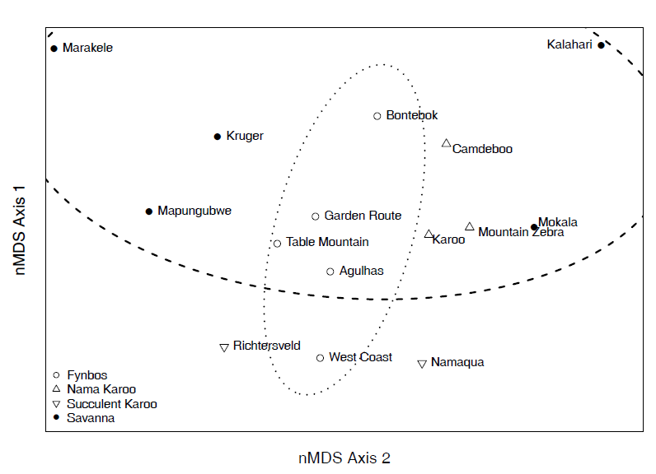
Figure S1 Relative similarity of resource use composition across national parks by biome showing large differences in species composition of resources used within and across parks and biomes. Non-metric multidimensional scaling ordination of Jaccard similarity indices, stress = 0.08; Fynbos Biome significantly different from Savanna Biome (R-statistic = 0.44, P<0.01; Global R = 0.35, P<0.05).
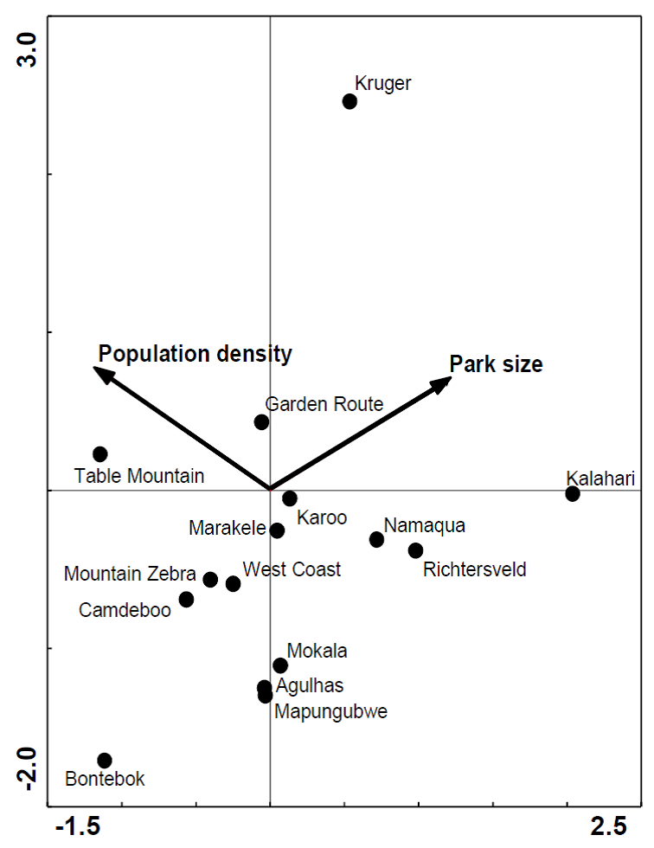

Figure S2 Contribution of park size and local human population density to explaining the composition of terrestrial resource use across national parks; canonical correspondence analysis ordination biplot (Axis 1: F = 1.31, p = 0.01; All axes: F = 1.21, p = 0.05).

Resource use purpose
The number of taxa used in ten different ‘purpose’ categories was calculated per park. The purposes included use of resources for food, fuel, grazing, handicrafts, thatch, timber, as well as for medicinal, ornamental (including cut-flower harvest and pet species) and recreational purposes and as bait (this use was limited to Marine Protected Areas and was only considered in certain analyses). Although use of resources for recreational purposes may be considered a motivation for resource use (along with for example financial gain or subsistence) rather than a ‘purpose’ of resource use per se, the distinction is not clear and species harvested for the principle motivation of recreation are often later consumed. Motivations for the use of particular resources were also often unclear and multiple and we therefore used ‘purpose of use’ rather than ‘motivation for use’ to categorise the resources harvested.

Most resources (230, or 67.3%) were harvested for a single purpose, while 29.2% and 3.2% were used for two and three (of 10 possible) purposes respectively. No resource was used for more than three purposes. The most common purposes for which resources were harvested were use in traditional medicine or rituals (38.9% of all resources) and food (38.1%, Fig. S3a). Recreational fishing was also important, although many of the species fished recreationally were also used as a source of food or as bait. Large scale commercial harvest occurred mainly in MPAs, but timber harvest from Garden Route also fell in this category. Most harvested resources, especially traditional medicines, were used for subsistence or sale on a small, informal scale. Subsistence resource use also included opportunistic applications from local communities for use of resources like whale fat from beached whales. Parks that were outliers in terms of disproportionately large numbers of resources used for a particular purpose were the Garden Route (52 medicinal resources and 14 timber) and Table Mountain (31 ornamental resources). Parks that were comparative outliers in terms of high frequencies of particular resource use purposes within their biome were Namaqua (Succulent Karoo biome) with 23 and 13 resources used for ornamental and food purposes respectively, and Kalahari (Savanna biome) with 31 resources used for medicinal purposes.

The diversity of resource use purposes across parks was more similar in general than resource use composition across parks (see results), with greater than 70 % similarity (Bray Curtis) between several pairs of parks (e.g. Table Mountain and Agulhas, Mountain Zebra and Karoo). The diversity of resource use purposes at Richtersveld was least similar to other parks, at an average similarity of between 0 and 40%. The similarity (Bray Curtis) of resource use purposes within biomes ranged from a low of 23.6 % between the two Succulent Karoo parks, to 61.8 % similarity across the three Nama Karoo parks (Fig. S3b). Similarity in the purpose of harvest across the three MPAs was 86.7%. There were however no significant differences in resource use purposes between biomes (Global R=0.13, P=0.15) or regions (Global R =0.07, P=0.31).

References
Clarke, K.R. & Warwick, R.M. (2001) Change in marine communities: an approach to statistical analysis and interpretation, 2nd edition. PRIMER-E, Plymouth.
Mucina, L. & Rutherford, M.C. (2006) The vegetation of South Africa, Lesotho and Swaziland. South African National Botanical Institute, Pretoria.
Stats SA, 1996. Population census, 1996. Statistics South Africa, www.statssa.gov.za.
ter Braak, C.J.F. & Smilauer, P. (2002) CANOCO Reference Manual and CanoDraw for Windows User's Guide: Software for Canonical Community Ordination (version 4.5).

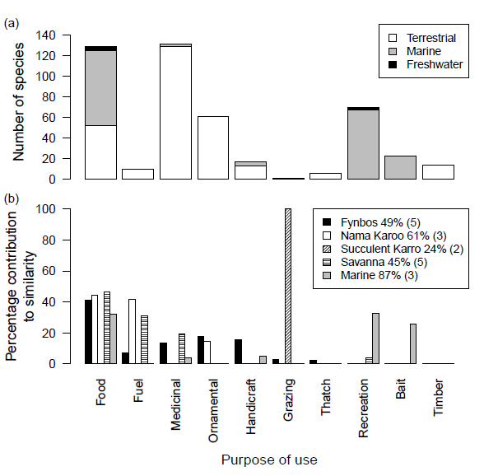
Figure S3 (a) Frequency of purposes for which each of the 341 resources harvested within parks is used. Resources are split according to their domain (terrestrial, marine (including estuarine species) or freshwater) and certain resources are used for more than one purpose. (b) Percentage contributions of resource use purposes to the similarity (Bray Curtis) of parks within biomes. Percentages next to biome names are the average similarity values between parks within that biome (number of parks in brackets). Timber had no values > 0%.

