**The legacy of a crowded ocean: indicators, status, and trends of anthropogenic pressures in the California Current ecosystem**

KELLY S. ANDREWS, GREGORY D. WILLIAMS, JAMEAL F. SAMHOURI, KRISTIN N. MARSHALL, VLADLENA GERTSEVA AND PHILLIP S. LEVIN

**APPENDIX 3**

**PRINCIPAL COMPONENTS AND DYNAMIC FACTOR ANALYSES**



**Figure S25** Scree plot of principal components. PC5 had an eigenvalue < 1.0 suggesting that only PC1-4 were statistically relevant.

**Table S2** Principal Component loadings for 15 pressures that had data from 1994 to 2008. Bold values indicate the principal component that each pressure is most closely correlated with.

|  |  |  |  |  |
| --- | --- | --- | --- | --- |
| **Pressure** | **PC1** | **PC2** | **PC3** | **PC4** |
| Aquaculture: finfish | **-0.64** | 0.22 | 0.14 | 0.48 |
| Aquaculture: shellfish | **-0.54** | -0.22 | 0.51 | -0.35 |
| Atmospheric pollution | -0.10 | **0.76** | -0.22 | -0.49 |
| Benthic structures | **0.91** | -0.01 | 0.00 | -0.13 |
| Coastal engineering | **-0.95** | 0.07 | 0.05 | 0.10 |
| Fisheries removals | -0.21 | -0.14 | **-0.85** | 0.29 |
| Freshwater retention | **-0.90** | 0.32 | -0.10 | 0.16 |
| Inorganic pollution | **-0.54** | -0.53 | -0.47 | -0.32 |
| Invasive species | -0.08 | **-0.80** | 0.16 | 0.39 |
| Light pollution | **0.95** | -0.21 | -0.04 | 0.02 |
| Nutrient input | **-0.81** | -0.32 | 0.14 | -0.14 |
| Oil & gas activities | **0.96** | -0.14 | -0.04 | -0.01 |
| Organic pollution | **-0.56** | -0.48 | -0.31 | -0.40 |
| Seafood demand | **-0.85** | -0.20 | 0.23 | -0.17 |
| Sediment retention | **-0.90** | 0.32 | -0.10 | 0.16 |

**Variance-covariance matrix options for the dynamic factor analysis (DFA)**

The variance-covariance matrix (R matrix) in the DFA describes the observation error structure of the set of time series. In the MARSS package (Holmes *et al.* 2012), there are five common R matrix structures built-in: identity, diagonal and equal, equal variance-covariance, diagonal and unequal, and unconstrained. The simplest is ‘identity’ which is an identity matrix in which the response variables (each time series) all have variance of 1 and are uncorrelated:

$$R=\left[\begin{matrix}1 & 0 & 0 \\ 0 & 1 & 0 \\ 0 & 0 & 1\end{matrix}\right]$$

‘Diagonal and equal’ is a diagonal R matrix in which the response variables all have the same variance and are uncorrelated:

$$R=\left[\begin{matrix}σ^{2} & 0 & 0 \\ 0 & σ^{2} & 0 \\ 0 & 0 & σ^{2}\end{matrix}\right]$$

‘Equal variance-covariance’ is a diagonal R matrix in which the response variables all have the same variance and are correlated with the same covariance:

$$R=\left[\begin{matrix}σ^{2} & β & β \\ β & σ^{2} & β \\ β & β & σ^{2}\end{matrix}\right]$$

‘Diagonal and unequal’ is a diagonal R matrix in which the response variables have unique variances and are uncorrelated:

$$R=\left[\begin{matrix}σ_{1}^{2} & 0 & 0 \\ 0 & σ_{2}^{2} & 0 \\ 0 & 0 & σ_{3}^{2}\end{matrix}\right]$$

‘Unconstrained’ is a non-diagonal R matrix in which there are unique variance and covariance values for each response variable:

$$R=\left[\begin{matrix}σ_{1}^{2} & σ_{1,2} & σ_{1,3} \\ σ_{1,2} & σ_{2}^{2} & σ_{1,2} \\ σ_{1,3} & σ_{2,3} & σ_{3}^{2}\end{matrix}\right]$$

We tested the appropriateness of each R matrix structure to determine which best explained our set of time series. The indicator time series for anthropogenic pressures consist of data measured and sampled using numerous methods across various scales of time and space. Some of these indicators take advantage of similar data sets and may be correlated. Thus, our expectation was that the ‘unconstrained’ R matrix would be most appropriate. However, the ‘unconstrained’ structure caused the solution to become unstable and parameters were not identifiable in all models. We attempted to limit the dataset by removing time series that did not resemble a random-walk (e.g., freshwater retention, coastal engineering), but even the model with no covariates and 1 trend became unstable and provided no solution. It is likely that we did not have enough data in several of the time series to estimate the large number of parameters in this type of unconstrained model. Due to these limitations, we removed ‘unconstrained’ from the analysis.

Models using the ‘diagonal and unequal’ R matrix suffered from similar issues. Models with 2 or fewer trends with and without covariates could be solved when we limited the dataset by removing time series that did not resemble a random walk, but models with > 2 trends became unstable as estimates of variance for various pressures became negative. We attempted to solve this problem by fixing the variance of pressures that went negative to very small values (0.00001), but subsequently the variance of other pressures went negative, the models became unstable and crashed. Due to these complications, we removed ‘diagonal and unequal’ from the analysis also.

The final set of models tested and presented in the main text of the manuscript compared the remaining three R matrix structures (‘identity’, ‘diagonal and equal’, and ‘equalvarcov’). It is plausible that the more complex ‘unconstrained’ or ‘diagonal and unequal’ R matrix structures would be most appropriate for an analysis of common trends among time series that no doubt vary dramatically in observation and measurement error. However, for various reasons (perhaps lack of data to estimate the large number of parameters) these time series could not be fit to a full set of models (using 1-5 trends) using these error structures, so we used simpler error structures to determine the best model in our final results.

Of the ‘diagonal and unequal’ models that ran (1-2 trends) using a subset of pressures (removed freshwater and sediment retention and coastal engineering), the best model was 2 trends with population as a significant covariate. This model produced a solution with common trends (Fig. S26) that were similar to the common trends we found in the best ‘diagonal and equal’ model (4 trends with no covariates; Table 3 in manuscript). Thus, we feel that limited data in some of the indicator time series may have precluded the use of the more complex R matrix structures, but it did not change the ultimate results we found using the less complex R matrix structure (‘diagonal and equal’).



**Figure S26** Common trends identified from dynamic factor analysis using 20 pressures (removed freshwater and sediment retention and coastal engineering) and time-series data from 1985 to 2011.

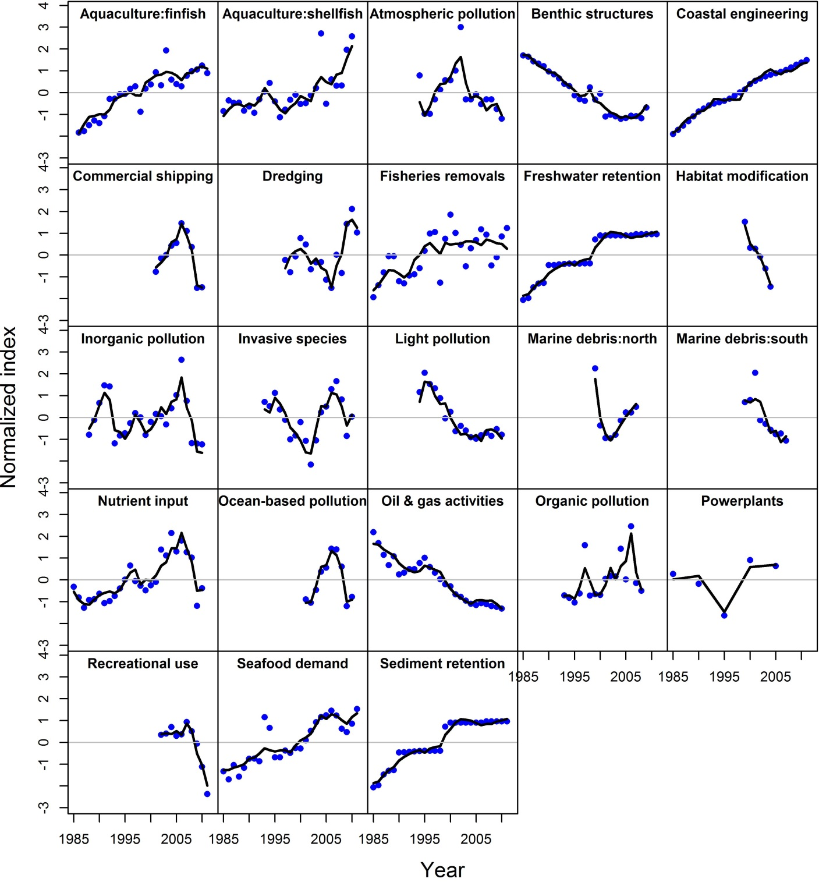**Figure S27** Model fits (black lines) to each pressure time series (blue points) for the dynamic factor analysis model with four common trends, ‘diagonal and equal’ R matrix and no covariates. Grey line shows the zero-line.



**Figure S28** Venn diagram showing factor loadings for each pressure relative to all four trends. Positive (+) or negative (-) loadings are distinguished for pressures that loaded significantly (>2) on only one trend. Aff: finfish aquaculture, Ash: shellfish aquaculture, AP: atmospheric pollution, BS: benthic structures, CE: coastal engineering, CS: commercial shipping activity, Dr: dredging, FR: fisheries removals, FW: freshwater retention, H: habitat modification, Ip: inorganic pollution, IS: invasive species, L: light pollution, MDn: marine debris (north), MDs: marine debris (south), NI: nutrient input, ObP: ocean-based pollution, Oil: oil and gas activities, Op: organic pollution, PP: power plant activity, R: recreational beach use, SD: seafood demand, SR: sediment retention.

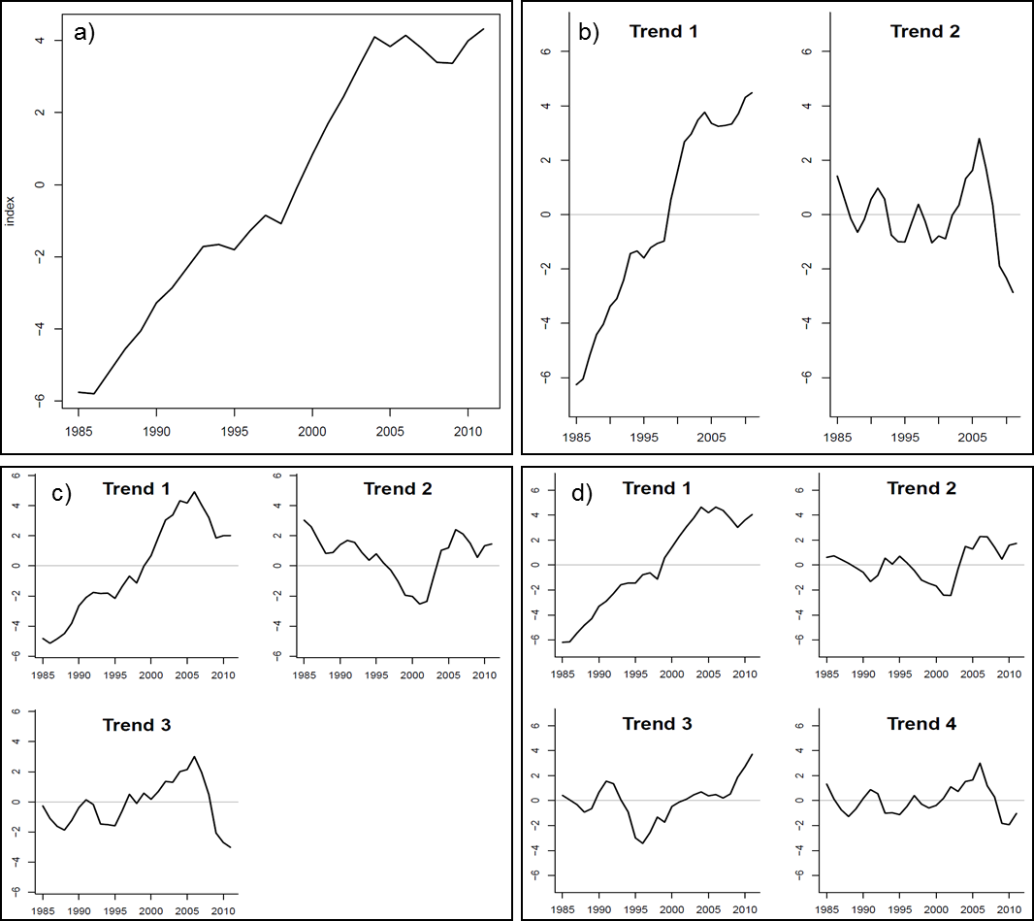

**Figure S29** Common trends in dynamic factor analysis models using all 23 anthropogenic pressure indicator time series, ‘diagonal and equal’ R matrix, no covariates, and a) one, b) two, c) three or d) four common trends. The four common trends model was the best model based on model selection criteria (AICc). Because all trends are estimated simultaneously, we cannot statistically determine which trend is most important; however, it appears that trend 1 explains the greatest amount of variation in this set of time series since it is the trend identified in the 1-trend model and remained relatively unchanged in the 2-, 3- and 4-trend models (Zuur *et al.* 2003*a*).