The legacy of a crowded ocean: indicators, status, and trends of anthropogenic pressures in the California Current ecosystem

KELLY S. ANDREWS, GREGORY D. WILLIAMS, JAMEAL F. SAMHOURI, KRISTIN N. MARSHALL, VLADLENA GERTSEVA AND PHILLIP S. LEVIN

APPENDIX 2

DESCRIPTIONS, SELECTION, STATUS AND TRENDS OF INDICATORS FOR EACH PRESSURE

Summary

The 23 pressures we chose were based primarily on pressures identified in spatial analyses by Halpern et al. (2009) and by vulnerability analyses by Teck et al. (2010). While there are many other pressures that could be considered that are both specific and general to various habitats within the California Current ecosystem (CCE), we decided to use pressures that have been considered in spatial analyses across the entire CCE. Additional pressures can be added to this framework as new data becomes available or as links between other pressures and ecosystem variables are defined.
We evaluated 44 indicators across 23 anthropogenic pressures. These 41 indicators were chosen based on initial searches of the literature for potential proxies of respective pressures. Each indicator was then formally evaluated with the indicator selection framework developed and used by Levin et al. (2011), Kershner et al. (2011) and James et al. (2012). We evaluated each indicator according to 18 criteria, using the scientific literature to determine whether there was support for each criterion for each indicator. This resulted in a matrix of references and notes with a corresponding value of literature support (1 for ‘support’, 0.5 for ‘ambiguous support’, 0 for ‘no support’; see Table S1). These values of literature support were summed across criteria for each indicator and the highest scoring indicator was chosen for each pressure. If only 1 indicator was evaluated for a particular pressure, it was only selected if it scored at least 3 points within the ‘Primary considerations’ criteria and had a minimum of 5 years of data. One pressure (disease) was removed from the analyses because we could not find any indicators that met the above criteria, so we ended up with 43 indicators across 22 pressures.

Aquaculture

Background

The increased demand for seafood products in conjunction with declines in capture fisheries has led to worldwide increases in commercial aquaculture (Naylor et al. 2000; Sequeira et al. 2008). Aquaculture provides several socio-economic benefits including improved nutrition and health and the generation of income and employment (Barg 1992). Environmental benefits of aquaculture include the prevention and control of aquatic pollution because of the inherent need for good water quality, the removal of excess nutrients and organic matter in eutrophic waters from the filtering action of molluscs and seaweeds, and the removal of incorporated nitrogen by shellfish when individuals are harvested (Barg 1992; Shumway et al. 2003). However, environmental impacts resulting from aquaculture production include: (1) impacts to the water quality from the discharge of organic wastes and contaminants; (2) seafloor impacts; (3) introductions of exotic invasive species; (4) food web impacts; (5) gene pool alterations; (6) changes in species diversity; (7) sediment deposition; (8) introduction of diseases; (9) habitat replacement or exclusion; and (10) habitat conversion (Johnson et al. 2008).
The impacts of aquaculture operations on various components of the CCE vary according to the species cultured (finfish or shellfish), the type and size of the operation, and the environmental characteristics of the site (Johnson et al. 2008). Finfish aquaculture generally occurs in large cage and floating net-pen systems that release excess food and waste directly into the environment, whereas shellfish aquaculture is generally associated with benefits to water quality aspects (Shumway et al. 2003). The relative impact of finfish and shellfish aquaculture also differs depending on the foraging behaviour of the cultured species. Finfish require the addition of a large amount of feed into the ecosystem, which can result in environmental impacts from the introduction of the feed, but also from the depletion of species harvested to provide the feed. Bivalves are filter feeders and typically do not require food additives; however, faecal deposition can result in benthic and pelagic habitat impacts, changes in trophic structure and nutrient and phytoplankton depletion (Dumbauld et al. 2009). Aquaculture activities can affect fisheries at both a habitat and species-level. Planting of culture species, harvesting practices and structure placement can alter the habitat as well as the community composition of the seafloor (Goldburg & Triplett 1997; Ruesink et al. 2005; Bendell-Young 2006; Dumbauld et al. 2009)
Growing USA and worldwide demand for seafood is likely to continue as a result of increases in population and consumer awareness of seafood’s health benefits. The most recent federal Dietary Guidelines for Americans (DGAC 2010) recommend Americans more than double their current seafood consumption. Because wild stocks are not projected to meet increased demand even with rebuilding efforts, future increases in supply are likely to come either from foreign aquaculture or increased domestic aquaculture production, or some combination of both (NOAA Aquaculture Draft Policy).

Evaluation and selection of indicators

Based on differences in the suite of impacts caused by different types of aquaculture, we have separated finfish and shellfish aquaculture and selected indicators for each. For finfish aquaculture, we evaluated 3 indicators (Table S1): finfish production, hectares of area used, and the amount of wild fish needed to feed aquaculture fish. For shellfish aquaculture, we evaluated 3 indicators (Table S1): Total USA shellfish production, CCE shellfish production and hectares of land leased by shellfish growers.
For both types of aquaculture, production estimates evaluated as the best indicator for measuring the status and trends of aquaculture activities in the CCE primarily because production values are a direct measure of the intensity of aquaculture operations, whereas indicators such as hectares of land will not reflect advances in technology and growing capabilities over time. For finfish, the only marine netpen operations in the CCE occur in Washington State. Data are available from the Washington Department of Fish & Wildlife (WDFW) for the years 1986-present. For shellfish production, ‘Total USA shellfish production’ evaluated higher than ‘CCE shellfish production’ for two reasons: (1) Washington State produces the most shellfish aquaculture in the United States and produces ~86% of shellfish on the West Coast (based on two years of data available from Washington); thus, total USA estimates should reflect the primary status and trend of shellfish aquaculture production in the CCE, and (2) Shellfish production data are collected by the California Department of Fish and Game and the Oregon Department of Agriculture, but these data are not collected by any state agency in Washington; thus, values from CA and OR may not reflect the actual status and trends of shellfish aquaculture in the CCE since WA represents 86% of production on the West Coast. Two years of data (2000 (PSAT 2003) & 2009 (PCSGA 2011)) was found for Washington State, but this lack of historical data and a continuous time series causes ‘CCE shellfish production’ to score lower than ‘Total USA shellfish production’ as the best indicator.

Status and trends

The status and trends of aquaculture were divided into an indicator for finfish aquaculture and an indicator for shellfish aquaculture. The status and trends of finfish aquaculture were measured using estimates of Atlantic salmon aquaculture production in the state of Washington because there are no other commercial marine netpen aquaculture operations along the USA West Coast. Using this dataset, finfish aquaculture over the last five years has been constant and at the upper limits of the long-term average (Fig. S1). With an increase in finfish aquaculture production over the next few years, the short-term average (last five years) will likely be greater than 1 standard deviation (SD) above the long-term average.
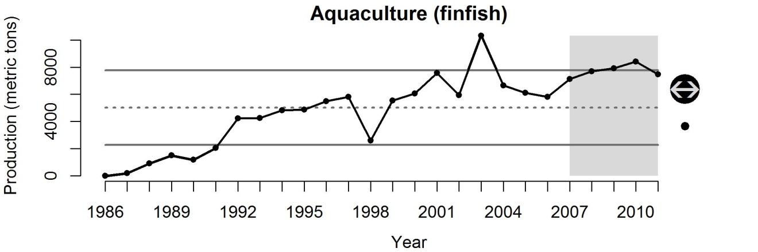
Figure S1 Production of finfish aquaculture occurring in marine waters of the CCE.
The status and trends of shellfish aquaculture was measured using estimates of USA shellfish production because estimates of shellfish production in Washington State are not readily available and because Washington produces the most shellfish in the entire USA. Using this dataset, shellfish aquaculture has increased significantly over the last five years, and is > 1 SD above the long-term average (Fig. S2). This increase in shellfish aquaculture is representative of global increases in aquaculture production to meet the increasing demand for seafood products.
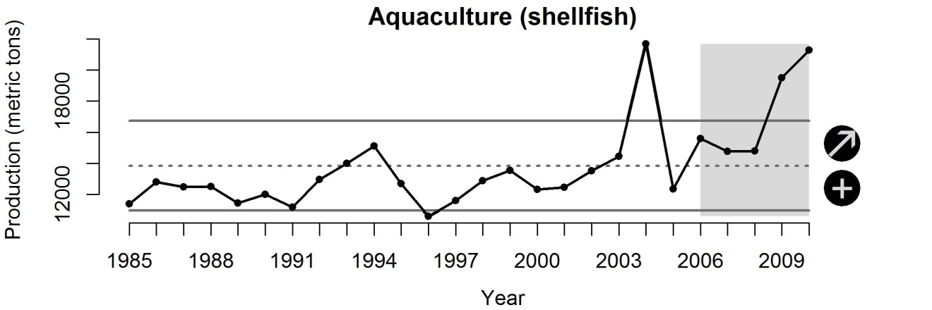
Figure S2 USA production of shellfish (clams, mussels and oysters) aquaculture.

Atmospheric pollution

Background

The impact of pollutants deposited from the atmosphere on marine populations is largely unstudied; however, many nutrient, chemical and heavy-metal pollutants are introduced to marine ecosystems from sources that are geographically far away via this process (Ramanathan & Feng 2009). Substances such as sulphur dioxide, nitrogen oxide, carbon monoxide, lead, volatile organic compounds, particulate matter, and other pollutants are returned to the earth through either wet or dry atmospheric deposition (Johnson et al. 2008). Atmospheric nitrogen input is rapidly approaching global oceanic estimates for N₂ fixation and is predicted to increase further due to emissions from combustion of fossil fuels and production and use of fertilizers (Paerl et al. 2002; Duce et al. 2008). Atmospheric deposition is one of the most rapidly increasing means of nutrient loading to both freshwater systems and the coastal zone, as well as one of the most important anthropogenic sources of mercury pollution in aquatic systems (Johnson et al. 2008). Industrial activities have increased atmospheric mercury levels, with modern deposition flux estimated to be 3-24 times higher than preindustrial flux (Swain et al. 1992; Hermanson 1998; Bindler 2003). In the south-western USA, atmospheric deposition rates have been calculated at the upper end of this range, 24 times higher than pre-industrial deposition rates (Heyvaert et al. 2000). We assume these pollutants represent similar pressures on marine populations as pollutants introduced through other mechanisms (e.g., urban runoff and dumping).

Evaluation and selection of indicators

We evaluated only one indicator for atmospheric deposition: the mean concentration of sulphates monitored by the National Trend Network (NTN) of the National Atmospheric Deposition Program (Table S1). The NTN provides a long-term record of precipitation chemistry for sites located throughout the USA Data have been consistently collected weekly using the same protocols since 1994. Specific ions that are measured include calcium (Ca²⁺), magnesium (Mg²⁺), sodium (Na⁺), potassium (K⁺), sulphate (SO₄²⁻), nitrate (NO³⁻), chloride (Cl⁻), and ammonium (NH₄⁺)ions. These data are easily accessible via the NADP website: http://nadp.isws.illinois.edu/ntn/. This indicator of atmospheric deposition evaluated very high under all criteria categories (Table S1).

Status and trends

The status and trends of atmospheric pollution were measured using the National Atmospheric Deposition Program’s National Trends Network database. Annual precipitation-weighted means (mg/L) from all sites in CA, OR, and WA were used to calculate annual means for sulphate deposition in the CCE. This monitoring network has data that goes back to 1985, but there was a major protocol shift in 1994, so we have limited the dataset to years from 1994 to the present. Using this dataset, atmospheric pollution has been constant over the last five years in the CCE and is within 1SD of the long-term average (Fig. S3).
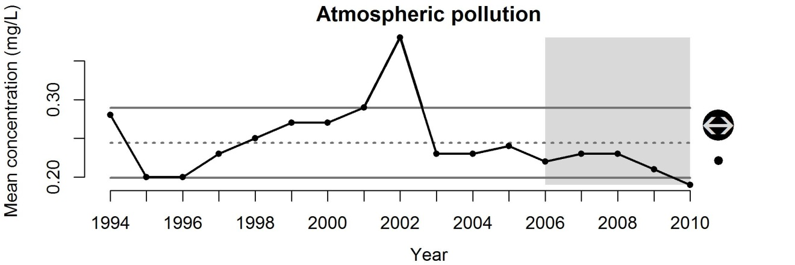
Figure S3 Precipitation-weighted mean concentration (mg/L) of sulphates deposited out of the atmosphere in CA, OR, and WA.

Benthic structures

Background

The effects of benthic structures, such as oil rigs, wells and associated anchorings, on fish and other organisms will be initially destructive with the loss or modification of habitat, but these risks may dissipate in the long term by potential enhanced productivity brought about by colonization of novel habitats by structure-associated fishes and invertebrates (e.g., rockfish, encrusting organisms, etc.) (Love et al. 2006). Decommissioned rigs could also enhance biological productivity, improve ecological connectivity, and facilitate conservation/restoration of deep-sea benthos (e.g. cold-water corals) by restricting access to fishing trawlers.
Petroleum extraction and transportation can lead to a conversion and loss of habitat in a number of other ways. Activities such as vessel anchoring, platform or artificial island construction, pipeline laying, dredging, and pipeline burial can alter bottom habitat by altering substrates used for feeding or shelter. Disturbances to the associated epifaunal communities, which may provide feeding or shelter habitat, can also result. The installation of pipelines associated with petroleum transportation can have direct and indirect impacts on offshore, nearshore, estuarine, wetland, beach, and rocky shore coastal zone habitats. The destruction of benthic organisms and habitat can occur through the installation of pipelines on the sea. Benthic organisms, especially prey species, may recolonize disturbed areas, but this may not occur if the composition of the substrate is drastically changed or if facilities are left in place after production ends (Johnson et al. 2008).
Increasing pressure to find energy resources, such as oil and gas on continental shelves will likely increase exploration and the addition of various structures on the seafloor in the North Pacific: Canada, the USAA., Republic of Korea and Japan have all indicated that they intend either to begin or to expand exploration on the continental shelves of the Pacific, and drilling already occurs off Alaska and California and in the East China Sea (Macdonald et al. 2002).

Evaluation and selection of indicators

We evaluated only one indicator of benthic structures in the CCE: the number of oil and gas wells within the CCE (Table S1). In the future, the inclusion of other large-scale benthic structures with emerging uses, such as tidal- and offshore wind energy, large ocean net-pen aquaculture operations and ocean mining projects should be done to account for the increasing activity of these industrial sectors. The number of oil and gas wells only provides estimates of structures off California waters, as this is the only state along the coast of the CCE that has offshore wells. Data are available from 1981–2009 on a yearly basis. The number of wells is easily understood and communicated to the public and policymakers.

Status and trends

The status and trends of benthic structures were measured using the number of oil and gas wells in offshore waters of the CCE. These data are available in annual reports from the California Department of Conservation’s Oil, Gas and Geothermal Resources Division for the years 1981–2009 (ftp://ftp.consrv.ca.gov/pub/oil/annual_reports/). We summed the number of state and federal offshore wells ‘producing’ and ‘shut-in’ (i.e. temporarily sealed up). The number of benthic structures in the CCE has been constant over the short term (2005–2009), but has been greater than 1SD below the long-term average of the entire time series for the last decade (Fig. S4).
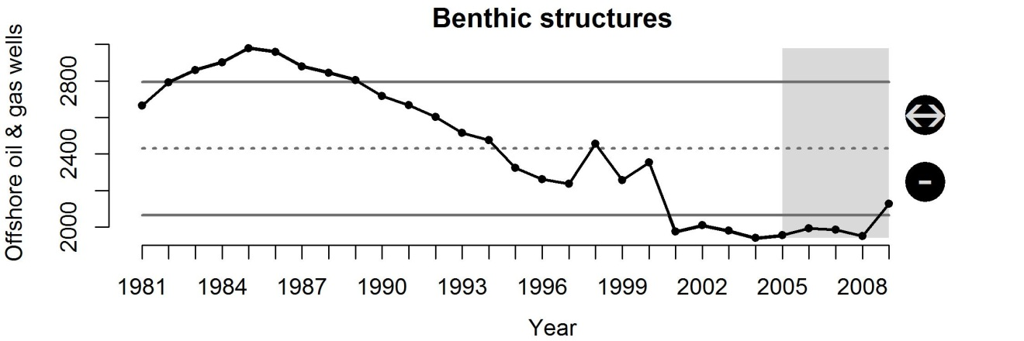
Figure S4 The number of offshore oil and gas wells in production or shut-in in the CCE.

Coastal engineering

Background

Many of the largest cities in the world are located in the coastal zone, and more than 75% of people worldwide are expected to live within 100 km of a coast by 2025 (Bulleri & Chapman 2010). In 2003, 53% of the population of the United States lived in the 673 coastal counties and this is expected to increase (Crossett et al. 2005). Transformation of coastal landscapes in response to urbanization also affects the intertidal zone and nearshore estuarine and marine waters, which are also increasingly altered by the loss and fragmentation of natural habitats and by the proliferation of a variety of built structures, such as breakwaters, seawalls, jetties and pilings.
Coastal engineering structures destroy the habitat directly under them and can significantly modify surrounding ecosystems through changes in circulation patterns and sediment transport (National Research Council 2007; Halpern et al. 2009; Shipman et al. 2010). Any structural modification of the shoreline will alter several important physical processes and can therefore be considered an impact (Williams & Thom 2001; Shipman et al. 2010). For the most part, impact potential can be related to the size and location of the structure and the types of physical processes it alters. Impacts may be considered direct or indirect. Direct impacts are generally associated with construction activities, including excavation, burial, and various types of pollution. Indirect impacts occur following physical disturbance, and are chronic in nature due to permanent alteration of physical processes such as sediment transport and wave energy. ‘Cumulative impacts’ are associated with increasing number or size of indirect or direct impacts, which can have either linear or non-linear cumulative responses. Various engineering approaches have been adopted to minimize these effects, however (Thom et al. 2005; Bulleri & Chapman 2010).
Many shoreline ‘hardening’ structures, such as seawalls and jetties, tend to reduce the complexity of habitats and the amount of intertidal habitats (Williams & Thom 2001; Bulleri & Chapman 2010). Because shorelines are highly diverse in their geologic nature and wave climate, acceptable ranges of armouring likely differ significantly from one location to another (Shipman et al. 2010). The definition of acceptable also will vary depending on the ecosystem response variable of interest. Differences in fish behaviour and usage between modified and unmodified shorelines are caused by physical and biological effects of the modifications, such as changes in water depth, slope, substrate, and shoreline vegetation (Toft et al. 2007; Morley et al. 2012). Urban infrastructure supports different epibiota and associated assemblages and does not function as a surrogate of natural rocky habitats (Bulleri & Chapman 2010). Its introduction in the intertidal zone or in nearshore waters can cause fragmentation and loss of natural habitats. Furthermore, the novel hard substrata along sedimentary shores can alter local and regional biodiversity by modifying natural patterns of dispersal of species, or by facilitating the establishment and spread of exotic species.
Almost all coastal engineering activities are subject to environmental reviews associated with the Coastal Zone Management Act, Endangered Species Act, and the US Army Corps of Engineers to assess potential impacts to natural resources and navigation. As coastal populations build, artificial structures are becoming ubiquitous features of coastal waters in urbanized centres, where they can form the dominant intertidal and shallow subtidal habitat. Ecological issues related to the introduction of coastal engineering structures into shallow coastal waters are only now beginning to receive more attention, with several recent reviews being published (e.g., Bulleri & Chapman 2010).

Evaluation and selection of indicators

We evaluated two indicators of coastal engineering: proportion of modified (e.g., armouring, overwater structures) shoreline and coastal population estimates. Although both scored equally well with regard to theoretical considerations, the coastal population indicator scored significantly better for data considerations (Table S1).
Inventories of coastal engineering have been carried out throughout the Pacific Coast of North America by a variety of federal, state, and local agencies under a number of programs, including Washington State’s shoreline management act (http://www.ecy.wa.gov/programs/sea/sma/st_guide/intro.html), the USGS national assessment of shoreline change (http://coastal.er.usgs.gov/shoreline-change/), and NOAA’s environmental assessment program (http://response.restoration.noaa.gov/maps-and-spatial-data/environmental-sensitivity-index-esi-maps.html), and the California Coastal Conservancy. However, time-series data of coastal engineering do not exist coast wide and therefore cannot be used to conduct change analysis. Most of these inventories only provide a baseline indication of current or recent conditions (e.g., Halpern et al. 2009) and if they represent data over multiple time periods and are generally only available over smaller spatial scales (e.g., county- or region-wide; personal communication, Lesley Ewing, California Coastal Commission).
Coastal engineering structures are classified in a variety of ways, but primarily account for the percent of modified shoreline along a particular reach. The NOAA Environmental Sensitivity Index (ESI) maps provide a concise summary of coastal resources that are at risk if an oil spill occurs nearby. Anthropogenic structures are classified as follows: Exposed, solid man-made structures (1B), Riprap (class 6B), sheltered, solid man-made structures (8B), and sheltered riprap (8C). Inventories exist primarily for central and southern California (http://www.coastal.ca.gov/recap/rcpubs.html) and parts of Puget Sound; GIS ESI atlases have been completed for all of California, Puget Sound, the lower Columbia River; ESI atlases (no GIS) have been completed for the outer coasts of WA and OR. Inventories of shoreline classification and modifications maps (baselines) exist for the following years: southern CA: 1980, 1995, 2010; San Francisco Bay: 1986, 1998; central CA: 1995, 2006; northern CA: 1995, 2008 (M. Sheer, NOAA personal communication); OR and WA coast: 1985; and Puget Sound: 2000 (http://response.restoration.noaa.gov/maps-and-spatial-data/shoreline-rankings.html). To classify each shoreline unit, ESI map developers use information and observations from a combination of sources, including: overflights, aerial photography, remotely sensed data, ground-truthing (visits to individual shorelines to validate aerial observations), and existing maps and data. Future assessments will attempt a change analysis as more recent classification actions are completed. This analysis will correlate the changes observed in shoreline armouring of specific counties in southern California with corresponding changes in coastal population growth.
The rate of shoreline armouring has been shown to correspond with the rate of population growth in coastal areas (Douglass & Pickel 1999), and in the absence of good time-series of geospatial data for hardened shorelines, coastal population data for the coastline counties of the West Coast of the United States provides a good proxy for this stressor. Population density has a long history of reporting and is known to affect coastal regions disproportionately (Crossett et al. 2005). Coastal population density data have been summarized by Crossett et al. (2005), who found that in 2003 the coastal population density (not including Alaska) of the Pacific Region was 303 persons per square mile, up from 207 in 1980, and expected to increase to 320 in 2008. From 2003 to 2008, the Pacific region was expected to increase by 2.2 million people or 6 percent in coastal population (Crossett et al. 2005). Population density is becoming increasingly understood in some regions as an agent of shoreline change (e.g. Puget Sound Partnership; http://www.psp.wa.gov/vitalsigns/shoreline_armouring.php). Coastline counties of the United States, located along the country’s saltwater edges, account for just 254 of the nation’s 3,142 counties yet contain 29 percent of its population, 5 of its 10 most populous cities, and 7 of its 10 most populous counties (Wilson & Fischetti 2010). To qualify as coastline, a county has to be adjacent to water classified as either coastal water or territorial sea. Transformation of coastal landscapes in response to urbanization also affects the intertidal zone and nearshore estuarine and marine waters, which are also increasingly altered by the loss and fragmentation of natural habitats and by the proliferation of a variety of built structures, such as breakwaters, seawalls, jetties and pilings. Unclear however, at this time, is the explicit relationship between coastal population levels and the relative amount of shoreline affected by coastal engineering structures; this data gap is likely driven by the lack of good time-series data on the latter.

Status and trends

The status and trends of coastal engineering were measured using estimates of human population in counties classified as ‘coastline’ in WA, OR and CA. Data for coastline population estimates were retrieved from the USA Census Bureau (1970–2009: http://www.nber.org/data/census-intercensal-county-population.html; 2010–2012: http://www.census.gov/popest/data/datasets.html). Using this indicator, coastal engineering has been increasing steadily over the entire time series. Over the last five years of this dataset, however, there was no change, but the current status is >1SD above the long-term average (Fig. S5). Populations along the coast continue to increase, but perhaps the rate of increase is slowing. Nonetheless, the ultimate driver of many anthropogenic pressures will continue to increase for the foreseeable future.
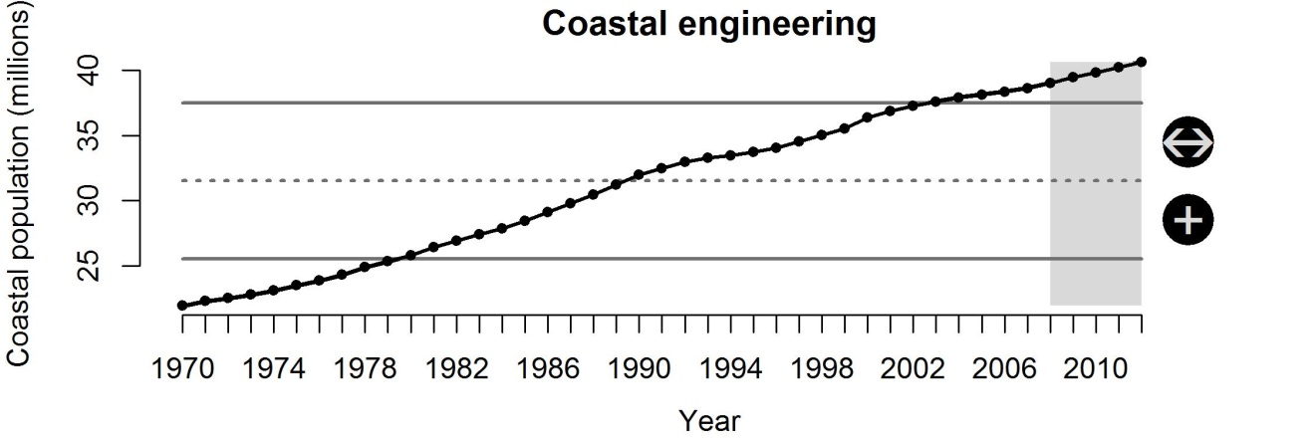
Figure S5 USA population in coastline counties of WA, OR and CA.

Commercial shipping activity

Background

Approximately 90% of world trade is carried by the international shipping industry and the volume of cargo moved through USA ports is expected to double (as compared to 2001 volume) by 2020 (AAPA 2012) due to the economic efficiencies of transporting goods via ocean waterways. The impacts of commercial shipping activity on the CCE are numerous, but we used commercial shipping activity as a proxy for the potential risk of ship strikes of large animals, noise pollution and the risk of habitat modification due to propeller scouring, sediment resuspension, shoreline erosion, and ship groundings or sinkings (similar definition as Halpern et. al. (2008)). Vessel activity in coastal waters is generally proportional to the degree of urbanization and port and harbour development within a particular area (Johnson et al. 2008). Benthic, shoreline, and pelagic habitats may be disturbed or altered by vessel use, resulting in a cascade of cumulative impacts in heavy traffic areas. The severity of boating-induced impacts on coastal habitats may depend on the geomorphology of the impacted area (e.g., water depth, width of channel or tidal creek), the current velocity, the sediment composition, the vegetation type and extent of vegetative cover, as well as the type, intensity, and timing of boat traffic (Johnson et al. 2008).
Ship strikes have been identified as a threat to endangered blue, humpback and fin whales (NMFS 1991; NMFS 1998; NMFS 2006), and this is of particular concern along the California coastline (Abramson et al. 2009; Berman-Kowalewski et al. 2010; Davidson et al. 2012). In addition to direct mortality from ship strikes, shipping vessels increase noise levels in the ocean which could interfere with normal communication and echolocation practices of marine mammals. When background noise levels increase, many marine mammals amplify or modify their vocalizations which may increase energetic costs or alter activity budgets when communication is disrupted among individuals (Holt et al. 2009; Dunlop et al. 2010). Underwater noise levels associated with commercial shipping activity increased by approximately 3.3 dB/decade between 1950 and 2007(Frisk 2012).
The effects of commercial shipping activity on fish populations is not very well understood, but some data suggest responses will be behavioural in nature (e.g. Rostad et al. 2006) and related to loss of habitat (Uhrin & Holmquist 2003; Eriksson et al. 2004) or noise pollution (Slabbekoorn et al. 2010). Some fish species may be attracted to vessels, rather than being repelled by them and are not bothered by noisy, passing ships (Rostad et al. 2006). However, frequently travelled routes such as those travelled by ferries and other transportation vessels may impact fish spawning, migration, communicative, and recruitment behaviours through noise and direct disturbance of the water column (Barr 1993; Codarin et al. 2009).

Evaluation and selection of indicators

We evaluated three indicators of commercial shipping activity in the CCE: port volume of cargo, number of vessel trips, and the volume of disturbed water during transit. Each of these indicators scored high in nearly all of the ‘Data Considerations’ criteria (Table S1) because most data are available from the USA Army Corps of Engineers (USACE) Navigation Data Center (http://www.ndc.iwr.usace.army.mil/index.htm). Each of these indicators is certainly correlated with some aspect of commercial shipping activity. The port volume of cargo moved through ports along the West Coast of the USA describes the total volume moving between ports, but this value does not give us any indication of how far shipping vessels are transporting these goods throughout the CCE. This indicator is also probably not a relevant measure that management could use to ‘turn the dial’ up or down. Increases or decreases to port volume may not have anything to do with the risk associated with ships striking marine mammals or increases to noise pollution off the coast (Table S1).
Using the number of vessel trips within the CCE as an indicator of commercial shipping activity provides a better link between the amount of risk shipping vessels have on various components of the CCE; however, this indicator does not distinguish between vessels of different sizes or between trips that occur within a single port (exposure is low) and trips that span the entire length of the USA West Coast (exposure is high).
The final indicator evaluated was the volume of disturbed water during transit. We have not found this metric used specifically in other literature sources, but it is similar to metrics used as an indicator of habitat modification caused by the disturbance of bottom-trawl fishing gear (Bellman & Heppell 2007). We calculated the distance travelled within the CCE by each vessel during transit from their shipping port to their receiving port and multiplied this value by the vessel’s draft and the vessel’s breadth. These values were then summed across domestic and foreign fleet vessels for the years 2001–2010. This indicator provided a more accurate estimate of the absolute exposure of the CCE to commercial shipping vessels. There are not any likely reference points or target values for this indicator on a coastwide basis, but this indicator could be used in a spatially-explicit way (create GIS data layers) to monitor trends in shipping activity in specific corridors or during specific times of year that are frequently used by marine mammals (Table S1).
In order to develop this indicator, we received port-to-port coastwise trip data with shipping and receiving drafts and names of all domestic shipping vessels for years 2001–2010 from the USACE Waterborne Commerce Statistics Center, New Orleans, LA. From the USACE Navigation Data Center database (http://www.ndc.iwr.usace.army.mil/data/dataclen.htm#Foreign Traffic Vessel Entrances and Clearances), we downloaded foreign traffic vessel entrances and clearances data to get all foreign port-to-port trips with draft and vessel names of each vessel for years 2001–2010. We then looked up the breadth of individual vessels from the USACE ‘Vessel Characteristics’ database (http://www.ndc.iwr.usace.army.mil//data/datavess.htm). For vessels that were not contained within this database, we used the mean breadth of vessels within the same ‘Vessel type’ for domestic vessels or within the same ‘Rig type’ for foreign vessels.
We categorized trips into two categories. If the shipping and receiving port was the same (i.e. the vessel was moving from one dock to another or moving a barge within the port), this was categorized as ‘port’ traffic, while all other trips were categorized as ‘coastal’ traffic. For this analysis, we removed all ‘port’ traffic because this pressure is defined as a measure of the risk of vessels striking marine mammals, causing noise pollution, and modifying coastal habitat. We include ‘port’ traffic in the indicator for ocean-based pollution below. In order to calculate the distance travelled within the CCE for each vessel, we used distances between ports as measured by NOAA’s Office of Coast Survey and documented in USDOC (2012). For trips that travelled outside of the CCE, we used the distance from the port within the CCE to the boundary of the CCE following the major shipping lane pathways. For example, if a vessel travelled from San Diego, CA to Houston, TX, we calculated the distance from San Diego to the southern boundary of the CCE on the vessel’s way toward the Panama Canal (estimated at 602 nm (1115 km)). These distances were then multiplied by the vessel’s shipping draft (m) and breadth (m) to give a volume (m³) of water directly disturbed by the vessel during transit through the CCE. Obviously the wake of a vessel will disturb more than our calculated volume, so this is a conservative estimate of absolute volume, but the trends over time will be relative.

Status and trends

The status and trends of commercial shipping activity were measured using the volume of water disturbed within the CCE. Using this dataset, we found that commercial shipping activity in the CCE has decreased over the last five years, but the short-term mean is within 1SD of the long-term mean of the entire dataset (Fig. S6). The decreasing trend in this dataset likely reflects current economic conditions over the last five years; thus, this indicator is likely to increase as economic conditions improve. The predominant contributor to this trend is foreign vessel traffic and these data are available back to 1997, while the domestic data may be available back to 1994 if funding were available to the USACE to perform this data inquiry.
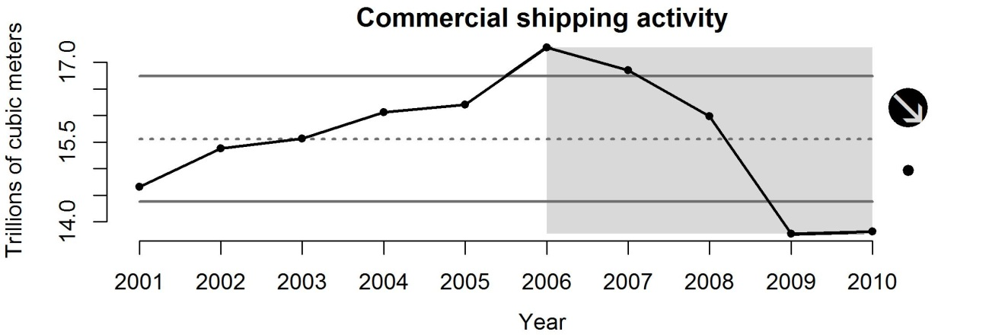
Figure S6 Volume (trillions m³) of water disturbed during transit of commercial shipping vessels along the coast of the CCE.

Disease/pathogens

Background

The last few decades have seen a worldwide increase in the reports of disease in the marine environment (Harvell et al. 1999), though these increases appear to be taxa related (Ward & Lafferty 2004). Diseases are thought to be fostered by increases in climate variability and human activity as many outbreaks are favoured by changing environmental conditions which increase pathogen transmission or undermine host resistance (Anderson 1998). Marine flora and fauna serve as hosts for numerous parasites and pathogens that may affect the host populations as well as have cascading effects throughout the ecosystem. For example, the near elimination of seagrass (Zostera marina) beds from many North Atlantic USA coastlines in the 1930’s due to wasting disease (thought be caused by a pathogenic strain of Labyrinthula, which has since been confirmed and identified in eelgrass beds in the 1980’s on both coasts of the United States (Short et al. 1987)) was responsible for numerous alterations to coastal habitats (Rasmussen 1977) and fauna, including a reduction or loss of migratory waterfowl populations (Addy & Aylward 1944) and the loss of the scallop fishery in the mid-Atlantic coast of the USA (Thayer et al. 1984).
The population dynamics of many pathogens are sensitive to changes in their physical environment (e.g., temperature) which could modify pathogen development and survival, disease transmission and host susceptibility (Harvell et al. 1999; Harvell et al. 2002; Selig et al. 2006). Thus, understanding how climate variability affects disease transmission in the marine environment is necessary for successful management efforts. These efforts, however, are hindered by the absence of baseline and epidemiological data on the normal disease levels in the ocean (Harvell et al. 1999).

Evaluation and selection of indicators

The only indicator we evaluated for marine disease/pathogens was the percentage of scientific articles published each year that reported disease among marine taxa (Ward & Lafferty 2004). Overall, this indicator did not evaluate well in Primary Considerations criteria (Table S1). The percentage of scientific articles reporting disease in marine taxa is a very broad proxy for testing whether diseases in the marine environment are increasing or decreasing - though it is the first quantitative baseline created to measure this. This measure may or may not respond predictably to actual measurements of disease in the ocean. There are many other factors - such as funding and the number of investigators interested in studying this topic - which will heavily influence this indicator each year. However, data are available from Ward & Lafferty (2004) for several marine taxa from 1970-2001 and the methods seem to be reproducible such that the time series could be updated in the future with yearly literature searches. Ward & Lafferty’s (2004) data are a worldwide estimate, so spatial variation is not understood and is not specific to the CCE. It is easily understood by the public and policymakers, but there has been no history of reporting the trend of disease in the marine environment with this indicator.
The overall trend of the Ward & Lafferty (2004) data suggests that disease may be increasing in marine ecosystems globally, but there are no time series data available to evaluate disease incidence in the CCE; thus, we have concluded that there are no appropriate indicators of disease to include at this time. The methods of Ward & Lafferty (2004) could be applied to studies of disease in the CCE and used as a baseline, but determining whether the trends are due to actual increases in disease or simply increases in the investigation and reporting of disease will be difficult to separate. The California Cooperative Oceanic Fisheries Investigations (CalCOFI) and NOAA’s Southwest Fisheries Science Center’s ecosystem surveys have been collecting and archiving plankton samples since 1951. If pathogens are preserved in these samples, perhaps this could be a line of research that could produce a baseline of disease incidence in the CCE given necessary funding.

Dredging

Background

Dredging is the removal or displacement of any material from the bottom of an aquatic area (USACE 1983). It is required in many ports of the world to deepen and maintain navigation channels and harbour entrances. Elsewhere, commercial sand mining and extraction of sand and gravel from borrowing areas is conducted to meet demand for sand for construction and land reclamation. Excavation, transportation, and disposal of soft-bottom material can have various adverse impacts on marine or estuarine environments (Johnston 1981). These effects may be due to physical or chemical changes in the environment at or near the dredging site, and may include: reduced light penetration by increased turbidity; altered tidal exchange, mixing, and circulation; reduced nutrient outflow; increased saltwater intrusion; alteration, disruption, or destruction of areas in which fish live, feed and reproduce; re-suspension of contaminants affecting water quality; and creation of an environment highly susceptible to recurrent low dissolved oxygen levels

Evaluation and selection of indicators

We evaluated two indicators of dredging impacts: dredging volumes and dredge dump volumes (Table S1). Dredge volumes scored better than the latter, primarily due to reporting omissions related to spatial coverage.
Most of the dredging activities conducted on the US West coast involve maintenance dredging of harbour or port areas and associated navigation channels, with associated material disposal in open water or integrated into beach nourishment programs. The amount of material (in cubic yards - CY) dredged from all US waterways off the US West coast is a concrete, spatially explicit indicator that concisely tracks the magnitude of this human activity throughout the California Current region.
These data are accessible through the USA Army Corps of Engineers navigation data centre dredging information system: http://www.ndc.iwr.usace.army.mil/data/datadrgsel.htm; data include dredge volumes, locations, and costs for individual private contracts and Corps operated dredge projects from 1997 through 2011 nationwide. We summarized annual dredge volumes (converted to cubic meters) for all projects conducted in California, Oregon, and Washington. Annual offshore dump volumes are not summarized and reported separately, but can be determined with some data manipulation from this database. In some locations, dredge dump volumes are also reported to give an indication of the extent of, and trends in dredging activities (e.g., Annual OSPAR Reports on the Dumping of Wastes at Sea).

Status and trends

The status and trends of dredging in the CCE were measured using dredged volume (millions of m³) of sediments from projects originating in WA, OR and CA waters. Using this indicator, dredging has increased over the last five years, but the short-term average is still within 1SD of the long-term average of the entire time series (Fig. S7).
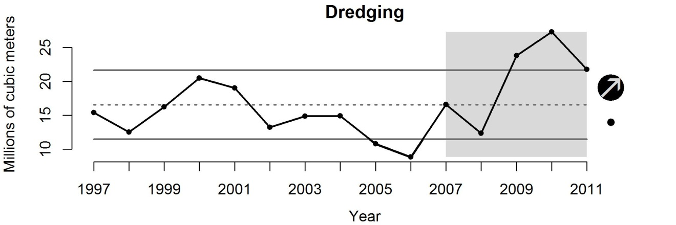
Figure S7 Volume (millions m³) of dredged sediments from projects originating in WA, OR and CA.

Fisheries removals

Background

Fishery removals directly impact target resources by reducing their abundance. When poorly managed, fisheries can develop excessive pressure on fishery stocks, leading to overfishing, and causing major ecological, economic and social consequences. Fisheries for the Pacific Ocean perch and widow rockfish are among the most notable examples of overexploitation in the CCE. Fisheries targeting Pacific ocean perch developed in the Northern California Current Ecosystem in the 1950s, and catches quickly grew from just over 1000 tonnes in 1951 to almost 19,000 tonnes in 1966, reducing the stock below the overfished threshold of 25% of unfished biomass, established by the Pacific Fishery Management Council, in 1980 (Hamel & Ono 2011). Fisheries targeting widow rockfish developed in the late 1970s, after it was discovered that the species forms aggregations in the pelagic waters at night. Widow rockfish catches sharply increased from 1,107 tonnes in 1978 to 28,419 tonnes in 1981 and started to drop, indicating reduction in the resource, so that severe catch limits were imposed in 1982 (Love et al. 2002).
Fisheries are rarely selective enough to remove only the desired targets (Garcia et al. 2003), and they often take other species incidentally, along with targets. Even though incidentally taken fish (often referred to as bycatch) are routinely discarded, discard mortality can be quite high, especially for deep-water species. Therefore, fisheries can significantly reduce abundance of bycatch species associated with removals of targeted resources as well. Unintended removals can also be facilitated by lost (or dumped) fishing gear, particularly pots, traps and gillnets, which may cause entanglement of fish, marine mammals, turtles and sea birds. The extent of such ‘ghost’ fishing in the CCE is unknown, but studies conducted elsewhere suggest that the impact might be non-trivial (Fowler 1987; Goni 1998; Garcia et al. 2003).
Fisheries typically target larger individuals. By removing particular size groups from a population, fisheries can alter size and age structure of targeted and bycatch stocks, their sex ratios (especially when organisms in a population exhibit sexual dimorphism in growth or distribution), spawning potential, and life history parameters related to growth, sexual maturity and other traits.
Extensive fishery removals may also affect large scale ecosystem processes and cause changes in species composition and biodiversity. These can occur with gradual decrease in the average trophic level of the food web, caused by reduction in larger, high trophic level (and high value) fish and increase in harvest of smaller, lower trophic level species, a process described as ‘fishing down the food chain’ (Pauly et al. 1998; Pauly & Watson 2009). The extensive removal of forage fish species, mid trophic level components, can also modify interactions within a trophic web, alter the flows of biomass and energy through the ecosystem, and make systems less resilient to environmental fluctuations through a reduction of the number of prey species available to top predators (Garcia et al. 2003; Pauly & Watson 2009).

Evaluation and selection of indicators

Fishery removals consist of two components: retained catch that is subsequently landed to ports (landings) and discarded catch that is thrown overboard. When discarded, fish either survive or die depending upon the characteristics of species and fishing and handling practices employed by the fishery. Thus, the total removals are the sum of landings and dead discard.
The best source for information on stock-specific fishery removals is typically stock assessments that report landings, estimate amount of discard, and evaluate discard mortality. Stock assessments also provide the longest time series of removals, commonly dating back to the beginning of exploitation. Stock assessments conducted for CCE species are available via Pacific Fishery Management Council website (http://www.pcouncil.org) by species and year of assessment. However, only some species from each fishery have been assessed. For non-assessed stocks, information on fishery removals can be obtained from a variety of state and federal sources. The most detailed and reliable CCE fishery landing data are summarized in the Pacific Fisheries Information Network (PacFiN) (http://pacfin.psmfc.org), a regional fisheries database that manages fishery-dependent information in cooperation with the National Marine Fisheries Service (NMFS) and West Coast state agencies. The data in PacFiN go back to 1981. NMFS and its predecessor agencies, the USA Fish Commission and Bureau of Commercial Fisheries, has also been reporting fishery landing statistics collected via comprehensive surveys of all USA coastal states conducted since 1951. These data are available via NMFS Science and Technology website at (http://www.st.nmfs.noaa.gov/st1/commercial/index.html. Recreational catches since the late 1970’s can be found in the Recreation Fisheries Information Network (RecFiN) (http://www.recfin.org), a project of the Pacific States Marine Fisheries Commission.
There have been a few historical studies conducted to evaluate discard in CCE fisheries (Pikitch et al. 1988; Sampson 2002), but those studies focused on specific areas and/or species groups, so that thorough analysis would be needed to extrapolate those estimates to other areas, species and years. Currently there are two observer programs operated by the NMFS NWFSC on the USA West Coast. These programs include the At-Sea Hake Observer Program (A-SHOP), which monitors the at-sea hake processing vessels, and the West Coast Groundfish Observer Program (WCGOP), which monitors catcher vessels that deliver their catch to a shore-based processor or a mothership. The A-SHOP dates back to the 1970s, while WCGOP was implemented in 2001. The WCGOP began with gathering data for the limited entry trawl and fixed gear fleets. Observer coverage has expanded to include the California halibut trawl fishery, the nearshore fixed gear and pink shrimp trawl fishery. Since 2011, the USA West Coast groundfish trawl fishery has been managed under a new groundfish catch share program. The WCGOP provides 100% at-sea observer monitoring of catch for the new, catch share based Individual Fishing Quota (IFQ) fishery, including both retained and discarded catch.
Since 2005, the WCGOP has been generating estimates of the groundfish total mortality from commercial, recreational and research sources including incidental catch from non-groundfish fisheries. For groundfish, WCGOP total fishing mortality estimates were selected as an indicator of fishery removal recognizing that the data to inform this indicator is only available for the most recent years. For other species groups, the PacFiN and RecFiN landings were selected as the best long-term fishery removal indicator, since they represent the bulk of removals for most species and have been routinely reported. For PacFiN data, we summed all shoreside landings data across all species for 1981–2011. For RecFiN data, we used the ‘ab1we’ data for all species in 2004–2011 and the ‘wab1’ data for all species in 1981–2003 (both data sets represent ‘weight of harvested dead catch (A+B1) in tonnes of fish caught’). We then summed commercial (PacFiN) and recreational (RecFiN) landings data to calculate total fisheries removals in the CCE from 1981–2011. However, if available, total mortality estimates would be the preferred indicator for all species groups, due to its higher evaluation in the ‘Primary considerations’ criteria (Table S1).

Status and trends

The status of fisheries removals was measured using the total shoreside landings from commercial and recreational fisheries as reported by the Pacific Fisheries Information Network (PacFiN) (http://pacfin.psmfc.org) and the Recreational Fisheries Information Network (RecFiN) (http://www.recfin.org) for Washington, Oregon and California. Commercial landings include all landings delivered to shoreside processing facilities. Using this indicator, fisheries removals have been variable over the last five years and are within historical removal levels (Fig. S8).
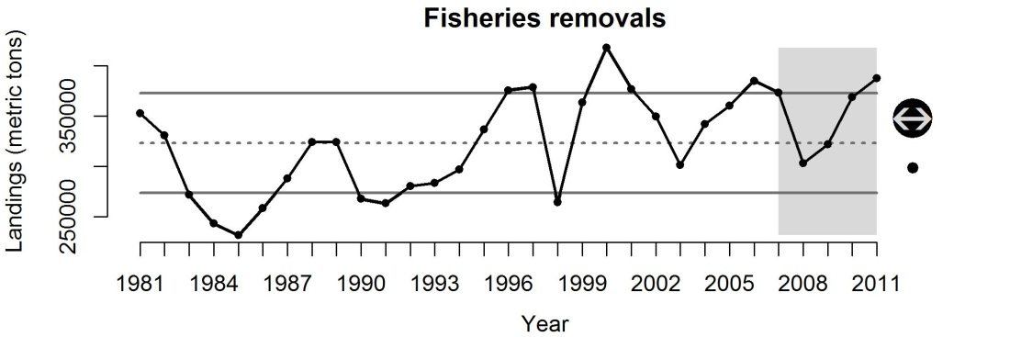
Figure S8 Total commercial and recreational fisheries shoreside landings in Washington, Oregon and California as reported by the Pacific and Recreational Fisheries Networks (PacFiN & RecFiN).

Freshwater retention

Background

As the world’s population grows along with increasing demands for freshwater, interannual variability and long-term changes in continental runoff are of great concern to water managers (Dai et al. 2009). Freshwater flow also affects fisheries and ESA-listed species. River discharge into many estuaries and coastal marine areas has been substantially altered by diversion for human use (Vorosmarty et al. 2000). Water withdrawals for public-supply and domestic uses have increased steadily since estimates began, with freshwater withdrawals of almost 350 Bgal/d (billion gallons per day) in 2005. Thermoelectric-power generation (see Power Plants, below) and irrigation withdrawals have generally been the two largest human use categories since these estimates were made. Hydropower is considered an ‘in-stream use’ of freshwater, but associated dams and dam operations also alter flow patterns, volume, and depth of water within and below impoundments. Dam projects operating as ‘store and release’ facilities drastically affect the magnitude, timing, and duration of downstream water flow and depth, resulting in dramatic deviations to natural fluctuations in habitat accessibility, acute temperature changes, and overall water quality.
Modified freshwater flow regimes change the salinity gradient and pattern in salinity variation within estuaries and coastal systems, and can induce large shifts in community composition and ecosystem function (Gillanders & Kingsford 2002). These ecosystems often respond most strongly on an interannual timescale to variability in freshwater flow. Several mechanisms for positive or negative flow effects on biological populations in estuaries have been proposed (Kimmerer 2002), with positive effects appearing to operate mainly through stimulation of primary production, with effects propagating up the food web. Overall impacts on the biota are generally considered negative, however, with documented changes to migration patterns, spawning habitat, species diversity, water quality, and distribution and production of lower trophic levels (Drinkwater & Frank 1994). For freshwater systems, a framework has been developed for assessing environmental flow needs for many streams and rivers to foster implementation of environmental flow standards at the regional scale (Poff et al. 2010).Studies focused on reductions in freshwater flow have generally shown detrimental ecosystem effects and altered community composition (Gillanders & Kingsford 2002). However, freshwater subsidies to estuaries or hypersaline lagoons have also been shown to cause major shifts in vegetation, fish, and macroinvertebrate assemblages (Nordby & Zedler 1991; Strydom et al. 2002; Rutger & Wing 2006).
Discharge trends for many rivers reflect mostly changes in precipitation, primarily in response to short- and longer-term atmospheric-oceanic signals; notably, the cumulative discharge from many rivers globally decreased by 60% during the last half of the 20th century, reflecting in large part impacts due to damming, irrigation and interbasin water transfers (Dai et al. 2009). However, a comprehensive analysis of worldwide river gauging data suggests that direct human influence on annual stream flow is likely small compared with climatic forcing during 1948–2004 for most of the world’s major rivers (Dai et al. 2009). The immediate effect of dams on freshwater impact is also seemingly mixed. Reservoirs can affect the timing of discharge as well as the amount of discharged sediment and dissolved constituents, but for most normal rivers, reservoirs appear to have little effect on annual discharge (Milliman et al. 2008). However, most deficit rivers have flow regulation and irrigation indices, underscoring the importance of reservoirs and irrigation in facilitating water loss by increased consumption and (ultimately) increased evapotranspiration (Milliman et al. 2008).

Evaluation and selection of indicators

We evaluated two potential indicators of freshwater input: river runoff or stream discharge and impoundment area behind dams (Table S1). Other potential indicators of consumption and flow regulation (Milliman et al. 2008) were identified but not comprehensively evaluated at this time. Stream discharge data are accessible from a variety of gauged streams (http://water.usgs.gov/nsip/) from 1948-2004, although one of the major obstacles in estimating continental discharge is incomplete gauging records or unmonitored stream flow. Dai et al. (2009) have updated stream flow records for the world’s major rivers with stream flow data simulated by a comprehensive land surface model. However, it has been shown that it is very difficult to distinguish signal from noise in rivers with widely variable interannual discharge (Milliman et al. 2008). The effects of human activities on annual stream flow are likely small compared with those of climate variations during 1948–2004 (Dai et al. 2009) and ENSO-induced precipitation anomalies are a major cause for the variations in continental discharge (Dai et al. 2009). Furthermore, regional analyses of trends in US stream flow (generally characterized by increases in stream flow across all water-resource regions of the conterminous USA between 1940 and 1999) have been designed specifically to detect climate signals and minimize anthropogenic effects (Lins & Slack 2005)
River runoff (R) can also be expressed as the difference between precipitation (P) and the sum of evapotranspiration (ET), storage (S) (e.g., groundwater), and consumption (C) (e.g., irrigation) (Milliman et al. 2008). Therefore, data series associated with the anthropogenically-derived parameters, C and S, likely provide some of the best indicators of human impacts to freshwater input. Freshwater storage (S) data are accessible and can be obtained on an annual basis from state agency databases, which include information on construction date and impoundment area/volume for all dams (California: http://cdec.water.ca.gov/misc/resinfo.html; Idaho: http://www.usbr.gov/projects/FacilitiesByState.jsp?StateID=ID; Oregon: http://www.usbr.gov/projects/FacilitiesByState.jsp?StateID=OR; Washington: https://fortress.wa.gov/ecy/publications/summarypages/94016.html). Furthermore, large-scale hydrological alteration are known to cause a variety of downstream habitat changes, such as deterioration and loss of river deltas and ocean estuaries (Rosenberg et al. 2000).
We selected impoundment volume as our indicator of changing freshwater flow, primarily based on the long-term availability of annual impoundment data and the additional known effects of these large-scale hydrological alterations to downstream habitats (Table S1).

Status and trends

The status and trends of freshwater retention in the CCE were measured using the total impoundment volume (millions m³) of freshwater stored behind dams in CA, OR and WA. Using this dataset, the storage of freshwater has been relatively constant for the last 40 years, but the short-term average was greater than 1SD above the long-term average of the entire time series (Fig. S9). This time series reflects the large increases in reservoir impoundment during the period of major dam building from the 1940’s to the early 1970’s with relatively little change since then.
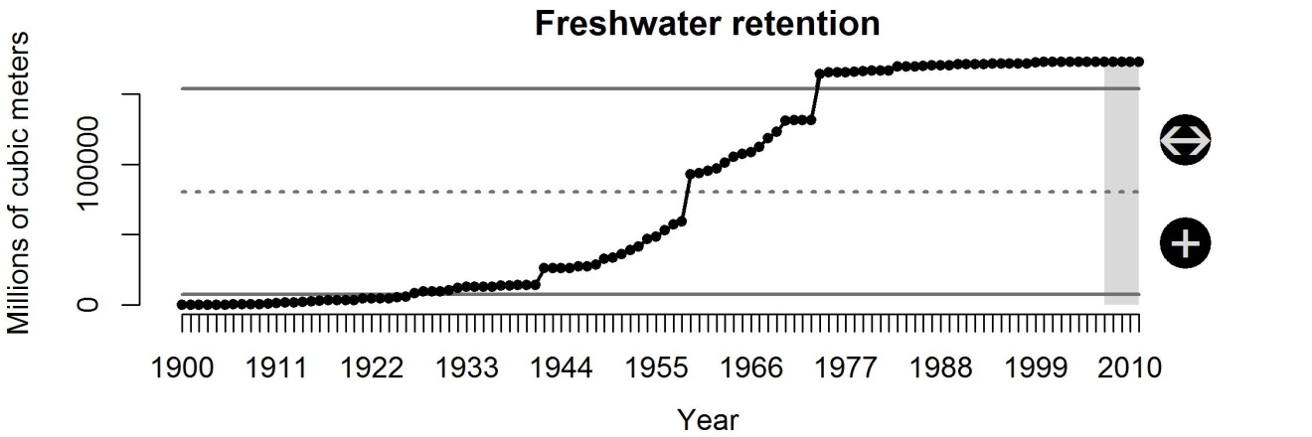
Figure S9 Volume (millions m³) of freshwater stored behind dams in WA, OR and CA.

Habitat modification

Background

Fishing can alter benthic habitats by disturbing and destroying bottom topography and associated communities, from the intense use of trawls and other bottom gear (Kaiser & Spencer 1996; Hiddink et al. 2006). Habitat destruction, in turn, can lead to extirpation of vulnerable benthic species and disruption of food web processes (Hall 1999; Hiddink et al. 2006). The effect is particularly dramatic when those gears are used in sensitive environments with sea grass, algal beds, and coral reefs, and is less evident on soft bottoms (Garcia et al. 2003). However, fisheries often tend to operate within certain areas more than others (Kaiser et al. 1998), and long-term impacts of trawling may cause negative changes in biomass and the production of benthic communities in any habitat type, to various degrees (Hiddink et al. 2006).
In the CCE, implementation of Essential Fish Habitats (EFP), areas necessary for fish spawning, breeding, feeding, or growth to maturity, and Marine Protected Areas (MPA), in combination with gear regulation measures, have been used to reduce adverse impact of fisheries on vulnerable habitats. Also, the introduction of the Cowcod Conservation Area (CCA) and Rockfish Conservation Areas (RCAs) as management measures to prevent overfishing makes additional areas along the coast inaccessible to fishing during some or all of the year.

Evaluation and selection of indicators

Habitat destruction could be expressed using a metric such as distance trawled by certain gear types, in certain habitat types. Development of such a metric, however, is non-trivial and requires a thorough analysis, since the destructive capacity of different trawl gear varies according to habitat/bottom type in which it is used. Such an analysis would also require very detailed habitat data that are currently unavailable.
Bellman and Heppell (2007) estimated distance trawled within the limited entry groundfish trawl fishery in the USA West Coast by habitat type, defined based on type of bottom substrate. The habitat types considered were of four basic categories, including shelf, slope, basin and ridge, and two subcategories, rocky and sedimentary. Logbook data was used to obtain information on vessel, date, time and location of each individual tow as well as gear used (Bellman & Heppell 2007). These data were then overlaid with GIS seafloor habitat maps off Washington, Oregon and California compiled by Goldfinger et al. (2003), Romsos (2004) and Green & Bizzarro (2003).
We used estimates of coast-wide distance trawled (1999–2004) as an indicator for habitat destruction (Table S1; Bellman & Heppell 2007). Currently, NOAA’s Northwest Fisheries Science Center is in the process of producing improved GIS seafloor habitat maps of the CCE to better define and describe Essential Fish Habitats (EFH). These GIS maps along with logbook, observer and trawl tracks from vessel monitoring system data will be used to improve and further extend time series of the estimated distance trawled.

Status and trends
The status and trends of habitat modification was measured using distance trawled by the limited entry groundfish trawl fishery, as estimated by Bellman and Heppell (2007). Using this indicator, habitat modification declined coast-wide between 1999 and 2004 (Fig. S10). Decreases in habitat modification are highly correlated with regulations implemented by the Pacific Fishery Management Council to reduce fisheries’ impact on depleted species. The time series of this indicator will soon be extended as analyses of the most recent logbook, observer, and trawl tracks from vessel monitoring system data are completed.
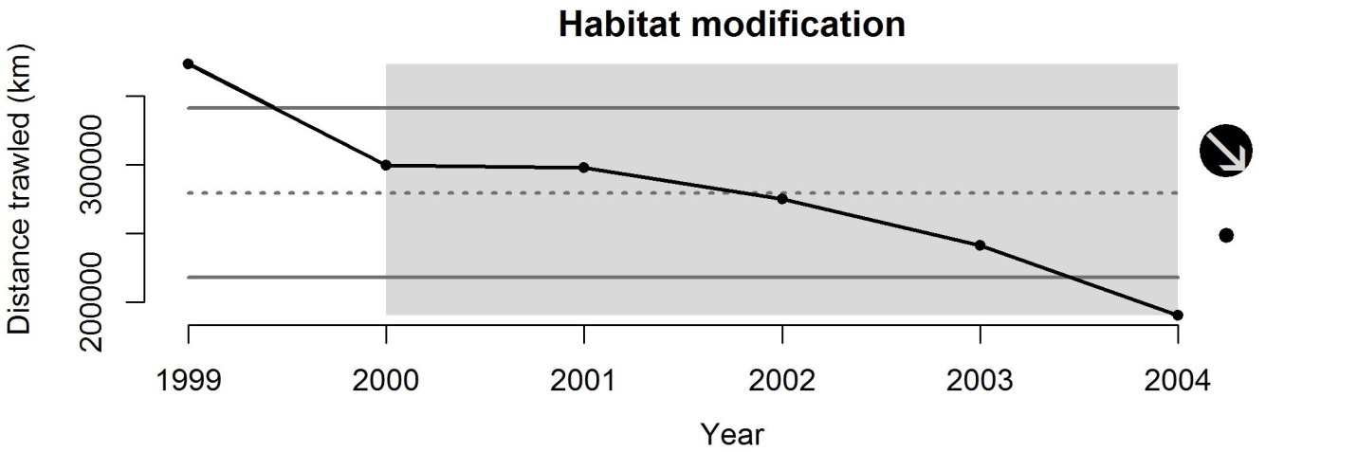
Figure S10 Total distance trawled (km) along the coast of Washington, Oregon and California by limited-entry groundfish trawl fishery vessels.

Inorganic pollution

Background
Tens of thousands of chemicals are used by industries and businesses in the United States for the production of goods which our society depends. Many of the chemicals used in the manufacturing and production of these goods are toxic at some level to humans and other organisms and some are inevitably released into the environment. The production, use and release of various toxic chemicals have changed over time depending on economic indices, management methods (recycling and treatment of chemicals), and environmental regulations (USEPA 2010). The pathway of these chemicals to estuarine and marine environments can be direct (e.g., wastewater discharge into coastal waters or rivers) or diffuse (e.g., atmospheric deposition or urban runoff). Over the past 40 years, direct discharges have been greatly reduced; however, the input of pollutants to the marine environment from more diffuse pathways such as runoff from land-based activities is still a major concern (Boesch et al. 2001).
While all pollutants can become toxic at high enough levels, there are a number of compounds that are toxic even at relatively low levels (Johnson et al. 2008). The US Environmental Protection Agency (USEPA) has identified and designated more than 126 analytes as ‘priority pollutants.’ According to the USEPA, ‘priority pollutants’ of particular concern for aquatic systems include: (1) dichlorodiphenyl trichloroethane (DDT) and its metabolites; (2) chlorinated pesticides other than DDT (e.g., chlordane and dieldrin); (3) polychlorinated biphenyl (PCB) congeners; (4) metals (e.g., cadmium, copper, chromium, lead, mercury); (5) polycyclic aromatic hydrocarbons (PAHs); (6) dissolved gases (e.g., chlorine and ammonium); (7) anions (e.g., cyanides, fluorides, and sulphides); and (8) acids and alkalis (Kennish 1998; USEPA 2003). While acute exposure to these substances produce adverse effects on aquatic biota and habitats, chronic exposure to low concentrations probably is a more significant issue for fish population structure and may result in multiple substances acting in ‘an additive, synergistic or antagonistic manner’ that may render impacts relatively difficult to discern (Thurberg & Gould 2005).
Coastal and estuarine pollution can affect all life stages of fish, but fish can be particularly sensitive to toxic contaminants during the first year of life (Rosenthal & Alderdice 1976). Over time, organisms will accumulate contaminants from water, sediments or food in their tissues, which then transfers to offspring through reproduction and throughout the food web via trophic interactions. One of the most widely recognized effects of inorganic pollution was the decline of bald eagles and brown pelicans during the 1960’s and 1970’s. These birds accumulated DDT in their tissues which changed their ability to metabolize calcium, which resulted in birds producing abnormally thin eggshells which led to reproductive failure (Hickey & Anderson 1968; Blus et al. 1971). Negative impacts of pollution on commercial fish stocks have generally not been demonstrated, largely due to the fact that only drastic changes in marine ecosystems are detectable and the difficulty in distinguishing pollution-induced changes from those due to other causes (Sindermann 1994). Normally, chronic and sublethal changes take place very slowly and it is impossible to separate natural fluctuations from anthropogenic causes. Furthermore, fish populations themselves are estimated only imprecisely, so the ability to detect and partition contaminant effects is made even more difficult. However, measurements of marine biodiversity have shown that species richness and evenness are reduced in areas of anthropogenic pollution (Johnston & Roberts 2009).

Evaluation and selection of indicators
We used inorganic pollution to describe the status and trends of inorganic pollution at locations that likely drain into the CCE. We excluded releases of inorganic pollution into the air, as this pressure is covered by ‘atmospheric pollution’ above. We evaluated three different indicators of inorganic pollution in the CCE: total inorganic pollutants, toxicity-weighted inorganic pollutants, and ISA-(Impervious Surface Area) toxicity-weighted inorganic pollutants (Table S1). Each of these indicators relies on data contained within the USEPA’s Toxic Release Inventory (TRI; http://www.epa.gov/tri/) database. Thousands of facilities from all across the United States have been required to report detailed information on the disposal (onsite and offsite) and releases to air, water, land or underground wells of over 650 chemicals since 1988. This provides a long-term, continuous time series of data across watersheds that drain directly into the CCE.
Two of the three indicators scored high in our evaluation based on the amount of data available and the historical use of this type of data to communicate trends to the public. However, users of TRI information should be aware that TRI data reflect releases and other waste management activities of chemicals, not whether (or to what degree) the public has been exposed to those chemicals. Release estimates alone are not sufficient to determine exposure or to calculate potential adverse effects on human health and the environment. TRI data, in conjunction with other information, can be used as a starting point in evaluating exposures that may result from releases and other waste management activities which involve toxic chemicals. The determination of potential risk depends upon many factors, including the toxicity of the chemical, the fate of the chemical, and the amount and duration of human or other exposure to the chemical after it is released. Thus, simply using ‘total inorganic pollutants’ data from the database scored lower than the other two indicators because it doesn’t take any other factors into account.
Toxicity-weighted pollutants provide more context to the types and risk of pollutants being released by industrial facilities; however, most studies trying to account for and quantify runoff of pollutants into streams and watersheds or the contamination of groundwater sources use impervious surface area (ISA) as an indicator or a leading contributing factor (Arnold & Gibbons 1996; Gergel et al. 2002; Halpern et al. 2008; Halpern et al. 2009). Impervious surface area generally allows greater concentrations of excess nutrients and pollutants to run into nearby streams and rivers. This can lead to stream communities with fewer fish species and lower indices of biotic integrity (Wang et al. 2001). Other researchers have documented increased erosion, channel destabilization and widening, loss of pool habitat, excessive sedimentation and scour, and reduction in large woody debris and other types of cover as a consequence of urbanization (Lenat & Crawford 1994; Schueler 1994; Arnold & Gibbons 1996; Booth & Jackson 1997).
The difficulty of incorporating ISA into this indicator was that there were only two years of data which quantify the amount of ISA within all of the watersheds that drain into the CCE. Because these data were lacking, its evaluation was much lower in the data consideration criteria than the other two potential indicators. However, spatially-explicit ISA data for all the watersheds of the CCE could be quantified from archived satellite data by the USA National Geophysical Data Center if it became a higher priority; thus we have chosen this as the best indicator in hopes that future processing of satellite data will increase the precision of ISA estimates at the scale of the CCE.
In order to calculate this indicator, we downloaded data from 1988–2010 from the TRI Explorer’s database under ‘Chemical Release’ reports (http://iaspub.epa.gov/triexplorer/tri_release.chemical) using ‘All Industries’ and ‘1988 Core chemicals’ as data selection criterion for California, Oregon and Washington states. In some years, data were reported in different disposal categories, but we used data from all categories that were related to ‘surface water discharges’ or included in the ‘total on-site releases to land’ category. Data (lbs. of releases) for each chemical were converted to kg and summed across each release category. In order to weight each chemical by its relative toxicity, we multiplied the amount of releases for each chemical by its score in the Indiana Relative Chemical Hazard Ranking Score (IRCHS; http://cobweb.ecn.purdue.edu/CMTI/IRCHS/) divided by 100:
Toxicity-weighted releases = chemical releases * (IRCHR/100)
For chemicals not listed in the IRCHR, we used the most closely-related substance on the list. These relative toxicity scores can range from 0 -100, but within our dataset, the highest scoring chemical was methyl hydrazine (IRCHR = 58.3). Toxicity-weighted releases were then summed across all chemicals for each year.
In order to provide weightings of ISA for each year, we used the ISA GIS data layers developed by the USA National Geophysical Data Center for the years 2000-2001 (global estimates) and January–June 2010 (estimates for the United States only). These data are available at http://www.ngdc.noaa.gov/dmsp/download_global_isa.html. We used the watershed drainage boundary for the CCE developed by Halpern et al. (2009) to delineate the watersheds in which ISA values would be summed across (Fig. S11). The 2000–2001 and 2010 ISA data layers were clipped to the watershed boundary polygon and then ISA values were summed across all cells. Because there were only two years of ISA data, we assumed a linear relationship between 2001 and 2010 and simply extrapolated summed ISA values to the remaining years between 1988 and 2010 based on this linear assumption. Summed ISA values were then standardized as a proportion of the maximum value (i.e., summed ISA value each year/maximum summed ISA value) such that the year with the highest summed ISA value had a weighting of 1 and all others were a proportion. Toxicity-weighted releases were then multiplied by the corresponding ISA weighting for each year. Finally, the ISA-Toxicity-weighted releases were normalized.

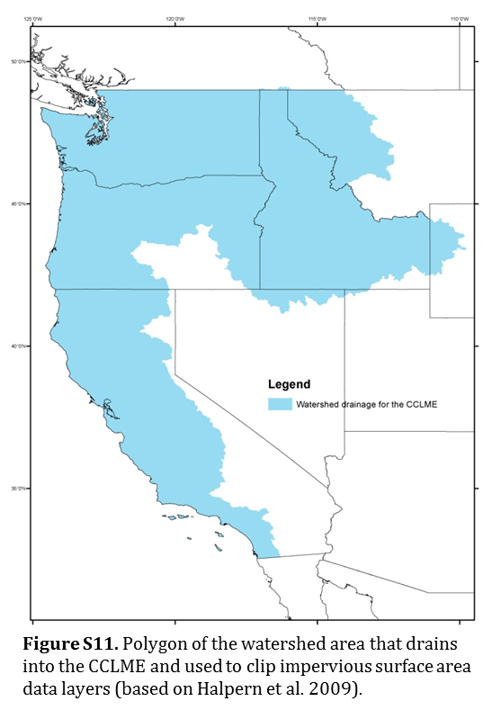
Status and trends
The status and trends of inorganic pollution in the CCE were measured using ISA-Toxicity-weighted chemical releases from data collected by the Environmental Protection Agency and reported by the Toxics Release Inventory (TRI) Program. This indicator incorporates the amount and toxicity of chemicals released into water and onto land by industrial facilities as well as the amount of impervious surface area in the CCE’s drainage basin. Using this indicator, inorganic pollution has decreased over the last five years, but is still within 1SD of the long-term average of the entire time series (Fig. S12). A couple more years of low levels of chemical releases should bring the short-term average below historic levels.
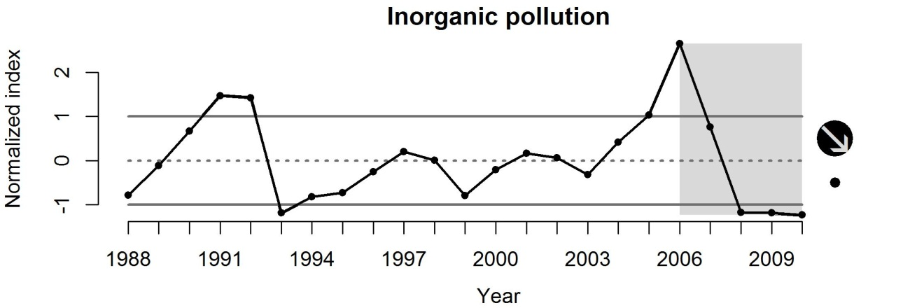
Figure S12 Normalized index of ISA-toxicity-weighted chemical releases in WA, OR and CA industrial facilities.

Invasive species

Background
Introductions of non-native invasive species into marine and estuarine waters are considered a significant threat to the structure and function of natural communities and to living marine resources in the United States (Carlton 2001; Johnson et al. 2008). The estimated damage from invasive species in the United States alone totals almost $120 billion per year (Pimentel et al. 2005). The mechanisms behind biological invasions are numerous, but generally include the rapid transport of invaders across natural barriers (e.g. plankton entrained in ship ballast water, organisms contained in packing material (Japanese eelgrass Zostera japonica) or fouling on aquaculture shipments, aquarium trade with subsequent release to natural environments) (Molnar et al. 2008). Non-native species can be released intentionally (i.e., fish stocking and pest control programs) or unintentionally during industrial shipping activities (e.g., ballast water releases), aquaculture operations, recreational boating, biotechnology, or from aquarium discharge.

Evaluation and selection of indicators
We evaluated three indicators of invasive species from the literature: number of alien species from regional records, number of shipping ports, and shipping cargo volume (Table S1).
The rate of biological species introductions has increased exponentially over the past 200 years, and it does not appear that this rate will level off in the near future (Carlton 2001). In a recent paper, Molnar et al. (2008) provided a quantitative global assessment of invasive species impacts, scored and ranked based on the severity of the impact on the viability and integrity of native species and natural biodiversity (http://conserveonline.org/workspaces/global.invasive.assessment/). This database serves as a regional baseline for invasion worldwide; unfortunately, it has not been updated since its creation and therefore lacks time series information, limiting its utility as an indicator.
Molnar et al. (2008) also examined potential pathways for invasion, using generalized linear models to quantify the correlation between the number of harmful species reported and various pathways of introduction (e.g., shipping, aquaculture, canals). Shipping was considered the most likely pathway of harmful species introductions in most regions, with statistically significant correlations found between the shipping indicators number of ports and shipping cargo volume. In the California Current, shipping was the key invasion pathway for northern California and the southern California Bight, whereas aquaculture was considered the more important invasion pathway in the Puget Trough/Georgia Basin and Oregon, Washington, Vancouver region. Empirical evidence increasingly indicates that the number of released individuals and number of released species are key determinants of the species that successfully invade new habitats (Lockwood et al. 2009). However, recent studies suggest this relationship may be taxa-specific, with invertebrates and diatoms appearing to be more sensitive to selective pressures during transportation that cause greater fluctuations in the number of released species than for other taxa, like dinoflagellates (Briski et al. 2012).
Invasive species were modelled as a function of ballast water release in ports by Halpern et al. (2009) when mapping cumulative human impacts to the CCE. In this case, port volume data (in tonnes) were available for 618 global ports from several sources: the 2002 World Port Ranking (N=36) and 2003 USA Port Ranking (N=102) compiled by the American Association of Port Authorities (http://www.aapa-ports.org), Australia ports database (N=30; http://www.aapma.org.au/tradestats; access date 3/19/05), and Lloyds List database [N=450; Ref (S17)]. Thus, data are available and comparable at many different scales around the globe. It should be noted, however, that changes in ballast water regulations and treatment technologies may have or will likely in the future influence the risk of invasive species introduction (Waite et al. 2003).
The USA Department of Transportation projects that, compared to 2001, total freight moved through USA ports will increase by more than 50 percent by 2020 and the volume of international container traffic will more than double (American Association of Port Authorities Fact Sheet 2011: http://www.aapa-ports.org/files/PDFs/facts.pdf). In order to estimate the potential for species invasions, we used data on the total amount of shipping cargo (thousands of short tonnes converted to millions of tonnes) that moved through each port along the Pacific coast of the Unites States. These data were available from the US Army Corps of Engineers Navigation Data Center (http://www.ndc.iwr.usace.army.mil/data/datawcus.htm). CSV files were available for years 1993–2010. These data included port tonnage data from Alaska, so we used data from 2001–2010 from the ‘State Summary Tonnage Data’ (http://www.ndc.iwr.usace.army.mil/data/datastat.htm) to calculate the proportion of tonnage along the Pacific Coast that was attributable to Alaska. We then used this proportion to subtract Alaska tonnage from the original dataset. For years in which we did not have an estimate of Alaska’s proportion (1993–2000), we used the average proportion from 2001–2010. This provided a dataset that was of the greatest temporal duration, but also removed the effects of Alaska’s port volume.
In addition to port volume, aquaculture has been associated with historic increases in invasive species, so an index that combines port activity and aquaculture (perhaps imports) should be added to this list of indicators and evaluated in the future. There are examples of combining these two metrics into a single spatial snapshot (Halpern et al. 2008; Halpern et al. 2009), but we need to modify this method into a temporal time series.

Status and trends
The status and trends of invasive species in the CCE were measured using the amount of cargo moving through coastal ports of the CCE. Using this indicator, the number of potentially invasive species entering ports along the CCE has decreased over the last five years, but the short-term average is still within 1SD of the long-term average of the entire time series (Fig. S13). In addition to using this indicator, it would be good to develop an index that combines port volume and aquaculture as a more thorough indicator of the status and trends of invasive species.
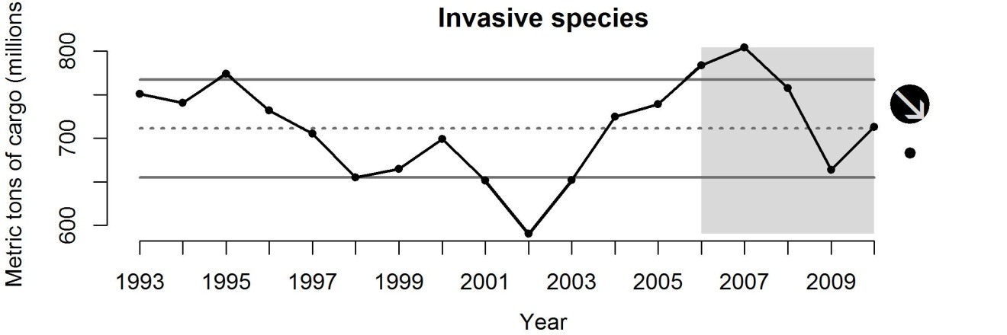
Figure S13 Metric tonnes (millions) of cargo moved through ports in WA, OR and CA.

Light pollution

Background
Ecological light pollution has demonstrable effects on the behavioural and population ecology of organisms in natural settings (Rich & Longcore 2006). As a whole, these effects derive from changes in orientation, disorientation, or misorientation, and attraction or repulsion from the altered light environment, which in turn may affect foraging, reproduction, migration, and communication (Longcore & Rich 2004). Many nocturnally migrating birds die or lose a large amount of their energy reserves during migration as a result of encountering artificial light sources (Poot et al. 2008). Juvenile sablefish exposed to a horizontal light gradient exhibited an avoidance of bright light (Sogard & Olla 1998). While juvenile sablefish were primarily surface-oriented, they nonetheless displayed clear day/night differences in vertical distribution. Proximity to the surface and low activity at night contrasted with higher activity and the greater range of vertical movement that typified daytime behaviour. Movement throughout the water column during the day and the negative phototaxis observed in a horizontal gradient suggests that juveniles in nature, at least during the day, may not be restricted to the neuston.
For some species that nest on beaches, such as sea turtles, excess amounts of light along the coast cause considerable disruptions to their innate behaviours. Light pollution on nesting beaches alters critical nocturnal behaviours such as, how to choose a nesting site, how to return to the sea after nesting, and how hatchlings find the sea after emerging from their nests (Witherington & Martin 2000). Changes in the amount of polarized light also affect predator-prey relationships. As many marine species are visual predators, they use changes in the surrounding water’s polarization signature to identify the presence of prey (Horváth et al. 2009). Planktivores are well-adapted at using changes in the polarization of the water to detect zooplankton in the water column that would otherwise be transparent (Flamarique & Browman 2001). Cephalopods also use polarized light as a hunting cue (Shashar et al. 1998) while other aquatic predators use light to detect camouflaged or distant prey resources (Shashar et al. 1998; Marshall et al. 1999). These alterations to the natural light dark cycles may allow for increased predation rates and subsequent changes to the community structure of areas with high levels of light pollution (Longcore & Rich 2004).

Evaluation and selection of indicators
We evaluated only one indicator of light pollution in the CCE: a normalized index of night-time light pixels present in waters of the CCE (Table S1). This indicator is based on data collected by the US Air Force Weather Agency and processed by NOAA’s National Geophysical Data Center (NGDC). This dataset is available from 1992–2010 on the NGDC’s website: http://www.ngdc.noaa.gov/dmsp/downloadV4composites.html. Specifically, we used the ‘Average Lights x Pct.’ (average night-time lights, hereafter) data layers for satellites F12-18 and years 1994–2010 (we deleted data from satellite F10 based on recommendations from Elvidge et al. (2009)). These data layers were derived from the average visible band digital number (DN) of cloud-free light detections multiplied by the percent frequency of light detection. The inclusion of the percent frequency of detection term normalized the resulting digital values for variations in the persistence of lighting. For instance, the value for a light only detected half the time is discounted by 50%. Note that this product contains detections from fires and a variable amount of background noise. We first clipped each
We then clipped each data layer to the area of the CCE. This polygon was created from the California Current LME data layer provided on NOAA’s Large Marine Ecosystems of the World website (http://www.lme.noaa.gov/). However, we extended the northern boundary to the northern tip of Vancouver island, British Columbia, as defined by the previous California Current Integrated Ecosystem Assessment (Fig. AP44 in Levin & Schwing 2011).
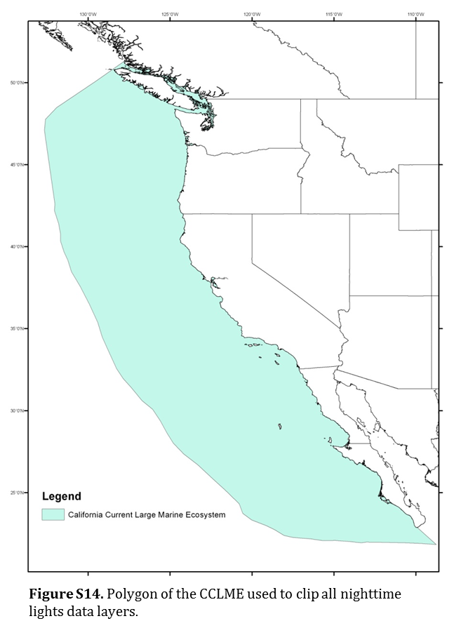
Data layers were collected by different satellites with no internal calibration instruments, so data values are not directly comparable among years without a calibration method. Because data were collected by overlapping satellites we were able to calibrate among years using calibration equations provided by Chris Elvidge of the NGDC. We used the coefficients in the calibration equations to standardize the underlying data values in each pixel cell of each data layer. After calibration, we summed the value of all average night-time lights for each cell in each data layer. For years in which multiple satellites collected data, we averaged the summed values for that year. These sums-of-average-night-time-lights values were then normalized across years for the final metric.

Status and trends
The status and trends of light pollution in the CCE were measured using a normalized index of the sum of average night-time lights. These data was processed and made available by the USA Geophysical Data Center. Using this indicator, light pollution has been constant over the last five years and is within 1SD of the long-term average of the time series (Fig. S15). This result is a little unexpected due to the contrasting increases observed in coastline populations, but this is likely caused by the decision to use stable lights that occur in waters off the coast and do not include values from any land areas. The overall time series showed that light pollution steadily decreased from 1995–2004 within the CCE and has been at these relatively low levels ever since.
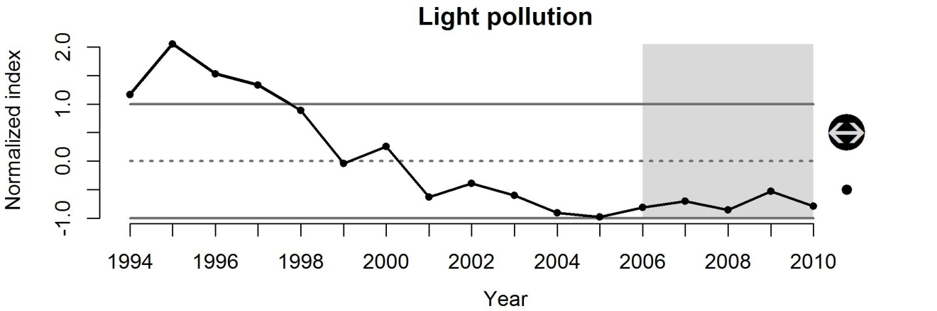
Figure S15 Normalized index of the sum of average night-time lights in waters of the CCE.

Marine debris

Background
Marine debris is ubiquitous to all habitats of the ocean, whether it’s in the form of metal cans or plastic bags on the beach (Ribic et al. 2012), derelict fishing gear caught on rocky bottom habitats (Good et al. 2010), household garbage in deep-water canyons (Watters et al. 2010) or micro-plastics in offshore surface waters (Doyle et al. 2011). The presence of marine debris along the coast extends from the shoreline to the greatest depths of the California Current, while 80% of this debris has been estimated to be from terrestrial runoff (Faris & Hart 1994). Data collected by Watters et al. (2010) using submersibles showed increases in marine debris on the ocean bottom in deep submarine canyons and continental shelf locations off California from the 1990's–2007. Bauer et al. (2008) found significantly higher densities of recreational fishing and other debris on rock ledges compared to other bottom types due to concentrated fishing effort where recreationally important fishes associate and the likelihood of gear becoming snagged on complex habitat.
While in some areas of the world the quantities of marine debris apparently show a decreasing trend during the past two decades (Ribic et al. 1997), other authors have reported increases (Coe & Rogers 1997). In general, the National Academy of Sciences (Criddle et al. 2008) has concluded that there is little quantitative information on amounts, sources, and trends of marine debris. However, recent programs such as the National Marine Debris Monitoring Program has developed standardized methods to quantify coastal debris and other surveys have begun to systematically quantify debris in meaningful ways (Gilfillan et al. 2009; Keller et al. 2010; Doyle et al. 2011). There are many coastal clean-up programs quantifying ‘marine debris’ from beach clean-up surveys but these are not effective for quantifying temporal trends as the amount of debris collected is most likely related to the number of volunteers instead of the amount of debris. In addition, beach surveys are assumed to be an index of conditions in the surrounding waters, but there are no corresponding estimates of actual debris in the water to validate this assumption. Standardized programs with standardized metrics of measuring marine debris along the coast have been funded by the Environmental Protection Agency in the past (NMDMP) and these methods could be adopted by other community groups which could make these data more effective.
Numerous researchers have documented the magnitude of marine debris and the threat that its ingestion or entangling poses to marine biota (Fowler 1987; Ryan 1990; Bjorndal et al. 1994; Moore et al. 2001; Moore et al. 2002). Marine debris, especially plastics, produces fragments that can be ingested by many marine organisms, resulting in mortality (Derraik 2002; Thompson et al. 2004; Browne et al. 2008). Marine debris in the form of lost fishing gear continues to ‘fish’ by trapping fish, invertebrates, seabirds and marine mammals (Kaiser et al. 1996; Good et al. 2010). Marine debris may also impact populations behaviourally by concentrating individuals both at the water’s surface (FAD–floating aggregation devices; Aliani & Molcard 2003)) and on the bottom (artificial reefs; Stolk et al. 2007).

Evaluation and selection of indicators
We evaluated three indicators for marine debris in the CCE. The first is marine debris measured by the National Marine Debris Monitoring Program (NMDMP). This program developed standardized methods using volunteers to record specific types of marine debris among 18 sites in the northern and southern CCE with Point Conception as the boundary between the two regions. Semi-permanent transects (500 m in length) were sampled at sites every 28 days from 1999–2007. This standardized sampling protocol allows for a temporal analysis of the data. Marine debris estimates from beach clean-ups or standardized sampling methods are still suspect as indicators of what debris is actually in the ocean waters or on the seafloor, so this indicator scores poorly in many criteria because of this. However, the data are sound and provide nearly a decade of broad-scale spatiotemporal information that has been lacking.
The second indicator evaluated was beach trash collected during the annual California Coastal Cleanup Day which is organized by the California Coastal Commission’s Public Education Program and occurs on the same day as the International Coastal Cleanup day organized by the Ocean Conservancy. Volunteers show up and remove trash from beaches, lakes and other waterways. This trash is recorded by the volunteers and reported to the Education Program where the data are summarized and available for download: www.coastal.ca.gov/publiced/ccd/data.xls. Sampling is not standardized by material or number of volunteers, so the amount of trash collected is most likely an indicator of the number of people who volunteer each year, rather than the actual amount of trash and debris on the coast; thus this indicator scored low in comparison with the NMDMP program.
The final indicator evaluated was ocean-based measurements. This would be an actual measurement of debris in the oceans rather than measurements of trash on the beach that may or not make its way into the ocean. There are some surveys that record marine debris including the Northwest Fisheries Science Center’s annual groundfish bottom trawl survey (Keller et al. 2010) which has collected and recorded marine debris since 2007. There are also examples of plankton surveys (e.g., California Cooperative Oceanic Fisheries Investigations (CalCOFI) and NOAA’s Southwest Fisheries Science Center’s ecosystem surveys) that also collect and quantify micro-plastics present in samples (Moore et al. 2002; Gilfillan et al. 2009; Doyle et al. 2011). However, these studies are usually short-term studies (1-2 years). The CalCOFI plankton samples (1951 to present) are archived at Scripps Pelagic Invertebrates Collection, so there is opportunity to retroactively quantify plastics in these samples, but funding for this work is not presently available. Lack of data for ocean-based measurements of marine debris eliminates it from being useful.
Thus, we used estimates of marine debris from the NMDMP as the indicator for marine debris in the CCE. Christine Ribic (USA Geologic Survey) provided predicted counts of marine debris data from the model developed by Ribic et al. (2012). These data were separated into northern and southern CCE regions and into three different debris categories: land, ocean and general. We summed the predicted counts for all three debris categories to provide a single estimate for each region.

Status and trends
The status and trends of marine debris in the CCE were measured using data from the Nation Marine Debris Monitoring Program (Ribic et al. 2012). These data were derived from a generalized additive model that used standardized surveys of debris along the coast of the CCE. Using this indicator, marine debris in the northern CCE (north of Point Conception, CA) was increasing between 2003 and 2007, but the short-term average was within historic levels (Fig. S16a). In the southern CCE, marine debris was relatively constant across the last five years of this time series and within historic levels (Fig. S16b). This program no longer collects data, so an extension of this dataset will not occur unless funding for the program is revisited.
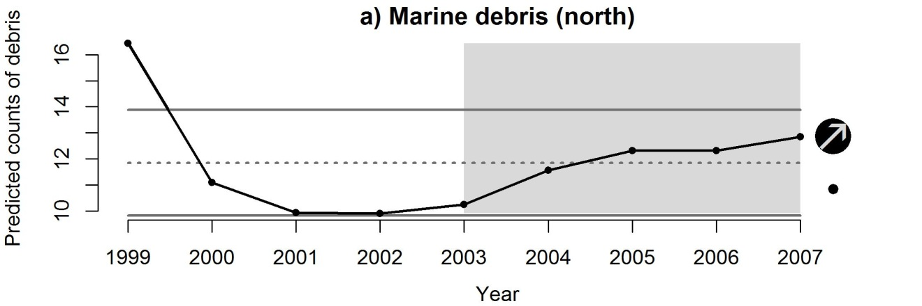
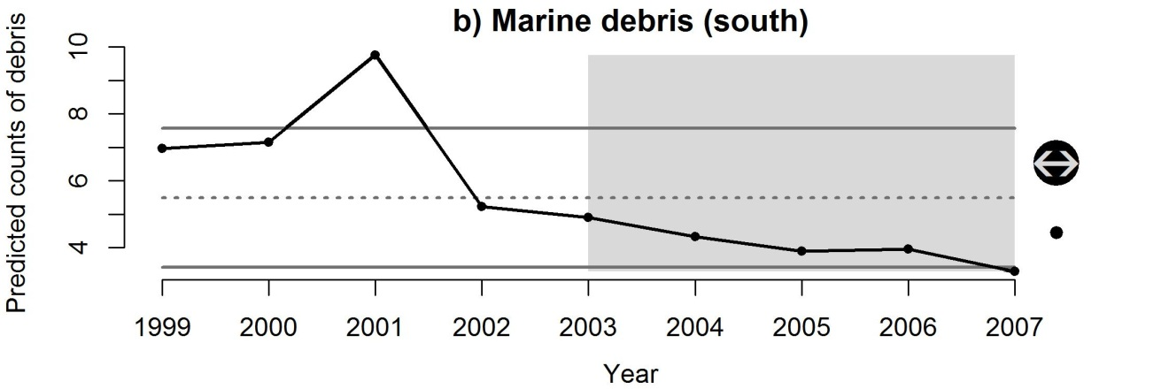
Figure S16 Predicted counts of debris along the a) northern and b) southern coasts of the CCE (Point Conception separates the regions). Data provided by Christine Ribic (Ribic et al. 2012).

Nutrient input

Background
Elevated nutrient concentrations are a leading cause of contamination in streams, lakes, wetlands, estuaries, and ground water of the United States (USEPA 2002). Nutrients (primarily nitrogen and phosphorus) are chemical elements that are essential to plant and animal nutrition; in marine waters, either phosphorus of nitrogen can limit plant growth. However, in high concentrations they can be considered water contaminants (USEPA 1999a).
Excess nutrients in a body of water can have many detrimental effects on drinking water supplies, recreational use, aquatic life use, and fisheries, and there are multiple indirect effects of nutrient enrichment of surface waters on human health. However, excessive nutrients are more often a cause of concern because of their role in accelerating eutrophication, which produces a wide range of other impacts on aquatic ecosystems and fisheries. Severely eutrophic conditions may adversely affect aquatic systems in a number of ways, including: algae blooms; declines in submerged aquatic vegetation (SAV) populations through reduced light transmittance, epiphytic growth, and increased disease susceptibility; mass mortality of fish and invertebrates through poor water quality (e.g., via oxygen depletion and elevated ammonia levels); and alterations in long-term natural community dynamics (Dubrovsky et al. 2010). Algal toxins harmful to animal and human health can be produced from blooms of some cyanobacteria species. High algal biomass also is associated with hypoxia (low dissolved-oxygen concentrations), which can contribute to the release of toxic metals from bed sediments, increased availability of toxic substances like ammonia and hydrogen sulphide, and fish kills. In recent years, nitrate and other nutrients discharged from the Mississippi River Basin have been linked to a large zone of hypoxia in the Gulf of Mexico along the Louisiana-Texas coast (Sprague et al. 2009).
Nonpoint sources of nutrients which affect stream and groundwater concentrations include fertilizer use, livestock manure, and atmospheric deposition (Ruddy et al. 2006). Within some coastal regions of the USA (e.g., mid-Atlantic states), much of the excess nutrients originates from point sources, such as sewage treatment plants, whereas failing septic systems often contribute to non-point source pollution and are a negative consequence of urban development (Johnson et al. 2008). However, nutrient loading can be a complex indicator to interpret, as a variety of hydro-geomorphic features (basin slope, basin area, mean annual precipitation, stream flow, and soil type) may also interact with possible nutrient sources to complicate estimates of nutrient concentration and loading. As well, there often are multiple and possibly counteracting anthropogenic factors influencing nutrient source and transport in a watershed, and without detailed knowledge of all important factors in each watershed, it may be difficult to discern the specific cause(s) of a trend in concentration (Sprague et al. 2009). Best land-use practices are known to reduce nutrient loading. Protocols for establishing total maximum daily load (TMDL) values of nutrients have been developed for specific bodies of water throughout the country (USEPA 1999a); however, we uncovered few examples in the literature of TMDLs for marine systems on the Pacific coast of the US.
Despite some of the previous cautions, nutrient loading in freshwater systems is generally a well understood indicator with a long history of reporting, as evidenced by requirements under the Clean Water Act, intensive nationwide monitoring programs at the federal, state, and local level, and a variety of national and regional trend reports by USGS (Ruddy et al. 2006; Wise et al. 2007; Sprague et al. 2009; Dubrovsky et al. 2010; Kratzer et al. 2011).

Evaluation and selection of indicators
Nutrient input to coastal areas can be estimated in multiple ways. For this analysis, we evaluated only two types of nutrient input indicators: county-level inputs of nitrogen and phosphorus via fertilizers and nutrient loading (TN, TP) from stream monitoring records.
Halpern et al. (2009) used time series data from Nolan and Hitt (2006) on county-level fertilizer application data from 1992–2001 (kg ha^{–1}) and confined manure (primarily from dairy farms) from 1992–1997. These files (http://water.usgs.gov/GIS/dsdl/gwava-s/index.html) (Nolan & Hitt 2006) have a relatively limited temporal range (between 1992–2001). A comparable alternative would be to compile county-level estimates of nutrient inputs (kg km⁻²) to the land surface of the conterminous USA, presented from 1982-2006 based on fertilizer use, livestock manure, and atmospheric deposition (Ruddy et al. 2006; Gronberg & Spahr 2012). An older time series (1945-1986) of nationwide fertilizer application data (Ruddy et al. 2006; Dubrovsky et al. 2010) could expand the time series further by assuming that watersheds bordering the Pacific coast follow the same historic trends in fertilizer applications. More recent data (2007–2010) is expected to be analysed and summarized in 2013 (N. Dubrovsky, USGS, personal communication). Models have been used to predict the probability of nitrate contamination in ground waters of the United States based on fertilizer loading and other factors (Nolan & Hitt 2006). It is unclear how this relates to coastal systems, however.
A more data-intensive approach would be to estimate nutrient loading from surface waters using publicly available data on nutrient concentrations and flow rates from various US watersheds sampled by the USGS and various state and local agencies. Changes in stream flow are an important influence on nutrient concentrations in streams: depending on the particular nutrient sources in a watershed and how these nutrients are transported to the stream, increases or decreases in stream flow can lead to increases or decreases in concentrations (Sprague et al. 2009). Nutrient data are publicly accessible through the online USGS National Water Information System (NWIS) database at (http://nwis.waterdata.usgs.gov/usa/nwis/qwdata). The majority of data contained in the NWIS database are from water samples collected using standard methods described in USA Geological Survey (variously dated). USGS flow data can be accessed from (http://nwis.waterdata.usgs.gov/nwis/dv/?referred_module=sw). Nutrient (TN and TP) loading can be estimated at various time increments (e.g., daily, annual) using LOADEST, a USGS program that finds a best fit data model for flux as a function of discharge. The Yale University interface LOADRUNNER (http://environment.yale.edu/loadrunner/) calculates daily, monthly, and annual element fluxes, from these USGS water quality sample and stream flow data sources.
Nutrient trends in west coast rivers (1993-2003) have been summarized using similar methods in a recent report by Sprague et al. (2009), which showed that flow adjusted trends in total phosphorus concentrations were generally upward or non-significant at sites in the South-western USA and non-significant in the North-western USA Trends in total nitrogen concentrations generally were downward or non-significant at sites in the North-western USA, but mixed in all other regions. Regional reports include an analysis of trends (1993–2003) in the Columbia River and Puget Sound basins (Wise et al. 2007) and the Sacramento, San Joaquin, and Santa Ana Basins, California (Kratzer et al. 2011). In the Pacific Northwest study, point-source nutrient loads generally were a small percentage of the total catchment nutrient loads compared to nonpoint sources, with most of the monitoring sites showing decreasing trends in TN and TP, indicating that inputs from nonpoint sources of nutrients probably have decreased over time in many of the catchments (Wise et al. 2007). In the California study, most trends in flow-adjusted concentrations of nutrients in the Sacramento Basin and Santa Anna River were downward, whereas nitrogen trends in the San Joaquin Basin were upward, especially over the 1975–2004 time period (Kratzer et al. 2011). As all of these studies note, fertilizer use, livestock manure, land-cover, atmospheric deposition, population growth, source loading (e.g., wastewater treatment plants) are all known nutrient sources that can contribute to increasing nutrient stream loads. However, basin slope, basin area, mean annual precipitation, and soil type may also interact with these sources, and flow-adjusted trends in concentration can also be complex, as there often are multiple and possibly counteracting anthropogenic factors influencing nutrient source and transport in a watershed. Without detailed knowledge of all important factors in each watershed, it may be difficult to discern the specific cause(s) of a trend.
Each of these indicators scored relatively well and there were no glaring differences (Table S1) to discern which to use. One of the goals of the indicator selection process is to develop operationally simple indicators, so we have chosen to use the simple alternative: county-level inputs of nitrogen and phosphorus via fertilizers. We extracted data from Ruddy et al. (2006) and Gronberg & Spahr (2012) for counties in WA, OR, CA, ID, MT and WY that drain into the California Current. We only used counties that had at least 50% of its area within a CC watershed. We then summed ‘farm’ and ‘nonfarm’ input of nitrogen and phosphorus from fertilizer use across relevant counties for the years 1987–2006 (data available at: http://water.usgs.gov/GIS/metadata/usgswrd/XML/sir2012-5207_county_fertilizer.xml). We then extracted nationwide data for 1945–2001 from figure 7 in Ruddy et al. (2006). We calculated the proportion of nitrogen and phosphorus that these counties accounted for in the nationwide data for the years 1987–2001. We then used the average proportion and multiplied that by the nationwide data for the years 1945–1986 to get estimates of nitrogen and phosphorus input across an extended temporal scale. We then normalized the time series data for nitrogen and phosphorus separately, summed the normalized values for each year, and then re-normalized these sums across all years to get a single normalized index of the sum of nitrogen and phosphorus input from fertilizers across counties that drain into the California Current.

Status and trends
The status and trends of nutrient input into the CCE were measured using a normalized index of the sum of nitrogen and phosphorus applied to lands as fertilizers in counties that drain into the California Current. Using this dataset, nutrient input decreased over the last five years of the dataset (2006–2010), but the short-term average was still > 1SD above the long-term average of the time series (Fig. S17). Further decreases in nutrient input over the next couple years will bring the short-term mean back within historical levels.
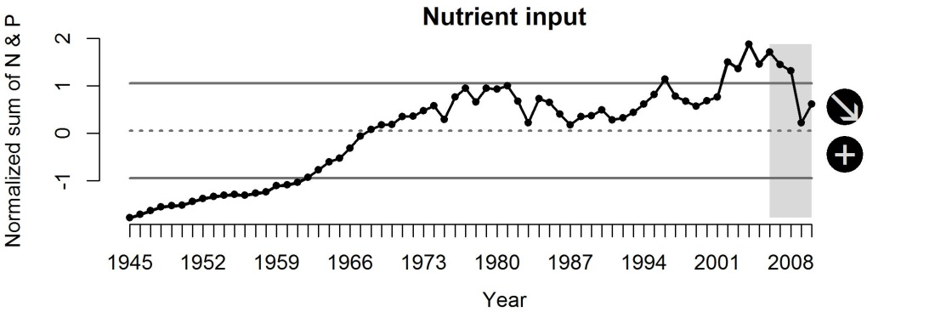
Figure S17 Normalized index of the sum of nitrogen and phosphorus applied as fertilizers in WA, OR and CA.

Ocean-based pollution

Background
The impact of ocean-based pollution is wide-spread as we include pollution from sea-going vessels and activity within ports throughout the California Current. Marine ports in the United States are major industrial centres providing jobs and steady revenue streams yet contributing significantly to pollution. Ships with huge engines running on bunker fuel without emission controls, thousands of diesel trucks per day, diesel locomotives, and other polluting equipment and activities at modern seaports cause an array of environmental impacts that can seriously affect local communities and marine and land-based ecosystems throughout a region (Bailey & Solomon 2004). As vessels transit within ports, along the coast, and along international shipping lanes, there are inevitable discharges of waste, leaks of oil and gas, loss of cargo during rough seas, and increased risk of oil spills from oil shipping vessels. Beaches close in proximity to oil shipping lanes have been observed to have high tar content related to the degree of oil pollution in the sea (Golik 1982).
The effects of oil pollution on components of the CCE are both direct and indirect. Because seabirds and marine mammals require direct contact with the sea surface, these taxa experience high risk from floating oil (Loughlin 1994). Oiled seabirds and marine mammals lose the insulating capacity of their feathers and fur which can lead to death from hypothermia (Peterson et al. 2003). Chronic exposure to partially weathered oil is toxic to eggs of pink salmon Oncorhynchus gorbuscha and herring Clupea pallasii (Marty et al. 1997; Heintz et al. 2000). Many effects of exposure to oil and the associated polycyclic aromatic hydrocarbons (PAHs) are sublethal and have lasting effects on individual survival which may scale up to population-level responses. For example, embryos of zebrafish Danio rerio exposed to PAHs showed delayed changes in heart shape and reduced cardiac output (Hicken et al. 2011). Strandings of oiled seabirds have been used as an indicator of chronic oil pollution along heavily used shipping lanes in the North Sea and recent studies show declining oil-rates reflecting reduced oil spills (Camphuysen 1998; Camphuysen 2010).
In addition to the potential for pollution, other common impacts of vessel activities include vessel wake generation, anchor chain and propeller scour, vessel groundings, the introduction of invasive or non-native species, and the discharge of contaminants and debris.

Evaluation and selection of indicators
Ocean-based pollution was used as a measure of the risk associated with pollution that occurs and originates from ocean-use sectors. This pollution was assumed to derive from two primary sources (Halpern et al. 2009): the movement of commercial vessels (oil and gas leaks, loss of cargo, waste dumping, discharges, etc.) and activity within ports (oil and gas leaks, loss of cargo, discharges, etc.). We evaluated only one indicator for ocean-based pollution which combined data from commercial shipping activity and port volume in the CCE (Table S1). This indicator is well supported in the literature as a proxy for ocean-based pollution and there are long-term continuous time series of data collected by the USA Army Corps of Engineers.
This indicator combined the use of two previously described indicators for commercial shipping activity (volume of water disturbed during transit of vessels) and invasive species (port volume). The only difference is that for volume of water disturbed, we summed all vessel movements within ports and along the coast. Commercial shipping activity was a measure of the risk associated with ship strikes on large animals, groundings, and habitat modification, so movement within ports was not relative to that pressure. The addition of the volume of water disturbed within ports was relatively undetectable and did not alter the trends of the original data. In order to combine these two datasets into one indicator, we normalized each time series separately, summed the normalized values, and then re-normalized these sums to produce the final normalized index.

Status and trends
The status and trends of ocean-based pollution were measured in the CCE using a normalized index which combined 1) the volume of water disturbed by vessels in the CCE during transit between or within ports and 2) the annual port volume of ports in the CCE. Using this indicator, ocean-based pollution has decreased over the last five years, but the short-term average is within 1SD of the long-term average (Fig. S18). The decreasing trend in this dataset reflects current economic conditions of the shipping and port industries over the last five years; thus, this indicator is likely to increase as economic conditions improve. The predominant contributor to the trend with the ‘Commercial shipping activity’ data is foreign vessel traffic and these data are available back to 1997, while the domestic data may be available back to 1994 if funding were available to the USACE to perform this data inquiry. These data could be integrated with the port volume data, which is available back to 1993, to increase the duration of this indicator’s time series.
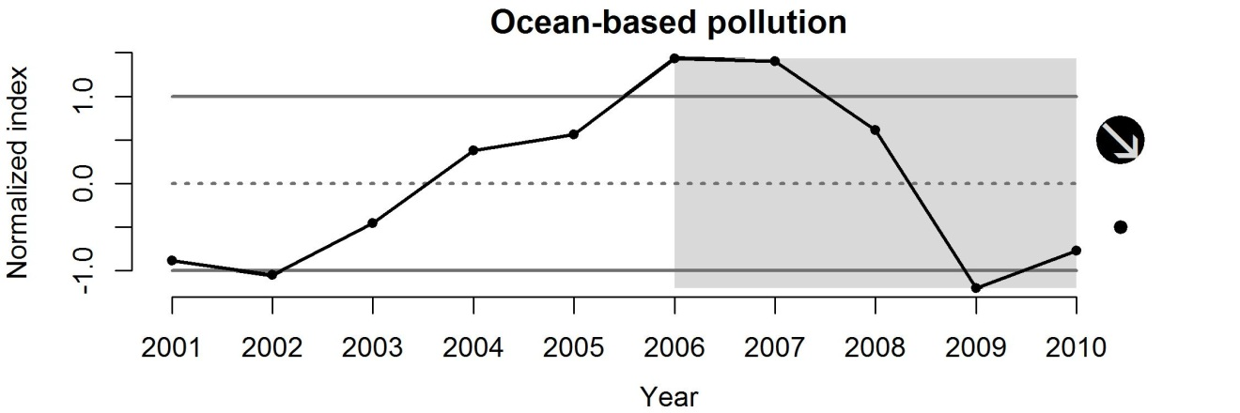
Figure S18 Normalized index that combines the volume (millions m³) of water disturbed by vessels during transit in port and along the coast and the volume of cargo moving through USA ports.

Offshore oil and gas activity

Background
The environmental risks posed by offshore exploration and production of oil and gas are well known. They include the loss of hydrocarbons to the environment, smothering of benthos, sediment anoxia, destruction of benthic habitat, and the use of explosives (Macdonald et al. 2002). Petroleum exploration involves seismic testing, drilling sediment cores, and test wells in order to locate potential oil and gas deposits (Johnson et al. 2008). Petroleum production includes the drilling and extraction of oil and gas from known reserves. Oil and gas rigs are placed on the seabed and as oil is extracted from the reservoirs, it is transported directly into pipelines. While rare, in cases where the distance to shore is too great for transport via pipelines, oil is transferred to underwater storage tanks. From these storage tanks, oil is transported to shore via tanker. According to the Minerals & Management Service, there are 21,000 miles of pipeline on the United States outer coastal shelf (OCS). According to the National Research Council (NRC), pipeline spills account for approximately 1,900 tonnes per year of petroleum into US OCS waters, primarily in the central and western Gulf of Mexico. Other potential negative impacts include: physical damage to existing benthic habitats within the ‘drop zone’, undesired changes in marine food webs, facilitation of the spread of invasive species, and release of contaminants as rigs corrode (Macreadie et al. 2011).
However, the effects of oil rigs on fish stocks is less conclusive, with these risks balanced out by the possible enhanced productivity brought about by colonization of novel habitats by structure-associated fishes and invertebrates (e.g., rockfish, encrusting organisms, etc.) (Love et al. 2006). Decommissioned rigs could enhance biological productivity, improve ecological connectivity, and facilitate conservation/restoration of deep-sea benthos (e.g. cold-water corals) by restricting access to fishing trawlers.
Petroleum extraction and transportation can lead to a conversion and loss of habitat in a number of other ways. Activities such as vessel anchoring, platform or artificial island construction, pipeline laying, dredging, and pipeline burial can alter bottom habitat by altering substrates used for feeding or shelter. Disturbances to the associated epifaunal communities, which may provide feeding or shelter habitat, can also result. The installation of pipelines associated with petroleum transportation can have direct and indirect impacts on offshore, nearshore, estuarine, wetland, beach, and rocky shore coastal zone habitats. The destruction of benthic organisms and habitat can occur through the installation of pipelines on the sea. Benthic organisms, especially prey species, may recolonize disturbed areas, but this may not occur if the composition of the substrate is drastically changed or if facilities are left in place after production ends (Johnson et al. 2008).
Offshore oil rigs in the California Current are exclusively found in southern California. Increasing pressure to find oil on continental shelves will probably increase the risk of hydrocarbon pollution to the North Pacific: Canada (British Columbia), the USAA. (California), Republic of Korea and Japan have all indicated that they intend either to begin or to expand exploration on the continental shelves of the Pacific, and drilling already occurs off Alaska and California and in the East China Sea (Macdonald et al. 2002).

Evaluation and selection of indicators
In order to estimate the temporal trend in activities related to offshore oil and gas activities off California, we evaluated two indicators: oil and gas production and the number of oil and gas wells in the CCE (Table S1). Both indicators have long time-series of data available and are easily used to communicate status and trends to the public and policymakers. However, the number of oil and gas wells may not likely reflect how much continuous activity surrounds each oil platform or well and thus, may not capture the variability associated with impact to the seafloor. Production of oil and gas from producing wells will capture the potential effects of continued activities (e.g., new anchorings, drilling, or maintenance of wells) on the seafloor habitat. In addition, available data for production values have a broader temporal extent (1970–2010) than number of wells (1981–2009), thus this indicator evaluated higher and will be used to measure the status and trends of this pressure.
We retrieved state and federal offshore oil and gas production data from annual reports of the California State Department of Conservation’s Division of Oil, Gas, and Geothermal Resources (ftp://ftp.consrv.ca.gov/../pub/oil/annual_reports/) for the years 1981–2009. A second on-line data resource, the National Ocean Economics Program at the Monterey Institute of International Studies (http://www.oceaneconomics.org/Minerals/oil_gas.asp), was used to verify these numbers and expand the temporal extent of the production rate data series from 1970 to 2010.

Status and trends
The status and trends of offshore oil and gas activity in the CCE were measured using a normalized index of the sum of oil and gas production from offshore wells in California waters. In order to combine oil (millions of barrels) and gas (1000’s of cubic feet) production values for each year, we normalized each dataset (mean = 0; SD = 1). We then summed the normalized values for each year and renormalized these sums. This provided equal weight to oil and gas production to the final index. Using this dataset, offshore oil and gas activity in the CCE has been constant over the last five years, but the short-term average was greater than 1SD below the long-term average (Fig. S19). A rather steady decrease in oil and gas production has occurred over the last 15 years.
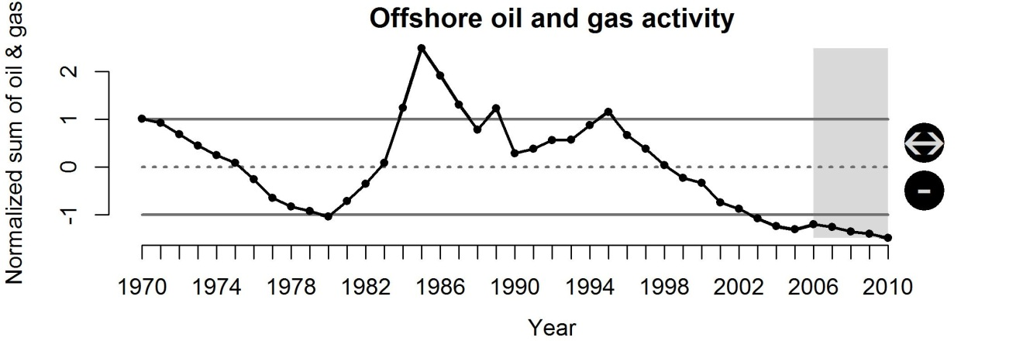
Figure S19 Normalized index of the sum of oil and gas production from offshore wells in CA.

Organic pollution

Background
Organic pollution encompass numerous classes of chemicals including pesticides, polycyclic aromatic hydrocarbons (PAHs) and other persistent organic pollutants (POPs) and is introduced to the marine environment via runoff to rivers, streams and groundwater, poor-disposal practices and the discharge of industrial wastewater. Pesticides can affect the health and productivity of biological populations in three basic ways: (1) direct toxicological impact on the health or performance of exposed individuals; (2) indirect impairment of the productivity of the ecosystem; and (3) loss or degradation of vegetation that provides physical structure for fish and invertebrates (Hanson et al. 2003; Johnson et al. 2008). For many marine organisms, the majority of effects from pesticide exposures are sublethal, meaning that the exposure does not directly lead to the mortality of individuals. Sublethal effects can be of concern, as they impair the physiological or behavioural performance of individual animals in ways that decrease their growth or survival, alter migratory behaviour, or reduce reproductive success (Hanson et al. 2003; Johnson et al. 2008), but in general the sublethal impacts of pesticides on fish health are poorly understood. Early development and growth of organisms involve important physiological processes and include the endocrine, immune, nervous, and reproductive systems. Many pesticides have been shown to impair one or more of these physiological processes in fish (Gould et al. 1994; Moore & Waring 2001). The direct and indirect effects that pesticides have on fish and other aquatic organisms can be a key factor in determining the impacts on the structure and function of ecosystems (Preston 2002).
Petroleum products, including PAHs, consist of thousands of chemical compounds which can be particularly damaging to marine biota because of their extreme toxicity, rapid uptake, and persistence in the environment (Johnson et al. 2008). PAHs have been found to be significantly higher in urbanized watersheds when compared to non-urbanized watersheds. Low-level chronic exposure to petroleum components and byproducts (i.e., polycyclic aromatic hydrocarbons [PAH]) have been shown in Atlantic salmon Salmo salar to increase embryo mortality, reduce growth (Heintz et al. 2000), and lower the return rates of adults returning to natal streams (Wertheimer et al. 2000). Effects of exposure to PAH in benthic species of fish include liver lesions, inhibited gonadal growth, inhibited spawning, reduced egg viability and reduced growth (Johnson et al. 2002). In general, the early life history stages of most species are most sensitive, juveniles are less sensitive, and adults least so.
Municipal wastewater treatment facilities have made great advances in treatment practices to eliminate pollutants prior to discharge, but any discharges will undoubtedly affect the quality of habitat in estuarine environments (Diaz & Rosenberg 1995; Kam et al. 2004). Several studies have shown that many benthic species increase in abundance and biomass in response to increased organic loading (Weston 1990; Savage et al. 2002; Alves et al. 2012). However, excessive nutrient enrichment can lead to hypoxia and potentially anoxic conditions, consequently leading to declines or shifts in biomass and diversity in the benthic community (Ysebaert et al. 1998; Essington & Paulsen 2010). Species richness among benthic communities has been shown to increase in relation to both temporal and spatial distance from organic loading sources (Savage et al. 2002; Wear & Tanner 2007). In addition to municipal wastewater treatment facilities, widely-distributed poorly-maintained septic systems contaminate shorelines in many places (Macdonald et al. 2002).

Evaluation and selection of indicators
We evaluated a single indicator for organic pollution in the CCE: toxicity-weighted concentrations of pesticides (Table S1). The toxicity of a chemical is an important factor when trying to understand the potential effects of pollution on biological components and is widely used to weight the relative importance of specific chemicals (Toffel & Marshall 2004); thus, we did not evaluate concentrations alone as an indicator.
Concentrations of 16 pesticides in streams were assessed by the USA Geological Survey using data from standardized sites all across the United States (Ryberg et al. 2010). These data are easily accessible from the USA Geological Survey (http://pubs.usgs.gov/sir/2010/5139/downloads/appendix6.txt). We used data from the five sites located in WA, OR and CA and summed the recovery-adjusted concentrations across all five sites for each pesticide in each year (1993–2008). Because three of the pesticides (fipronil, desulfinylfipronil, and fipronil sulphide) did not have data prior to 2002, we eliminated them. We then multiplied the recovery-adjusted concentrations by their toxicity score and summed these values across all pesticides for each year. The toxicity score was calculated by dividing the pesticides Indiana Relative Chemical Hazard Score (https://engineering.purdue.edu/CMTI/IRCHS/) by 100 (maximum value of the scoring system). For pesticides that were not in the IRCHS list, we used the average value of the other pesticides in our dataset. The toxicity-weighted sums were then normalized to provide the final indicator.

Status and trends
The status and trends of organic pollution in the CCE were measured using a normalized index of the toxicity-weighted concentrations of 16 pesticides measured in streams in WA, OR and CA. Using this indicator, organic pollution has decreased over the last five years, but the short-term average remains within 1SD of the long-term average of the time series (Fig. S20). Prior to this most recent trend, organic pollution had been increasing since the early 1990’s.
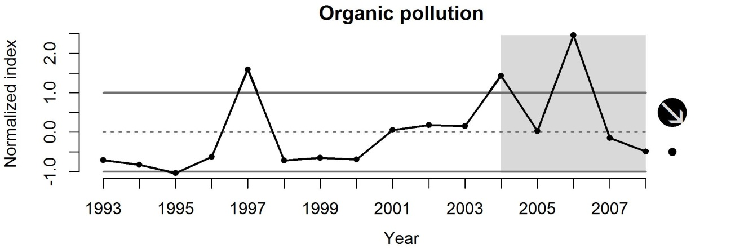
Figure S20 Normalized index of toxicity-weighted concentrations of 16 pesticides measured in WA, OR and CA.

Power plants

Background
Water for thermoelectric power is used in generating electricity with steam-driven turbine generators. Coastal power plants draw in huge amounts of marine water for cooling purposes, creating an area around the intake pipes where larvae and small plants are entrained. These entrainment ‘plumes’ will vary in size and shape depending on ocean currents and the size of the power plant. The construction and operation of water intake and discharge facilities can have a wide range of physical effects on the aquatic environment including changes in the substrate and sediments, water quality and quantity, habitat quality, and hydrology. Most facilities that use water depend upon freshwater or water with very low salinity for their needs (Johnson et al. 2008).
The entrainment and impingement of fish and invertebrates in power plant and other water intake structures have immediate as well as future impacts to estuarine and marine ecosystems (Johnson et al. 2008). Not only is fish and invertebrate biomass removed from the aquatic system, but the biomass that would have been produced in the future would not become available to the ecosystem. Water intake structures, such as power plants and industrial facilities, are a source of mortality for managed-fishery species and play a role as one of the factors driving changes in species abundance over time. Organisms that are too large to pass through in-plant screening devices become stuck or impinged against the screening device or remain in the forebay sections of the system until they are removed by other means.
Determining the relative importance of these impacts, however, is more controversial, and may be equally dependent on year-class strength, recruitment, fishery mortality, predation, and a variety of other human facilities (dams, etc.) (Barnthouse 2000). The primary approach for assessing adult-equivalent population losses at coastal power plants in California has used the ‘Empirical Transport Model’ (ETM), which relies on estimates of power plant entrainment and source water larval populations (Steinbeck et al. 2006). Although Steinbeck et al. (2006) conclude that the ETM may be the best current approach for these impact assessments, a variety of other considerations may play a more important role in determining entrainment impacts, including effectively sampling organisms potentially affected by entrainment (often determined by life history, including spawning location and timing), sampling frequency, determining source water areas potentially affected, and design, location, and hydrodynamics of the power plant intake structure. Helvey and Dorn (1987) examined the selective removal of reef fish associated with an offshore cooling-water intake structure, and found that removal was a selective process governed by species’ behavioural characteristics associated with the intake currents and visibility (fish may not be capable of rheotropic responses when illumination falls below a critical threshold. Diurnally active species seeking benthic cover at night were least susceptible to intake removal. Diurnally active species that hover in the water column at night and predators that periodically feed at twilight and evening hours (e.g., Sebastes paucispinis) were more susceptible to removal. Nocturnally active transient species, such as Seriphus politus and Engraulis mordax, were most susceptible to removal (Helvey & Dorn 1987).

Evaluation and selection of indicators
We evaluated two indicators of power plant activity in the CCE: 1) average daily saline water withdrawal volumes and 2) daily entrainment mortality (Table S1). The largest total thermoelectric withdrawals on the west coast are in California, where nearly all of the water was withdrawn from marine surface waters for use in once-through cooling systems (Kenny et al. 2009). Washington and Oregon thermoelectric power withdrawals rely almost exclusively on fresh surface waters. In 2005, the total daily water withdrawals for thermoelectric power generation from all west coast states combined (WA, OR, CA) equalled over 13 Bgal/d (billion gallons per day), with the vast majority (96%; 12.6 Bgal/d) attributed to CA marine surface water withdrawals. Over the course of record-keeping, marine surface water withdrawals from California have consistently represented more than 80% of thermoelectric water withdrawals. The USGS has conducted water-use compilations in the United States every 5 years since 1950 (http://water.usgs.gov/watuse/50years.html), and thermoelectric power has represented the largest total category of water withdrawals in every compilation since 1960 (Hutson et al. 2005; Kenny et al. 2009). Withdrawals by thermoelectric-power plants have ranged from a low of 40 Bgal/d during 1950 to a high of 210 Bgal/d in 1980. In 2005, thermoelectric water withdrawals totalled 201 Bgal/d and comprised 49 percent of total water use in the country. Declines in thermoelectric-power water withdrawals from 1980 to present are primarily a result of Federal legislation requiring stricter water-quality standards for return flow and by limited water supplies in some areas of the United States. Consequently, power plants have increasingly been built with or converted to closed-loop cooling systems or air-cooled systems instead of using once-through cooling systems. By 2000, an alternative to once-through cooling was used in about 60 percent of the installed steam-generation capacity in the power plants (Hutson et al. 2005).
There is a long history of studying and reporting impacts of cooling systems on fish populations, especially the Hudson River and other coastal estuaries along the mid-Atlantic (Barnthouse 2000). In California, calculations of daily entrainment mortality have been limited to a few power plants; historical data are limited and time series information is generally lacking. Furthermore, the uncertainties associated with estimating larval durations and hydrodynamics used in estimating the size of the source water populations make estimating variance for ETM problematic (Steinbeck et al. 2006).
Primarily due to data considerations (Table S1), we selected average daily water withdrawals to estimate the potential entrainment impact of coastal power plants. We extracted the average daily withdrawal volumes (millions of gallons per day converted to millions of m³ per day) of saline water over time from all thermoelectric power plants on the west coast of North America (Pacific Northwest and California regions, from Kenny et al. (2009) and other previous USGS water use reports (http://water.usgs.gov/watuse/50years.html). The temporal extent of these data ranges from 1955 to 2005 and the reporting interval is every five years.

Status and trends
The status and trends of power plants in the CCE were measured using the volume (millions of m³) of saline water withdrawn daily by thermoelectric power plants in WA, OR and CA. Because these data were sampled every 5 years, we interpolated the annual value over the last five years (asterisks in Fig. S21) assuming a linear relationship between the last two data points in order to keep the short-term status (most recent five years) consistent with the other pressure indicators. The mean and standard deviation of the dataset were calculated using the original dataset. Power plant activity was constant over the last five years of the dataset (2000–2005), but the short-term average was >1SD above the long-term average (Fig. S21). Trends of water withdrawals by thermoelectric power plants have been constant or decreasing across the USA since the 1980’s (Kenny et al. 2009), so the CCE may have slightly elevated its power plant activity compared to the rest of the USA in the early 2000’s.
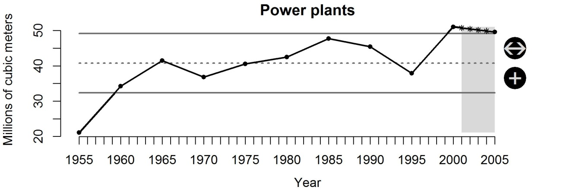
Figure S21 Daily saline water withdrawals (millions m³) from thermoelectric power plants in CA, OR and WA.

Recreational use

Background
People visiting beaches and coastal areas can impact intertidal and nearshore ecosystems through direct trampling or by disturbing or displacing species that would normally use those locations (Halpern et al. 2009). This may be particularly important to species which inhabit intertidal zones their entire lives or for species that reproduce or rest on populated beaches (Moffett et al. 1998; McClenachan et al. 2006; Defeo et al. 2009). Species which represent some value as a source of food (e.g., shellfish) or collections (e.g. seashells) will also be impacted with increases in beach visitations.

Evaluation and selection of indicators
We evaluated only one indicator of recreational use: beach attendance. This indicator evaluated highly in most criteria (Table S1) because it was used in previous studies as an indicator of direct human impact to intertidal and nearshore ecosystems (Halpern et al. 2008; Halpern et al. 2009). However, the use of state beaches and parks may not necessarily reflect how many people are actually spending time walking around on the beach or in the intertidal zones, but rather may reflect time spent at upland areas or simply sitting in their vehicles. There is also recent evidence that the methodologies used to calculate beach attendance by state agencies overestimate actual attendance in a non-random fashion (King & McGregor 2012).
For California, we extracted total visitor attendance at 48 California state parks identified as ‘State Beach’ from the California State Park System Annual Statistical Reports: 2001 -2010 (http://www.parks.ca.gov/?page_id=23308). For Oregon, the only measure of annual beach attendance is collected by the Oregon Parks and Recreation Department’s Stewardship Division for the years 2002–2011. This estimate is measured using automated car counters in the parking lots of coastal state parks. These estimates are based on the assumption that there are on average four occupants per vehicle (based on results of a state-wide visitor survey). These measures are likely an overestimate of actual pressure on the associated beaches as some people use the parking lots and do not go to the beach. For Washington, the Washington State Parks and Recreation Commission collects attendance data at parks with ocean beach access and these data are available in annual ‘Attendance Reports’. We limited these datasets to years in which data were available for all three states (2002–2010) and to parks/beaches that were open and censused in all years (i.e. if a state park was closed at some point during the time series, this park was excluded from the analysis).

Status and trends
The status and trends of recreational beach use were measured using annual estimates of beach attendance at state parks and beaches in WA, OR and CA. Using this dataset, we found that direct human impact has decreased significantly over the last five years, but the short-term mean is still within 1 SD of the long-term mean of the dataset (Fig. S22).
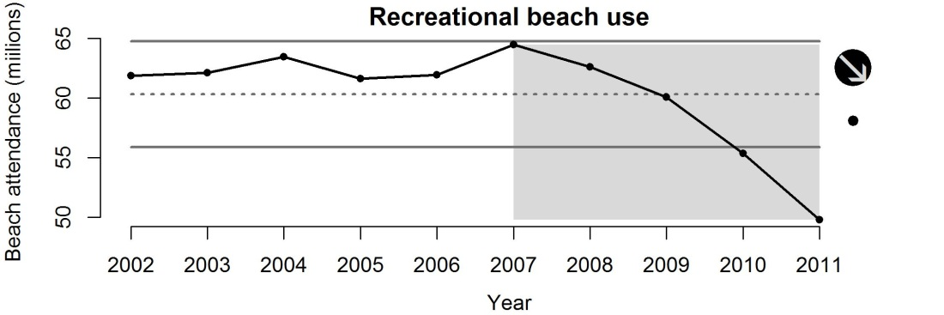
Figure S22 Annual beach attendance (millions of persons) at state parks and beaches with access points to a beach in WA, OR and CA.

Seafood demand

Background
The global population continues to increase and seafood is one of the most important sources of protein for humans all over the world, so demand for edible fisheries products will continue to be a strong pressure on the world’s oceans (Garcia & Rosenberg 2010). In addition to the underlying driver of population growth, the most recent report of the Dietary Guidelines for Americans has recommended Americans more than double their intake of seafood due to a variety of health benefits (DGAC 2010). Depending on the response and potential change in dietary behaviours by humans, pressure could increase greatly for the production of high-quality seafood. However, the production of world capture fisheries has been relatively constant since the 1980’s (NRC 2006), and there is little room for increase. The world’s demand for seafood has thus, become more dependent on aquaculture production, which has been growing at about 8% annually, making it the fastest growing form of food production in the world. However, much of the feed for the aquaculture (and pig and poultry) industry is derived from forage fish species such as anchovy and capelin (Hannesson 2003). This pressure to catch fish in order to grow fish may not necessarily result in a net increase in the production of edible fish. Another common use of fisheries products is for use as fertilizers.
This pressure has obvious effects on the biological components of the CCE through direct removals of individuals from the benthic and pelagic communities. Direct fishery removals, however, also have a whole host of indirect effects that have been discussed under the Fisheries Pressures.

Evaluation and selection of indicators
We identified two primary indicators of seafood demand: total consumption and per capita consumption (Table S1). Both indicators are published in NOAA’s ‘Fisheries of the United States’ annual reports to describe the utilization of fisheries products (http://www.st.nmfs.noaa.gov/st1/publications.html). Total edible and non-edible seafood demand evaluates higher (Table S1) because fundamentally total consumption provides a concrete estimate of what is being used, whereas per capita consumption is simply based on the total consumption estimates divided by the population of the USA
We retrieved total consumption estimates (billion pounds) of total (imports and commercial landings) edible and non-edible seafood from each of the Fisheries of the United States annual reports which provided data from 1962–2010.

Status and trends
The status and trends of seafood demand in the CCE were measured using total consumption of edible and non-edible fisheries products. Using this dataset, seafood demand has varied with no overall trend over the last five years (Fig. S23), but the short-term average was greater than 1SD of the long-term average. With total demand already at historic levels, increasing populations, and recommendations by the USA Dietary Guidelines to increase our intake of seafood, this indicator will likely increase over the next few years. If per capita consumption increases, as recommended, total consumption could increase dramatically as human populations continue to increase globally as well as in the CCE. In many ways, seafood demand in states or countries outside of the CCE will have a large impact on the trends of this indicator and may limit the ability of regional managers to alter the effects of this pressure.
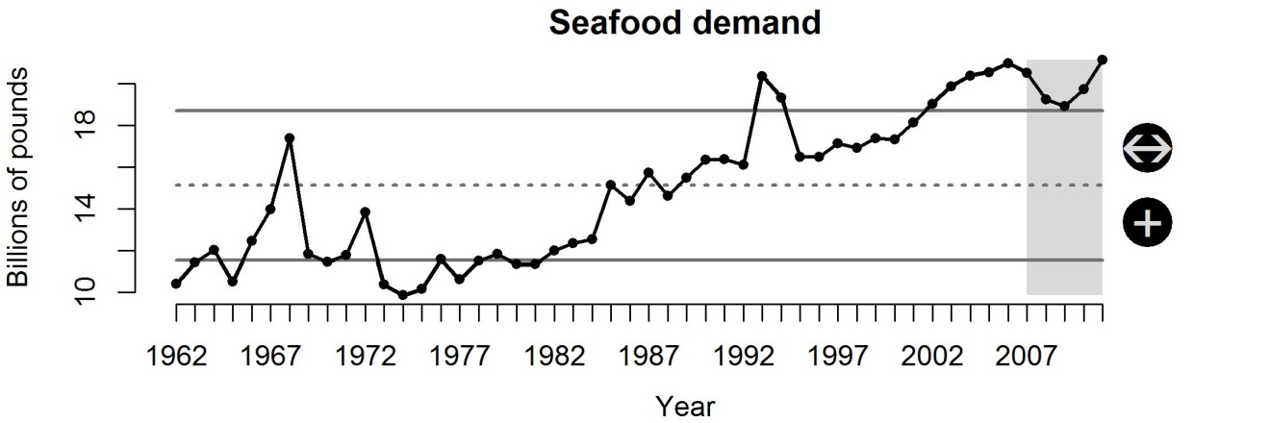
Figure S23 Total utilization of edible and non-edible fisheries products across the United States.

Sediment retention

Background
Sediment is a natural component in water bodies and the uses they support, but can also impair them in many ways (USEPA 1999b). Excessive sediments in waterways can cause direct physical harm to organisms (e.g. clogged gills), as well as impairment of aquatic feeding, rearing, spawning, and refuge habitats. As well, sediment deficits can result in stream channel scour and destruction of other habitat features. As a result, the federal Clean Water Act requires states, territories, and authorized tribes to identify and list impaired waters every two years and to develop total maximum daily loads (TMDLs) for sediment in these waters, with oversight from the USA Environmental Protection Agency. TMDLs establish the allowable pollutant loadings, thereby providing the basis for establishing water quality-based controls (USEPA 1999b).
Rivers are important conduits of large amounts of particulate and dissolved minerals and nutrients to the oceans, and play a key role in the global biogeochemical cycle (Dai et al. 2009). Humans are simultaneously increasing the river transport of sediment and dissolved constituents through soil erosion activities, and decreasing this flux to the coastal zone through sediment retention in reservoirs (Syvitski et al. 2005; Milliman et al. 2008). The net result is a global reduction in sediment flux by about 1.4 BT/year over pre-human loads. Rivers are globally getting dirtier and would otherwise move more sediment to the coast if not for the impact of reservoirs. The seasonal delivery of sediment to the coast affects the dynamics of nutrient fluxes to the coast and has serious implications to coastal fisheries, coral reefs, and seagrass communities (Syvitski et al. 2005). One example includes a reduction in natural dissolved silicate loads, which translates into silicon limitation in the coastal zone that discourages diatom blooms and favours nuisance and toxic phytoplankton, thereby compromising the integrity of coastal food webs (Vorosmarty & Sahagian 2000). Coastal retreat, which is directly influenced by the reduction of river-supplied sediment, has major implications for human habitat because >37% (2.1 billion people in 1994) of the world's population live within 100 km of a coastline (Syvitski et al. 2005). Dam removal restores the natural sediment transport regime and has become an increasingly adopted strategy to manage the environmental costs of these structures (Graf 1999; The Heinz Center 2002).
Changes in sediment supply can greatly influence the benthic environment of coastal estuaries, coral reefs, and seagrass communities, and are intimately tied to nutrient fluxes in these systems (Syvitski et al. 2005). Sediment delivery rates also affect harbour maintenance and pollutant burial or resuspension. Decreases in sediment input are largely the result of river damming or diversions, which directly influence the rate of coastal retreat. Dams affect the physical integrity of watersheds by fragmenting the lengths of rivers, changing their hydrologic characteristics, and altering their sediment regimes by trapping most of the sediment entering the reservoirs and disrupting the sediment budget of the downstream landscape (The Heinz Center 2002; Johnson et al. 2008). Because water released from dams is relatively free of sediment, downstream reaches of rivers may be altered by increased particle size, erosion, channel shrinkage, and deactivation of floodplains (The Heinz Center 2002). The consequence of reduced sediment also extends to long stretches of coastline where the erosive effect of waves is no longer sustained by sediment inputs from rivers (World Commission on Dams 2000). The effects to fishes of a reduced sediment regime would be indirect and primarily experienced through the long-term loss of soft-bottom habitat features and coastal landforms and/or changes to benthic habitat composition.
Increases in sediment input are largely due to land use practices that increase erosion rates (e.g., deforestation, wetland drainage, mining) or human activities in or near aquatic habitats (e.g., dredging) that re-suspend bottom sediments and create turbid conditions (Syvitski et al. 2005). Suspended sediments can elicit a variety of responses from aquatic biota; these responses may range from an active preference for turbid conditions, presumably to facilitate feeding and avoidance behaviours, to detrimental physical impacts that may result in egg abrasion, reduced bivalve pumping rates, and direct mortality (Wilber & Clarke 2001). Much of the available data on biological effects on organisms come from bioassays that measure acute responses and require high concentrations of suspended sediments to induce the measured response, usually mortality (Wilber & Clarke 2001). Although anadromous salmonids have received much attention, little is known of behavioural responses of many estuarine fishes to suspended sediment plumes. There is a high degree of species variability in response to sedimentation; reports of ‘‘no effect’’ were made at concentrations as great as 14,000 mg/L for durations of 3 d and more (oyster toadfish and spot) and mortality was observed at a concentration/duration combination of 580 mg/L for 1 d (Atlantic silversides). For both salmonid and estuarine fishes, the egg and larval stages are more sensitive to suspended sediment impacts than are the older life history stages.

Evaluation and selection of indicators
Two indicators of sediment input were evaluated: dam/reservoir storage area and suspended sediment loading (Table S1). To estimate the temporal change in sediment decrease, we focused on dams as the key feature affecting this change, per Halpern et al. (2008). Construction of large dams peaked in the1970’s in Europe and North America (World Commission on Dams 2000). Today most activity in these regions is focused on the management of existing dams, including rehabilitation, renovation, and optimizing the operation of dams for multiple functions. The history of total reservoir storage area by US water resource region was summarized from the early 1900’s to the early 1990’s by Graf (1999), based on data from the USA Army Corps of Engineers (1996). Since these data are no longer available electronically from the USACE, we compiled total reservoir storage in 10⁹ cubic m over time (year of construction) for the California and PNW water resource regions. Freshwater storage was obtained from state agency databases, which include information on construction date and impoundment area/volume for all dams (California: http://cdec.water.ca.gov/misc/resinfo.html; Idaho: http://www.usbr.gov/projects/FacilitiesByState.jsp?StateID=ID; Oregon: http://www.usbr.gov/projects/FacilitiesByState.jsp?StateID=OR; Washington: https://fortress.wa.gov/ecy/publications/summarypages/94016.html.). Note that the data compiled using this summary does not precisely replicate the Graf (1999) data, but the temporal trends are comparable.
Another more data-intensive approach would involve estimating sediment loading from surface waters using publicly available data on sediment concentrations and flow rates from various US watersheds sampled by the USGS and various state and local agencies. Sediment data are publicly accessible through the online USGS National Water Information System (NWIS) database at (http://nwis.waterdata.usgs.gov/usa/nwis/qwdata). The majority of data contained in the NWIS database are from water samples collected using standard methods described in USA Geological Survey (variously dated). USGS flow data can be accessed from (http://nwis.waterdata.usgs.gov/nwis/dv/?referred_module=sw). Suspended sediment loading can be estimated at various time increments (e.g., daily, annual) using LOADEST, a USGS program that finds a best fit data model for flux as a function of discharge. The Yale University interface LOADRUNNER (http://environment.yale.edu/loadrunner/) calculates daily, monthly, and annual fluxes, from these USGS water quality sample and stream flow data sources. Currently, we have queried data from the USGS surface water database (http://infotrek.er.usgs.gov/apex/f?p=NAWQA:HOME:5572182579967972) for suspended sediment (SS) levels [mg/L] from sampled Pacific coastal basins from 1991-2011. Flow adjusted trends in concentration can be complex, as there often are multiple and possibly counteracting anthropogenic factors influencing sediment source and transport in a particular watershed.
A recent report from USGS summarizes the annual mean loads for SS in the Puget Sound and Columbia River basins using the USGS computer program Load Estimator (LOADEST), which uses a linear regression model that incorporates flow, time, and seasonal terms to estimate loads of mass over specified time periods (for this study, annual loads) (Wise et al. 2007). During water year 2000, considered an average stream flow year in the Pacific Northwest, the Columbia River discharged about 14,000 tonnes per day of SS to the Pacific Ocean. For most catchments between water years 1993-2003, the net change in non-hydrologic characteristics (land use and other human activities) was not great enough to cause any significant (p < 0.05) flow-adjusted trend in concentration (FATC) for suspended sediment (SS). Nineteen of the 48 sites available for SS trend analysis had significant FATC for SS (4 increasing, 15 decreasing), seven sites showed significant trend in load for SS (1 increasing, 6 decreasing), and more than 65 percent of the sites had decreasing (but not necessarily significant) FATC and trend in load for SS. There is currently no comparable analysis yet available for California basins.
We selected dam/reservoir storage area as our proxy for sediment input, primarily based on data considerations (Table S1); furthermore, the net global reduction in sediment flux to coastal areas is primarily due to reservoir construction (Syvitski et al. 2005).

Status and trends
The status and trends of sediment input in the CCE were measured using the total reservoir impoundment volume (millions m³) of dams along rivers in WA, OR and CA. Using this dataset, sediment input has been constant over the last five years and the short-term average was greater than 1SD of the long-term average of the time series (Fig. S24). Increases in reservoir impoundment volume lead to less sediment making its way to the deltas of the dammed rivers; thus, increases in this indicator represent decreases in sediment input to estuarine and marine habitats. This is one of the longest datasets for non-fisheries pressures, so changes in the long-term trend will only occur in the future if large changes occur over the next few decades. In contrast, many of the other indicators have short time series, so relatively smaller changes over just a few years will impact the short- and long-term trends and thus our interpretation of the current status of these indicators.
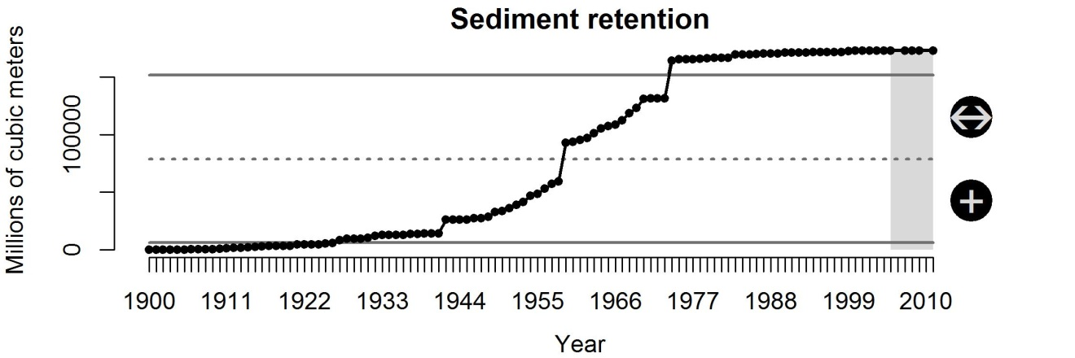
Figure S24 Volume (millions m³) of freshwater impoundments in WA, OR and CA (increasing freshwater storage is a proxy for decreasing sediment input).

References

AAPA (2012) American Association of Port Authorities. http://www.aapa-ports.org. accessed August 9, 2012.
Abramson, L.M., Polefka, S., Hastings, S. & Bor, K. (2009) Reducing the Threat of Ship Strikes on Large Cetaceans in the Santa Barbara Channel Region and Channel Islands National Marine Sanctuary: Recommendations and Case Studies. US Department of Commerce, National Oceanic and Atmospheric Administration, National Ocean Service, Office of Ocean and Coastal Resource Management, Office of National Marine Sanctuaries.
Addy, C. & Aylward, D.A. (1944) Status of eelgrass in Massachusetts during 1943. The Journal of Wildlife Management 8: 269-544.
Aliani, S. & Molcard, A. (2003) Hitch-hiking on floating marine debris: macrobenthic species in the Western Mediterranean Sea. Hydrobiologia 503(1): 59-67.
Alves, J.A., Sutherland, W.J. & Gill, J.A. (2012) Will improving wastewater treatment impact shorebirds? Effects of sewage discharges on estuarine invertebrates and birds. Animal Conservation 15: 44-52.
Anderson, R.M. (1998) Analytical theory of epidemics. In: Emerging infections, ed. R.M. Krause, pp. 23-50. New York, NY: Academic Press.
Arnold, C.L. & Gibbons, C.J. (1996) Impervious Surface Coverage: The Emergence of a Key Environmental Indicator. Journal of the American Planning Association 62(2): 243-258.
Bailey, D. & Solomon, G. (2004) Pollution prevention at ports: clearing the air. Environmental Impact Assessment Review 24(7): 749-774.
Barg, U.C. (1992) Guidelines for the promotion of environmental management of coastal aquaculture development. In: FAO Fisheries Technical Paper 328, Rome, Italy: Food & Agriculture Organization of the United Nations (FAO).
Barnthouse, L.W. (2000) Impacts of power-plant cooling systems on estuarine fish populations: the Hudson River after 25 years. Environmental Science and Policy 3(2000): S341-S348.
Barr, B.W. (1993) Environmental impacts of small boat navigation: vessel/sediment interactions and management implications. In: Coastal Zone 1993: proceedings of the eighth Symposium on Coastal and Ocean Management, ed. O.T. Magoon, pp. 1756-1770. American Shore and Beach Preservation Association.
Bauer, L.J., Kendall, M.S. & Jeffrey, C.F.G. (2008) Incidence of marine debris and its relationships with benthic features in Gray's Reef National Marine Sanctuary, Southeast USA. Marine pollution bulletin 56(3): 402-413.
Bellman, M.A. & Heppell, S.A. (2007) Trawl Effort Distribution off the USA Pacific Coast: Regulatory Shifts and Seafloor Habitat Conservation. In: Biology, assessment, and management of North Pacific rockfishes, eds. J. Heifetz, J. DiCosimo, A.J. Gharrett, M.S. Love, V.M. O’Connell & R.D. Stanley: Alaska Sea Grant, University of Alaska Fairbanks.
Bendell-Young, L. (2006) Contrasting the community structure and select geochemical characteristics of three intertidal regions in relation to shellfish farming. Environmental conservation 33(1): 21-27.
Berman-Kowalewski, M., Gulland, F., Wilkin, S., Calambokidis, J., Mate, B., Cordaro, J., Rotstein, D., Leger, J.S., Collins, P. & Fahy, K. (2010) Association between Blue Whale (Balaenoptera musculus) mortality and ship strikes along the California coast. Aquatic Mammals 36(1): 59-66.
Bindler, R. (2003) Estimating the natural background atmospheric deposition rate of mercury utilizing ombrotrophic bogs in southern Sweden. Environmental science & technology 37(1): 40-46.
Bjorndal, K.A., Bolten, A.B. & Lagueux, C.J. (1994) Ingestion of marine debris by juvenile sea turtles in coastal Florida habitats. Marine pollution bulletin 28: 154-312.
Blus, L.J., Heath, R.G., Gish, C.D., Belisle, A.A. & Prouty, R.M. (1971) Eggshell thinning in the brown pelican: implication of DDE. BioScience 21(24): 1213-1215.
Boesch, D.F., Burroughs, R.H., Baker, J.E., Mason, R.P. & Rowe, C.L. (2001) Marine pollution in the United States. Arlington, Virginia, USA: Pew Oceans Commission.
Booth, D.B. & Jackson, C.R. (1997) Urbanization of aquatic systems: Degradation thresholds, stormwater detection, and the limits of mitigation. Journal of the American Water Resources Association 33(5): 1077-1090.
Briski, E., Bailey, S.A., Casas-Monroy, O., DiBacco, C., Kaczmarska, I., Levings, C., MacGillivary, M.L., McKindsey, C.W., Nasmith, L.E., Parenteau, M., Piercey, G.E., Rochon, A., Roy, S., Simard, N., Villac, M.C., Weise, A.M. & MacIsaac, H.J. (2012) Relationship between propagule pressure and colonization pressure in invasion ecology: a test with ships' ballast. Proceedings of the Royal Society B-Biological Sciences 279: 2990-2997.
Browne, M.A., Dissanayake, A., Galloway, T.S., Lowe, D.M. & Thompson, R.C. (2008) Ingested microscopic plastic translocates to the circulatory system of the mussel, Mytilus edulis (L.). Environmental science & technology 42(13): 5026-5031.
Bulleri, F. & Chapman, M.G. (2010) The introduction of coastal infrastructure as a driver of change in marine environments. Journal of Applied Ecology 47: 26-35.
Camphuysen, K. (1998) Beached bird surveys indicate decline in chronic oil pollution in the North Sea. Marine pollution bulletin 36(7): 519-526.
Camphuysen, K.C.J. (2010) Declines in oil-rates of stranded birds in the North Sea highlight spatial patterns in reductions of chronic oil pollution. Marine pollution bulletin 60(8): 1299-1306.
Carlton, J.T. (2001) Introduced species in USA coastal waters: Environmental impacts and management priorities. Arlington, VA: Pew Oceans Commission.
Codarin, A., Wysocki, L.E., Ladich, F. & Picciulin, M. (2009) Effects of ambient and boat noise on hearing and communication in three fish species living in a marine protected area (Miramare, Italy). Marine pollution bulletin 58(12): 1880-1887.
Coe, J.M. & Rogers, D.B., eds. (1997) Marine debris: sources, impacts, and solutions. New York: Springer.
Criddle, K., Amos, A., Carroll, P., Coe, J., Donohue, M., Kim, K., McDonald, A., Metcalf, K., Rieser, A. & Young, N. (2008) Tackling marine debris in the 21st century. The National Academies Press, Washington, DC.
Crossett, K.M., Culliton, T.J., Wiley, P.C. & Goodspeed, T.R. (2005) Population trends along the coastal United States: 1980-2008. In: National Oceanic and Atmospheric Administration, Coastal Trends Reports Series.
Dai, A., Qian, T.T., Trenberth, K.E. & Milliman, J.D. (2009) Changes in Continental Freshwater Discharge from 1948 to 2004. Journal of Climate 22(10): 2773-2792.
Davidson, A., Boyer, A., Kim, H., Pompa-Mansilla, S., Hamilton, M., Costa, D., Ceballos, G. & Brown, J. (2012) Drivers and hotspots of extinction risk in marine mammals. Proceedings of the National Academy of Sciences of the United States of America.
Defeo, O., McLachlan, A., Schoeman, D.S., Schlacher, T.A., Dugan, J., Jones, A., Lastra, M. & Scapini, F. (2009) Threats to sandy beach ecosystems: a review. Estuarine, Coastal and Shelf Science 81(1): 1-12.
Derraik, J.G.B. (2002) The pollution of the marine environment by plastic debris: a review. Marine pollution bulletin 44: 842-852.
DGAC (2010) US Department of Agriculture and US Department of Health and Human Services. Report of the Dietary Guidelines Advisory Committee on the dietary guidelines for Americans, 2010. http://www.cnpp.usda.gov/DGAs2010-DGACReport.htm, last accessed: August 8, 2012.
Diaz, R.J. & Rosenberg, R. (1995) Marine benthic hypoxia: a review of its ecological effects and the behavioural responses of benthic macrofauna. Oceanography and Marine Biology Annual Review 33: 245-303.
Douglass, S.L. & Pickel, B.H. (1999) The tide doesn't go out anymore - the effects of bulkheads on urban bay shorelines. Shore and Beach 67: 19-25.
Doyle, M.J., Watson, W., Bowlin, N.M. & Sheavly, S.B. (2011) Plastic particles in coastal pelagic ecosystems of the Northeast Pacific ocean. Marine environmental research 71(1): 41-52.
Drinkwater, K.F. & Frank, K.T. (1994) Effects of river regulation and diversion on marine fish and invertebrates. Aquatic Conservation: Marine and Freshwater Ecosystems 4(2): 135-151.
Dubrovsky, N.M., Burow, K.R., Clark, G.M., Gronberg, J.M., P.A., H., Hitt, K.J., Mueller, D.K., Munn, M.D., Nolan, B.T., Puckett, L.J., Rupert, M.G., Short, T.M., Spahr, N.E., Sprague, L.A. & Wilber, W.G. (2010) The quality of our Nation’s waters—Nutrients in the Nation’s streams and groundwater, 1992–2004. USA Geological Survey Circular 1350.
Duce, R.A., LaRoche, J., Alteri, K., Arrigo, K.R. & Baker, A.R. (2008) Impacts of atmospheric Nitrogen on the open ocean. Science 320: 893-897.
Dumbauld, B.R., Ruesink, J.L. & Rumrill, S.S. (2009) The ecological role of bivalve shellfish aquaculture in the estuarine environment: A review with application to oyster and clam culture in West Coast (USA) estuaries. Aquaculture 290: 196-419.
Dunlop, R.A., Cato, D.H. & Noad, M.J. (2010) Your attention please: increasing ambient noise levels elicits a change in communication behaviour in humpback whales (Megaptera novaeangliae). Proceedings of the Royal Society B: Biological Sciences 277(1693): 2521-2529.
Elvidge, C., Ziskin, D., Baugh, K., Tuttle, B., Ghosh, T., Pack, D., Erwin, E. & Zhizhin, M. (2009) A Fifteen Year Record of Global Natural Gas Flaring Derived from Satellite Data. Energies 2(3): 595-622.
Eriksson, B., Sandström, A., Isæus, M., Schreiber, H. & Karås, P. (2004) Effects of boating activities on aquatic vegetation in the Stockholm archipelago, Baltic Sea. Estuarine, Coastal and Shelf Science 61(2): 339-349.
Essington, T.E. & Paulsen, C.E. (2010) Quantifying Hypoxia Impacts on an Estuarine Demersal Community Using a Hierarchical Ensemble Approach. Ecosystems 13(7): 1035-1048.
Faris, J. & Hart, K. (1994) Seas of debris: A summary of the third international conference on marine debris. In: N.C. Sea Grant College Program and NOAA.
Flamarique, I.N. & Browman, H.I. (2001) Foraging and prey-search behaviour of small juvenile rainbow trout (Oncorhynchus mykiss) under polarized light. Journal of Experimental Biology 204(14): 2415-2422.
Fowler, C.W. (1987) Marine Debris and Northern Fur Seals - a Case-Study. Marine pollution bulletin 18(6B): 326-335.
Frisk, G.V. (2012) Noiseonomics: The relationship between ambient noise levels in the sea and global economic trends. Scientific Reports 2: 437.
Garcia, S.M. & Rosenberg, A.A. (2010) Food security and marine capture fisheries: characteristics, trends, drivers and future perspectives. Philosophical Transactions of the Royal Society B: Biological Sciences 365(1554): 2869-2880.
Garcia, S.M., Zerbi, A., Aliaume, C., Do Chi, T. & Lasserre, G. (2003) The ecosystem approach to fisheries. Issues, terminology, principles, institutional foundations, implementation and outlook. Rep. No. 443. Rome: FAO.
Gergel, S.E., Turner, M.G., Miller, J.R., Melack, J.M. & Stanley, E.H. (2002) Landscape indicators of human impacts to riverine systems. Aquatic Sciences 64(2): 118-128.
Gilfillan, L.R., Ohman, M.D., Doyle, M.J. & Watson, W. (2009) Occurrence of Plastic Micro-Debris in the Southern California Current System. CalCOFI Report 50(ea5ea203-e1a7-f9f6-9141-3327d8c4cd16): 123-256.
Gillanders, B.M. & Kingsford, M.J. (2002) Impact of changes in flow of freshwater on estuarine and open coastal habitats and the associated organisms. In: Oceanography and Marine Biology, eds. R.N. Gibson, M. Barnes & R.J.A. Atkinson, pp. 233-309. Taylor & Francis.
Goldburg, R. & Triplett, T. (1997) Murky waters: Environmental effects of aquaculture in the United States. Washington (DC): Environmental Defense Fund.
Goldfinger, C., Romsos, C., Robison, R., Milstein, R. & Myers, B. (2003) Interim seafloor lithology maps for Oregon and Washington. Oregon State University, Active Tectonics and Seafloor Mapping Laboratory Publication 02-01. CD-ROM.
Golik, A. (1982) The distribution and behaviour of tar balls along the Israeli coast. Estuarine, Coastal and Shelf Science 15(3): 267-276.
Goni, R. (1998) Ecosystem effects of marine fisheries: an overview. Ocean & Coastal Management 40(1): 37-64.
Good, T.P., June, J.A., Etnier, M.A. & Broadhurst, G. (2010) Derelict fishing nets in Puget Sound and the Northwest Straits: Patterns and threats to marine fauna. Marine pollution bulletin 60(1): 39-50.
Gould, E., Clark, P.E. & Thurberg, F.P. (1994) Pollutant effects on dermersal fishes. In: Selected living resources, habitat conditions, and human perturbations of the Gulf of Maine: environmental and ecological considerations for fishery management. Woods Hole (MA): NOAA Technical Memorandum NMFS-NE-106. p 30-41., eds. R.W. Langton, J.B. Pearce & J.A. Gibson.
Graf, W.L. (1999) Dam nation: A geographic census of American dams and their large-scale hydrologic impacts. Water Resources Research 35(4): 1305-1311.
Greene, H.G. & Bizzarro, J.J. (2003) Essential fish habitat characterization and mapping of the California continental margin. Pacific States Marine Fisheries Commission (PSMFC), Pacific Coast Marine Fish Habitat Data Project. CD-ROM.
Gronberg, J.M. & Spahr, N.E. (2012) County-level estimates of nitrogen and phosphorus from commercial fertilizer for the conterminous United States, 1987–2006. USA Geological Survey Scientific Investigations Report 2012-5207, 20 p.
Hall, S.J. (1999) The effects of fishing on marine ecosystems and communities. Oxford, U.K.: Blackwell Science.
Halpern, B.S., Kappel, C.V., Selkoe, K.A., Micheli, F., Ebert, C.M., Kontgis, C., Crain, C.M., Martone, R.G., Shearer, C. & Teck, S.J. (2009) Mapping cumulative human impacts to California Current marine ecosystems. Conservation Letters 2(3): 138-148.
Halpern, B.S., Walbridge, S., Selkoe, K.A., Kappel, C.V., Micheli, F., D'Agrosa, C., Bruno, J.F., Casey, K.S., Ebert, C., Fox, H.E., Fujita, R., Heinemann, D., Lenihan, H.S., Madin, E.M.P., Perry, M.T., Selig, E.R., Spalding, M., Steneck, R. & Watson, R. (2008) A global map of human impact on marine ecosystems. Science 319(5865): 948-952.
Hamel, O. & Ono, K. (2011) Stock Assessment of Pacific Ocean Perch in Waters off of the USA West Coast in 2011. In: Status of the Pacific Coast Groundfish Fishery through 2011, Stock Assessment and Fishery Evaluation: Stock Assessments, STAR Panel Reports, and Rebuilding Analyses, Portland, Oregon: Pacific Fishery Management Council.
Hannesson, R. (2003) Aquaculture and fisheries. Marine Policy 27(2): 169-178.
Hanson, J., Helvey, M. & Strach, R. (2003) Non-fishing impacts to essential fish habitat and recommended conservation measures. Long Beach (CA): National Marine Fisheries Service (NOAA Fisheries) Southwest Region. Version 1. 75 p.
Harvell, C.D., Kim, K., Burkholder, J.M., Colwell, R.R. & others. (1999) Emerging marine diseases—climate links and anthropogenic factors. Science 285: 1505–1510.
Harvell, C.D., Mitchell, C.E., Ward, J.R., Altizer, S., Dobson, A.P., Ostfeld, R.S. & Samuel, M.D. (2002) Climate warming and disease risks for terrestrial and marine biota. Science 296(5576): 2158-2162.
Heintz, R.A., Rice, S.D., Wertheimer, A.C., Bradshaw, R.F., Thrower, F.P., Joyce, J.E. & Short, J.W. (2000) Delayed effects on growth and marine survival of pink salmon Oncorhynchus gorbuscha after exposure to crude oil during embryonic development. Marine Ecology Progress Series 208: 205-216.
Helvey, M. & Dorn, P.B. (1987) Selective removal of reef fish associated with an offshore cooling-water intake structure. Journal of Applied Ecology 24(1): 1-12.
Hermanson, M.H. (1998) Anthropogenic mercury deposition to Arctic lake sediments. Water, Air, & Soil Pollution 101(1): 309-321.
Heyvaert, A.C., Reuter, J.E., Slotton, D.G. & Goldman, C.R. (2000) Paleolimnological Reconstruction of Historical Atmospheric Lead and Mercury Deposition at Lake Tahoe, California−Nevada. Environmental science & technology 34(17): 3588-3597.
Hicken, C.E., Linbo, T.L., Baldwin, D.H., Willis, M.L., Myers, M.S., Holland, L., Larsen, M., Stekoll, M.S., Rice, S.D. & Collier, T.K. (2011) Sublethal exposure to crude oil during embryonic development alters cardiac morphology and reduces aerobic capacity in adult fish. Proceedings of the National Academy of Sciences 108(17): 7086.
Hickey, J.J. & Anderson, D.W. (1968) Chlorinated hydrocarbons and eggshell changes in raptorial and fish-eating birds. Science 162(3850): 271-273.
Hiddink, J.G., Jennings, S., Kaiser, M.J., Queiros, A.M., Duplisea, D.E. & Piet, G.J. (2006) Cumulative impacts of seabed trawl disturbance on benthic biomass, production, and species richness in different habitats. Canadian Journal of Fisheries and Aquatic Sciences 63(4): 721-736.
Holt, M.M., Noren, D.P., Veirs, V., Emmons, C.K. & Veirs, S. (2009) Speaking up: Killer whales (Orcinus orca) increase their call amplitude in response to vessel noise. Journal of the Acoustical Society of America 125(1): EL27-EL32.
Horváth, G., Kriska, G., Malik, P. & Robertson, B. (2009) Polarized light pollution: a new kind of ecological photopollution. Frontiers in Ecology and the Environment 7(6): 317-325.
Hutson, S.S., Barber, N.L., Kenny, J.F., Linsey, K.S., Lumia, D.S. & Maupin, M.A. (2005) Estimated Use of Water in the United States in 2000. USGS Circular 1268.
James, C.A., Kershner, J., Samhouri, J., O’Neill, S. & Levin, P.S. (2012) A Methodology for Evaluating and Ranking Water Quantity Indicators in Support of Ecosystem-Based Management. Environmental Management 49(3): 703-719.
Johnson, L.L., Collier, T.K. & Stein, J.E. (2002) An analysis in support of sediment quality thresholds for polycyclic aromatic hydrocarbons (PAHs) to protect estuarine fish. Aquatic Conservation: Marine and Freshwater Ecosystems 12(5): 517-538.
Johnson, M.R., Boelke, C., Chiarella, L.A., Colosi, P.D., Greene, K., Lellis, K., Ludemann, H., Ludwig, M., McDermott, S., Ortiz, J., Rusanowsky, D., Scott, M. & Smith, J. (2008) Impacts to marine fisheries habitat from nonfishing activities in the Northeastern United States. In: Gloucester, MA: NOAA Tech. Memo. NMFS-NE-209.
Johnston, E.L. & Roberts, D.A. (2009) Contaminants reduce the richness and evenness of marine communities: A review and meta-analysis. Environmental Pollution 157(6): 1745-1752.
Johnston, S.A. (1981) Estuarine dredge and fill activities: A review of impacts. Environmental Management 5(5): 427-440.
Kaiser, M., Bullimore, B., Newman, P., Lock, K. & Gilbert, S. (1996) Catches in'ghost fishing' set nets. Marine Ecology Progress Series 145(1): 11-16.
Kaiser, M.J., Edwards, D.B., Armstrong, P.J., Radford, K., Lough, N.E.L., Flatt, R.P. & Jones, H.D. (1998) Changes in megafaunal benthic communities in different habitats after trawling disturbance. Ices Journal of Marine Science 55(3): 353-361.
Kaiser, M.J. & Spencer, B.E. (1996) The effects of beam-trawl disturbance on infaunal communities in different habitats. Journal of Animal Ecology 65(3): 348-358.
Kam, J.V., Ens, B., Piersma, T. & Zwarts, L. (2004) Shorebirds: an illustrated behavioural ecology. Utrecht: KNNV Publishers.
Keller, A.A., Fruh, E.L., Johnson, M.M., Simon, V. & McGourty, C. (2010) Distribution and abundance of anthropogenic marine debris along the shelf and slope of the US West Coast. Marine pollution bulletin 60(5): 692-700.
Kennish, M.J. (1998) Pollution impacts on marine biotic communities. Boca Raton, FL: CRC Press.
Kenny, J.F., Barber, N.L., Hutson, S.S., Linsey, K.S., Lovelace, J.K. & Maupin, M.A. (2009) Estimated use of water in the United States in 2005: USA Geological Survey Circular 1344. 52 pp.
Kershner, J., Samhouri, J.F., James, C.A. & Levin, P.S. (2011) Selecting Indicator Portfolios for Marine Species and Food Webs: A Puget Sound Case Study. PLoS One 6(10).
Kimmerer, W.J. (2002) Effects of freshwater flow on abundance of estuarine organisms: physical effects or trophic linkages? Marine Ecology Progress Series 243: 39-55.
King, P. & McGregor, A. (2012) Who's counting: An analysis of beach attendance estimates and methodologies in southern California. Ocean & Coastal Management 58: 17-25.
Kratzer, C.R., Kent, R.H., Saleh, D.K., Knifong, D.L., Dileanis, P.D. & Orlando, J.L. (2011) Trends in nutrient concentrations, loads, and yields in streams in the Sacramento, San Joaquin, and Santa Ana Basins, California, 1975–2004. USA Geological Survey Scientific Investigations Report 2010-5228.
Lenat, D.R. & Crawford, J.K. (1994) Effects of Land-Use on Water-Quality and Aquatic Biota of 3 North-Carolina Piedmont Streams. Hydrobiologia 294(3): 185-199.
Levin, P.S., James, A., Kersner, J., O'Neill, S., Francis, T., Samhouri, J.F. & Harvey, C.J. (2011) The Puget Sound ecosystem: What is our desired future and how do we measure progress along the way? In Puget Sound Science Update, Chapter 1a. Online at http://www.psp.wa.gov/scienceupdate.php [accessed 17 August 2012].
Levin, P.S. & Schwing, F.B. (2011) Technical background for an integrated ecosystem assessment of the California Current: Groundfish, salmon, green sturgeon, and ecosystem health. USA Dept. of Commerce, NOAA Tech. Memo., NMFS-NWFSC-109, 330 p.
Lins, H.F. & Slack, J.R. (2005) Seasonal and regional characteristics of US streamflow trends in the United States from 1940 to 1999. Physical Geography 26(6): 489-501.
Lockwood, J.L., Cassey, P. & Blackburn, T.M. (2009) The more you introduce the more you get: the role of colonization pressure and propagule pressure in invasion ecology. Diversity and Distributions 15(5): 904-910.
Longcore, T. & Rich, C. (2004) Ecological light pollution. Frontiers in Ecology and the Environment 2: 191-198.
Loughlin, T.R., ed. (1994) Marine mammals and the Exxon Valdez. San Diego and London: Academic Press.
Love, M.S., Schroeder, D.M., Lenarz, W., MacCall, A., Bull, A.S. & Thorsteinson, L. (2006) Potential use of offshore marine structures in rebuilding an overfished rockfish species, bocaccio (Sebastes paucispinis). Fishery Bulletin 104(3): 383-390.
Love, M.S., Yoklavich, M. & Thorsteinson, L. (2002) The rockfishes of the northeast Pacific. Berkeley: University of California Press.
Macdonald, R.W., Morton, B., Addison, R.F. & Johannessen, S.C. (2002) Marine environmental contaminant issues in the North Pacific: What are the dangers and how do we identify them? In: PICES Science: The first ten years and a look to the future, eds. R.I. Perry, P. Livingston & A.S. Bychkov, Sidney, B.C., Canada: North Pacific Marine Science Organization (PICES).
Macreadie, P.I., Fowler, A.M. & Booth, D.J. (2011) Rigs-to-reefs: will the deep sea benefit from artificial habitat? Frontiers in Ecology and the Environment 9: 455-461.
Marshall, J., Cronin, T.W., Shashar, N. & Land, M. (1999) Behavioural evidence for polarisation vision in stomatopods reveals a potential channel for communication. Current Biology 9(14): 755-758.
Marty, G.D., Hinton, D.E., Short, J.W., Heintz, R.A., Rice, S.D., Dambach, D.M., Willits, N.H. & Stegeman, J.J. (1997) Ascites, premature emergence, increased gonadal cell apoptosis, and cytochrome P4501A induction in pink salmon larvae continuously exposed to oil-contaminated gravel during development. Canadian Journal of Zoology 75(6): 989-1007.
McClenachan, L., Jackson, J.B.C. & Newman, M.J.H. (2006) Conservation implications of historic sea turtle nesting beach loss. Frontiers in Ecology and the Environment 4(6): 290-296.
Milliman, J.D., Farnsworth, K.L., Jones, P.D., Xu, K.H. & Smith, L.C. (2008) Climatic and anthropogenic factors affecting river discharge to the global ocean, 1951-2000. Global and Planetary Change 62(3-4): 187-194.
Moffett, M., McLachlan, A., Winter, P.E.D. & De Ruyck, A.M.C. (1998) Impact of trampling on sandy beach macrofauna. Journal of Coastal Conservation 4: 87-177.
Molnar, J.L., Gamboa, R.L., Revenga, C. & Spalding, M.D. (2008) Assessing the global threat of invasive species to marine biodiversity. Frontiers in Ecology and the Environment 6(9): 485-492.
Moore, A. & Waring, C.P. (2001) The effects of a synthetic pyrethroid pesticide on some aspects of reproduction in Atlantic salmon (Salmo salar L.). Aquatic Toxicology 52(1): 1-12.
Moore, C., Moore, S., Weisberg, S., Lattin, G. & Zellers, A. (2002) A comparison of neustonic plastic and zooplankton abundance in southern California's coastal waters. Marine pollution bulletin 44: 1035-1043.
Moore, S.L., Gregorio, D., Carreon, M., Weisberg, S.B. & Leecaster, M.K. (2001) Composition and distribution of beach debris in Orange County, California. Marine pollution bulletin 42(3): 241-245.
Morley, S.A., Toft, J.D. & Hanson, K.M. (2012) Ecological effects of shoreline armouring on intertidal habitats of a Puget Sound urban estuary. Estuaries and Coasts 35: 699-711.
National Research Council (2007) Mitigating shore erosion along sheltered coasts. Washington, D.C.: National Academies Press.
Naylor, R., Goldburg, R., Primavera, J., Kautsky, N., Beveridge, M., Clay, J., Folke, C., Lubchenco, J., Mooney, H. & Troell, M. (2000) Effect of aquaculture on world fish supplies. Nature 405: 1017-1041.
NMFS (1991) National Marine Fisheries Service. Recovery Plan for the Humpback Whale. Office of Protected Resources. National Oceanic and Atmospheric Administration. http://www.nmfs.noaa.gov/pr/pdfs/recovery/whale_humpback.pdf.
NMFS (1998) National Marine Fisheries Service. Recovery Plan for the Blue Whale. Office of Protected Resources. National Oceanic and Atmospheric Administration. www.nmfs.noaa.gov/pr/pdfs/recovery/whale_blue.pdf.
NMFS (2006) National Marine Fisheries Service. DRAFT: Recovery Plan for the Fin Whale. Office of Protected Resources. National Oceanic and Atmospheric Administration. http://www.nmfs.noaa.gov/pr/pdfs/recovery/draft_finwhale.pdf.
Nolan, B.T. & Hitt, K.J. (2006) Vulnerability of shallow ground water and drinking-water wells to nitrate in the United States. Environmental science & technology 40: 7834-7840.
Nordby, C.S. & Zedler, J.B. (1991) Responses of Fish and Macrobenthic Assemblages to Hydrologic Disturbances in Tijuana Estuary and Los Penasquitos Lagoon, California. Estuaries 14(1): 80-93.
NRC (2006) Dynamic changes in marine ecosystems: fishing, food webs and future options. Washington, DC: National Research Council.
Paerl, H.W., Dennis, R.L. & Whitall, D.R. (2002) Atmospheric deposition of nitrogen: Implications for nutrient over-enrichment of coastal waters. Estuaries 25(4B): 677-693.
Pauly, D., Christensen, V., Dalsgaard, J., Froese, R. & Torres, F. (1998) Fishing down marine food webs. Science 279(5352): 860-863.
Pauly, D. & Watson, R. (2009) Spatial Dynamics of Marine Fisheries. In: The Princeton Guide to Ecology, ed. S.A. Levin, pp. 501–509. Princeton and Oxford: Princeton University Press.
PCSGA (2011) Pacific Coast Shellfish Growers Association. Shellfish production on the West Coast. http://pcsga.net/wp-content/uploads/2011/02/production_stats.pdf.
Peterson, C.H., Rice, S.D., Short, J.W., Esler, D., Bodkin, J.L., Ballachey, B.E. & Irons, D.B. (2003) Long-term ecosystem response to the Exxon Valdez oil spill. Science 302(5653): 2082-2086.
Pikitch, E.K., Erickson, D.L. & Wallace, J.R. (1988) An evaluation of the effectiveness of trip limits as a management tool. In: Northwest and Alaska Fisheries Center.
Pimentel, D., Zuniga, R. & Morrison, D. (2005) Update on the environmental and economic costs associated with alien-invasive species in the United States. Ecological Economics 52(3): 273-288.
Poff, N.L., Richter, B.D., Arthington, A.H., Bunn, S.E., Naiman, R.J., Kendy, E., Acreman, M., Apse, C., Bledsoe, B.P., Freeman, M.C., Henriksen, J., Jacobson, R.B., Kennen, J.G., Merritt, D.M., O'Keeffe, J.H., Olden, J.D., Rogers, K., Tharme, R.E. & Warner, A. (2010) The ecological limits of hydrologic alteration (ELOHA): a new framework for developing regional environmental flow standards. Freshwater Biology 55(1): 147-170.
Poot, H., Ens, B.J., de Vries, H., Donners, M.A.H., Wernand, M.R. & Marquenie, J.M. (2008) Green light for nocturnally migrating birds. Ecology and Society 13(2): 47.
Preston, B.L. (2002) Indirect effects in aquatic ecotoxicology: implications for ecological risk assessment. Environmental Management 29(3): 311-323.
PSAT (2003) Puget Sound Water Quality Action Team. Shellfish Economy: treasures of the tidelands. Puget Sound Partnership, Office of the Governor. Olympia, WA. http://www.psparchives.com/publications.htm.
Ramanathan, V. & Feng, Y. (2009) Air pollution, greenhouse gases and climate change: Global and regional perspectives. Atmospheric Environment 43(1): 37-50.
Rasmussen, E. (1977) The wasting disease of eelgrass (Zostera marina) and its effects on environmental factors and fauna. In: Seagrass ecoystems: A scientific perspective, eds. C.P. McRoy & C. Helfferich, New York, NY: Marcel Dekker.
Ribic, C., Sheavly, S., Rugg, D. & Erdmann, E. (2012) Trends in marine debris along the USA Pacific Coast and Hawai'i 1998-2007. Marine pollution bulletin 64: 994-1998.
Ribic, C.A., Johnson, S.W. & Cole, C.A. (1997) Distribution, type, accumulation, and source of marine debris in the United States, 1989–1993. In: Marine debris: Sources, impacts, and solution, eds. J.M. Coe & D.B. Rogers, pp. 35-47. New York: Springer.
Rich, C. & Longcore, T. (2006) Ecological consequences of artificial night lighting. Washington DC: Island Press.
Romsos, C. (2004) Mapping surficial geologic habitats of the Oregon continental margin using integrated interpretive and GIS techniques. M.S. thesis, Oregon State University, Corvallis. 84 pp.
Rosenberg, D.M., McCully, P. & Pringle, C.M. (2000) Global-scale environmental effects of hydrological alterations: Introduction. BioScience 50(9): 746-751.
Rosenthal, H. & Alderdice, D. (1976) Sublethal effects of environmental stressors, natural and pollutional, on marine fish eggs and larvae. J. Fish. Res. Board Can. 33(9): 2047-2065.
Rostad, A., Kaartvedt, S., Klevjer, T.A. & Melle, W. (2006) Fish are attracted to vessels. Ices Journal of Marine Science 63: 1431-1437.
Ruddy, B.C., Lorenz, D.L. & Mueller, D.K. (2006) County-level estimates of nutrient inputs to the land surface of the conterminous United States, 1982-2001. USA Geological Survey, National Water-Quality Assessment Program, Scientific Investigations Report 2006-5012.
Ruesink, J.L., Lenihan, H.S., Trimble, A.C., Heiman, K.W., Micheli, F., Byers, J.E. & Kay, M.C. (2005) Introduction of non-native oysters: ecosystem effects and restoration implications. Annual Review of Ecology, Evolution, and Systematics 36: 643-689.
Rutger, S.M. & Wing, S.R. (2006) Effects of freshwater input on shallow-water infaunal communities in Doubtful Sound, New Zealand. Marine Ecology-Progress Series 314: 35-47.
Ryan, P.G. (1990) The effects of ingested plastic and other marine debris on seabirds. Proceedings of the Second International Conference on Marine Debris, Honululu, Hawai, April (a3384c1a-fe77-a603-7528-35462a5d6991): 623-1257.
Ryberg, K.R., Vecchia, A.V., Martin, J.D. & Gilliom, R.J. (2010) Trends in pesticide concentrations in urban streams in the United States, 1992–2008. USA Geological Survey Scientific Investigations Report 2010–5139.
Sampson, D.B. (2002) Analysis of Data from the At-Sea Data Collection Project. In: Report to the Oregon Trawl Commission.
Savage, C., Elmgren, R. & Larsson, U. (2002) Effects of sewage-derived nutrients on an estuarine macrobenthic community. Marine Ecology Progress Series 243: 67-82.
Schueler, T.R. (1994) The importance of imperviousness. Watershed Protection Techniques 1 3: 100-111.
Selig, E.R., Harvell, C.D., Bruno, J.F., Willis, B.L., Page, C.A., Casey, K.S. & Sweatman, H. (2006) Analysing the relationship between ocean temperature anomalies and coral disease outbreaks at broad spatial scales. In: Coral reefs and climate change: Science and management, eds. J.T. Phinney, O. Hoegh-Guldberg, J. Kleypas, W. Skirving & A. Strong, pp. 111-128. Washington DC: American Geophysical Union.
Sequeira, A., Ferreira, J.G., Hawkins, A.J.S., Nobre, A., Lourenco, P., Zhang, X.L., Yan, X. & Nickell, T. (2008) Trade-offs between shellfish aquaculture and benthic biodiversity: A modelling approach for sustainable management. Aquaculture 274(2-4): 313-328.
Shashar, N., Hanlon, R.T. & deM Petz, A. (1998) Polarization vision helps detect transparent prey. Nature 393(6682): 222-223.
Shipman, H., Dethier, M.N., Gelfenbaum, G., Fresh, K.L. & Dinicola, R.S. (2010) Puget Sound shorelines and the impacts of armouring - Proceedings of a state of the science workship, May 2009. In: USA Geological Survey Scientific Investigations Report 2010-5254.
Short, F.T., Muehlstein, L.K. & Porter, D. (1987) Eelgrass wasting disease: cause and recurrence of a marine epidemic. The Biological Bulletin 173(8b183310-7747-e36f-90af-00d4c67ae2f0): 557-1119.
Shumway, S.E., Davis, C., Downey, R., Karney, R., Kraeuter, J., Parsons, J., Rheault, R. & Wikfors, G. (2003) Shellfish aquaculture–in praise of sustainable economies and environments. World Aquaculture 34(4): 8-10.
Sindermann, C.J. (1994) Quantitative effects of pollution on marine and anadromous fish populations. US Department of Commerce, National Oceanic and Atmospheric Administration, National Marine Fisheries Service, Northeast Region, Northeast Fisheries Science Center.
Slabbekoorn, H., Bouton, N., van Opzeeland, I., Coers, A., ten Cate, C. & Popper, A.N. (2010) A noisy spring: the impact of globally rising underwater sound levels on fish. Trends in Ecology & Evolution 25(7): 419-427.
Sogard, S.M. & Olla, B.L. (1998) Behaviour of juvenile sablefish, Anoplopoma fimbria (Pallas), in a thermal gradient: Balancing food and temperature requirements. Journal of Experimental Marine Biology and Ecology 222(1-2): 43-58.
Sprague, L.A., Mueller, D.K., Schwarz, G.E. & Lorenz, D.L. (2009) Nutrient trends in streams and rivers of the United States, 1993–2003. USA Geological Survey Scientific Investigations Report 2008–5202.
Steinbeck, J.R., Hedgepeth, J., Raimondi, P., Cailliet, G. & Mayer, D.L. (2006) Assessing power plant cooling water intake system entrainment impacts. In: Report to California Energy Commission.
Stolk, P., Markwell, K. & Jenkins, J.M. (2007) Artificial reefs as recreational scuba diving resources: a critical review of research. Journal of Sustainable Tourism 15(4): 331-350.
Strydom, N.A., Whitfield, A.K. & Paterson, A.W. (2002) Influence of altered freshwater flow regimes on abundance of larval and juvenile Gilchristella aestuaria (Pisces : Clupeidae) in the upper reaches of two South African estuaries. Marine and Freshwater Research 53(2): 431-438.
Swain, E.B., Engstrom, D.R., Brigham, M.E., Henning, T.A. & Brezonik, P.L. (1992) Increasing rates of atmospheric mercury deposition in midcontinental North America. Science 257(5071): 784-787.
Syvitski, J.P.M., Vorosmarty, C.J., Kettner, A.J. & Green, P. (2005) Impact of humans on the flux of terrestrial sediment to the global coastal ocean. Science 308: 376-380.
Thayer, G.W., Kenworthy, W.J. & Fonseca, M.S. (1984) Ecology of Eelgrass Meadows of the Atlantic Coast: a community profile. National Marine Fisheries Service, Beaufort, NC (USA). Beaufort Lab.; Virginia Univ., Charlottesville (USA). Dept. of Environmental Sciences (5c15c27d-abd2-c62f-1dec-00e508fb609c).
The Heinz Center. (2002) Dam Removal: Science and Decision Making. Washington, DC: H. John Heinz Center for Science, Economics, and the Environment.
Thom, R.M., Williams, G.D. & Diefenderfer, H.L. (2005) Balancing the need to develop coastal areas with the desire for an ecologically functioning coastal environment: Is net ecosystem improvement possible? Restoration Ecology 13(1): 193-203.
Thompson, R.C., Olsen, Y., Mitchell, R.P., Davis, A., Rowland, S.J., John, A.W.G., McGonigle, D. & Russell, A.E. (2004) Lost at sea: Where is all the plastic? Science 304(5672): 838-838.
Thurberg, F.P. & Gould, E. (2005) Pollutant effects upon cod, haddock, pollock, and flounder of the inshore fisheries of Massachusetts and Cape Cod Bays. In: The decline of fisheries resources in New England: evaluating the impact of overfishing, contamination, and habitat degradation, eds. R. Buchsbaum, J. Pederson & W.E. Robinson, pp. 43-66. Cambridge (MA): MIT Sea Grant College Program; Publication No. MITSG 05-5.
Toffel, M.W. & Marshall, J.D. (2004) Improving Environmental Performance Assessment: A Comparative Analysis of Weighting Methods Used to Evaluate Chemical Release Inventories. Journal of Industrial Ecology 8(1-2): 143-172.
Toft, J.D., Cordell, J.R., Simenstad, C.A. & Stamatiou, L.A. (2007) Fish distribution, abundance, and behaviour along city shoreline types in Puget Sound. North American Journal of Fisheries Management 27: 465-480.
Uhrin, A.V. & Holmquist, J.G. (2003) Effects of propeller scarring on macrofaunal use of the seagrass Thalassia testudinum. Marine Ecology Progress Series 250: 61-70.
USACE (1983) Dredging and dredged material disposal. Engineering and Design. Engineer Manual EM 1110-2-5025. USA Army Corps of Engineers, Department of the Army, Washington (DC).
USACE (1996) USA Army Corps of Engineers. Water Control Infrastructure: National Inventory of Dams [CD-ROM]. Federal Emergency Management Agency. Washington (DC).
USDOC (2012) Distances between United States ports. USA Dept. of Commerce; National Oceanic and Atmospheric Administration; National Ocean Service. http://www.nauticalcharts.noaa.gov/nsd/distances-ports/distances.pdf.
USEPA (1999a) Protocol for Developing Nutrient TMDLs. EPA 841-B-99-007. Office of Water (4503F). United States Environmental Protection Agency. Washington (DC).
USEPA (1999b) Protocol for Developing Sediment TMDLs. EPA 841-B-99-004. Office of Water (4503F). United States Environmental Protection Agency. Washington (DC).
USEPA (2002) National water quality inventory: 2000. EPA-841-R-02-001. Office of Water. US Environmental Protection Agency. Washington (DC).
USEPA (2003) US Environmental Protection Agency. Guide for industrial waste management. US EPA Office of Solid Waste. EPA-530-R-03-001. Washington (DC).
USEPA (2010) US Environmental Protection Agency. Toxics release inventory national analysis overview. Available: http://www.epa.gov/tri/tridata/tri10/nationalanalysis/index.htm. Accessed last on August 10, 2012.
Vorosmarty, C.J., Green, P., Salisbury, J. & Lammers, R.B. (2000) Global water resources: vulnerability from climate change and population growth. Science 289: 284-288.
Vorosmarty, C.J. & Sahagian, D. (2000) Anthropogenic disturbance of the terrestrial water cycle. BioScience 50(9): 753-765.
Waite, T.D., Kazumi, J., Lane, P.V.Z., Farmer, L.L., Smith, S.G., Smith, S.L., Hitchcock, G. & Capo, T.R. (2003) Removal of natural populations of marine plankton by a large-scale ballast water treatment system. Marine Ecology Progress Series 258: 51-63.
Wang, L., Lyons, J., Kanehl, P. & Bannerman, R. (2001) Impacts of Urbanization on Stream Habitat and Fish Across Multiple Spatial Scales. Environmental Management 28(2): 255-266.
Ward, J.R. & Lafferty, K.D. (2004) The Elusive Baseline of Marine Disease: Are Diseases in Ocean Ecosystems Increasing? PLoS Biol 2(4): e120.
Watters, D., Yoklavich, M., Love, M. & Schroeder, D. (2010) Assessing marine debris in deep seafloor habitats off California. Marine pollution bulletin 60(1): 131-139.
Wear, R. & Tanner, J.E. (2007) Spatio-temporal variability in faunal assemblages surrounding the discharge of secondary treated sewage. Estuarine, Coastal and Shelf Science 73(3-4): 630-638.
Wertheimer, A.C., Heintz, R.A., Thedinga, J.F., Maselko, J.M. & Rice, S.D. (2000) Straying of adult pink salmon from their natal stream following embryonic exposure to weathered Exxon Valdez crude oil. Transactions of the American Fisheries Society 129(4): 989-1004.
Weston, D.P. (1990) Quantitative examination of macrobenthic community changes along an organic enrichment gradient. Marine Ecology Progress Series 61(3): 233-244.
Wilber, D.H. & Clarke, D.G. (2001) Biological effects of suspended sediments: A review of suspended sediment impacts on fish and shellfish with relation to dredging activities in estuaries. North American Journal of Fisheries Management 21: 855-875.
Williams, G.D. & Thom, R.M. (2001) Development of guidelines for aquatic habitat protection and restoration: marine and estuarine shoreline modification issues. Prepared for the WA State Department of Transportation, WA Department of Fish and Wildlife, and the WA Department of Ecology.
Wilson, S.G. & Fischetti, T.R. (2010) Coastline population trends in the United States: 1960 to 2008. Population estimates and projections. USA Dept. of Commerce, Economics and Statistics Administration, USA Census Bureau.
Wise, D.R., Rinella III, F.A., Rinella, J.F., Fuhrer, G.J., Embrey, S.S., Clark, G.E., Schwarz, G.E. & Sobieszczyk, S. (2007) Nutrient and suspended-sediment transport and trends in the Columbia River and Puget Sound Basins, 1993–2003. USA Geological Survey Scientific Investigations Report 2007–5186.
Witherington, B.E. & Martin, R.E. (2000) Understanding, assessing, and resolving light-pollution problems on sea turtle nesting beaches. Florida Marine Research Institute. Technical Report No. TR-2.
World Commission on Dams (2000) Dams and development: a new framework for decision-making. London, UK: Earthscan Publications, Ltd.
Ysebaert, T., Meire, P., Coosen, J. & Essink, K. (1998) Zonation of intertidal macrobenthos in the estuaries of Schelde and Ems. Aquatic ecology 32(1): 53-71.

