Environmental attitudes associate with large-scale cultural differences, not to local environmental conflicts
Kristin E. Gangaas, Bjørn P. Kaltenborn and Harry P. Andreassen

APPENDIX 1

Figure S1 Map of Scandinavia, indicating the general distribution of the four large carnivore species in Norway and Sweden (the darker the colour of the area, the higher the density of carnivores).
Bear: brightest colour < 0.5 individuals km^{–2} to darkest colour > 10 individuals km^{–2}. Wolf: brightest colour 0–1.5 territorial individuals registered per county to darkest colour > 4 territorial individuals registered per county. Wolverine: brightest colour 0–2 births registered per county to darkest colour > 16 births registered per county. Lynx brightest colour < 1.7 family groups registered per county to darkest colour > 18 family groups registered per county.

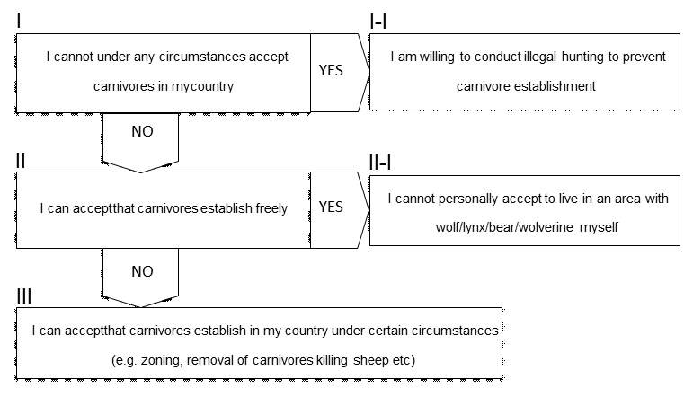
Figure S2 Questions related to acceptance of carnivores. All respondents answered the three first questions, while the fourth question depended on the answer to the first question.

