Water cisterns as death traps for amphibians and reptiles in arid environments
LUÍS GARCÍA-CARDENETE, JUAN M. PLEGUEZUELOS, JOSÉ C. BRITO, F. JIMÉNEZ-CAZALLA, M.T. PÉREZ-GARCÍA AND XAVIER SANTOS

APPENDIX 1

Table S1 List of amphibians and reptiles in the study area (south-western Morocco), presence in the four regions in which the study area was divided (from Bons & Geniez 1996; Geniez et al. 2004; our own unpublished data), IUCN global category and criteria (from http://www.iucnredlist.org/), and endemic status in Morocco. *Species found within cisterns, but not considered trapped due to their climbing abilities.
Species | Presence |  |  |  | IUCN | Endemic | Trapped
 | Anti- Atlas | Ifni | Guelmim | Low Draa
Amphibians Anura
Amietophrynus mauritanicus | 1 | 1 | 1 | 1 | LC |  | 1
Bufo brongersmai | 1 | 1 | 1 | 1 | NT | END | 1
Bufo boulengeri | 1 | 1 | 1 | 1 | LC |  | 1
Discoglossus scovazzi | 1 |  |  |  | LC
Hyla meridionalis | 1 | 1 |  |  | LC |  | 1*
Pelophylax saharicus | 1 | 1 | 1 | 1 | LC |  | 1
Reptiles Chelonia
Mauremys leprosa | 1 | 1 | 1 | 1 | LC
Testudo graeca | 1 | 1 |  |  | LC |  | 1
Reptiles Sauria
Acanthodactylus aureus |  |  | 1 | 1 | LC
Acanthodactylus boskianus | 1 |  | 1 | 1 | LC |  | 1
Acanthodactylus busacki |  | 1 | 1 | 1 | LC | END | 1
Acanthodactylus dumerili |  |  |  | 1 | LC
Agama impalearis | 1 | 1 | 1 | 1 | LC |  | 1
Chalcides boulengeri |  |  |  | 1 | LC
Chalcides manueli |  |  |  |  | VU B1ab(iii) | END
Chalcides mionecton |  | 1 | 1 |  | LC | END | 1
Chalcides ocellatus | 1 |  |  | 1 | LC |  | 1
Chalcides polylepis |  |  | 1 |  | LC | END | 1
Chalcides sphenopsiformis |  |  | 1 | 1 | LC |  | 1
Chamaeleo chamaeleon | 1 | 1 | 1 | 1 | LC |  | 1
Eumeces algeriensis | 1 | 1 |  | 1 | LC |  | 1
Mesalina guttulata | 1 |  |  | 1 | LC |  | 1
Mesalina olivieri | 1 | 1 | 1 | 1 | LC |  | 1
Mesalina rubropunctata |  |  |  | 1 | LC
Psammodromus algirus | 1 |  |  |  | LC
Ptyodactylus oudrii | 1 |  |  | 1 | LC
Quedenfeldtia moerens | 1 | 1 | 1 | 1 | LC | END
Saurodactylus brosseti | 1 | 1 | 1 | 1 | LC | END | 1
Scincus albifasciatus |  |  |  | 1 | LC
Stenodactylus petrii |  |  | 1 | 1 | LC
Stenodactylus mauritanicus |  | 1 | 1 | 1 | LC |  | 1
Tarentola annularis |  |  |  | 1 | LC
Tarentola boehmei | 1 |  |  | 1 | LC | END
Tarentola chazaliae |  | 1 | 1 | 1 | LC | END | 1
Tarentola ephippiata |  |  |  | 1 | LC
Tarentola mauritanica | 1 | 1 | 1 | 1 | LC |  | 1*
Timon tangitanus | 1 |  |  |  | LC
Trapelus boehmei | 1 |  | 1 | 1 | LC |  | 1
Tropiocolotes algericus | 1 | 1 | 1 | 1 | LC
Uromastyx nigriventris | 1 | 1 | 1 | 1 | NT |  | 1
Uromastyx dispar |  |  |  | 1 | LC |  | 1
Varanus griseus |  |  | 1 | 1 | LC |  | 1
Reptiles Amphisbaenia
Trogonophis wiegmanni | 1 |  |  |  | LC
Reptiles Serpentes
Bitis arietans | 1 | 1 | 1 | 1 | LC
Cerastes cerastes | 1 |  | 1 | 1 | LC |  | 1
Cerastes vipera |  |  | 1 | 1 | LC
Daboia mauritanica | 1 | 1 | 1 | 1 | NT |  | 1
Dasypeltis sahelensis |  | 1 | 1 | 1 | LC |  | 1
Echis leucogaster | 1 |  |  | 1 | LC
Hemorrhois algirus | 1 |  | 1 | 1 | LC |  | 1
Hemorrhois hippocrepis | 1 | 1 | 1 | 1 | LC |  | 1
Boaedon fuliginosus |  | 1 | 1 | 1 | LC
Myriopholis algeriensis | 1 |  |  | 1 | LC |  | 1
Lytorhynchus diadema |  |  | 1 | 1 | LC |  | 1
Macroprotodon brevis | 1 | 1 | 1 | 1 | NT |  | 1
Macroprotodon cucullatus |  |  | 1 |  | LC |  | 1
Rhagerhis moilensis | 1 | 1 | 1 | 1 | LC |  | 1
Malpolon monspessulanus | 1 | 1 | 1 | 1 | LC |  | 1
Naja haje | 1 | 1 | 1 | 1 | LC |  | 1
Natrix Maura | 1 | 1 | 1 | 1 | LC |  | 1
Psammophis schokari | 1 | 1 | 1 | 1 | LC |  | 1
Spalerosophis diadema |  |  | 1 |  | LC
Spalerosophis dolichospilus | 1 | 1 | 1 | 1 | DD |  | 1
Telescopus tripolitanus | 1 |  |  | 1 | LC |  | 1
Total species | 41 | 32 | 42 | 53 |  |  | 41

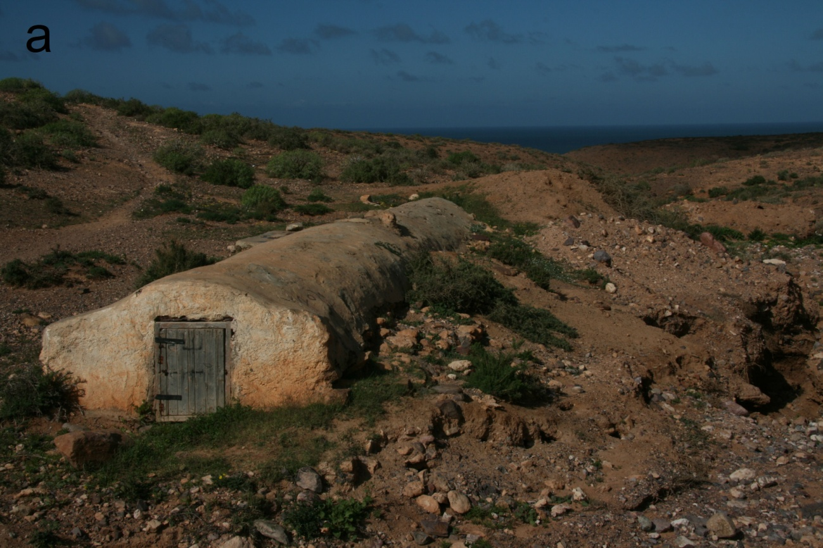
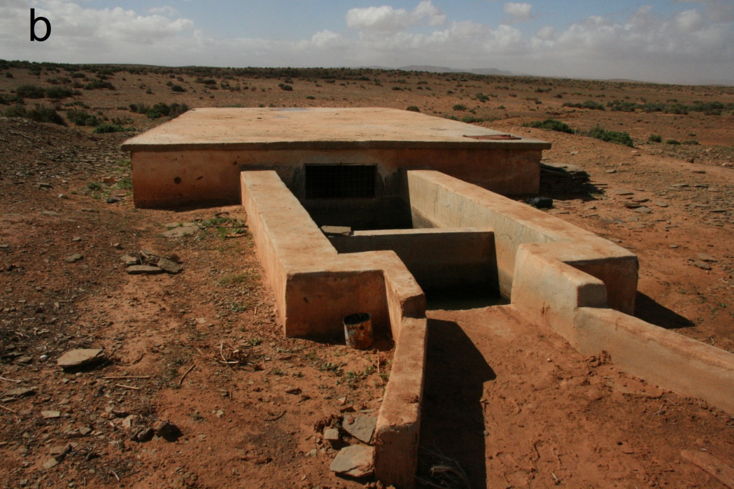
Figure S1 In the study area (south-western Morocco) cisterns may act as death traps for amphibians and reptiles. The photographs show typical examples of (a) an old cistern, located south of Sidi Ifni, and (b) a modern cistern, located in Ras el Tarf.

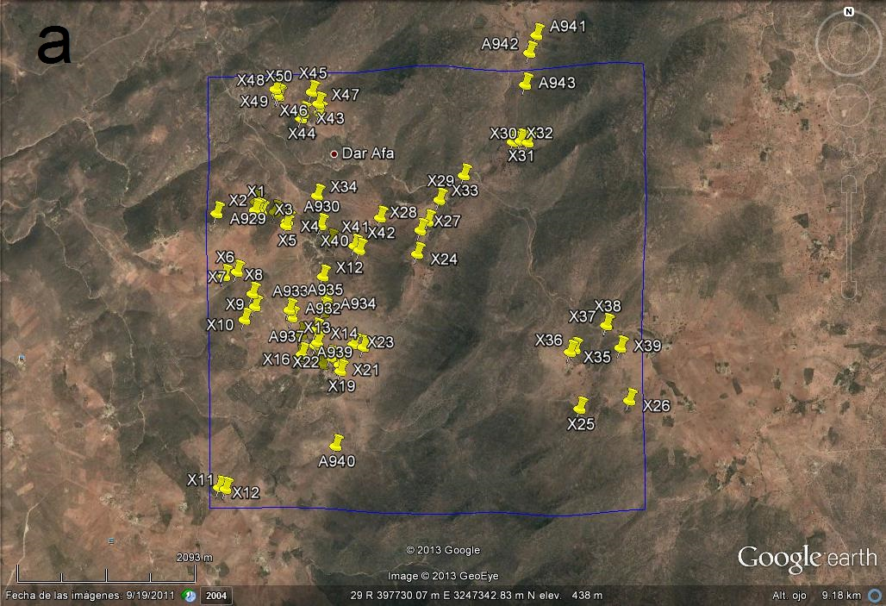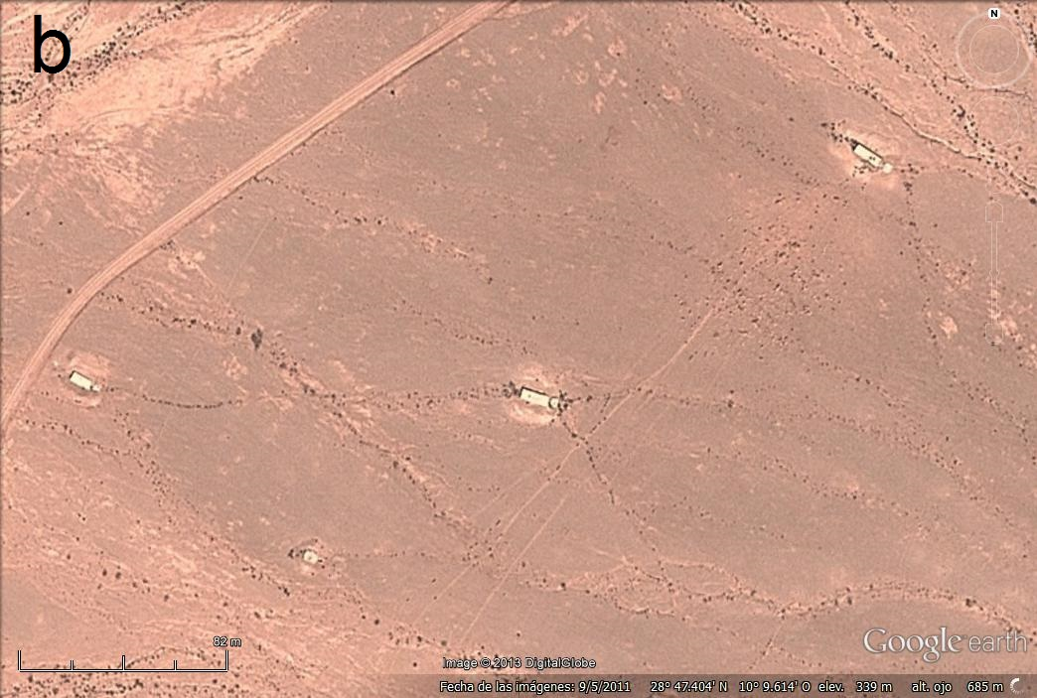
Figure S2 (a) Image from Google Earth of a 5 × 5 km square (blue square) indicating the locations of the water cisterns detected. (b) Magnified image of an area containing three cisterns; the scale bar is 82 m.
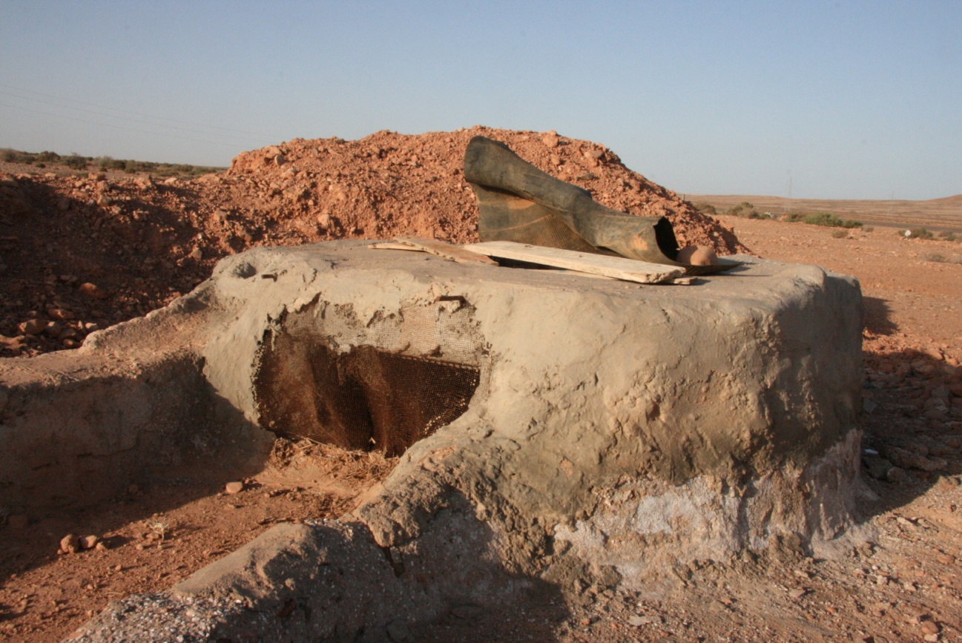
Figure S3 A dense wire mesh in the cistern inlet may prevent many amphibians and reptiles from being caught.

References
Bons, J. & Geniez, P. (1996) Amphibiens et reptiles du Maroc (Sahara occidental compris). Atlas biogéographique. Barcelona, Spain: Asociación Herpetológica Española.
Geniez, P., Mateo, J.A., Geniez, M. & Pether, J. (2004) The amphibians and reptiles of the Western Sahara. Frankfurt and Main, Germany: Chimaira.

