Impacts of recreational fishing in Australia: historical declines, self-regulation and evidence of an early warning system
MATTHEW A. L. YOUNG, SIMON FOALE AND DAVID R. BELLWOOD

APPENDIX 1

Chronology of Australian spearfishing publications

Table S1 Chronology of Australian skindiving/spearfishing publications. Title sequence A–C were published by the Australian Underwater Skindivers and Fishermen’s Association (USFA). Title sequence D–I were published by Mountain, Ocean and Travel Publications. At commencement of the second sequence the editor notes that the new magazine was created to replace the USFA publications that had ceased production.
Sequence |  | Years | Title
A |  | 1952–53 | Spearfishing News
B |  | 1953–1961 | Australian Skin Diving and Spearfishing Digest
C |  | 1961–1970 | Australian Skindivers Magazine
D |  | 1970–1974 | Skindiving in Australia
E |  | 1975–1979 | Skindiving in Australia and New Zealand
F |  | 1980–1986 | Skindiving in Australia and the South Pacific
G |  | 1987–1993 | Sportdiving in Australia and the South Pacific/Sportdiving
H |  | 1993–1997 | Australian Free Diving and Spearfishing News
I |  | 1998–2011 | International Freediving and Spearfishing News

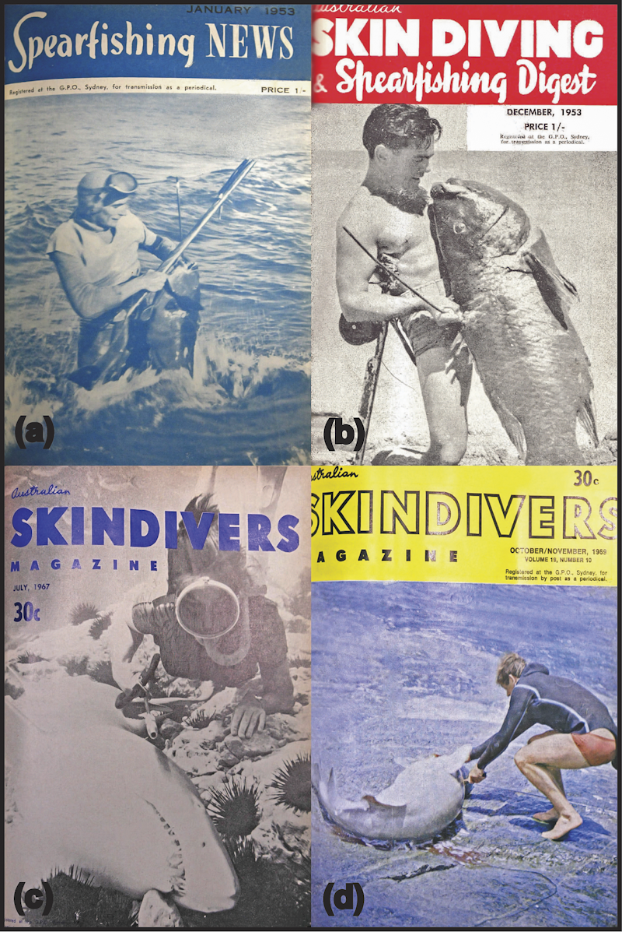

Figure S1 Magazine covers highlighting the importance of eastern blue groper (Achoerodus viridis) and grey nurse shark (Carcharias taurus) as target species for spearfishers during the 1950s and 1960s. (a) Blue groper on the cover of the January 1953 issue of Spearfishing News. (b) Blue groper on the cover of the December 1953 issue of Skin Diving and Spearfishing Digest. (c) Grey nurse shark on the cover of the July 1967 issue of Australian Skindivers Magazine. (d) Grey nurse shark on the cover of the October 1969 issue of Australian Skindivers Magazine.

APPENDIX 2

Declines in target fish species: an insight into the perspectives of spearfishers

The demise of blue groper from the perspective of spearfishers

Recreational spearfishers also expressed increasing concern for declining eastern blue groper populations commencing from the first spearfishing journal we assessed in 1952 (Fig. 1 in main text; Table S2). In May 1952, Keith Vagg, a prominent spearfisher, magazine contributor and later associate editor of Spearfishing News, made a plea to readers that spearfishers only take enough blue groper for their needs and to allow the other fish to breed. He also suggested imposing a bag limit as a means of self-regulation, and reminded spearfishers that the primary objective of the Underwater Skindivers and Fishermen’s Association (USFA) was the ‘protection and propagation of fish’ (Table S2).
Concern for blue groper populations continued and, by 1958, the scarcity of blue groper had alarmed numerous spearfishing bodies. These groups, under the initiative of Edward du Cros and Ted Louis (both prominent spearfishers, magazine contributors and USFA members), took their concerns to the government and requested a bag limit on the capture of blue groper. A bag limit of two groper was subsequently imposed. Four years later, in 1962, decline in blue groper numbers was still troubling spearfishers. A meeting of the Amateur Fishermen’s Advisory Council (AFAC) discussed the problem of spearfishers killing adult blue groper, while line fishers removed juveniles. Ted Louis suggested imposing a one fish bag limit on all fishers. Warnings from spearfishers continued to emerge and in 1965 Edward du Cros reflected on the loss of eastern blue groper and notes that the case should be a learning experience. The USFA of New South Wales, with the recommendation of AFAC, then submitted a request to the government asking for complete prohibition on the capture of blue groper. As of 17 January 1969, it was an offence for a person to have blue groper in their possession in New South Wales (NSW). This legislation for protection was enacted 17 years after the first concerns for blue groper populations were raised by the spearfishing community.

Table S2 Published comments/views by prominent spearfishers depicting their concern for eastern blue groper (Achoerodus viridis) populations from 1952 until their protection in 1969.
Year | Publication/Issue | Author | Comments/Quotes
1952 | Spearfishing News  (May 1952) | Keith Vagg | Keith highlights to members of the Underwater Skindivers and Fishermen’s Association (USFA) that the first objective of the USFA is the protection and propagation of fish. He pleads that spearfishers take only enough blue groper for their needs and leave the others to breed. He suggests imposing a bag limit as a means of self-regulation  ‘…the Association’s first object is ‘The protection and propagation of fish’. If we don’t heed this object, the USFA will be ‘Jack’ in a very short time’  ‘I’m merely pleading that we take only enough for our needs and leave the others to get married and raise big happy families of big blue groper’  ‘If we are going to continue to spear groper, we shall have to forget the quoted golden rules and the ‘If I don’t spear it, some other B…..d will’ kind of thinking, by imposing a bag limit on ourselves, and remembering that the first object of the Association to which you belong is: The Protection and Propagation of Fish’
1953 | Skindiving and Spearfishing Digest  (October 1953) | Keith Vagg (Associate Editor) | Keith Vagg discusses Rod McNeil’s plea on behalf of blue groper in relation to their slow growth rates  ‘Rod is a conservationist and it was pleasing to read his plea on behalf of the blue groper in the September issue, in which he quotes Gilbert Whitley as estimating the age of a 30 pound blue to be about 30 years’
1958 | Australian Skindivers Magazine  (Jan/Feb 1963) | Ted Louis (USFA Secretary) | Underwater groups realize the scarcity of blue groper and, initiated by Edward Du Cros and Ted Louis, suggest to the Chief Secretaries Department that a bag limit be imposed  ‘…the largest groper taken by line during the year was a nine pounder and that generally groper were very scarce indeed. The underwater groups have realised this fact for some time and suggested to the Chief Secretary’s Department some four years ago that a bag limit be placed on this fish’  A limit of two groper was subsequently enacted
1962 | Australian Skindivers Magazine  (Jan/Feb 1963) | Ted Louis (USFA Secretary) | A meeting of the Amateur Fishermen’s Advisory Council (AFAC) further discusses the scarcity of blue groper. Ted Louis explains that blue groper are hard to target for line fishers because they swim into caves and snag them, while spearfishers use this behaviour to their advantage. Spearfishers target large fish, however, anglers tend to take juvenile groper. Ted suggests a one fish bag limit for all anglers  ‘This habitat is his downfall when pursued by spearfishermen, as he is simply speared and killed in his cave and presents no problem at all’  ‘It is not, of course, the spearmen only who are depleting groper stocks, as we often see anglers on the rocks with six or seven tiny brown groper’  ‘In my early days of spearfishing I went along with the general idea that puny man could not possibly upset a natural state of affairs such as fish life-cycles. I have had to change my ideas radically, as by observation I have seen it happen under my nose in this case’
1962 | Australian Skindivers Magazine  (Jan/Feb 1963) | Ted Louis (USFA Secretary) | Ted Louis explains that in the past groper were plentiful and sea urchins were less common. However, groper numbers have declined and sea urchins increased by as much as 300–400%  ‘During this five years past, there was no doubt in my mind that the groper has decreased in numbers and the sea-urchin increased as can be seen on any underwater dive, as the colonies have extended as much as 300 and 400%’
1965 | Australian Skindivers Magazine (March 1965) | Ben Cropp | Ben has noticed a tremendous reduction in the fish population around such famous reefs as Nine Mile, Flinders and Long Reef. Where the spearfishers once met hordes of fish, there is now a vast emptiness. Ben notes that blue groper and cod have really suffered  “In the past year I have noticed a tremendous reduction in the fish population around such famous reefs at Nine Mile, Flinders, Long Reef etc. Where the spearman once (only two years ago) met hordes of fish, he is greeted now by a vast emptiness. The blue groper and cod have really suffered’  ‘Our sons (and even ourselves in a few years) are not going to see the fish we have all been fortunate in hunting over the past years.’  ‘This fish shortage is due to several things which have rapidly increased over the past years; mainly the sudden increase of spearfishermen since the Sea Hunt TV era, the increased commercialism amongst spearmen, and the use of SCUBA for spearfishing.’
1965 | Australian Skindivers Magazine  (May, July 1965) | Edward Du Cros | Edward Du Cros proposes skindivers shift away from spearfishing to wreck diving, underwater photography and research work. He reflects on the loss of blue groper and notes that it should be a learning experience  ‘to avoid a decline or a debacle—for the future of our sport... a move, on the largest possible scale, to make the ‘big things’ in skindiving finding and exploring wrecks, underwater photography, and research work, tagging, etc.—with sharks. The proposal is to see whether a great effort to shift the emphasis away from spearfishing and to these three elements in skindiving would succeed.’  ‘I agree with George Davies that the blue groper episode in fishing history is symbolic of our folly.’
1969 | Australian Skindivers Magazine  (April/May 1969) | George Davies | Legislation submitted from the USFA of NSW to prohibit the capture of Blue Groper was recommended by the NSW AFAC to the Chief Secretary  ‘On January 17 the Chief Secretary, Mr. Willis, acting on the recommendation of the NSW Amateur Fishermen’s Advisory Council, advised that a complete prohibition on the capture of Blue Groper had been introduced in New South Wales.’  ‘This legislation, which had been submitted originally from the USFA of NSW, would take effect from the previously mentioned date’  ‘All skindivers are advised that it is now an offence to have a blue or brown groper in their possession.’  As of the 17 January 1969, it was an offence to have a blue or brown groper in possession
1969 | Australian Skindivers Magazine (July/August 1969) | John Gillies (Editor) | Recommended by the AFAC and the USFA, a ban on scuba fishing is introduced on the 27 June 1969  ‘The State Government has banned the use of self-contained underwater breathing apparatus – Scuba gear – for spearfishing.’  ‘the regulations had been recommended by the NSW Amateur Fishermen’s Advisory Council, and had been endorsed by the Underwater Skindivers’ and Fishermen’s Association.’

The demise of grey nurse sharks from the perspective of spearfishers

In the early 1960s, shark hunting was promoted in magazines, books and films (Table S3). However, in the January 1965 issue of Australian Skindivers Magazine, contributor George Davies highlighted that, contrary to public perception, grey nurse sharks were not dangerous and that their populations were at risk of extinction. He criticized shark hunting films for encouraging the slaughter, and noted that wherever grey nurse populations were discovered, spearfishers promptly decimated their numbers. He also pointed out that the general public loved spearfishers for removing the threat of sharks.
In the May 1965 issue of Australian Skindivers Magazine, prominent spearfisher and filmmaker Ben Cropp noted that the killing of grey nurse sharks was quickly wiping out the species. He voiced regret that he helped to instigate the craze for killing sharks through his articles, books and films, and acknowledged the need for conservation. Cropp also noted that neither the general public nor the fisheries department of New South Wales would be interested in the conservation of grey nurse sharks (Table S3). In 1970, aware of the contribution of spearfishing to the decline in grey nurse populations, Skindiving in Australia magazine supported a ban on skindivers killing grey nurse sharks. The magazine also made the decision to stop publishing reports on their killing (Fig. 3 in main text). Warnings from the spearfishing community about the demise of grey nurse shark populations and the misconceptions surrounding sharks continued until a prohibition on taking grey nurse sharks was announced in November 1984 (19 years after the first concerns were raised by spearfishers).

Table S3 A chronology of important developments and published comments by spearfishers concerning grey nurse shark (Carcharias taurus) populations from 1959 until their protection in 1984.
Year | Publication/Issue | Author | Summary/Quotes
1962 |  |  | Ron Taylor and Ben Cropp’s film Shark Hunters is released
1963 | Australian Skindivers Magazine  (April/May 1963) | Ted Louis | Ted discusses the development of powerheads and experimenting with their use on grey nurse sharks  ‘We have recently been trying out a new weapon for shark destruction. It is a .303 calibre breech, which fits to the head of a handspear and a 1.5lb jolt sets it off. The idea is to load it like an ordinary handspear and hit a shark with it, the impact fires it and a projectile hits the shark where it will do most good.’  ‘The idea is not new, as several spearos are using a 12-gauge cartridge for a similar purpose. It all adds up to one thing and that is in a short space of time the spearman will have evolved a method of destroying a shark in an emergency and the weapon will be available to all for a very nominal cost.’  ‘Also needed are plenty of sharks to experiment on, and one of the most prolific places I know is Jervis Bay’
1964 | Australian Skindivers Magazine  (July/August 1969) | John Gillies (Editor) | Ben Cropp’s book Shark Hunters is released. It details everything about shark hunting with spears and powerheads. It is re-released in 1969  ‘Ben Cropp, one of Australia’s foremost authors on skindiving and allied subjects, has released his popular book, ‘Shark Hunters’.’  ‘The author covers virtually every aspect of shark hunting, spearing the extra large fish, and while doing so traces his early experiences and attempts before the advent of the ultimate weapon, ‘Shotgun for Sharks’.’
1965 | Australian Skindivers Magazine  (Various Issues) | Advertisements | Several Ron Taylor and Ben Cropp films about hunting sharks are released. Titles include Slaughter at Saumarez, Shark Fighters, Revenge of a Shark Victim and Shark Safari
1965 | Australian Skindivers Magazine  (January Issue) | George Davies (AUF Secretary) | Contrary to public perception, George highlights that grey nurse sharks aren’t dangerous and that their populations are at risk of extinction. He criticizes shark hunting films for encouraging the slaughter and notes that wherever grey nurse populations are discovered, they are promptly decimated. He also points out that the general public love spearfishers removing the (perceived) threat of sharks  ‘Ron Taylor and Dave Rowlings received widespread publicity when they killed two 8ft grey nurses with spine shots and proved the much hated shark was at least vulnerable. This seemed to be the signal for a mass crusade against this so-called man-eating fast shark. Great schools were entirely exterminated in their secluded gutters. Yes, I was there bashing away at these ‘man eaters’ doing some great public service and soaking up a share of the glory from a public that wouldn’t know the difference between a bream and a basking shark.’  ‘When harassed the nurse is even more docile that the ‘wobby’ and will avoid her tormentor’  ‘With the advent of the ‘Big Boom’ or ‘Smokey Pokey’, the lethal power of which seemed to lend courage to scores of skindivers who previously were uncertain of the long-toothed nurse, the slaughter of grey nurses rapidly increased and with a combination of aqualungs and explosive heads was beyond the calling of the sport. The general public loved it, the waters were being cleared of sharks, soon the menace of death on our beaches would be practically eliminated.’  ‘The shark-hunting spearmen were heroes. This was good publicity but nevertheless a sound case of false pretences.’  ‘Recently I had the pleasure of viewing a recent underwater production by Ben Cropp. The presentation was perfect, the narration really good. Every detail was exceptional including the first thrust of the explosive head and the luckless ‘nurse’ spiralling to her doom. A procession of thrusts later I was nauseated. The general public, and these are the persons we have to please most, would perhaps be delighted. I had one feeling of revulsion for an orgy of senseless killing. My sympathy lies with the ‘nurses’. There was not an ounce of sport in their systematic destruction.’  ‘It has reached a stage now where the location of a newly found school of ‘nurses’ has to be kept secret or the school quickly ceases to exist.’  ‘Let’s not kid ourselves, the grey nurse could fast follow the path of the great white shark into the realms of the extinct.’
1965 | Australian Skindivers Magazine  (January Issue) | Buggy Beaver | This club report mentions the influence Ron Taylor and Ben Cropp’s shark hunting films are having on spearfishers  ‘Robbie shot his first real shark, a 4 foot grey nurse, but after seeing Ben’s new film Robbie was back in the water, but only resulted in one 5 foot nurse.’
1965 | Australian Skindivers Magazine  (May Issue) | Ben Cropp | Ben reflects on the criticism by George Davies in the January issue. He agrees that grey nurse sharks are being wiped out and expresses regret that he helped to instigate the shark killing craze  ‘I agree with you wholeheartedly that the senseless killing of these sharks is quickly wiping out this species. I know I helped instigate this craze for killing sharks and led such killings many times.’  ‘I am looking to other forms of spectacular scenes with the grey nurse—without having to kill them. My only worry is finding a tame school which will co-operate—or finding a school of grey nurse at all.’  ‘Neither the general public nor the Fisheries Department are going to be interested in the conservation of grey nurse.’
1975 |  |  | The movie Jaws is released in Australia at the start of summer
1975 | Skindiving in Australia & New Zealand  (Vol. 5, No. 4) | John Harding | John discusses the misconception of sharks within the community and the media sensationalism that has coincided with the release of the movie Jaws  ‘In that era shark attacks were occurring at an average of one or two each year, sufficient to keep the media interested in perpetuating the great shark myth of Australia.’  ‘It is this false portrayal of shark behaviour which annoys and upsets the dedicated attempts by many individuals professionally involved with the ocean. Entertainment in films is essential, but many people believe what their eyes see, and in the case of Jaws, it will be a major set-back for marine wildlife experts and many others associated with the sea.’  ‘Originally I had intended to write on how the shark menace had almost faded away on the east coast, as compared with the menace which apparently existed forty and fifty years ago. However newspapers are in business to sell more papers. Being accurate in an intelligent persons mind is certainly not essential.’  ‘The Daily Telegraph published my original text almost word for word on the first two days of the ‘Shark – A series which could save your life’ serial. However on the third day 90% of the text, credited as mine, was written by an unknown staff reporter. It was the most misleading and inaccurate heap of rubbish about sharks I’ve seen in years.’
1977 | Skindiving in Australia & New Zealand  (Vol. 7, No. 2) | John Harding | John discusses powerheads and how they were originally intended for defence, yet were mostly used to attack sharks  ‘Explosive powerheads are designed to protect divers from the remote possibility of a shark attack. Most powerheads have been used by skindivers to attack sharks. There are very few cases where a powerhead has been used to save the diver from the rushes of an ‘attaching’ shark. Unfortunately the truth is that powerheads themselves are far more dangerous than most sharks.’  ‘The commercial manufacture began in Australia in 1962.’
1984 | Skindiving in Australia & the South Pacific  (Vol. 15, No. 3, 1985) | Barry Andrewartha (Editor) | The NSW Department of Agriculture, with the support of the NSW Amateur Fishermen’s Advisory Council and the NSW Australian Underwater Federation, places a ban on the capture of grey nurse sharks. Skindiving magazine notes that it has supported a ban on divers killing grey nurse sharks since 1970  ‘The ban, gazetted under the Fisheries and Oyster Farms Act, 1935, will protect the declining populations of grey nurse’  ‘Fishermen thought they were doing the community a favour by eradicating these sharks. But the grey nurse is not known to pose any threat to human life’  ‘Skindiving Magazine has supported the ban on divers killing grey nurse sharks for the past 15 years and congratulates Dr Peter Ayres and his department for supporting this ban.’  The prohibition of taking grey nurse sharks is announced in November 1984.

