Effects of different sampling scales and selection criteria on modelling net primary productivity of Indonesian tropical forests
STEPHAN J. GMUR^{1*}, DANIEL J. VOGT¹, KRISTIINA A. VOGT¹ AND ASEP S. SUNTANA^{1, 2}
APPENDIX 1
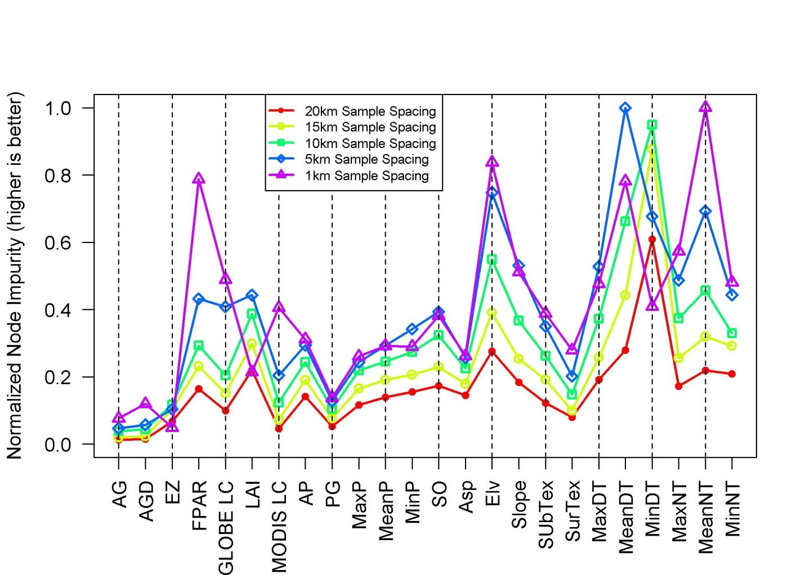
Figure S1 Normalized variable importance as ranked by randomForest for the five different spatial sampling resolutions. Those variables that ranked higher received a greater number of votes when creating the forest of binary trees. The shortened variable names on the x axis are explained in Table 2.
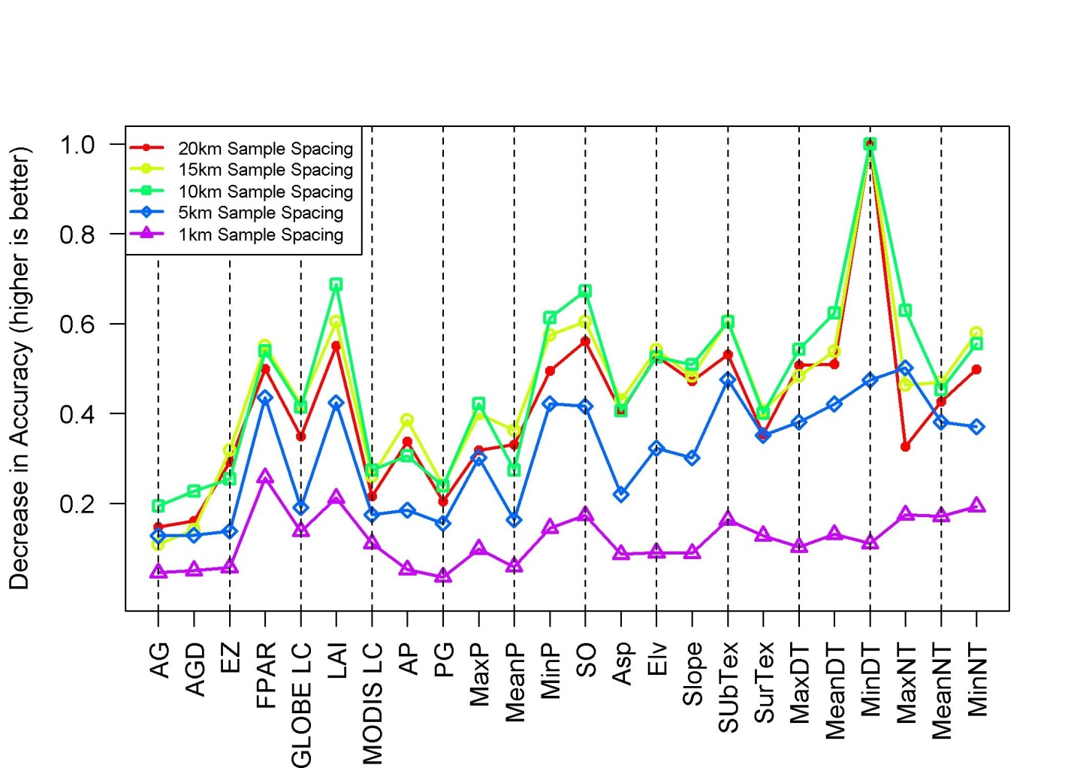
Figure S2 Normalized increase in the mean squared error of a variable when used in the creation of a binary tree for the five different spatial sampling resolutions. Those variables that ranked higher explained a greater amount of the variance when used in the randomForest binary trees. The shortened variable names on the x axis are explained in Table 2.

