Climate change and conservation implications for wet meadows in dry Patagonia
RAMIRO D. CREGO, CLAYTON K. NIELSEN AND KARL A. DIDIER

APPENDIX 1

Figure S1 Maps of mean predicted suitability probabilities and standard deviations obtained in the ensemble forecast framework for modelling current (2012) and future (2050) meadows distribution in arid and semi-arid Patagonia. The first eight maps show mean predicted probabilities and standard deviations among the four single models and 10 repetitions per model for each of the four different general circulation models (GCMs). The last two maps show mean predicted probabilities and standard deviations among the four ensemble GCMs.
GCMs | Mean-suitability probability | Standard deviation
CGCM3.1(T47) | 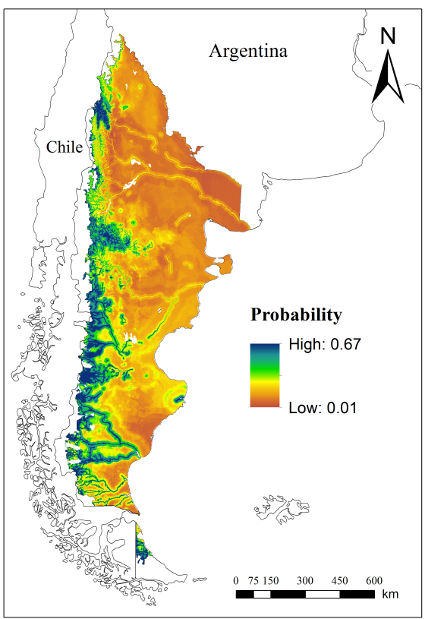 | 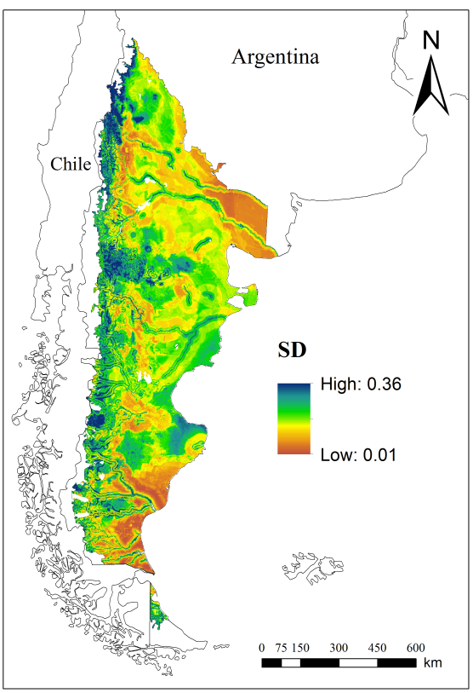
HadCM3 | 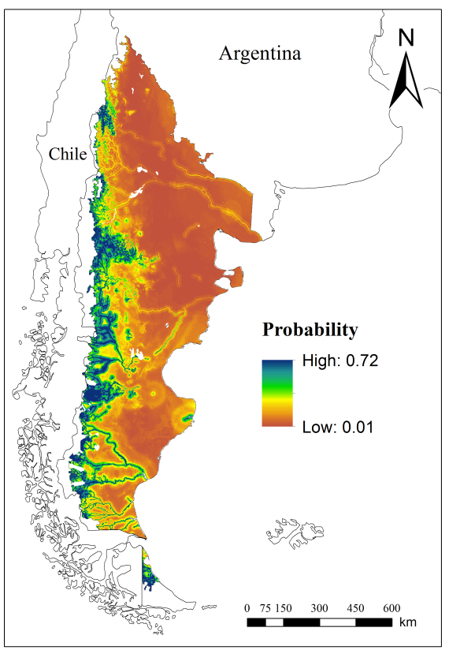 | 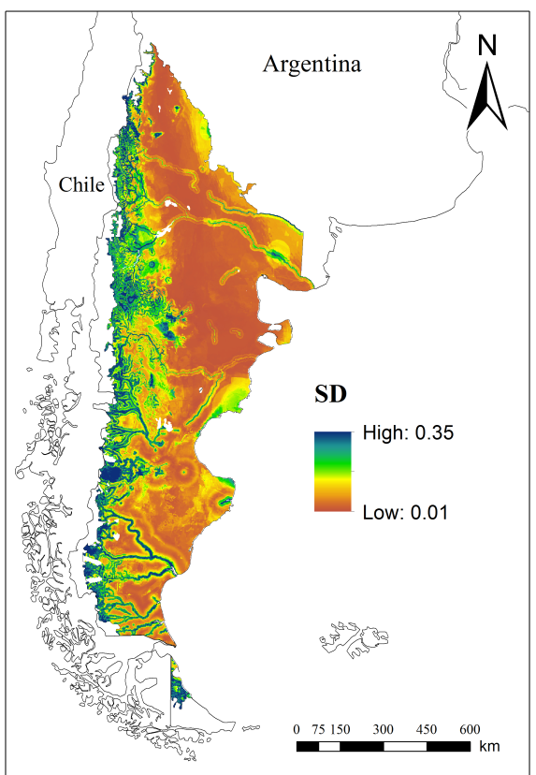
MIROC3.2  (hires) | 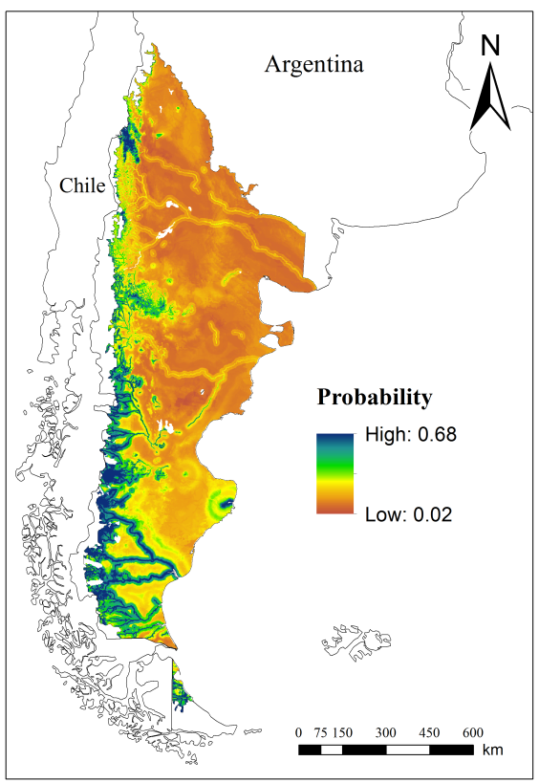 | 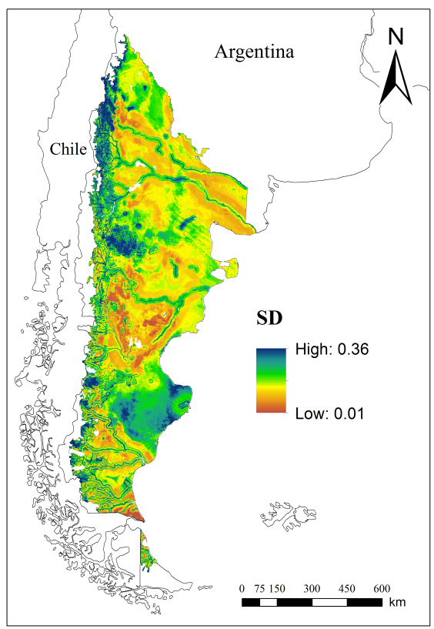
MK3.0 | 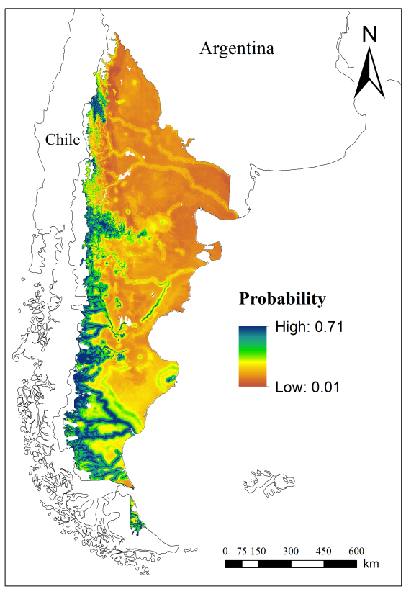 | 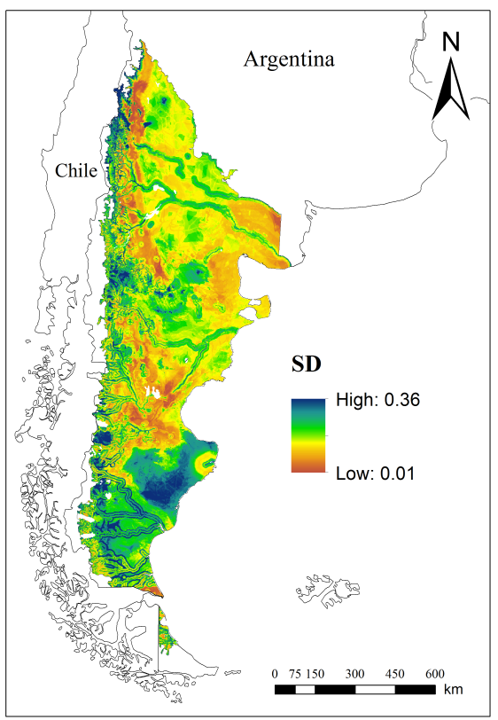
Ensemble among  GCMs | 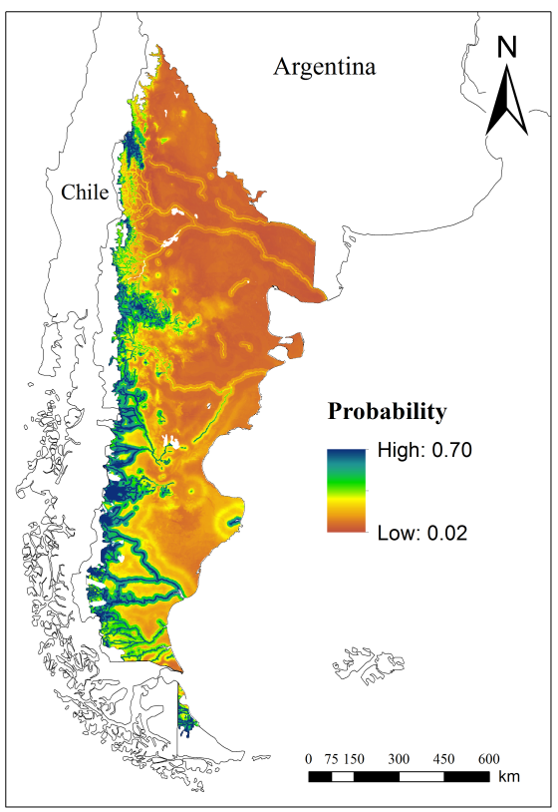 | 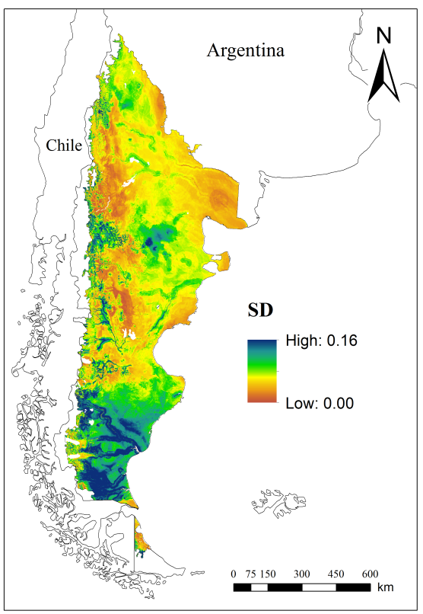

Figure S2 Map of non-analogue climate conditions for the year 2050 in arid and semi-arid Patagonia. This map depicts the total number of variables (seven variables × four GCMs) per cell used to model the future distribution on meadows to the year 2050, which values fall outside the training-value range. Brown colours represent areas with low future non-analogue climate conditions and blue colours represent areas with many future non-analogue conditions.


