Synergies and trade-offs between ecosystem services in Costa Rica
BRUNO LOCATELLI, PABLO IMBACH AND SVEN WUNDER

Figure S1 Map of forests, topography, and major cities of Costa Rica.

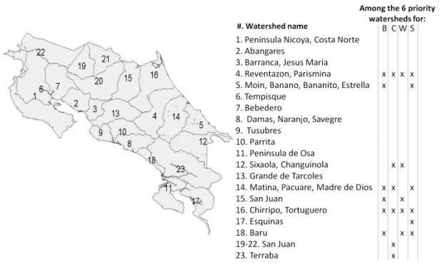
Figure S2 Maps of priority watersheds for multiple ES (B = biodiversity, C = carbon, W = water, S = scenic beauty). The six priority watersheds host 80% of biodiversity hotspots, 79% of carbon hotspots, 64% of water ES hotspots, and 65% of scenic beauty hotspots.

Table S1 Indicators, proxies and data (B = biodiversity, C = carbon, W = water, S = scenic beauty).
ES and  indicators | Proxies | Data, resolution (r) or scale (s), source, and method
B: Species richness | Number of species | Map of bird, mammal and amphibian species richness (number of unique species) (r = 0.05° or 5 km) (Anderson et al. 2008)
B: Species endemism | Number of endemic species | Map of amphibian endemic species (number of species) (r = 0.05° or 5 km) (Anderson et al. 2008)
C: Carbon in vegetation | Carbon density (tC ha⁻¹) | Map of carbon density in above and belowground vegetation in forests (r = 1 km) (Saatchi et al. 2011)
C: Carbon in soils | Carbon density (tC ha⁻¹) | Maps of soil organic carbon, bulk density and gravel content (r = 0.5 arc min or 1 km) (FAO et al. 2009)
W: Soil protection | Difference in erosion rates between forest and pasture/crop lands (function of slope, the erosive force of rainfall, and the susceptibility of soils to erosion). | Gridded monthly precipitation (r = 0.5 min or 0.8 km) (Hijmans et al. 2005). Maps of soil texture and organic matter (r = 1 km) (FAO et al. 2009). Digital elevation map (s = 1:50 000) derived from the National Topographic Sheets of the National Geographic Institute of Costa Rica. Erosion rate functions from the revised universal soil loss equation and its components (Renard & Freimund 1997; Renard et al. 1997)
W: Water  infiltration | Effect of forests on soil infiltration capacity | Soil infiltration capacity as a function of soil texture and soil depth (FAO 1988). Maps of soil texture and depth (r = 1 km) (FAO et al. 2009)
W: Cloud water interception | Amount of water intercepted from fog by forests | Map of fog interception (r = 1 km) (Mulligan & Burke 2005)
W:  Downstream water use | Index of aggregated water intake | Spatial data on abstracted volumes of underground and surface water for human consumption, agriculture and energy (r = 90 m) from the databases of the Ministry of Energy and the Environment, the Costa Rican Institute of Electricity (ICE), and the Institute of Aqueducts and Sewer Systems (AyA). Maps of micro‐watersheds for each water inlet (derived from elevation maps at r = 10m) and aquifers (s = 1:500 000) (ITCR 2004)
S: Extent of forests | Area of forest in the surrounding region | Forest cover map (s = 1:250 000) (World Bank & Comisión Centroamerica de Ambiente y Desarrollo 2000)
S: Population density | Population density | Population density map (r = 250 m). Spatial downscaling of the 2000 census data from INEC (Instituto Nacional de Estadística y Censos de Costa Rica), based on slope, distance to roads and land use
S: Tourist presence | Hotel room density | Map of hotel locations (r = 250 m) from the 2004 hotel census of the Costa Rica Tourism Board

References
Anderson, E., Cherrington, E., Flores, A., Pérez, J., Carrillo, R. & Sempris, E. (2008) Potential Impacts of Climate Change on Biodiversity in Central America, México and Dominican Republic. Panama City, Panama: CATHALAC/USAID.
FAO (1988) Irrigation Water Management. Rome, Italy: FAO.
FAO, IIASA, ISRIC, ISSCAS & JRC (2009) Harmonized World Soil Database (version 1.1). FAO, Rome, Italy and IIASA, Laxenburg, Austria [www document]. URL http://www.fao.org/nr/land/soils/harmonized-world-soil-database/en/
Hijmans, R.J., Cameron, S.E., Parra, J.L., Jones, P.G. & Jarvis, A. (2005) Very high resolution interpolated climate surfaces for global land areas. International Journal of Climatology 25(15): 1965–1978.
ITCR (2004) Digital Atlas of Costa Rica: CD-Rom. Cartago, Costa Rica: Instituto Tecnológico de Costa Rica.
Mulligan, M. & Burke, S. (2005) FIESTA: Fog Interception for the Enhancement of Streamflow in Tropical Areas. First Technical Report for AMBIOTEK contribution to DfID FRP R7991. United Kingdom Department for International Development, London, UK.
Renard, J.G. & Freimund, J.R. (1997) Using monthly precipitation data to estimate the R-factor in the revised USLE. Journal of Hydrology 157: 287–306.
Renard, K.G., Foster, G.R., Weesies, G.A., McCool, D.K. & Yoder, D.C. (1997) Predicting Soil Erosion by Water: A Guide to Conservation Planning with the Revised Universal Soil Loss Equation (RUSLE). Agriculture Handbook 703. Washington, DC, USA: US Department of Agriculture, Agriculture Research Service.
World Bank & Comisión Centroamerica de Ambiente y Desarrollo. (2000) Ecosystems of Central America (Arcview map files at 1:250,000). Washington, DC, USA: World Bank, Comisión Centroamerica de Ambiente y Desarrollo (CCAD), World Institute for Conservation and Environment (WICE), and the Centro Agronómico Tropical de Investigación y Enseñanza (CATIE).

