Heterogeneity in fishers’ and managers’ preferences towards management restrictions and benefits in Kenya
Timothy R. McClanahan, Caroline A. Abunge and Joshua E. Cinner

APPENDIX 1

Figure S1 Map of the Kenyan coastline and location of the 22 fish landing sites and marine protected areas where the interviews were undertaken.
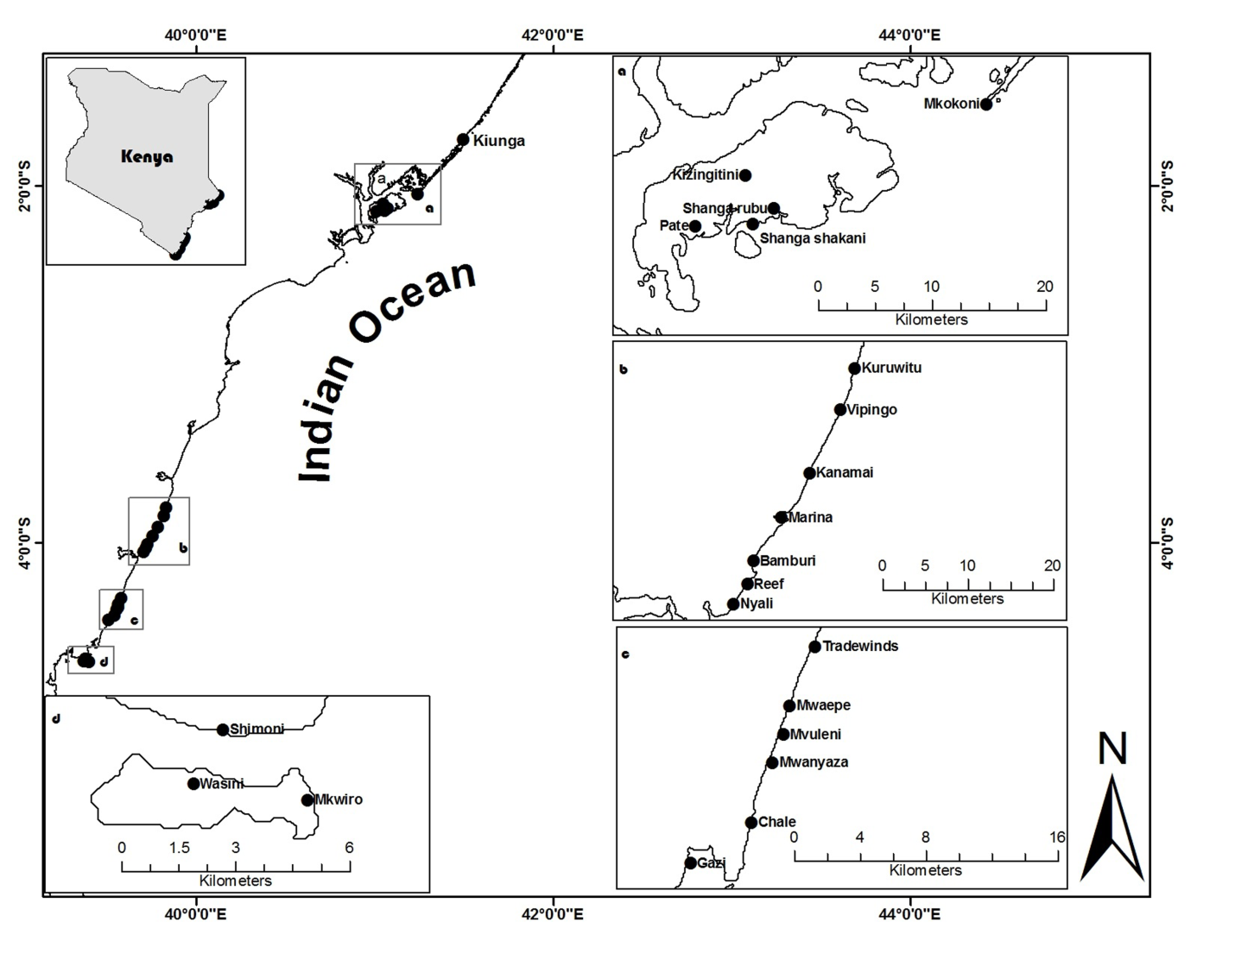

Figure S2 Cluster analysis of similarities in the respondents’ level of agreement with the various management options. Includes the 22 fish landing sites and the government fisheries and park management officers or marine attendants. Kizingitini and Reef responses were more negative and pooled into the weakly positive cluster in subsequent analyses. Box on bottom presents the percentage of variance explained for iterations of the clustering. There were three main clusters numbered from strongly positive to weakly positive. Nested analysis showed significant difference between clusters, F = 33.07, p < 0.0001. Sites within clusters were not significantly different, F = 1.57, p = not significant.
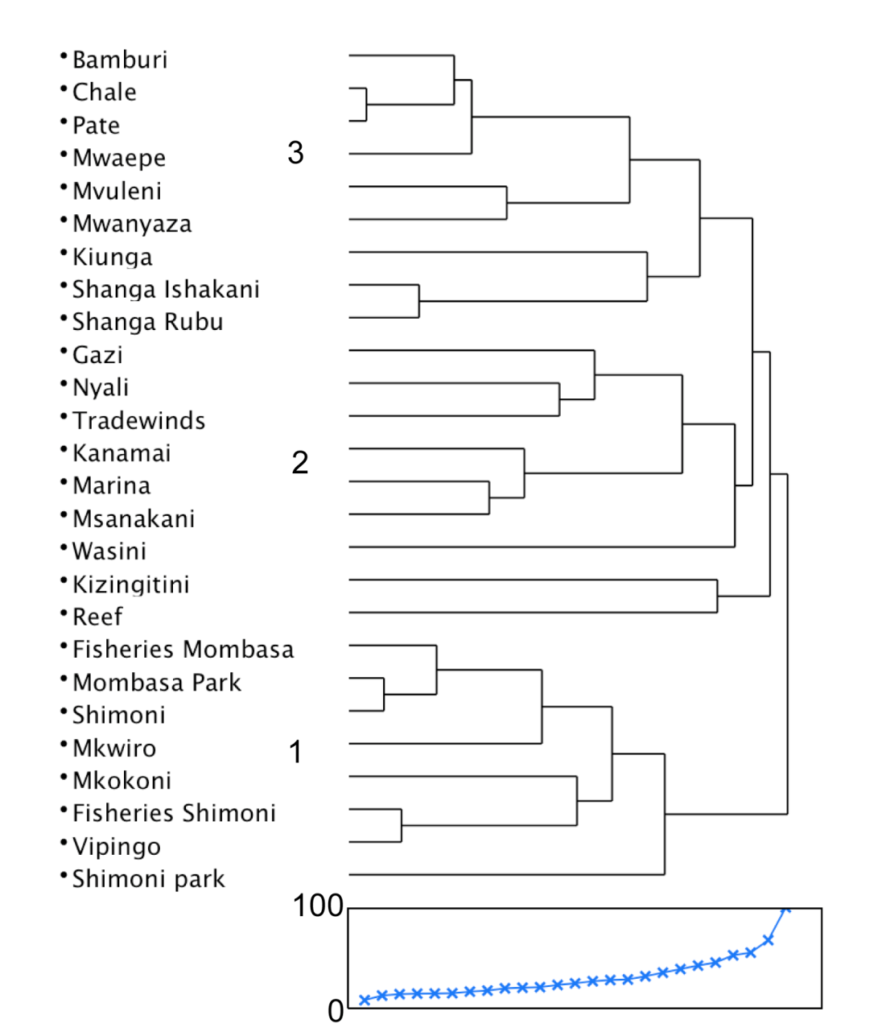

Figure S3 Frequency of the ranks of dependency on fishing in the three management preferences clusters.
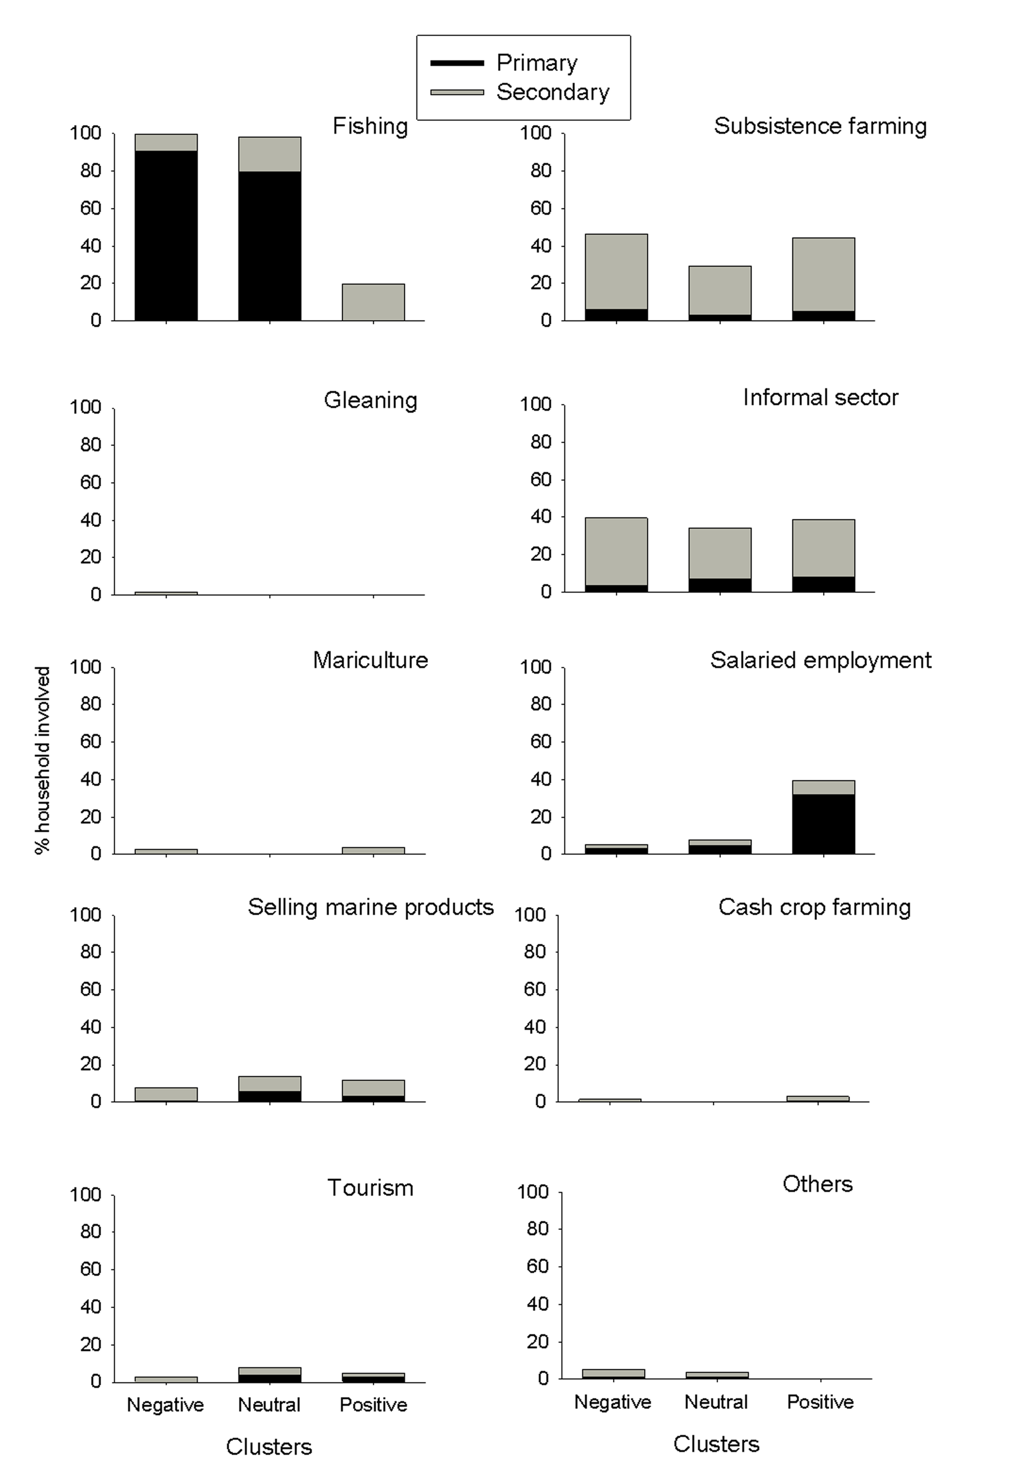

APPENDIX 2

Respondents characteristics showing sites, sample size, means and standard error of the mean (SEM) of the age of respondents, level of education, biweekly expenditures, perceived disparity, total jobs per household, material style of life (first axis of PCA) and distance to government protected areas.
Sites | Respondents (n) | Age of respondent (yr) | Level of education (yr) | Biweekly expenditure (US$) | Perceived mean disparity | Total jobs per household (n) | Material style of life | Distant from park (km)
Bamburi | 24 | 38 ± 1.4 | 7.8 ± 0.3 | 68.1 ± 2.4 | 2.4 ± 0.4 | 2.1 ± 0.1 | -0.11 ± 0.0 | 3.2
Chale | 19 | 47 ± 1.7 | 5.3 ± 0.5 | 65.3 ± 1.0 | 1.7 ± 0.4 | 2.3 ± 0.1 | -0.12 ± 0.0 | 38.4
Kiunga | 26 | 38 ± 1.1 | 4.3 ± 0.3 | 58.3 ± 1.7 | 1.5 ± 0.3 | 1.9 ± 0.1 | -0.37 ± 0.0 | 12.9
Mvuleni | 15 | 53 ± 1.3 | 2.5 ± 0.4 | 73.0 ± 1.8 | 3.8 ± 0.4 | 2.4 ± 0.1 | -0.10 ± 0.1 | 44.1
Mwaepe | 19 | 47 ± 1.4 | 4.5 ± 0.4 | 65.5 ± 1.3 | 2.6 ± 0.3 | 2.7 ± 0.1 | -0.17 ± 0.1 | 46.0
Mwanyaza | 13 | 48 ± 1.8 | 2.3 ± 0.3 | 71.8 ± 2.0 | 4.5 ± 0.5 | 2.6 ± 0.1 | -0.50 ± 0.0 | 42.2
Pate | 27 | 304 ± 1.2 | 4.4 ± 0.3 | 51.7 ± 2.2 | 2.3 ± 0.3 | 2.3 ± 0.1 | 0.11± 0.1 | 57.5
Shanga Ishakani | 27 | 35 ± 1.4 | 4.3 ± 0.2 | 73.0 ± 3.3 | 4.0 ± 0.3 | 1.5 ± 0.1 | -0.28 ± 0.0 | 53.5
Shanga Rubu | 22 | 36 ± 1.2 | 4.0 ± 0.4 | 55.2 ± 1.7 | 3.6 ± 0.3 | 1.5 ± 0.0 | -0.38 ± 0.0 | 51.1
Gazi | 14 | 44 ± 1.0 | 3.4 ± 0.4 | 66.4 ± 2.4 | 3.0 ± 0.5 | 1.8 ± 0.1 | -0.03 ± 0.1 | 34.8
Kanamai | 13 | 40 ± 1.3 | 6.9 ± 0.5 | 58.6 ± 1.7 | 0.7 ± 0.3 | 2.4 ± 0.1 | -0.07 ± 0.1 | 9.2
Kizingitini | 12 | 48 ± 1.6 | 4.3 ± 0.5 | 57.9 ± 2.2 | 3.5 ± 0.4 | 1.2 ± 0.0 | -0.22 ± 0.1 | 57.2
Marina | 14 | 37 ± 1.1 | 7.6 ± 0.5 | 50.6 ± 1.9 | 1.1 ± 0.4 | 1.9 ± 0.1 | -0.17 ± 0.1 | 3.2
Msanakani | 18 | 36 ± 1.3 | 8.0 ± 0.2 | 53.4 ± 2.0 | 0.7 ± 0.3 | 2.1 ± 0.1 | -0.02 ± 0.1 | 24.4
Nyali | 13 | 43 ± 2.1 | 4.0 ± 0.4 | 79.6 ± 2.9 | 2.5 ± 0.4 | 2.1 ± 0.1 | -0.33 ± 0.1 | 8.5
Reef | 13 | 40 ± 2.5 | 4.1 ± 0.5 | 70.5 ± 4.8 | 2.7 ± 0.5 | 2.3 ± 0.1 | 0.62 ± 0.1 | 5.6
Tradewinds | 12 | 50 ± 1.6 | 2.3 ± 0.4 | 74.3 ± 3.4 | 1.1 ± 0.4 | 2.1 ± 0.1 | -0.59 ± 0.1 | 49.6
Mkokoni | 13 | 42 ± 1.5 | 5.6 ± 0.5 | 48.6 ± 1.6 | 3.7 ± 0.5 | 1.9 ± 0.1 | 0.13 ± 0.1 | 31.3
Mkwiro | 11 | 48 ± 2.0 | 5.2 ± 0.4 | 78.1 ± 3.0 | 2.0 ± 0.4 | 2.8 ± 0.1 | -0.53 ± 0.0 | 6.0
Shimoni | 10 | 32 ± 1.6 | 8.4 ± 0.6 | 70.7 ± 3.2 | 1.5 ± 0.3 | 2.4 ± 0.1 | 1.27 ± 0.2 | 6.8
Vipingo | 32 | 32 ± 0.7 | 9.9 ± 0.6 | 50.9 ± 2.2 | 0.01± 0.5 | 2.4 ± 0.1 | 0.30 ± 0.1 | 17.3
Wasini | 6 | 41 ± 4.8 | 7.8 ± 0.3 | 113.8 ± 15.6 | 3.0 ± 0.1 | 2.4 ± 0.1 | -0.09 ± 0.1 | 5.3
Fisher grand total | 373 | 40 ± 0.4 | 5.2 ± 0.1 | 63.8 ± 0.6 | 2.4 ± 0.1 | 2.1± 0.0 | 0.09 ± 0.0 | 31 ± 0.4
Fisheries officers | 14 | 36 ± 6.8 | 11.5 ± 0.9 | 85.9 ± 4.7 | 0.9 ± 0.4 | 1.7 ± 0.1 | 1.64± 0.2 | 0.0
Marine attendants | 15 | 28 ± 3.7 | 12.7 ± 0.2 | 69.5 ± 2.4 | 0.4 ± 0.2 | 1.5 ± 0.1 | -0.52 ± 0.1 | 0.0
Managers grand total | 29 | 1.6 | 12.6 ± 0.28 | 83.0 ± 1.5 | 0.6 ± 0.2 | 1.6 ± 0.0 | 1.9±0.1 | 0.0
Grand total | 402 | 39 ±0.3 | 5.7 ± 0.1 | 65.4 ± 0.6 | 2.1 ± 0.1 | 2.0 ± 0.0 | 1.6 ± 05 | 0.0

APPENDIX 3

Reasons for agreement and disagreement for various management options.

Management options | Agree | Disagree
Closed areas | 1. Breeding site | 1. Not beneficial
 |  | 2. Reduced fishing grounds
 |  | 3. Restrictions
Closed seasons | 1. Natural phenomenal | 1. No alternative job
 |  | 2. Natural phenomenal
Protected areas | 1. Conservation | 1. Restrictions
 | 2. Improved catch and spill over | 2. Reduced fishing ground
Minimum fish size | 1. Market availability and good prices
 | 2. Improved catch
Gear restriction | 1. Destructive, | 1.Gear protection
 | 2. Juvenile fishing
 | 3. Overfishing

