Supplementary material

Delimiting tropical mountain ecoregions for conservation

Philip J. Platts, Neil D. Burgess, Roy E. Gereau, Jon C. Lovett, Andrew R. Marshall,
Colin J. McClean, Petri K. E. Pellikka, Ruth D. Swetnam and Rob Marchant

APPENDIX 1

Description of spatial data for boundary placement

The following spatial files are available online at http://www.journals.cambridge.org/enc2011004. The projection is Africa Albers equal-area conic (WGS 1984 spheroid, central meridian 25E, standard parallels 20N-23S). Boundaries were derived using elevation data from the CGIAR-SRTM DEM (Jarvis et al. 2008). For general use, we recommend version [9] because it includes all highland habitats as well as the lowest parts of Matundu forest in Udzungwa. Two alternative coordinate systems are provided: UTM zone 37S and geographic WGS 1984, available online at http://www.journals.cambridge.org/enc2011002 and http://www.journals.cambridge.org/enc2011003, respectively.

 | File name (dbf, prj, shp, shx) | Description
[1] | EasternArc_halfdegSquares | 56 half-degree grid squares that intersect with the Eastern Arc region. Defines the spatial limits of data in [2-9]
[2] | RegionalMountainTypology | Mountain classification as defined in Appendix 2
[3] | MountainClusters_prominence | Mountainous features from [2] aggregated within simplified bounds. Prominence is summit height minus lowest boundary elevation. Small, isolated fragments not included (< 1 km² and > 1 km from nearest neighbour)
[4] | EasternArc_byPart | Eastern Arc boundary definition, according to topographic prominence (≥ 600 m) and phytogeographical divisions described by Lovett (1990)
[5] | EasternArc_byBloc | As in [4], dissolved by mountain bloc
[6] | EasternArc_byBloc_incMikumi | As in [5], retaining Mikumi relief that surrounds Malundwe Mountain
[7] | EasternArc_byBloc_incPlateaus | As in [5], with the addition of mid-elevation plateaus in Udzungwa
[8] | EasternArc_inclusionZones | As in [7], including 10, 20 and 30 km buffer zones around the perimeter. Some lowland remnants of characteristic Eastern Arc forest persist within 10 km (e.g. Magombera); all ‘near-endemic’ plant taxa (as defined in the main article text) have been collected within 20 km; the density of rural persons is highest within 30 km
[9] | EasternArc_byBloc_incPlateaus&LowMatundu | As in [7], with the addition of low-lying forest in Matundu. This version was created for the Valuing the Arc Programme (http://www.valuingthearc.org/) to investigate ecosystem service provision. It is also used by the KITE project (http://www.york.ac.uk/res/kite/) to assess biodiversity and land cover change, and by Missouri Botanical Garden to investigate the spatial limits of plant endemism.
APPENDIX 2

Mountain classes defined in the regional mountain typology

Mountain classes defined in the regional mountain typology (90 m raster resolution). LER is local elevational range, defined across a circle of 500 m radius. Areas include south-western slopes of Mt. Kilimanjaro and northern parts of the Lake Nyasa Highlands (see file [2]).

Mountain class | Elevational zone | Slope and LER constraints | Area in half-degree grid cells (km²)
1 | 0–1000 m | LER_{500 m} ≥ 100 m | 15 890
2 | 1000–1500 m | Slope > 10˚ or LER_{500 m} ≥ 100 m | 13 570
3 | 1500–2500 m | Slope > 5˚ | 11 579
4 | 2500–3500 m | No constraint | 96
5 | 3500–4500 m | No constraint | 11
6 | ≥ 4500 m | No constraint | 0
7 | [ Isolated inner basins and plateaus < 25 km² in area ] |  | 1913

APPENDIX 3

Derivation of the population surface

The distribution of persons at 1 km resolution was based on a modelled population surface, provided by LandScan (LandScan 2006; 30 arc-sec resolution). These estimates were rescaled on a ward-by-ward basis, such that ward totals matched empirical data from the 2002 Tanzania census (NBS 2002). An additional correction was made, such that no person should be permanently resident in a national park or game reserve (World Database on Protected Areas; UNEP-WCMC 2009). It was not appropriate to use previous LandScan releases, closer to the census year, because of errors and shortfalls in those datasets (see http://www.ornl.gov/sci/landscan/). Census data were not available for Kenya, and so population estimates for the Taita Hills were mapped directly from LandScan.

ESRI ArcMap procedure for deriving the high-resolution human population surface in Tanzania

- Using the total population field in the Tanzania census (2002) shapefile, grid the wards polygon data at 30 arc-sec resolution (WGS1984 coordinate system; Feature to Raster Tool). Let this raster be called ‘wardPop02’.

- Extract national parks and game reserves from the WDPA (2009) shapefile. Grid these polygons at 30 arc-sec resolution and reclassify NoData values such that national parks and game reserves have zeroes and all other cells have ones (Reclassify Tool). Multiply this grid and the LandScan (2006) grid to remove persons from these protected areas (Single Map Algebra Tool). Let the resultant raster be called ‘LS06_WDPA’.

- Using the census ward number as the zone marker, calculate the total ‘LS06_WDPA’ population in each census ward (Zonal Statistics Tool). Depending on computational power, it may be necessary to perform this operation separately for each region of Tanzania (merge results using Mosaic to Raster Tool). Let the resultant raster be called ‘LS06_WDPA_tot’.

- Using the Single Map Algebra Tool, divide ‘LS06_WDPA’ by ‘LS06_WDPA_tot’ (allocate zero values where the quotient is undefined) and multiply by ‘wardPop02’. The result is a 30 arc-sec population surface where ward totals match the 2002 census counts, and where no people are resident in game reserves or national parks. Let this grid be called ‘popgrid02_dd’.

- Population density in the form persons.km⁻² (rather than persons per 30 arc-sec) can be obtained as follows. First, calculate the areas of all 30 arc-sec grid squares in Tanzania. This can be achieved by generating a 30 arc-sec raster in which each cell has a unique value, converting this to polygons, adding an ‘area_km2’ field to the attribute table (calculate geometry using Africa Albers Equal Area Conic coordinate system), and then converting this shapefile back to raster format (snap to ‘popgrid02_dd’). Second, divide ‘popgrid02_dd’ by the area grid. Finally, project the resultant raster from the geographic coordinate system (WGS 1984) to UTM zone 37S or Africa Albers, using nearest neighbour assignment.

(a) Ward populations, 2002 Tanzania census | (b) Protected areas where no people live
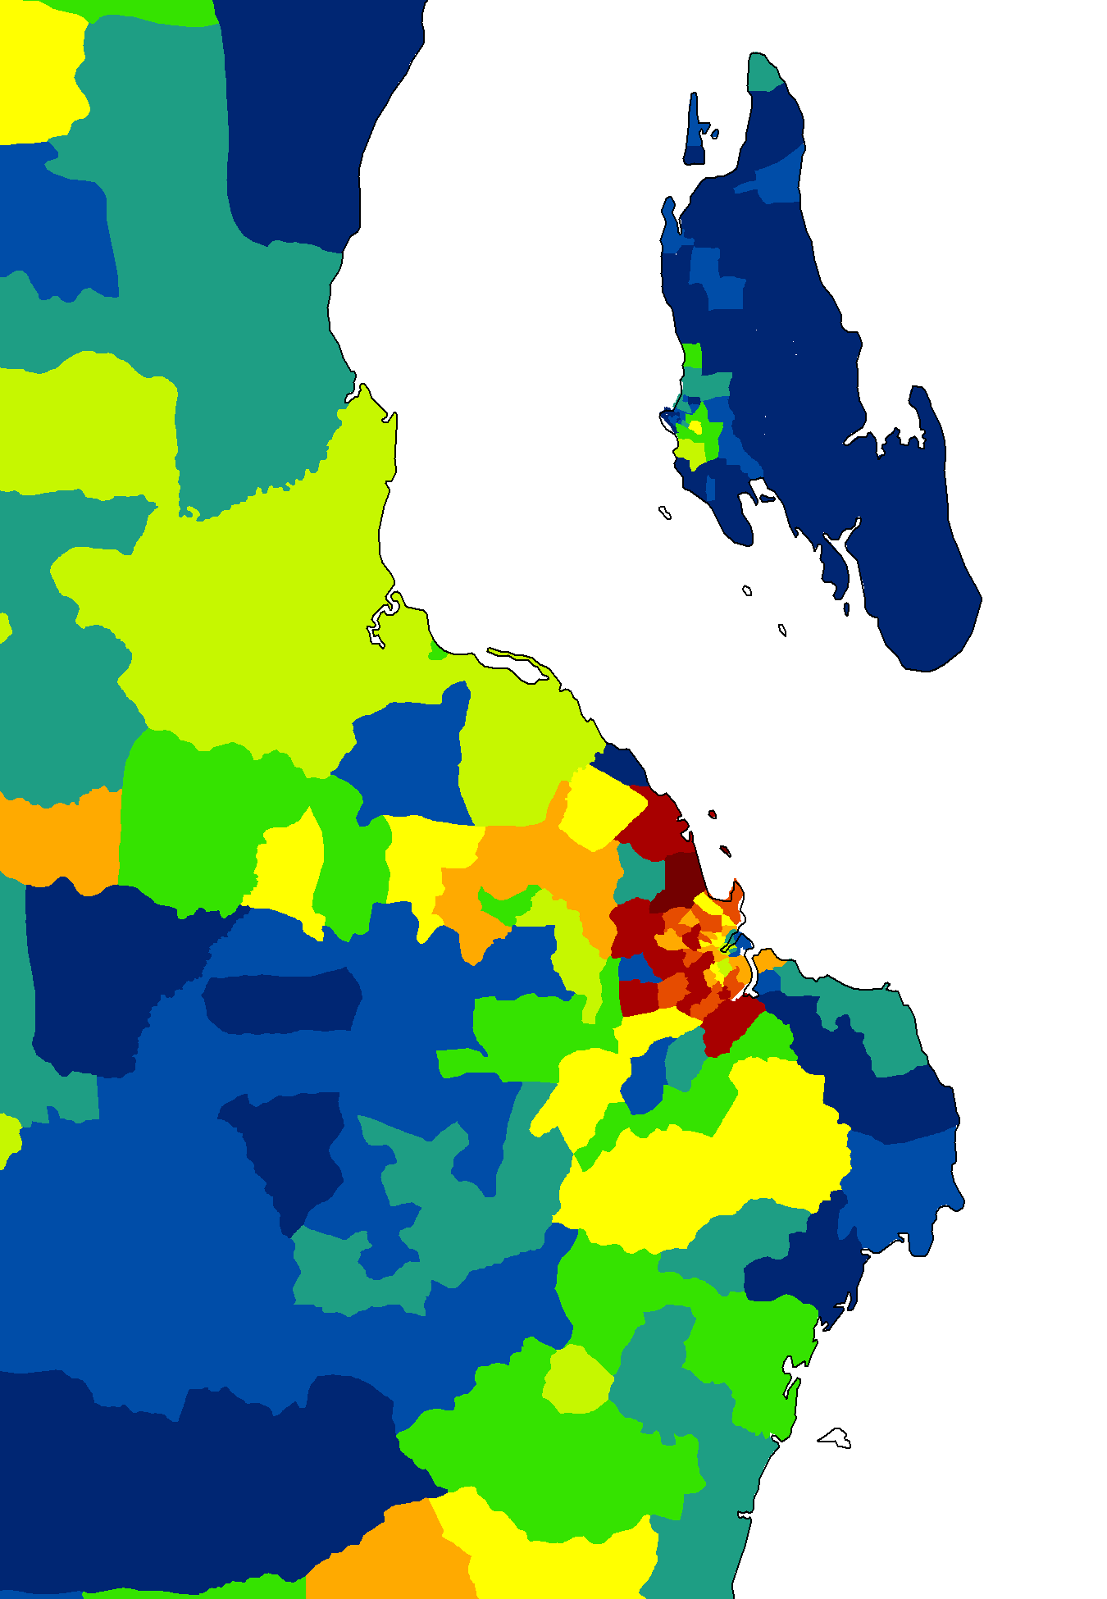  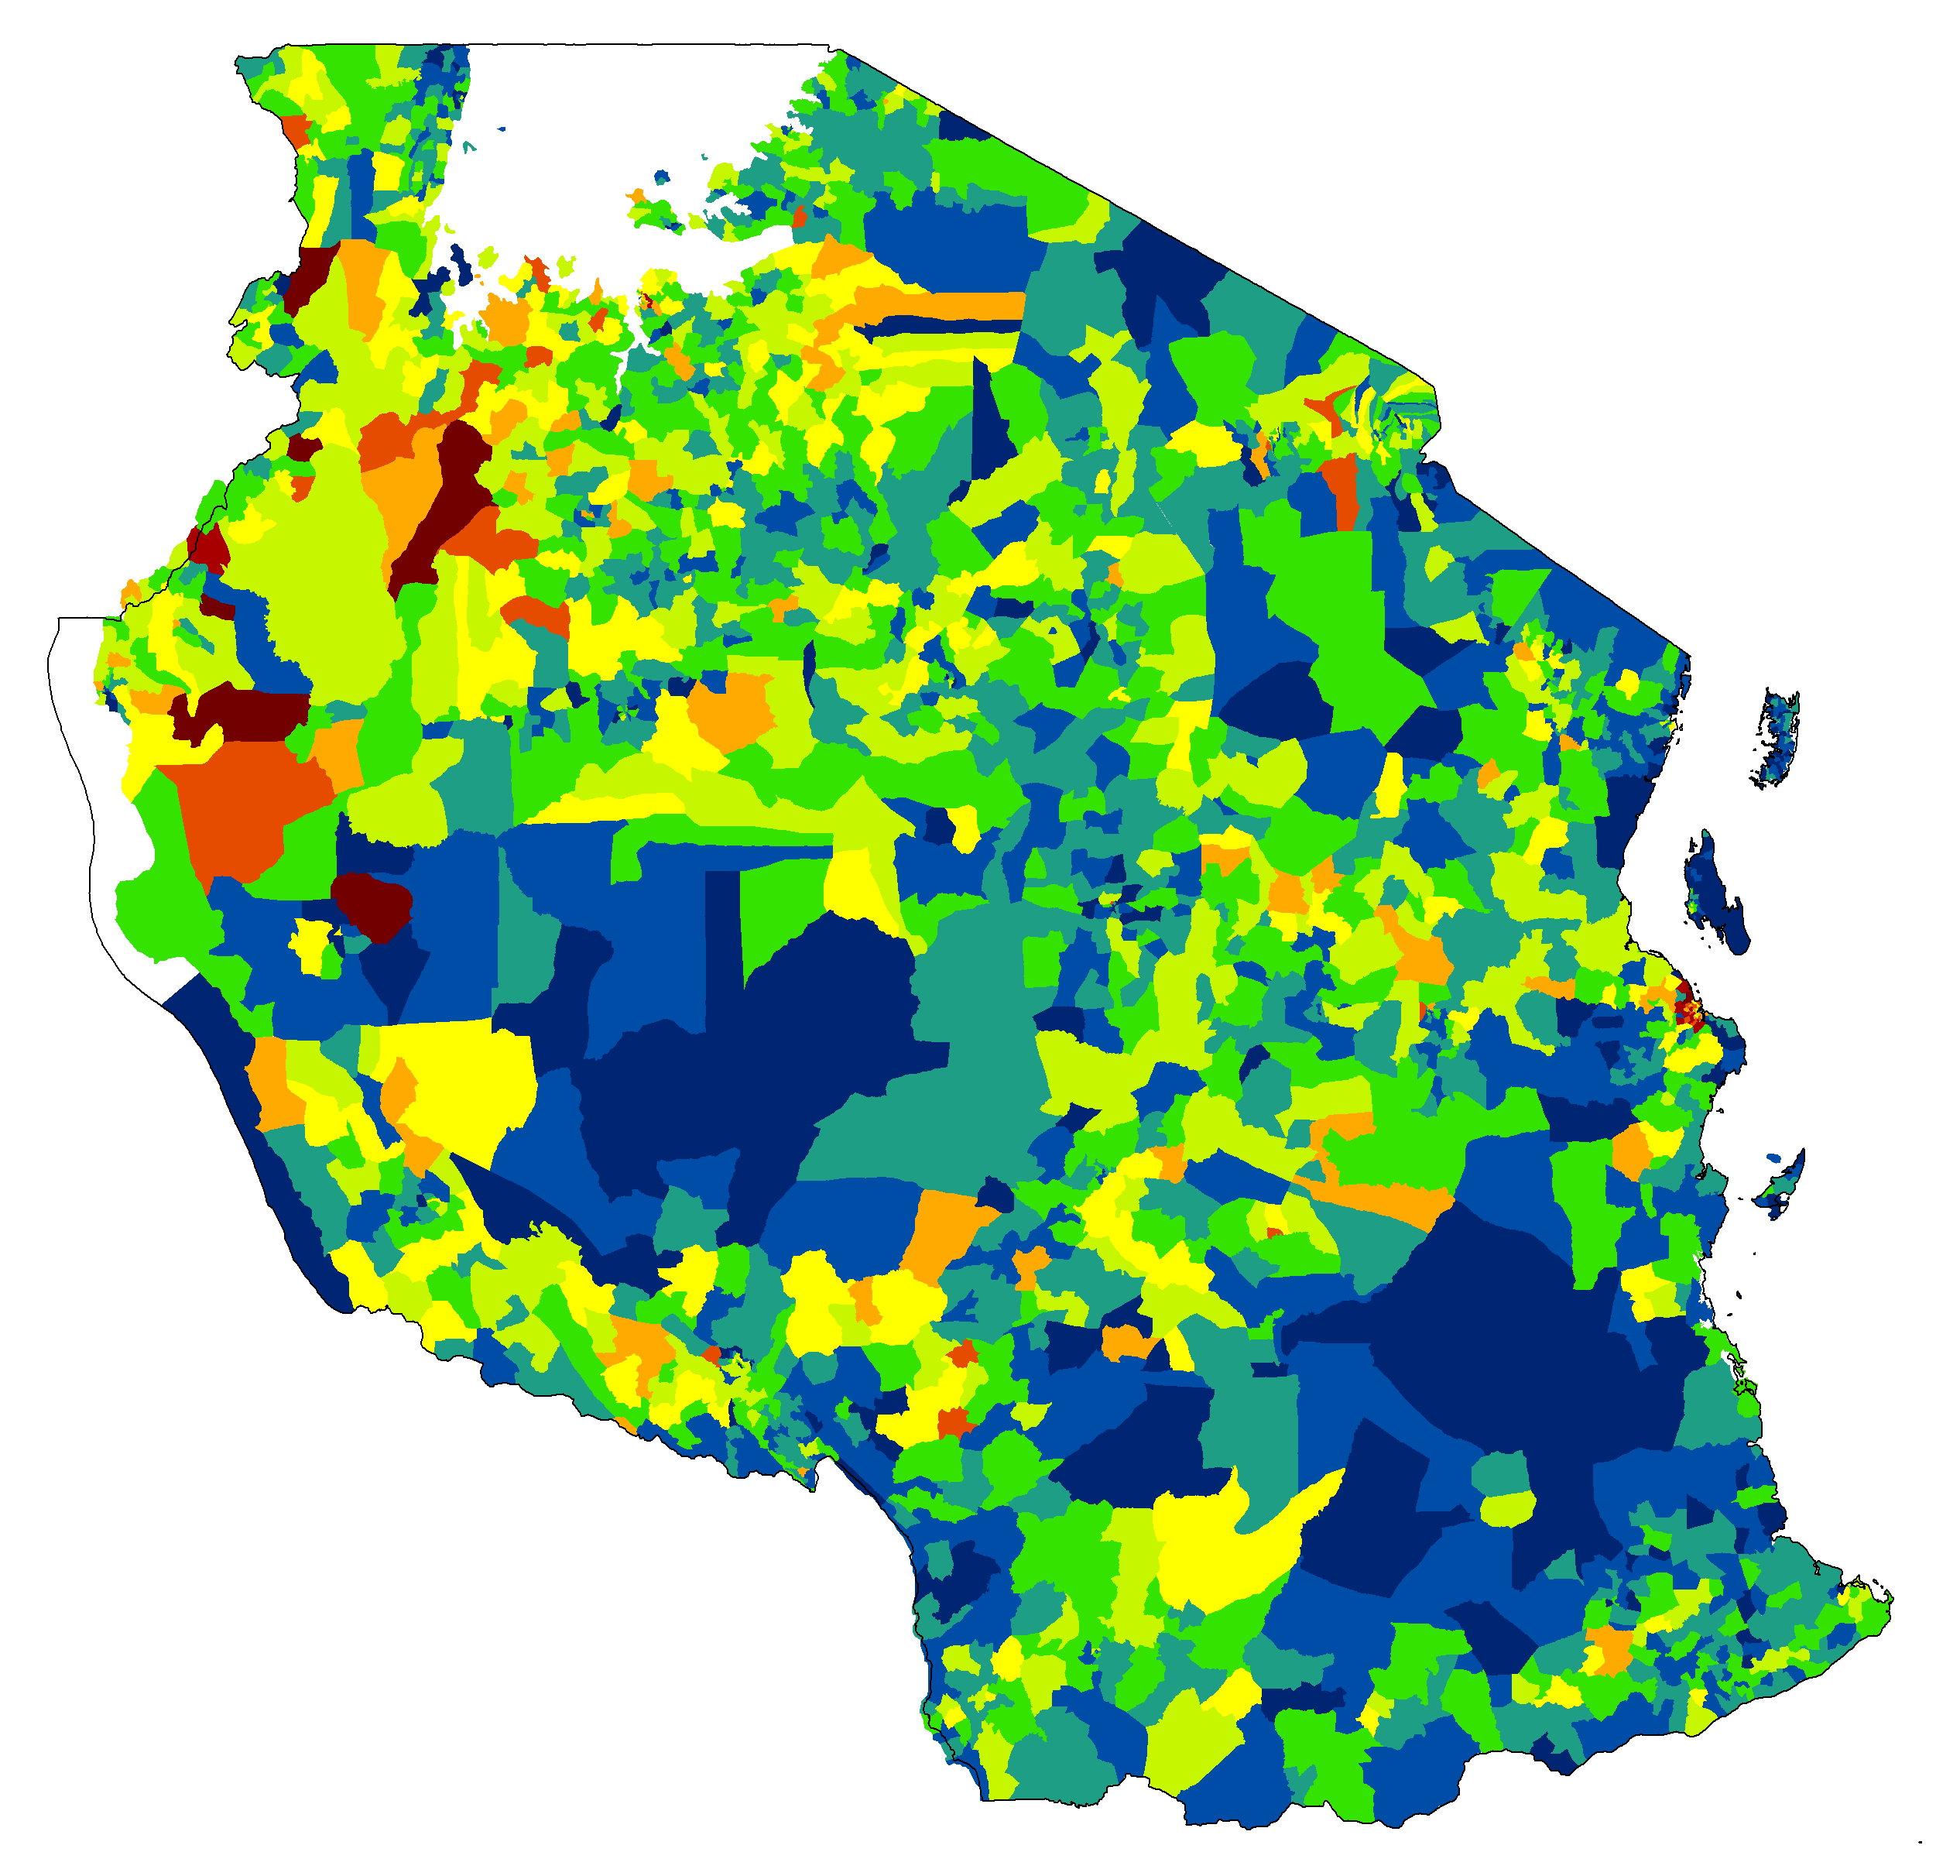 | 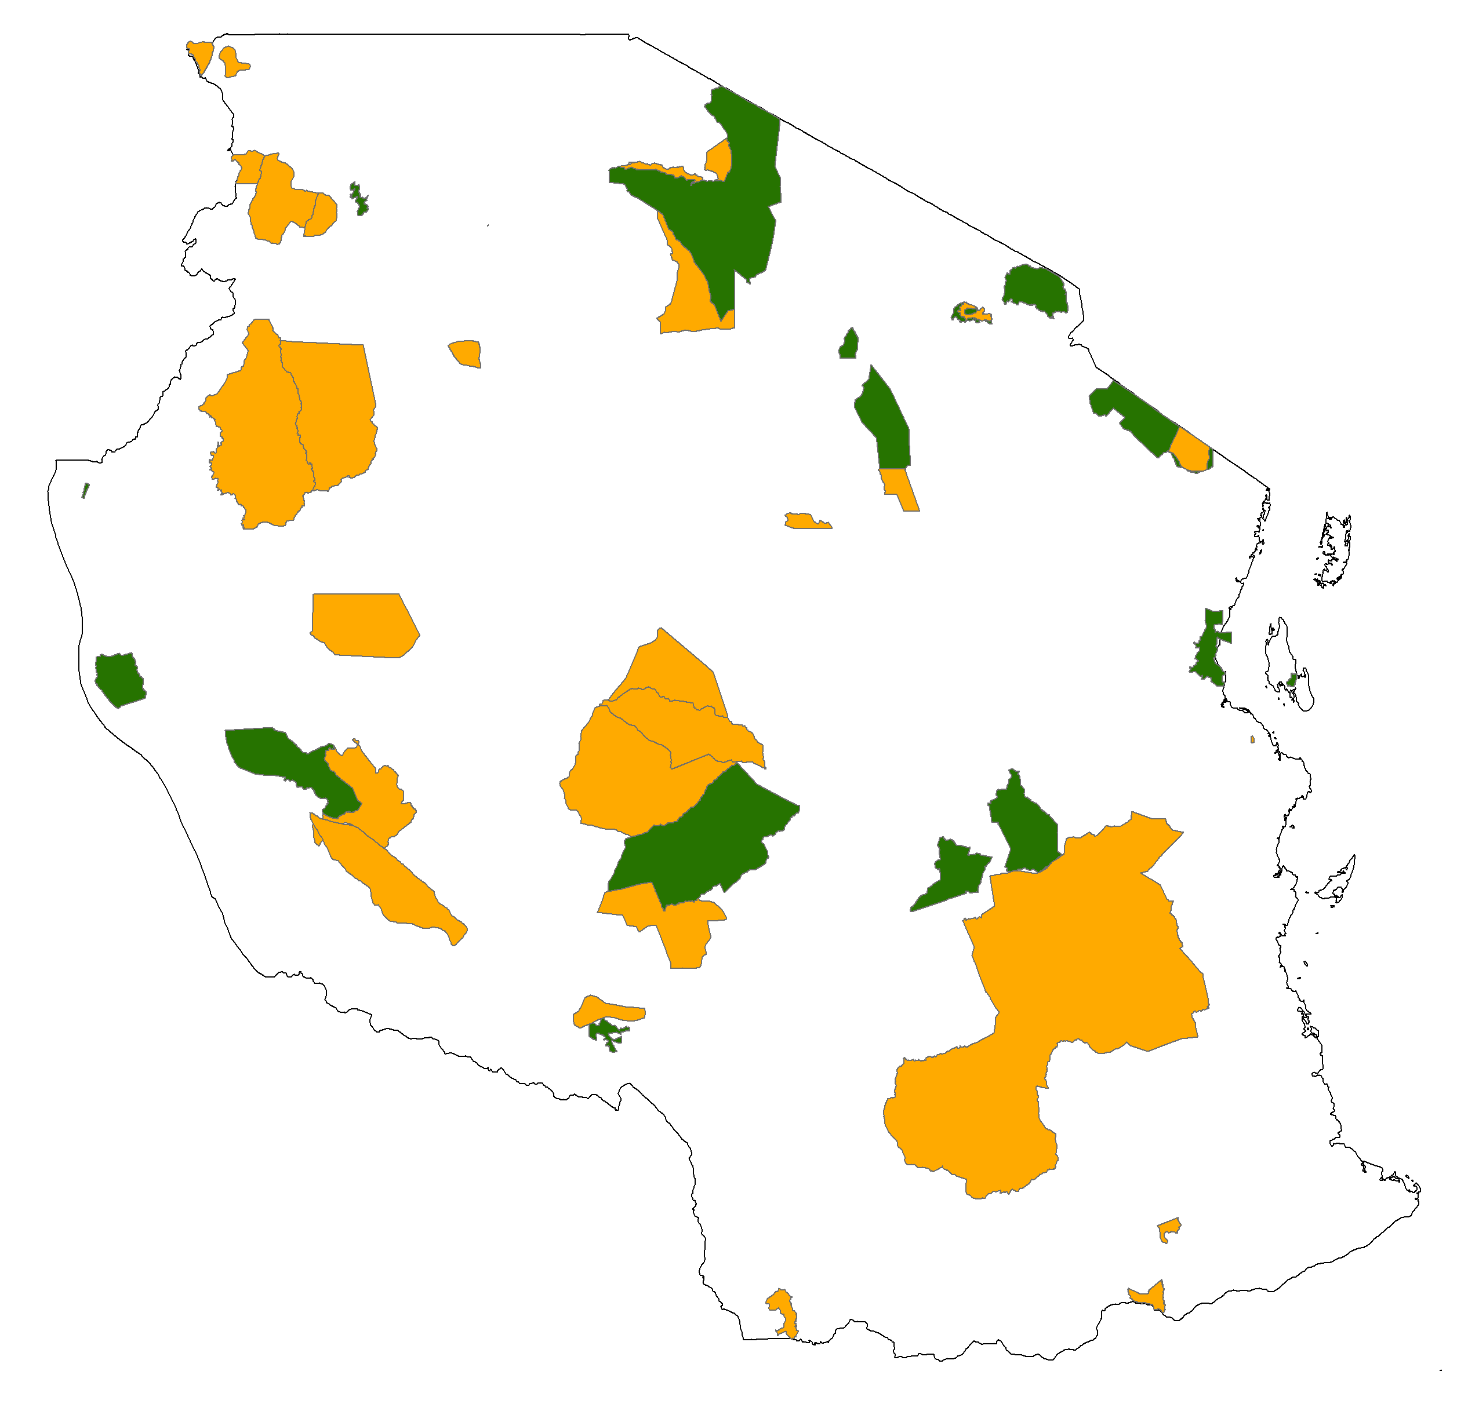
(c) LandScan 2006, persons.km⁻² | (d) High-resolution estimates for 2002, persons.km⁻²
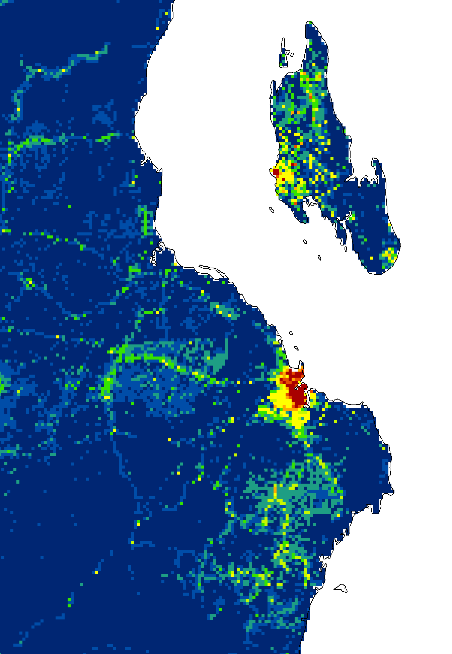  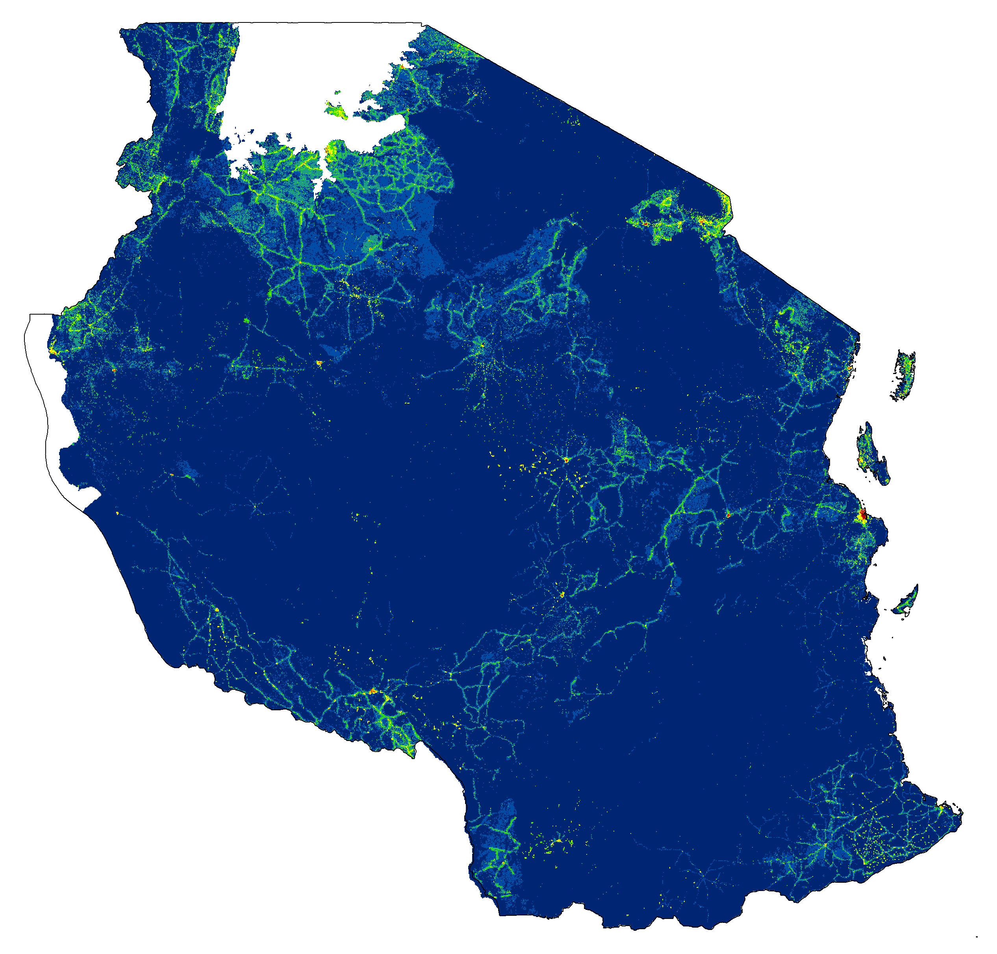 | 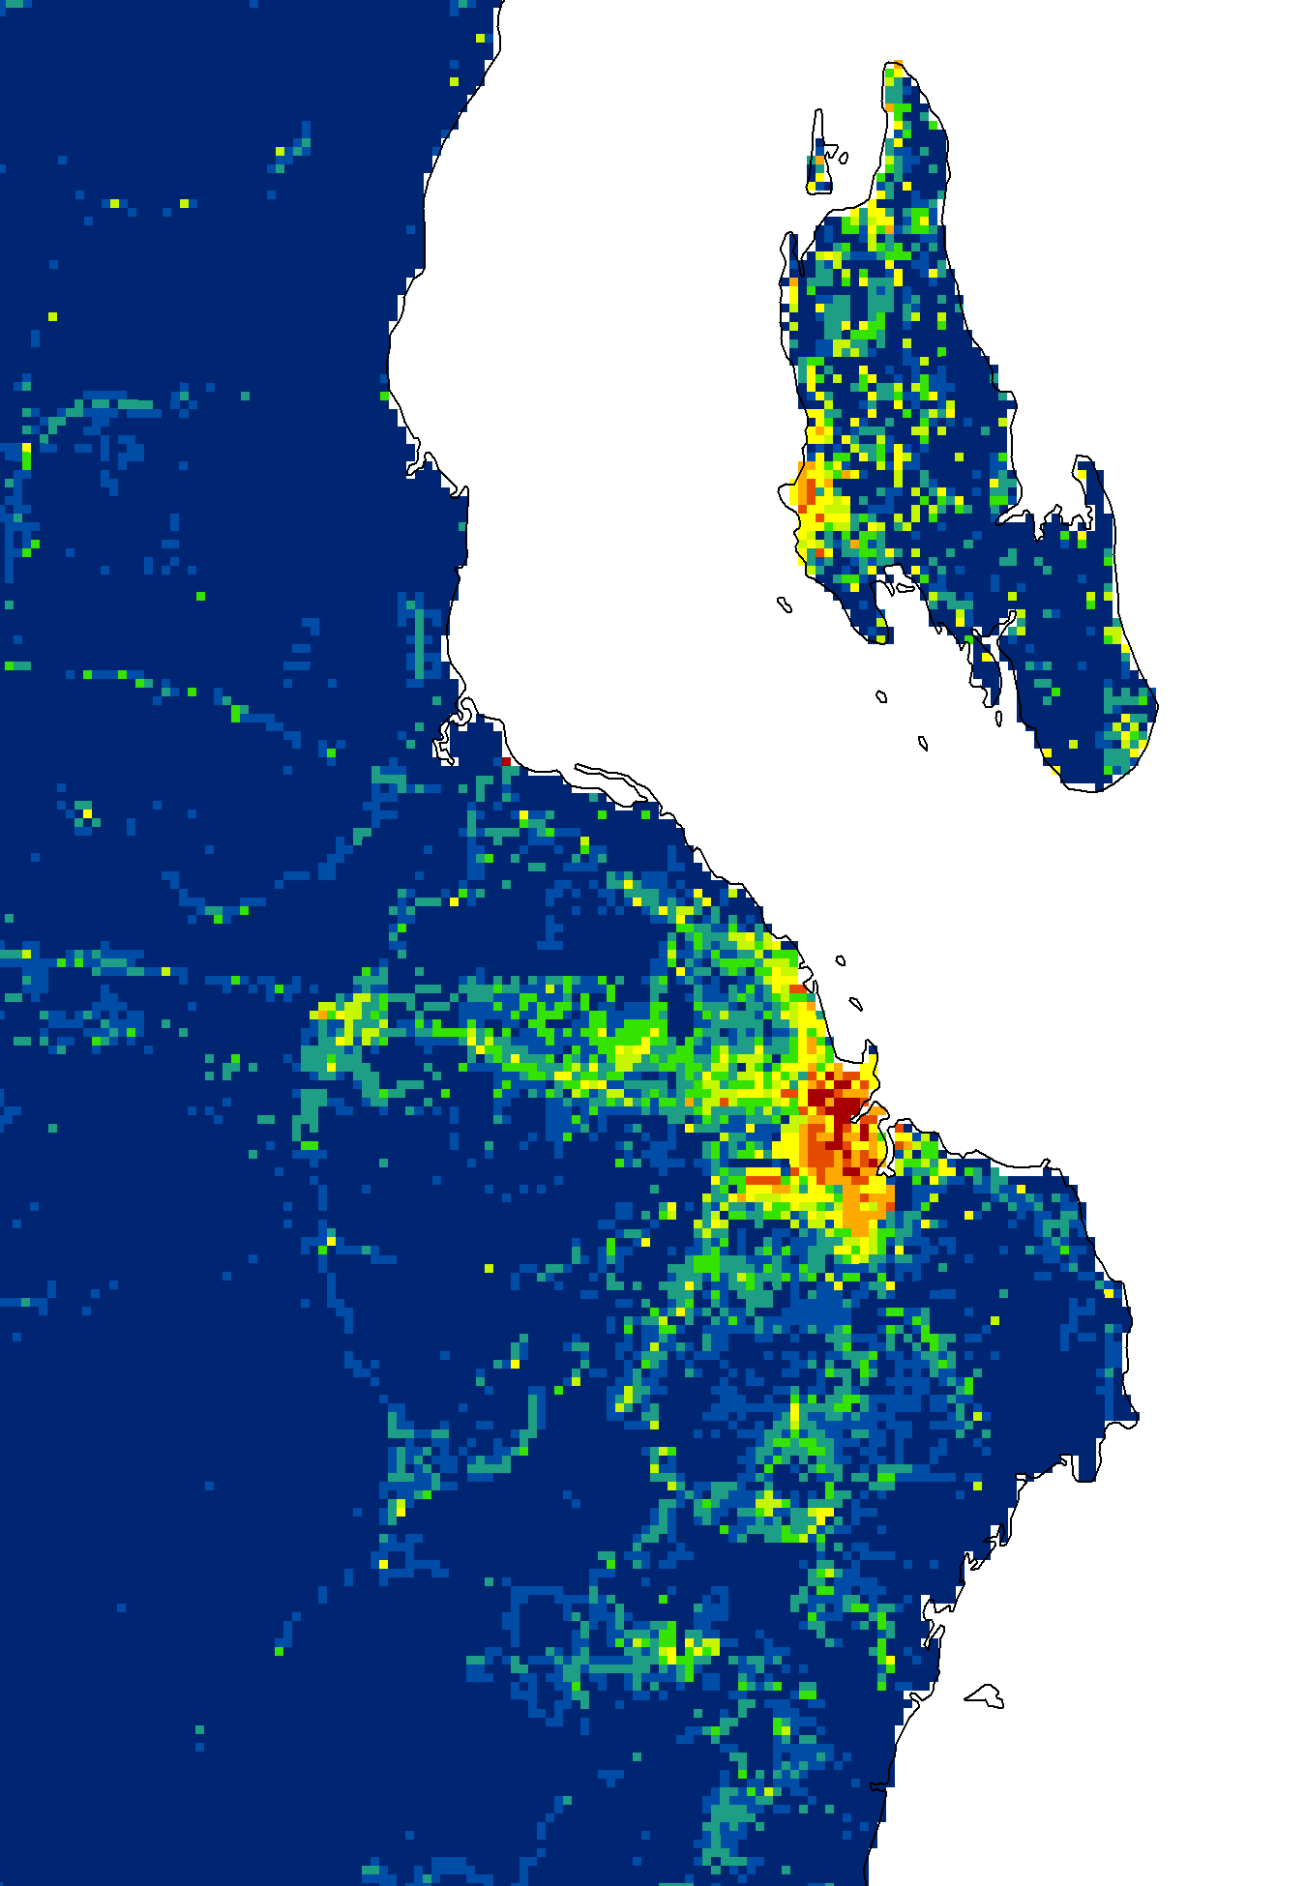  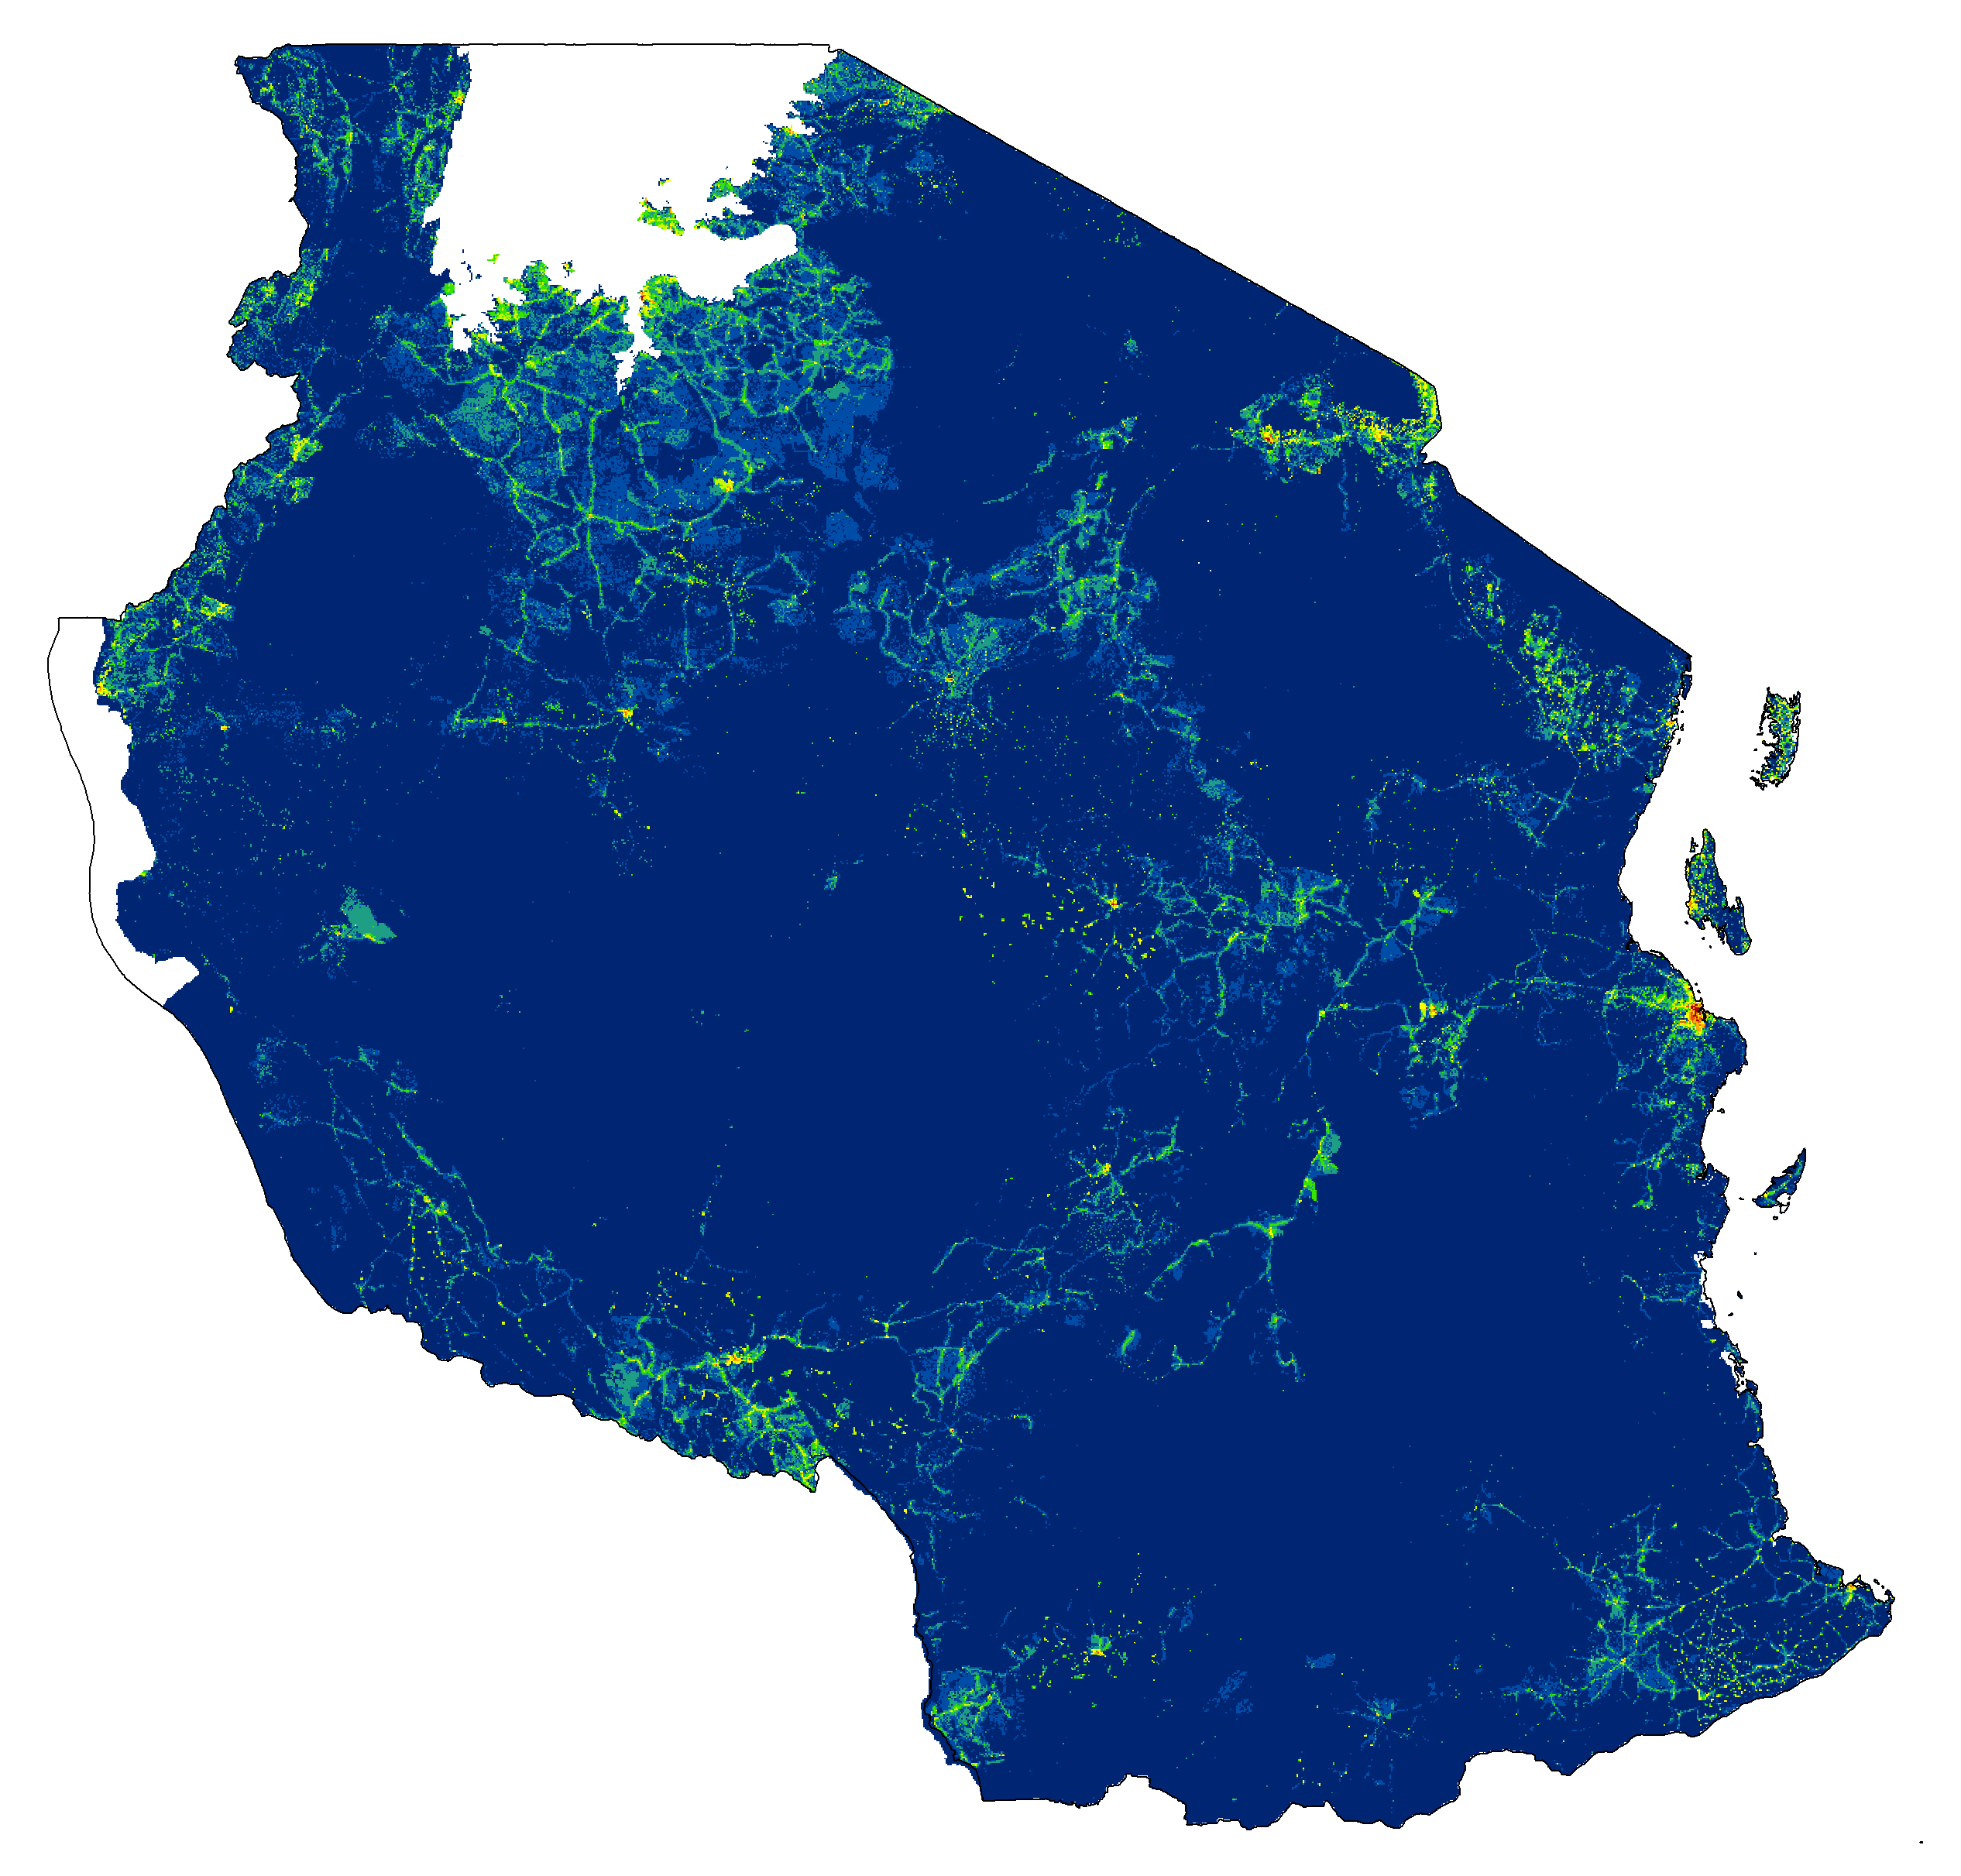
(a) Ward populations according to the Tanzania census in 2002. (b) Game reserves (orange) and national parks (green) from the World Database on Protected Areas. (c) Population distribution according to LandScan 2006. (d) As in (c) but with cell values adjusted to match the ward census counts and protected area data. Respectively, cool colours (blue-green) and warm colours (yellow-red) correspond to areas of low and high population. Insets show zoomed perspectives of Dar es Salaam and Zanzibar Island.

REFERENCES

URL http://www.wdpa.org/

