Data Supplement

Title: Health Care Utilization and All-Cause Mortality in Adults with Epilepsy Prior and During the COVID-19 Pandemic: A Population-Based Study

Authors: Maria Espinoza Vargas; Andrea S. Gershon; Michael Pugliese; Ryan Jason Gotfrit; Douglas Manuel; Mohsen Sadatsafavi; Therese A Stukel; Teresa To; Claire E. Kendall; Kednapa Thavorn; Rebecca Robillard; Tetyana Kendzerska

Supplementary Text:
Text 1: Details on the cost calculations from health administrative data.
Text 2: Details on mental health status definition.

Supplementary Tables
Table 1: Observed and projected monthly rates and 95% confidence intervals (CI) estimated by ARIMA Models for all-cause outpatient visit rates in individuals with epilepsy: rates were calculated as the number of events per 100,000 people at risk.
Table 2: Observed and projected monthly rates and 95% confidence intervals (CI) estimated by ARIMA Models for all-cause primary care visit rates in individuals with epilepsy: rates were calculated as the number of events per 100,000 people at risk.
Table 3: Observed and projected monthly rates and 95% confidence intervals (CI) estimated by ARIMA Models for all-cause specialist visit rates in individuals with epilepsy: rates were calculated as the number of events per 100,000 people at risk.
Table 4: Observed and projected monthly rates and 95% confidence intervals (CI) estimated by ARIMA Models for all-cause outpatient virtual visit rates in individuals with epilepsy: rates were calculated as the number of events per 100,000 people at risk.
Table 5: Observed and projected monthly rates and 95% confidence intervals (CI) estimated by ARIMA Models for sleep studies’ rates in individuals with epilepsy: rates were calculated as the number of events per 100,000 people at risk.
Table 6: Observed and projected monthly rates and 95% confidence intervals (CI) estimated by ARIMA Models for electroencephalography (EEG) studies’ rates in individuals with epilepsy: rates were calculated as the number of events per 100,000 people at risk.
Table 7: Observed and projected monthly rates and 95% confidence intervals (CI) estimated by ARIMA Models for magnetic resonance (MRI) studies’ rates in individuals with epilepsy: rates were calculated as the number of events per 100,000 people at risk.
Table 8: Observed and projected monthly rates and 95% confidence intervals (CI) estimated by ARIMA Models for computed tomography (CT) studies’ rates in individuals with epilepsy: rates were calculated as the number of events per 100,000 people at risk.
Table 9: Observed and projected monthly rates and 95% confidence intervals (CI) estimated by ARIMA Models for all-cause emergency department (ED) visit rates in individuals with epilepsy: rates were calculated as the number of events per 100,000 people at risk.
Table 10: Observed and projected monthly rates and 95% confidence intervals (CI) estimated by ARIMA Models for all-cause hospitalization rates in individuals with epilepsy: rates were calculated as the number of events per 100,000 people at risk.
Table 11: Observed and projected monthly rates and 95% confidence intervals (CI) estimated by ARIMA Models for all-cause mortality rates in individuals with epilepsy: rates were calculated as the number of events per 100,000 people at risk.

Supplementary Figures
Figure 1: Observed versus projected all-cause primary care visit rates per 100,000 people at-risk.
Figure 2: Observed versus projected relevant diagnostic test rates per 100,000 people at-risk.
Figure 3: Observed versus projected all-cause mortality rates per 100,000 people at-risk.

References
Text 1: Details on the health system cost calculations from health administrative data.

The standardized previously developed approach (GETCOST macro) was used to determine individual-level health system costs from a public payer's perspective.¹ Costs included hospital admissions, ED visits, same-day surgery visits, cancer centre treatments and visits, dialysis, other outpatient care (e.g., laboratory services), physician costs, homecare and long-term services, and prescription medications (covered by the Ontario Drug Benefit program for eligible individuals). All costs were standardized using health sector-specific consumer price indices to their equivalent 2021 Canadian dollar value.²

Text 2: Details on mental health status definition.

Mental health status was based on a previously developed mental health and addictions-related services classification algorithms for outpatient visits (the Ontario Health Insurance Plan [OHIP]), ED visits (the National Ambulatory Care Reporting System [NACRS]) and inpatient hospitalizations (the Discharge Abstract Database [DAD] and the Ontario Mental Health Reporting System [OMHRS]) for mental health and addictions-related complaints and ICES dementia cohort definition.

Definition of mental health condition at baseline (Y/N) | One or more mental health hospitalization/ED visit/outpatient visits within the last year OR met dementia definition
Hospitalizations/ED visits (from CIHI-DAD, NACRS, and OMHRS): Y/N
Hospitalizations/ED visits | ICD-10-CA (DAD/NACRS) | DSM or provisional diagnoses* (OMHRS)
Overall, any mental health disorder or addiction | Primary diagnosis at discharge equals F06−F99 (which excludes dementia), or secondary diagnoses fields equal X60−X84, Y10−Y19, Y28 when primary diagnosis is not F06−F99 | DSM IV (For visits before April 1st, 2016):  - AXIS1_DSM4CODE_DISCH1 = Any OMHRS diagnosis (includes missing; excludes 290.x, 294.x).  - Exclude if AXIS1_DSM4CODE_DISCH1 missing and PROVDX_DSM4CODE_ADM1 =2  DSM V (visits April 1st, 2016, and after):  - DSM5CODE_DISCH1 = Any OMHRS (includes missing; excludes 290.x, 294.0x-294.7x, 294.9x).  - Exclude if DSM5CODE_DISCH1 missing and PROVDX_DSM5CODE_ADM1 =17
Outpatient visits (from OHIP): Y/N
Outpatient visits | Algorithm | ​Qualifying diagnoses codes (DXCODE)
Overall, any mental health disorder or addiction | Psychiatrist [SPEC=19] and outpatient (LOCATION: O, L, H) and non-lab service [substr(FEECODE,1,1) ne 'G']  OR  FP/GP [SPEC=00] and MHA diagnosis code [DXCODE] and outpatient (LOCATION: O, L, H) and non-lab service [substr(FEECODE,1,1) ne 'G'] | ​Psychotic Disorders  - 295 Schizophrenia  - 296 Manic-depressive psychoses, involutional melancholia  - 297 Other paranoid states  - 298 Other psychoses  Non-Psychotic Disorders  - 300 Anxiety neurosis, hysteria, neurasthenia, obsessive-compulsive neurosis, reactive depression  - 301 Personality disorders  - 302 Sexual deviations  - 306 Psychosomatic illness  - 309 Adjustment reaction  - 311 Depressive disorder  Substance Use Disorders  - 303 Alcoholism  - 304 Drug dependence  Social Problems  - 897 Economic problems  - 898 Marital difficulties  - 899 Parent-child problems  - 900 Problems with aged parents or in-laws  - 901 Family disruption/divorce  - 902 Education problems  - 904 Social maladjustment  - 905 Occupational problems  - 906 Legal problems  - 909 Other problems of social adjustment
Dementia: Y/N
Met dementia definition | A person aged 40 to 110 years old is identified with dementia if s/he meets one of the following criteria:  - The person had at least 3 OHIP claims with a dementia diagnosis recorded which were each at least 30 days apart in a 2-year period, or  - The person had at least one hospitalization or same day surgery with a dementia diagnosis recorded, or  - The person had at least one ODB claim with a dementia medication (SUBCLNAM= CHOLINESTERASE INHIBITORS) dispensed

DAD, the Discharge Abstract Database; DSM, the Diagnostic and Statistical Manual; ED, emergency department; NACRS, the National Ambulatory Care Reporting System; ODB, the Ontario Drug Benefit; OHIP, the Ontario Health Insurance Plan; OMHRS, the Ontario Mental Health Reporting System.

Table 1: Observed and projected monthly rates and 95% confidence intervals (CI) estimated by ARIMA Models for all-cause outpatient visit rates in individuals with epilepsy: rates were calculated as the number of events per 100,000 people at risk. Similar periods in previous years (2016-2019) were used to calculate projected rates.

Population of interest | Observed | Projected  (95% CI) | Observed | Projected  (95% CI) | Observed | Projected  (95% CI) | Observed | Projected  (95% CI)
 | Pre-COVID  Jan-Feb 2020 |  | Wave I  Mar-May 2020 |  | Summer Lull  Jun-Aug 2020 |  | Wave II  Sep 2020 - Mar 2021
Total population | 76922.81 | 73897.67 (69688.25-78361.36) | 71262.71 | 80347.15 (75471.30-85538.66) | 79337.19 | 76357.40 (71533.38-81506.74) | 85,535.37 | 76,620.60 (71,546.91-82,059.42)
Age subgroups, years old
18-24 | 52535.70 | 51597.38 (47643.85-55878.98) | 47785.16 | 54463.18 (50094.24-59213.57) | 53804.34 | 53535.97 (49129.22-58337.99) | 59004.14 | 52340.84 (47822.37-57293.06)
25-34 | 63426.12 | 60805.95 (57421.89-64389.44) | 58491.47 | 65631.11 (61662.11-69856.43) | 64803.68 | 62027.64 (58136.13-66179.63) | 69474.95 | 62518.74 (58413.24-66916.79)
35-49 | 71830.66 | 70960.69 (65918.59-76388.45) | 65531.16 | 74489.82 (69196.96-80187.53) | 71709.91 | 70512.21 (65501.97-75905.67) | 78790.94 | 71403.51 (66118.75-77115.40)
50-64 | 79930.20 | 78935.14 (74148.20-84031.13) | 74217.61 | 84926.69 (79656.32-90545.89) | 81777.95 | 80421.34 (75188.97-86017.83) | 88332.71 | 80990.84 (75473.20-86916.00)
65 and older | 97766.89 | 92996.24 (87855.56-98437.71) | 91780.54 | 104428.22 (98379.66-110849.05) | 104003.96 | 99187.88 (93092.24-105682.67) | 110331.88 | 99370.21 (92918.39-106276.11)
Sex subgroups
Female | 83774.97 | 80638.00 (75770.77-85817.89) | 78478.61 | 88107.17 (82452.20-94150.72) | 87511.37 | 84122.55 (78509.58-90136.83) | 94204.52 | 83931.18 (78059.82-90250.80)
Male | 70489.10 | 67786.89 (64151.88-71627.87) | 64497.57 | 72927.82 (68640.79-77483.65) | 71689.96 | 69238.36 (64985.05-73770.06) | 77438.89 | 69727.68 (65241.63-74526.27)

In bold: observed rates outside the projected 95% confidence intervals of projected rates were considered as significantly different.

Table 2: Observed and projected monthly rates and 95% confidence intervals (CI) estimated by ARIMA Models for all-cause primary care visit rates in individuals with epilepsy: rates were calculated as the number of events per 100,000 people at risk. Similar periods in previous years (2016-2019) were used to calculate projected rates.

Population of interest | Observed | Projected  (95% CI) | Observed | Projected  (95% CI) | Observed | Projected  (95% CI) | Observed | Projected  (95% CI)
 | Pre-COVID  Jan-Feb 2020 |  | Wave I  Mar-May 2020 |  | Summer Lull  Jun-Aug 2020 |  | Wave II  Sep 2020 - Mar 2021
Total population | 45761.40 | 45729.83 (42787.47-48874.53) | 43975.48 | 48139.30 (45041.90-51449.69) | 48261.52 | 46270.24 (43293.11-49452.10) | 50765.80 | 46415.54 (43303.85-49753.31)
Age subgroups, years old
18-24 | 29362.96 | 29228.79 (26956.75-31692.33) | 25431.95 | 30414.38 (27988.40-33050.71) | 29316.58 | 29758.01 (27350.41-32377.54) | 31815.42 | 29524.73 (27072.96-32199.58)
25-34 | 36742.16 | 36197.72 (33974.66-38566.23) | 33828.19 | 38528.04 (36136.42-41077.96) | 37589.07 | 36683.53 (34277.45-39258.51) | 39946.85 | 37101.55 (34555.25-39837.13)
35-49 | 43440.23 | 41720.43 (39176.68-44429.35) | 40218.42 | 43619.03 (40858.10-46566.67) | 43462.96 | 41480.97 (38708.76-44451.76) | 47140.32 | 41718.14 (38622.61-45065.31
50-64 | 47251.19 | 47074.61 (44167.49-50173.08) | 46206.92 | 49845.06 (46709.08-53191.65) | 50354.65 | 47657.12 (44563.20-50965.86) | 52802.23 | 47817.96 (44513.72-51370.38)
65 and older | 59362.36 | 58191.05 (54680.62-61926.85) | 59679.16 | 62067.06 (58299.29-66078.34) | 65480.24 | 60743.14 (56999.18-64733.02) | 67015.21 | 60622.43 (56653.96-64872.69)
Sex subgroups
Female | 49770.57 | 49102.11 (46161.51-52230.03) | 48486.94 | 52484.01 (49284.58-55891.21) | 53363.07 | 50784.47 (47530.46-54261.26) | 56256.33 | 50711.74 (47311.28-54358.93)
Male | 41997.07 | 41260.66 (39517.83-43080.34) | 39745.87 | 44200.62 (42308.79-46177.04) | 43488.88 | 41838.87 (39979.88-43784.32) | 45637.94 | 42769.55 (40594.59-45070.57)

In bold: observed rates outside the projected 95% confidence intervals of projected rates were considered as significantly different.

Table 3: Observed and projected monthly rates and 95% confidence intervals (CI) estimated by ARIMA Models for all-cause specialist visit rates in individuals with epilepsy: rates were calculated as the number of events per 100,000 people at risk. Similar periods in previous years (2016-2019) were used to calculate projected rates.

Population of interest | Observed | Projected  (95% CI) | Observed | Projected  (95% CI) | Observed | Projected  (95% CI) | Observed | Projected  (95% CI)
 | Pre-COVID  Jan-Feb 2020 |  | Wave I  Mar-May 2020 |  | Summer Lull  Jun-Aug 2020 |  | Wave II  Sep 2020 - Mar 2021
Total population | 31161.92 | 29960.56 (28338.30-31675.68) | 27287.23 | 32630.78 (30423.56-35001.12) | 31076.01 | 31138.68 (28856.00-33601.93) | 34769.57 | 31288.92 (28923.82-33848.76)
Age subgroups, years old
18-24 | 23172.73 | 23115.36 (21047.31-25386.61) | 22353.22 | 23906.14 (21675.19-26366.93) | 24487.76 | 23845.39 (21577.52-26351.61) | 27188.72 | 23068.34 (20764.07-25632.83)
25-34 | 26683.96 | 25127.30 (23073.07-27364.42) | 24663.28 | 28036.02 (25744.19-30531.87) | 27216.61 | 26204.93 (24062.87-28537.66) | 29528.10 | 26520.91 (24225.73-29038.41)
35-49 | 28390.43 | 27550.55 (25650.75-29591.06) | 25312.74 | 29220.89 (26985.78-31642.06) | 28246.96 | 27768.74 (25551.60-30178.26) | 31650.62 | 28121.87 (25783.84-30674.44)
50-64 | 32679.01 | 32440.45 (31126.26-33810.12) | 28010.69 | 34116.35 (32648.87-35649.91) | 31423.30 | 32343.12 (30832.50-33928.03) | 35530.48 | 32828.13 (30941.86-34829.45)
65 and older | 38406.56 | 36812.07 (34134.56-39699.61) | 32101.38 | 42427.41 (39213.52-45904.93) | 38523.72 | 39423.17 (36385.12-42714.88) | 43316.67 | 40033.18 (36797.97-43557.46)
Sex subgroups
Female | 34004.40 | 32107.83 (30041.25-34316.58) | 29991.67 | 35966.49 (33369.41-38766.91) | 34148.30 | 34177.05 (31591.65-36974.03) | 37948.18 | 34178.87 (31488.82-37101.33)
Male | 28493.03 | 27609.86 (25914.46-29416.19) | 24751.70 | 29850.46 (27774.63-32082.51) | 28201.74 | 28235.11 (26171.07-30461.94) | 31800.95 | 28694.11 (26513.01-31056.62)

In bold: observed rates outside the projected 95% confidence intervals of projected rates were considered as significantly different.

Table 4: Observed and projected monthly rates and 95% confidence intervals (CI) estimated by ARIMA Models for all-cause outpatient virtual visit rates in individuals with epilepsy: rates were calculated as the number of events per 100,000 people at risk. Similar periods in previous years (2016-2019) were used to calculate projected rates.

Population of interest | Observed | Projected  (95% CI) | Observed | Projected  (95% CI) | Observed | Projected  (95% CI) | Observed | Projected  (95% CI)
 | Pre-COVID  Jan-Feb 2020 |  | Wave I  Mar-May 2020 |  | Summer Lull  Jun-Aug 2020 |  | Wave II  Sep 2020 - Mar 2021
Total population | 2095.12 | 1951.95 (1808.70-2095.20) | 40590.38 | 2154.37 (2006.51-2302.23) | 46017.95 | 2227.40 (2037.05-2417.74) | 48091.56 | 2357.71 (2110.30-2605.13)
Age subgroups, years old
18-24 | 1605.45 | 1422.85 (1181.94-1663.75) | 31428.56 | 1505.47 (1264.45-1746.48) | 36814.28 | 1597.02 (1354.22-1839.82) | 39217.65 | 1718.16 (1463.68-1972.64)
25-34 | 3267.59 | 3233.53 (2953.75-3513.31) | 35845.46 | 3447.45 (3162.31-3732.59) | 41062.76 | 3581.01 (3280.26-3881.76) | 43636.30 | 3702.94 (3377.86-4028.01)
35-49 | 3352.97 | 2899.05 (2537.99-3260.11) | 39953.33 | 3220.03 (2848.71-3591.35) | 45375.57 | 3281.50 (2880.71-3682.29) | 48520.56 | 3532.22 (3072.25-3992.20)
50-64 | 1785.76 | 1257.03 (716.93-2204.00) | 43009.51 | 1413.06 (805.92-2477.57) | 48066.03 | 1430.70 (815.99-2508.51) | 49743.80 | 1422.14 (800.57-2529.76)
65 and older | 792.56 | 805.17 (692.14-918.20) | 45793.23 | 836.24 (718.68-953.81) | 51761.44 | 874.54 (743.51-1005.57) | 52829.60 | 930.17 (775.59-1084.74)
Sex subgroups
Female | 2071.55 | 1936.18 (1767.30-2105.06) | 45463.36 | 2108.15 (1929.66-2286.64) | 51450.90 | 2186.29 (1954.28-2418.31) | 53843.28 | 2323.58 (2020.10-2627.05)
Male | 2117.26 | 1967.95 (1791.81-2144.09) | 36022.34 | 2111.20 (1935.05-2287.34) | 40935.26 | 2182.21 (2006.07-2358.35) | 42719.80 | 2295.07 (2115.74-2474.40)

In bold: observed rates outside the projected 95% confidence intervals of projected rates were considered as significantly different.

Table 5: Observed and projected monthly rates and 95% confidence intervals (CI) estimated by ARIMA Models for sleep studies’ rates in individuals with epilepsy: rates were calculated as the number of events per 100,000 people at risk. Similar periods in previous years (2016-2019) were used to calculate projected rates.

Population of interest | Observed | Projected  (95% CI) | Observed | Projected  (95% CI) | Observed | Projected  (95% CI) | Observed | Projected  (95% CI)
 | Pre-COVID  Jan-Feb 2020 |  | Wave I  Mar-May 2020 |  | Summer Lull  Jun-Aug 2020 |  | Wave II  Sep 2020 - Mar 2021
Total population | 207.16 | 210.28 (181.88-243.11) | 52.92 | 216.05 (186.21-250.67) | 114.38 | 214.09 (184.10-248.97) | 184.11 | 208.15 (179.03-242.00)
Age subgroups, years old
18-24 | 87.85 | 116.18 (47.97-184.39) | 36.88 | 117.13 (47.90-186.36) | 117.60 | 130.02 (60.79-199.25) | 102.36 | 114.76 (44.79-184.72)
25-34 | 180.71 | 185.92 (123.14-280.73) | 54.87 | 172.12 (113.31-261.44) | 120.66 | 170.45 (112.21-258.91) | 194.60 | 174.61 (114.44-266.43)
35-49 | 233.82 | 246.09 (186.15-325.34) | 62.51 | 251.84 (189.73-334.28) | 113.60 | 250.31 (187.06-334.96) | 253.41 | 249.88 (186.48-334.84)
50-64 | 266.58 | 276.39 (214.34-356.41) | 60.17 | 276.39 (214.34-356.41) | 141.61 | 276.39 (214.34-356.41) | 205.03 | 276.39 (214.34-356.41)
65 and older | 193.07 | 181.18 (128.95-254.55) | 43.10 | 204.94 (145.42-288.84) | 81.68 | 203.15 (144.15-286.31) | 133.48 | 186.83 (132.13-264.18)
Sex subgroups
Female | 192.80 | 186.60 (148.37-234.68) | 44.15 | 202.68 (160.60-255.78) | 112.72 | 198.23 (157.08-250.17) | 171.53 | 187.47 (148.17-237.19)
Male | 220.64 | 236.12 (194.04-287.34) | 61.13 | 223.56 (181.24-275.78) | 115.94 | 229.63 (183.59-287.21) | 195.86 | 224.92 (176.82-286.12)

In bold: observed rates outside the projected 95% confidence intervals of projected rates were considered as significantly different.

Table 6: Observed and projected monthly rates and 95% confidence intervals (CI) estimated by ARIMA Models for electroencephalography (EEG) studies’ rates in individuals with epilepsy: rates were calculated as the number of events per 100,000 people at risk. Similar periods in previous years (2016-2019) were used to calculate projected rates.

Population of interest | Observed | Projected  (95% CI) | Observed | Projected  (95% CI) | Observed | Projected  (95% CI) | Observed | Projected  (95% CI)
 | Pre-COVID  Jan-Feb 2020 |  | Wave I  Mar-May 2020 |  | Summer Lull  Jun-Aug 2020 |  | Wave II  Sep 2020 - Mar 2021
Total population | 1808.74 | 1825.91 (1688.09-1975.00) | 700.13 | 1922.09 (1771.35-2085.68) | 1199.39 | 1798.59 (1649.30-1961.39) | 1347.96 | 1792.12 (1636.33-1962.76)
Age subgroups, years old
18-24 | 3168.06 | 2754.43 (2157.72-3516.17) | 974.84 | 3111.40 (2437.35-3971.86) | 1630.25 | 2865.22 (2244.50-3657.59) | 2094.40 | 2761.72 (2163.42-3525.47)
25-34 | 2523.12 | 2429.60 (1924.64-3067.05) | 926.14 | 2427.03 (1891.21-3114.88) | 1821.61 | 2296.53 (1774.28-2972.50) | 1825.92 | 2198.77 (1693.95-2854.11)
35-49 | 1935.63 | 2001.22 (1523.03-2479.40) | 575.40 | 1987.89 (1508.76-2467.02) | 1078.44 | 1916.47 (1435.49-2397.46) | 1378.10 | 1957.79 (1471.66-2443.93)
50-64 | 1325.09 | 1408.08 (1154.48-1717.38) | 670.06 | 1613.19 (1320.53-1970.70) | 967.59 | 1370.35 (1079.18-1740.09) | 1062.80 | 1542.20 (1199.98-1983.51)
65 and older | 1131.88 | 1282.33 (1057.50-1554.95) | 565.66 | 1280.42 (1055.89-1552.70) | 935.84 | 1277.46 (1053.42-1549.15) | 972.20 | 1277.46 (1053.42-1549.15)
Sex subgroups
Female | 1794.46 | 1874.73 (1687.82-2082.34) | 694.59 | 2026.19 (1821.33-2254.09) | 1138.42 | 1872.73 (1683.39-2083.37) | 1358.84 | 1861.38 (1671.29-2073.10)
Male | 1822.15 | 1686.47 (1433.64-1983.87) | 705.32 | 1803.65 (1533.26-2121.72) | 1256.43 | 1677.29 (1425.84-1973.08) | 1337.82 | 1682.75 (1429.68-1980.62)

In bold: observed rates outside the projected 95% confidence intervals of projected rates were considered as significantly different.

Table 7: Observed and projected monthly rates and 95% confidence intervals (CI) estimated by ARIMA Models for magnetic resonance (MRI) studies’ rates in individuals with epilepsy: rates were calculated as the number of events per 100,000 people at risk. Similar periods in previous years (2016-2019) were used to calculate projected rates.

Population of interest | Observed | Projected  (95% CI) | Observed | Projected  (95% CI) | Observed | Projected  (95% CI) | Observed | Projected  (95% CI)
 | Pre-COVID  Jan-Feb 2020 |  | Wave I  Mar-May 2020 |  | Summer Lull  Jun-Aug 2020 |  | Wave II  Sep 2020 - Mar 2021
Total population | 2024.73 | 2006.34 (1912.39-2104.90) | 1353.05 | 2068.11 (1969.86-2171.26) | 1870.51 | 1998.60 (1903.66-2098.29) | 2112.39 | 2040.84 (1942.85-2143.77)
Age subgroups, years old
18-24 | 1374.04 | 1526.29 (1269.39-1835.20) | 1000.53 | 1478.80 (1225.89-1783.91) | 1326.67 | 1507.10 (1241.59-1829.37) | 1638.93 | 1507.10 (1241.59-1829.37)
25-34 | 1623.10 | 1697.07 (1532.89-1878.83) | 1025.11 | 1659.13 (1493.70-1842.91) | 1561.92 | 1633.62 (1464.07-1822.80) | 1755.07 | 1675.81 (1500.37-1871.77)
35-49 | 2241.86 | 2150.54 (1910.57-2420.64) | 1422.92 | 2199.97 (1951.96-2479.49) | 2001.25 | 2081.71 (1845.68-2347.92) | 2270.26 | 2171.71 (1920.02-2456.51)
50-64 | 2428.70 | 2344.44 (2168.07-2535.16) | 1705.47 | 2409.97 (2226.06-2609.09) | 2198.51 | 2352.17 (2172.67-2546.51) | 2497.04 | 2384.35 (2200.50-2583.56)
65 and older | 1975.21 | 1965.28 (1808.63-2135.51) | 1303.51 | 2100.07 (1926.82-2288.91) | 1866.96 | 2043.11 (1871.34-2230.64) | 2035.40 | 2090.67 (1914.51-2283.05)
Sex subgroups
Female | 2137.96 | 2093.64 (1940.23-2259.17) | 1373.17 | 2222.81 (2059.74-2398.79) | 1905.58 | 2101.89 (1947.11-2268.97) | 2204.10 | 2168.21 (2006.81-2342.60)
Male | 1918.41 | 1915.61 (1785.27-2055.47) | 1334.17 | 1922.84 (1791.80-2063.47) | 1837.70 | 1900.91 (1770.73-2040.66) | 2026.73 | 1922.26 (1789.33-2065.06)

In bold: observed rates outside the projected 95% confidence intervals of projected rates were considered as significantly different.

Table 8: Observed and projected monthly rates and 95% confidence intervals (CI) estimated by ARIMA Models for computed tomography (CT) studies’ rates in individuals with epilepsy: rates were calculated as the number of events per 100,000 people at risk. Similar periods in previous years (2016-2019) were used to calculate projected rates.

Population of interest | Observed | Projected  (95% CI) | Observed | Projected  (95% CI) | Observed | Projected  (95% CI) | Observed | Projected  (95% CI)
 | Pre-COVID  Jan-Feb 2020 |  | Wave I  Mar-May 2020 |  | Summer Lull  Jun-Aug 2020 |  | Wave II  Sep 2020 - Mar 2021
Total population | 3884.55 | 3879.68 (3647.37-4126.78) | 2926.87 | 4199.82 (3948.34-4467.31) | 3875.36 | 4140.35 (3892.43-4404.06) | 4096.44 | 4130.12 (3878.41-4398.19)
Age subgroups, years old
18-24 | 1624.01 | 1529.00 (1206.16-1851.83) | 1055.86 | 1462.34 (1126.46-1798.23) | 1558.67 | 1433.49 (1079.97-1787.02) | 1587.01 | 1420.60 (1063.01-1778.18)
25-34 | 1871.03 | 2036.31 (1777.08-2295.53) | 1440.82 | 2060.70 (1799.07-2322.34) | 2066.54 | 2014.05 (1746.28-2281.83) | 2217.23 | 2003.70 (1724.33-2283.06)
35-49 | 3027.59 | 2784.28 (2451.73-3161.94) | 2135.94 | 2938.23 (2587.29-3336.77) | 2973.85 | 2901.48 (2554.93-3295.04) | 3037.75 | 2878.71 (2529.51-3276.21)
50-64 | 4349.61 | 4297.42 (4031.71-4580.65) | 3565.61 | 4719.99 (4415.19-5045.84) | 4383.93 | 4604.11 (4300.22-4929.47) | 4675.67 | 4564.95 (4262.30-4889.08)
65 and older | 6454.21 | 6518.71 (5975.71-7111.05) | 4738.44 | 6718.20 (6147.74-7341.60) | 6321.39 | 6574.11 (5985.97-7220.05) | 6714.55 | 6578.53 (5931.47-7296.56)
Sex subgroups
Female | 3773.38 | 3774.71 (3562.15-3999.96) | 2830.50 | 4106.21 (3858.00-4370.43) | 3689.86 | 4007.69 (3743.20-4290.87) | 3899.63 | 4008.34 (3732.44-4304.64)
Male | 3988.93 | 3887.72 (3513.85-4301.36) | 3017.21 | 4084.66 (3691.86-4519.26) | 4048.90 | 4016.05 (3629.85-4443.35) | 4280.29 | 3964.54 (3574.85-4396.85)

In bold: observed rates outside the projected 95% confidence intervals of projected rates were considered as significantly different.

Table 9: Observed and projected monthly rates and 95% confidence intervals (CI) estimated by ARIMA Models for all-cause emergency department (ED) visit rates in individuals with epilepsy: rates were calculated as the number of events per 100,000 people at risk. Similar periods in previous years (2016-2019) were used to calculate projected rates.

Population of interest | Observed | Projected  (95% CI) | Observed | Projected  (95% CI) | Observed | Projected  (95% CI) | Observed | Projected  (95% CI)
 | Pre-COVID  Jan-Feb 2020 |  | Wave I  Mar-May 2020 |  | Summer Lull  Jun-Aug 2020 |  | Wave II  Sep 2020 - Mar 2021
Total population | 10100.69 | 10068.26 (9784.08-10360.69) | 7493.03 | 10732.22 (10424.83-11048.68) | 9521.78 | 11212.29 (10891.15-11542.90) | 8665.09 | 10421.43 (10119.82-10732.04)
Age subgroups, years old
18-24 | 10635.96 | 10406.63 (9514.42-11382.50) | 6920.14 | 10689.30 (9772.86-11691.68) | 8823.35 | 11143.63 (10188.23-12188.61) | 8329.43 | 10774.22 (9837.51-11800.24)
25-34 | 10883.78 | 10561.66 (9953.70-11206.76) | 8174.95 | 11976.97 (11212.84-12793.49) | 9790.89 | 12469.92 (11603.33-13401.23) | 9020.75 | 11456.07 (10652.73-12319.99)
35-49 | 10794.69 | 10671.54 (9966.06-11426.95) | 7978.22 | 11348.54 (10561.48-12194.35) | 10134.04 | 12070.14 (11123.99-13096.85) | 9533.79 | 11103.14 (10081.62-12228.82)
50-64 | 9550.07 | 9497.15 (9063.98-9951.03) | 7375.21 | 10268.54 (9754.42-10809.85) | 9727.70 | 10759.18 (10182.51-11368.52) | 8299.70 | 9838.96 (9304.23-10404.44)
65 and older | 9331.92 | 9390.75 (8902.21-9906.11) | 7004.47 | 9954.36 (9434.83-10502.50) | 8921.56 | 10134.67 (9600.67-10698.37) | 8218.92 | 9574.99 (9062.68-10116.26)
Sex subgroups
Female | 10872.34 | 10678.63 (10235.94-11140.48) | 7477.15 | 11263.43 (10789.72-11757.95) | 9447.19 | 11626.72 (11137.72-12137.19) | 8699.14 | 10968.44 (10502.28-11455.28)
Male | 9376.17 | 9355.86 (9004.28-9721.17) | 7507.85 | 10078.15 (9654.03-10521.18) | 9591.56 | 10662.91 (10055.23-11307.49) | 8633.30 | 9756.32 (9026.57-10545.57)
In bold: observed rates outside the projected 95% confidence intervals of projected rates were considered as significantly different.

Table 10: Observed and projected monthly rates and 95% confidence intervals (CI) estimated by ARIMA Models for all-cause hospitalization rates in individuals with epilepsy: rates were calculated as the number of events per 100,000 people at risk. Similar periods in previous years (2016-2019) were used to calculate projected rates.

Population of interest | Observed | Projected  (95% CI) | Observed | Projected  (95% CI) | Observed | Projected  (95% CI) | Observed | Projected  (95% CI)
 | Pre-COVID  Jan-Feb 2020 |  | Wave I  Mar-May 2020 |  | Summer Lull  Jun-Aug 2020 |  | Wave II  Sep 2020 - Mar 2021
Total population | 2286.45 | 2272.71 (2141.90-2411.51) | 1754.93 | 2302.32 (2169.81-2442.93) | 2130.06 | 2243.01 (2113.91-2380.00) | 2190.15 | 2279.70 (2145.83-2421.94)
Age subgroups, years old
18-24 | 1258.26 | 1149.99 (933.50-1416.67) | 815.68 | 1218.22 (977.34-1518.60) | 949.36 | 1198.81 (930.29-1544.94) | 1012.71 | 1278.25 (944.15-1731.47)
25-34 | 1601.58 | 1523.98 (1344.67-1727.19) | 1173.16 | 1706.02 (1495.92-1945.65) | 1566.18 | 1627.78 (1423.77-1861.03) | 1469.25 | 1659.24 (1449.37-1899.51)
35-49 | 1713.85 | 1612.76 (1425.64-1824.43) | 1261.04 | 1687.11 (1485.55-1916.03) | 1646.16 | 1604.38 (1409.13-1826.70) | 1669.55 | 1646.82 (1443.87-1878.34)
50-64 | 2360.06 | 2347.80 (2145.36-2569.34) | 1869.30 | 2340.50 (2136.77-2563.65) | 2197.30 | 2340.04 (2135.30-2564.42) | 2250.24 | 2340.05 (2135.30-2564.43)
65 and older | 3599.06 | 3758.63 (3434.18-4113.73) | 2849.11 | 3716.07 (3395.30-4067.15) | 3355.08 | 3622.29 (3309.61-3964.51) | 3543.37 | 3700.21 (3375.84-4055.80)
Sex subgroups
Female | 2281.23 | 2294.19 (2112.72-2491.25) | 1769.21 | 2295.62 (2105.77-2502.60) | 2100.16 | 2289.69 (2096.18-2501.06) | 2128.69 | 2289.69 (2096.18-2501.06)
Male | 2291.35 | 2236.10 (2070.79-2414.61) | 1741.55 | 2309.28 (2122.08-2513.07) | 2158.04 | 2230.24 (2041.19-2436.80) | 2247.58 | 2279.01 (2077.09-2500.83)

In bold: observed rates outside the projected 95% confidence intervals of projected rates were considered as significantly different.

Table 11: Observed and projected monthly rates and 95% confidence intervals (CI) estimated by ARIMA Models for all-cause mortality rates in individuals with epilepsy: rates were calculated as the number of events per 100,000 people at risk. Similar periods in previous years (2016-2019) were used to calculate projected rates.

Population of interest | Observed | Projected  (95% CI) | Observed | Projected  (95% CI) | Observed | Projected  (95% CI) | Observed | Projected  (95% CI)
 | Pre-COVID  Jan-Feb 2020 |  | Wave I  Mar-May 2020 |  | Summer Lull  Jun-Aug 2020 |  | Wave II  Sep 2020 - Mar 2021
Total population | 332.72 | 327.38 (292.97-365.83) | 355.78 | 308.78 (276.33-345.05) | 301.28 | 276.44 (247.39-308.91) | 342.71 | 320.15 (286.50-357.75)
Age subgroups, years old
18-24 | 36.99 | 35.93 (7.01-64.84) | 33.85 | 35.93 (7.01-64.84) | 30.91 | 35.93 (7.01-64.84) | 42.53 | 35.93 (7.01-64.84)
25-34 | 73.49 | 54.21 (18.31-90.12) | 62.87 | 52.11 (15.97-88.26) | 64.36 | 54.16 (17.67-90.66) | 62.66 | 56.09 (19.43-92.76)
35-49 | 115.72 | 103.91 (65.99-163.61) | 105.74 | 103.91 (65.99-163.61) | 127.97 | 103.91 (65.99-163.61) | 127.08 | 103.91 (65.99-163.61)
50-64 | 294.04 | 300.36 (233.29-386.73) | 307.57 | 268.39 (208.45-345.56) | 276.59 | 254.48 (197.65-327.66) | 292.37 | 276.93 (214.44-357.66)
65 and older | 857.70 | 868.91 (752.01-1004.00) | 950.48 | 809.41 (700.51-935.24) | 746.93 | 711.18 (615.49-821.74) | 886.76 | 830.92 (719.12-960.10)
Sex subgroups
Female | 329.85 | 306.25 (241.92-387.68) | 323.14 | 286.88 (226.55-363.28) | 273.13 | 248.11 (195.93-314.19) | 310.82 | 294.30 (231.67-373.88)
Male | 335.42 | 343.02 (282.96-415.84) | 386.39 | 350.44 (288.79-425.24) | 327.61 | 284.87 (234.62-345.87) | 372.50 | 344.87 (280.53-424.31)

In bold: observed rates outside the projected 95% confidence intervals of projected rates were considered as significantly different.

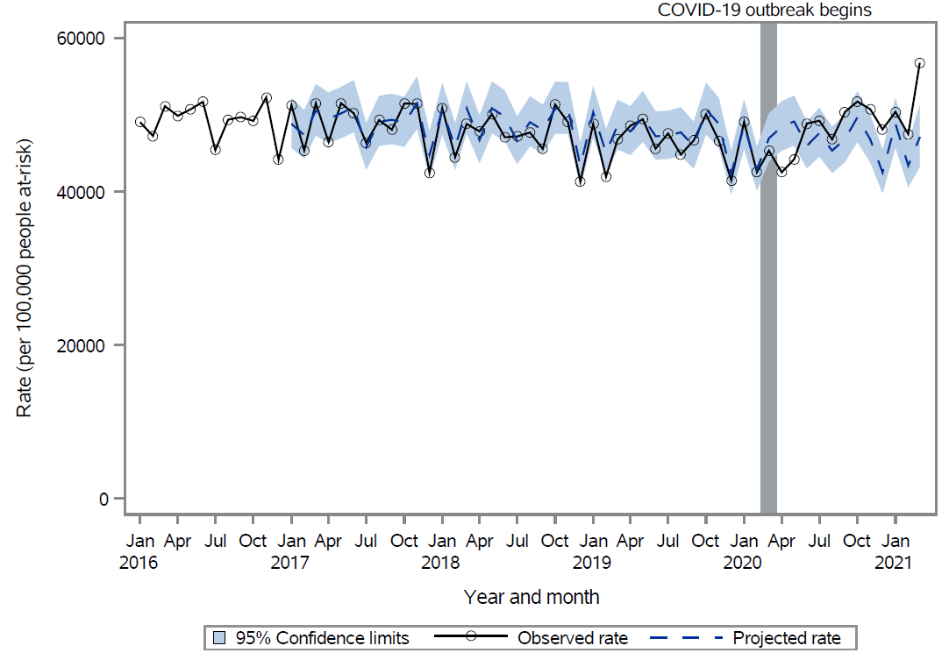

Figure 1: Observed versus projected all-cause primary care visit rates per 100,000 people at-risk.

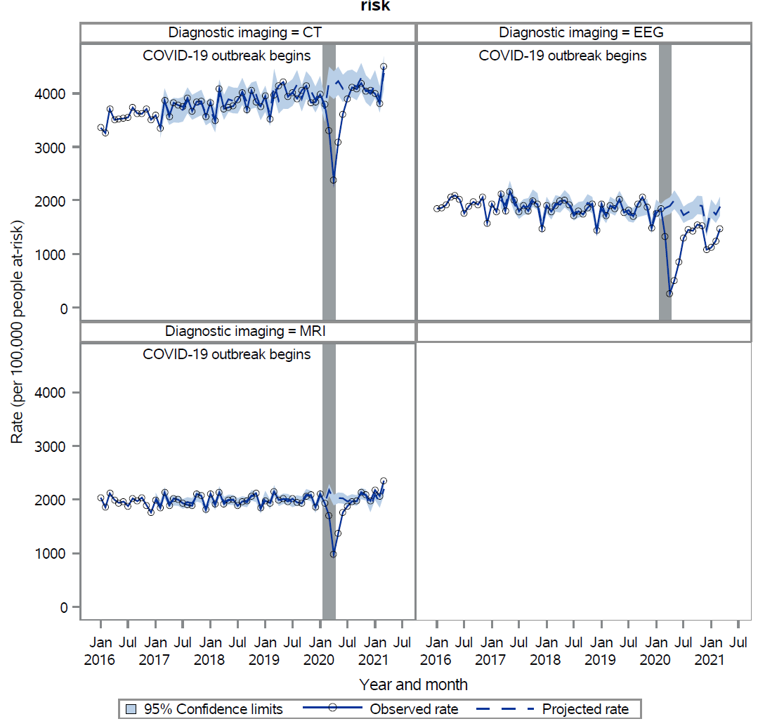

Figure 2: Observed versus projected relevant diagnostic test rates per 100,000 people at-risk.

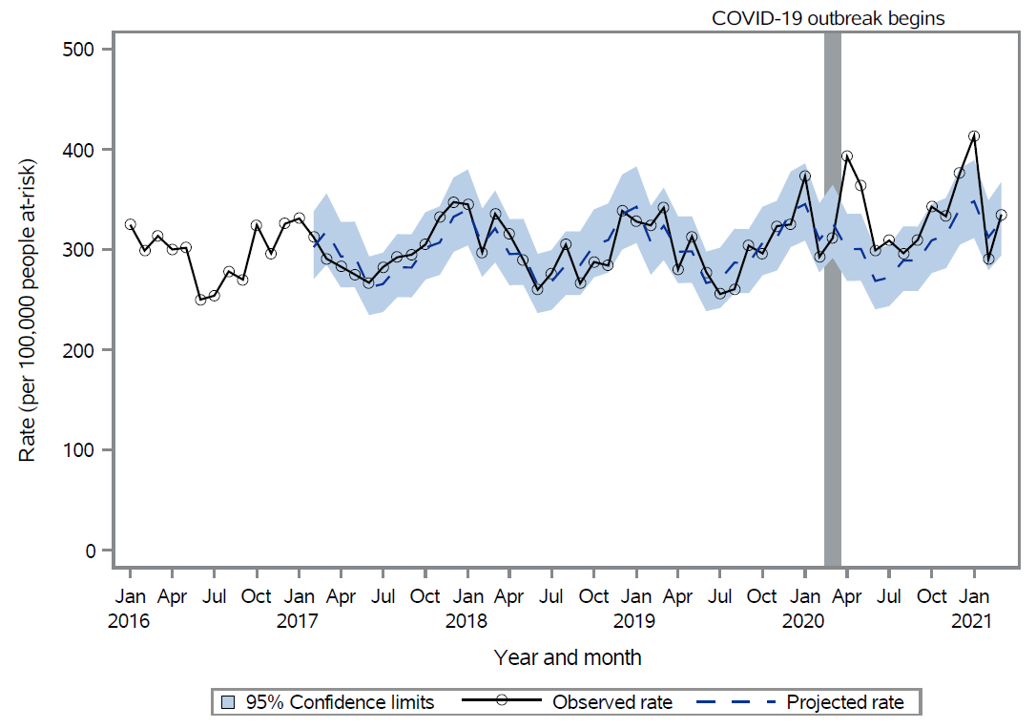

Figure 3: Observed versus projected all-cause mortality rates per 100,000 people at-risk.

References

1. Wodchis WP, Bushmeneva K, Nikitovic M, McKillop I. Guidelines on Person-Level Costing Using Administrative Databases in Ontario. vol 1. Working Paper Series. 2013.
2. Consumer price index portal. Accessed May 4, 2023, https://www.statcan.gc.ca/en/subjects-start/prices_and_price_indexes/consumer_price_indexes

