Supplementary Information

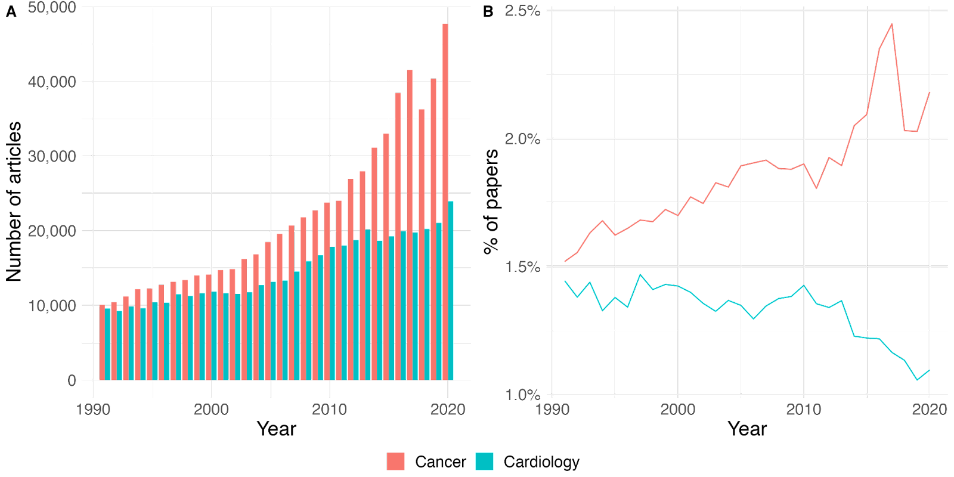
Figure S1. Number of articles in WoS related to Cancer and Nursing (A), and proportion of Cancer and Nursing research articles with respect to all WoS over time (B)

