SUPPLEMENT

Interview Guide………………………………………………………………………………....2

Supplementary Figure 1……………………………………………………………………….4
Interview Guide for In-Depth Interview with Physicians

Subtopic: Anti-thrombotic Management of the Hot Carotid

This guide is not an exhaustive list of questions. Be flexible in the interview process and adapt your questions to suit the topics and concerns raised by the participants.

DNO: ||_||_|_|_|_|_|_|_||_|_|

Date of interview: ___/___/___ Location: _______________

Interviewer: ___________________________________

Duration of Interview: _________________

DEMOGRAPHIC INFORMATION

Respondent  ID | Sex | Speciality | Country/Region

Thank you for agreeing to participate in our interview today. We wish to discuss your experience in managing patients with acutely symptomatic carotid stenosis (>50%), in the pre/peri-operative period as they await revascularization with endarterectomy/stenting. As part of this interview, we will also ask you some questions about your management of patients with symptomatic carotid stenosis <50%, as well as intraluminal thrombi.
We are seeking to better understand how physicians approach the risks versus benefits of various anti-thrombotic options in these patients, and how they envision the field evolving in the near future.

Please note that this conversation will be audio-recorded.

1. Overview of typical management

Please describe your role in stroke/TIA management at your centre, and your typical role in the management of patients with acutely symptomatic carotid stenosis.

Please describe your current approach to managing patients with acutely symptomatic carotid stenosis.
- What carotid revascularization procedure is typically preferred at your centre?
- How long does the patient typically wait in your centre before getting carotid endarterectomy? Carotid artery stenting?
- What anti-thrombotic agents will you typically favour in patients who are awaiting carotid revascularization (endarterectomy/stenting)?
- Who decides (or has a say in deciding) the anti-thrombotic regimen for patients in the peri-operative period at your centre?
- Have you practiced in any other centres or countries other than the one where you are presently working? How was the prevailing practice or philosophy similar or different in those centres?

Are there any challenges or uncertainties that you face in the process of selecting anti-thrombotic regimens for these patients?

What are the factors that you take into account when choosing an anti-thrombotic regimen for these patients?
- Does the type of procedure being performed make a difference? i.e. Is there one regimen you favour in endarterectomy versus another in carotid stenting?
- Are there any specific clinical features that would increase/decrease your enthusiasm for additional agents beyond single anti-platelet and statin therapy in these patients? If prompts required:
  - Demographics, Risk factors, Co-morbidities
  - Type of event (stroke/TIA)
  - Severity of event, Number of events
  - Days awaiting procedure
  - Type of procedure anticipated
  - Availability of surgeon/interventionist
  - Swallowing issues
- If the patient is already on an anti-platelet agent (e.g. ASA), will this change your approach? If so, how?
- Are there any specific imaging features that would increase/decrease your enthusiasm for additional agents beyond single anti-platelet and statin therapy in these patients? If prompts required:
  - Degree of stenosis
  - Nature of plaque (smooth versus ulcerated etc)
  - Microembolic signals
  - Tandem disease, intracranial disease
  - Uncertain mechanism
  - Microbleeds
  - Number of strokes on imaging
  - Size of stroke on imaging
  - Evidence of hemorrhagic transformation on imaging etc.

2. Perceptions and opinions of current evidence

What are your thoughts on the current state of evidence about anti-thrombotic management in patients with acutely symptomatic carotid stenosis? Specifically those awaiting CAS/CEA?

Do you consider your approach to be well justified by current evidence? Or do you see yourself as operating outside or beyond the current evidence?

What specific gaps, if any, do you find in the current evidence? What uncertainties remain?

3. Vision/attitudes towards future research

Do you envision the peri-procedural management of these patients changing in the near future? How?

What new research/trials do you think would change your current practice? Are there any such trials currently under way?

What are your thoughts about further trials of different anti-thrombotic regimens in patients with acutely symptomatic carotid stenosis?

If could compare benefits/risks of any regimens for this indication, what would they be?

What would you consider to be the most important outcome measures to demonstrate the superiority of one approach over another for this indication?
- Are there any imaging endpoints that you would view as acceptable surrogates?

What factors encourage/discourage you from participating in such trials?
- What are some appealing aspects of pursuing a randomized controlled trial in this population?
- What do you envision as core challenges in pursuing a trial in this population?

Do you have any additional comments or suggestions for optimizing the peri-operative anti-thrombotic management for patients with symptomatic carotid stenosis?

Thank you for participating in today’s interview.

Add additional follow-up questions in a flexible manner depending on what comes up in the interviewee’s responses, aiming to obtain a comprehensive picture.

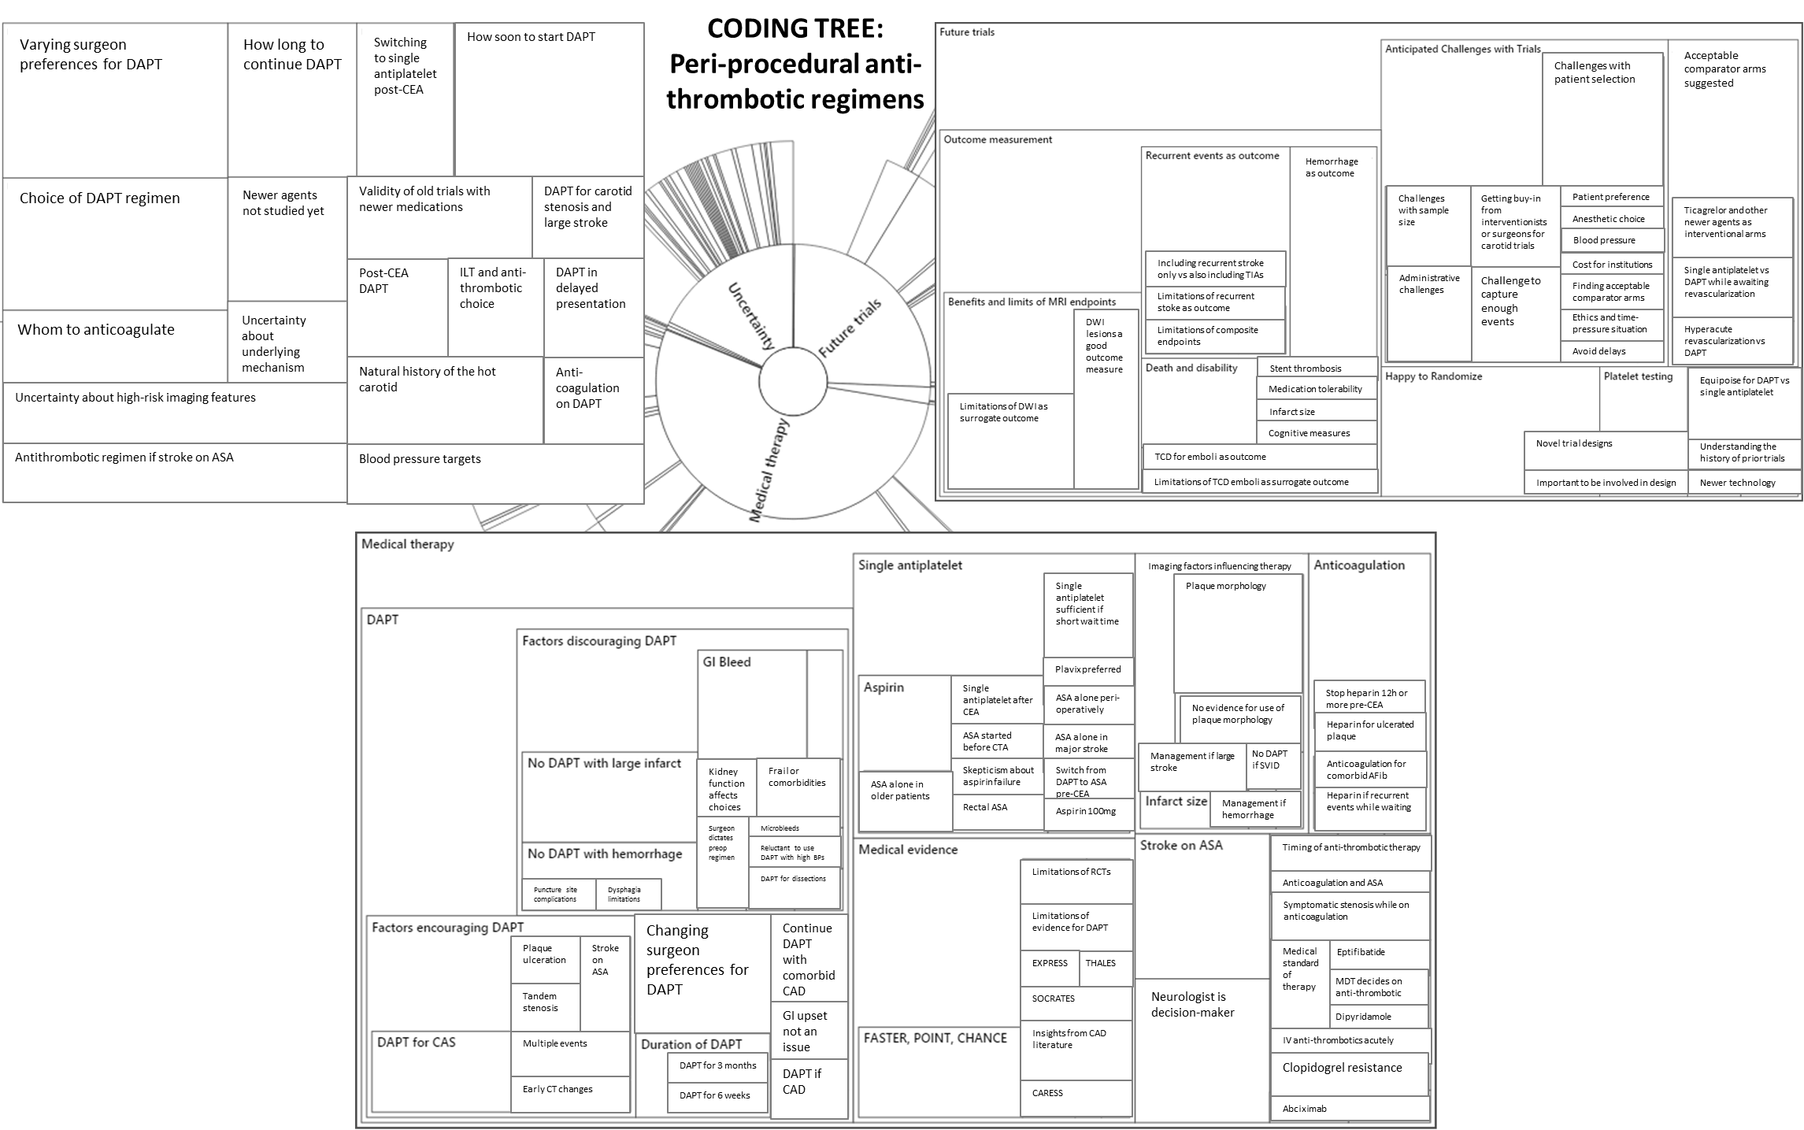
Supplementary Figure 1. Coding Tree used for this paper. At the core are the three main topics explored – approach to medical (ant-thrombotic) therapy for the hot carotid, thoughts about future trials in this area, and exploring areas of uncertainty. The areas are sized to reflect the number of coding references in the interviews. A larger area indicates more coding references.

