Supplementary Material

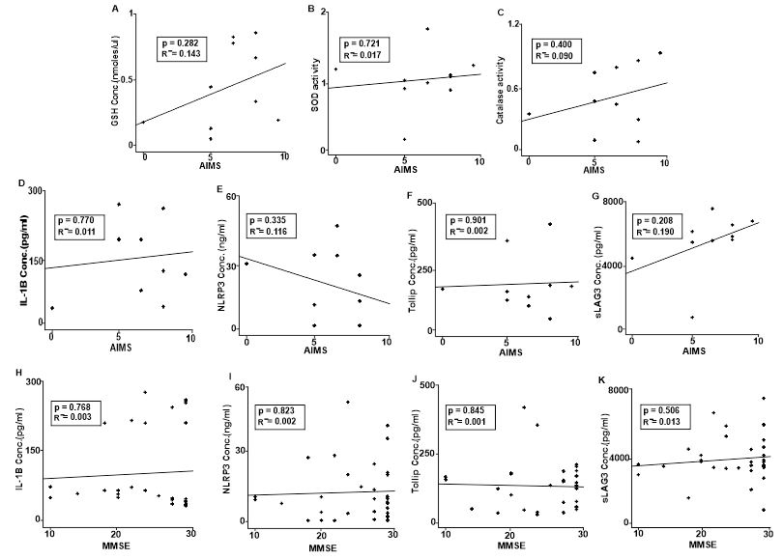

Supplementary Figure: All negative correlations. No significant association between Oxidative markers and AIMS (A-C). No significant association between inflammatory markers and AIMS (D-G). No significant association between inflammatory markers and MMSE (H-K).

